**H ∞ and μ - synthesis Design of Coupled Tanks Level Control**

Mustefa Jibril 1, Messay Tadese 2, Eliyas Alemayehu Tadese 3

1. School of Electrical & Computer Engineering, Dire Dawa Institute of Technology, Dire Dawa, Ethiopia

2. School of Electrical & Computer Engineering, Dire Dawa Institute of Technology, Dire Dawa, Ethiopia

3. Faculty of Electrical & Computer Engineering, Jimma Institute of Technology, Jimma, Ethiopia

[mustefazinet1981@gmail.com](mailto:mustefazinet1981@gmail.com)

**Abstract:** In this paper, the design and analysis of coupled tank water level control system is done using robust control theory. The main aim of this work is to improve level controlling mechanisms in industries and household areas. In this paper, H ∞ and μ –synthesis controllers are designed to improve the level control system. The coupled tank water level control system is designed using the proposed controller’s comparison and tested for tracking a reference level signals (step, sine wave and random) and simulation results have been analyzed successfully. Finally the comparative simulation results prove the effectiveness of the proposed coupled tank water level control system with H ∞ controller for improving the tracking mechanism performance of the system.

[Mustefa Jibril, Messay Tadese, Eliyas Alemayehu Tadese. **H ∞ and μ - synthesis Design of Coupled Tanks Level Control.** *Researcher* 2020;12(6):22-26]. ISSN 1553-9865 (print); ISSN 2163-8950 (online). <http://www.sciencepub.net/researcher>. 4. doi:[10.7537/marsrsj120620.04](http://www.dx.doi.org/10.7537/marsrsj120620.04).

**Keywords:** H infinity, μ –synthesis, robust control theory

1. **Introduction**

Many in advance works dealt with various strategies of controlling of liquid level of coupled tanks in industrial and home packages. Broadly this manage problem can be completed underneath two method: mechanical methods and electrical methods. Float ball type liquid level control is a famous technique of control nevertheless utilized in practice for regular applications such as overhead tank overflow restrictors etc. The electrical techniques of control include a microcontroller-control based circuits which robotically expect the liquid level and for that reason active the circuit to perform the action. In spite of several such to be had techniques, still there are new techniques on this application so as keep away from dangerous working situations in commercial boilers.

1. **Mathematical model of the two tanks system**

Figure 1 represents a two-tank liquid-level control system. Definitions of the system parameters are

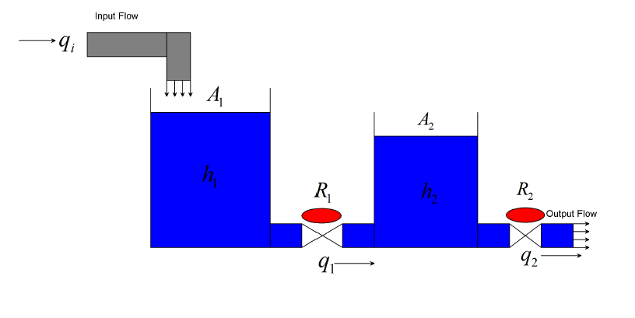

Figure 1 two-tank liquid-level control system



The following basic linear relationships hold for this system:





Applying equation (2) to tanks 1 and 2 respectively yields:





Letting x1 = h1, x2 = h2, and u =qi in Equation (3) and (4) reveals that x1 and x2 are independent state variables. Thus, the state equation is



The levels of the two tanks are the outputs of the system. Letting y1=x1=h1 and y2 = x2 = h2 yields



The parameters of the tank is shown in Table 1 below

Table 1 parameters of the tank

|  |  |  |  |
| --- | --- | --- | --- |
| No | Parameter | Symbol | value |
| 1 | Area 1 |  |  |
| 2 | Area 2 |  |  |
| 3 | Resistance 1 |  |  |
| 4 | Resistance 2 |  |  |



1. **Weighting Functions**

It is required that within the H ∞ framework to use weighting functions to reconciliation distinct overall performance targets. The performance aim of a comments system may be normally determined in phrases of requirements at the sensitivity features and/or complementary sensitivity features or in phrases of some other closed loop transfer functions. The odds of occupying weighted overall performance in multivariable system design is firstly, some part of a vector signal are generally more essential than others, secondly, measuring each signal will not be inside the equal unit. For instance, a few part of the output error signal can be measured in terms of period, and others may be measured in phrases of voltage. Therefore, weighting functions play a vital rule to kind those component similar. The weighting functions are mentioned beneath.

W h1 and W h2 are used to keep the water level of the tank small over the desired range. The water level W h1 is given as



The water level h2 is used via weighting function W h2. The weighting function is given as



1. **The Proposed Controller Design**

The design of water level of the tank system to provide level control is evolved the use of H ∞ and μ - synthesis controllers design. In the water level of the tank system, the proposed controllers design to control the level of the water within the two tanks. The predominant purpose of the controller design is to decrease the error of the level of the two tanks. Synthesis method is used to design the proposed controllers through reaching the overall performance objective through minimizing the weighted transfer characteristic norm. The water level of the tank system with H ∞ and μ - synthesis controllers system interconnections block diagram for tracking level h1 and level h2 is shown in Figure 2 and Figure 3 respectively.

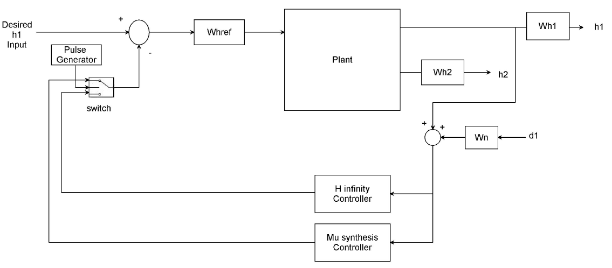

Figure 2: water level of the tank system with H ∞ and μ - synthesis controllers system interconnections block diagram for tracking level h1

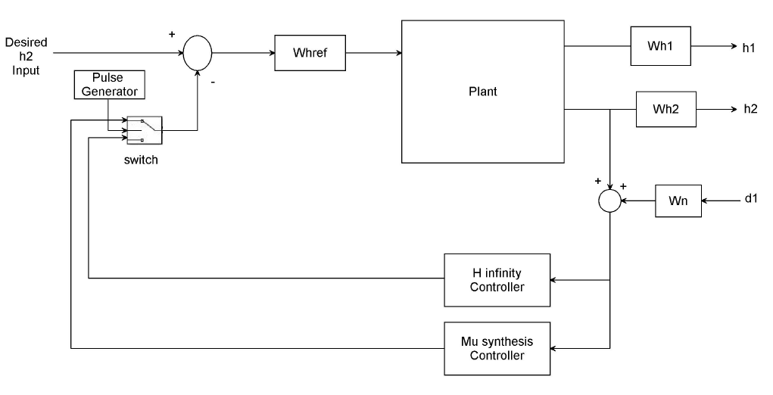

Figure 3: water level of the tank system with H ∞ and μ - synthesis controllers system interconnections block diagram for tracking level h2

A μ -synthesis controller is synthesized the usage of D-K iteration. The D-K iteration method is an approximation to synthesis that tries to synthesize the controller. There is one manipulate input the desired level signal. There are two purposes for the weighted functions norm: for a given norm, there will be a direct evaluation for extraordinary performance targets and they are used for understanding the frequency data incorporated into the analysis. The output or feedback signal y is



The controller’s acts on the y signal to produce the feedback level signal. The Wn block modeled the disturbance inside the channel. Wn is given a disturbance noise of 0.05m.



W n is used to model the noise of the level sensor. The magnitude of the level disturbance is scaled using the weight Whref. Let us assume the maximum level disturbance is 0.15 m which means



1. **Result and Discussion**
   1. **Comparison of the Water Level of the Tank System with H ∞ and μ - synthesis Controllers**

In this subsection, we simulate the water level of the tank system with H ∞ controller and μ - synthesis controller for the tracking of desired level using step, sine wave and random desired input signals.

1. **Simulation of a Desired Level Step Signal**

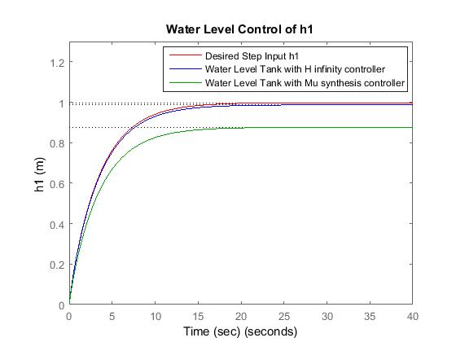

Figure 4: Simulation of the actual and desired level for h1

The simulation for a step input level signal is shown below. In this simulation, we simulate the water level of the tank system with H ∞ controller and μ - synthesis controller for the tracking of desired level signal.

The tracking of desired level signal simulation output is shown in Figure 4 and Figure 5 respectively for tracking of desired level h1 and h2 respectively.

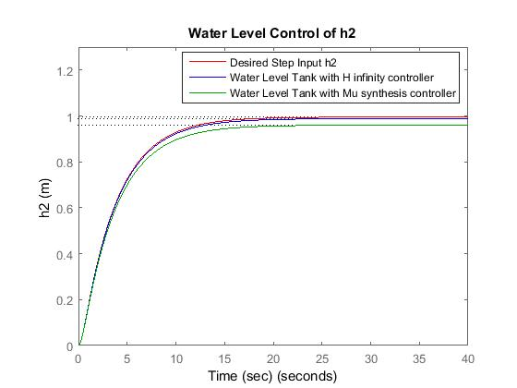

Figure 5: Simulation of the actual and desired level for h2

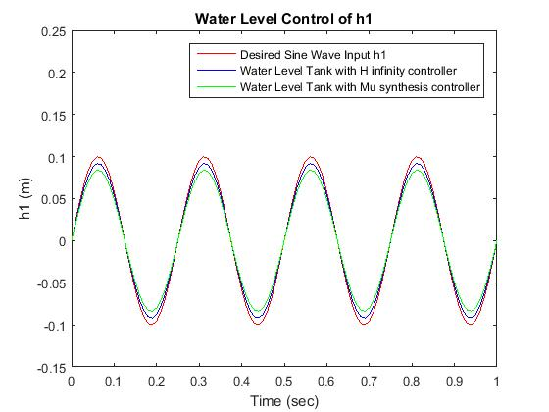

Figure 6: Simulation of the actual and desired level for h1

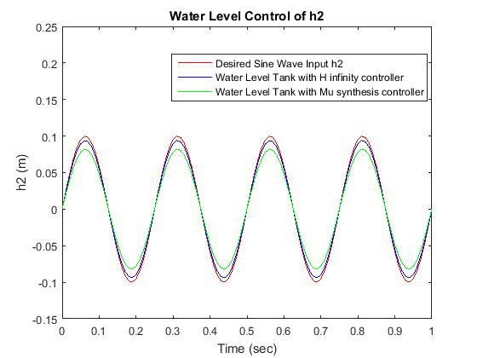

Figure 7: Simulation of the actual and desired level for h2

1. **Simulation of a Desired Level Sine Wave Signal**

The simulation for a sine wave input level signal is shown. In this simulation, we simulate the water level of the tank system with H ∞ controller and μ - synthesis controller for the tracking of desired level signal.

The tracking of desired level signal simulation output is shown in Figure 6 and Figure 7 respectively for tracking of desired level h1 and h2 respectively.

1. **Simulation of a Desired Level Random Signal**

The simulation for a random input level signal is shown below. In this simulation, we simulate the water level of the tank system with H ∞ controller and μ - synthesis controller for the tracking of desired level signal.

The tracking of desired level signal simulation output is shown in Figure 8 and Figure 9 respectively for tracking of desired level h1 and h2 respectively.

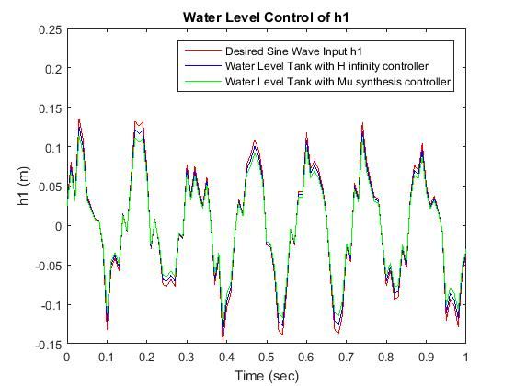

Figure 8: Simulation of the actual and desired level for h1

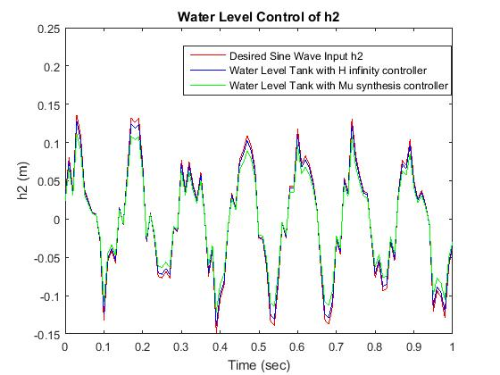

Figure 9: Simulation of the actual and desired level for h2

1. **Numerical Values of the Simulation Outputs**

The numerical values of the simulation output for the tracking of desired level using step, sine wave and random desired input signals is shown in Table 2, Table 3 and Table 4 bellow.

Table 2: Numerical steady state values of the desired step signal simulation output

|  |  |  |  |
| --- | --- | --- | --- |
| No | Systems | h1 | h2 |
| 1 | Desired Input signal | 1 m | 1 m |
| 2 | H ∞ | 0.99 m | 1 m |
| 3 | μ - synthesis | 0.87 m | 0.92 m |

Table 2 shows us the water level of the tank system with H ∞ controller have track the desired step input signal in the level h1 and h2 with good improvement than the water level of the tank system with μ - synthesis controller.

Table 3: Numerical peak values of the desired sine wave signal simulation output

|  |  |  |  |
| --- | --- | --- | --- |
| No | Systems | h1 | h2 |
| 1 | Desired Input signal | 0.1 m | 0.1 m |
| 2 | H ∞ | 0.097 m | 0.096 m |
| 3 | μ - synthesis | 0.085 m | 0.084 m |

Table 3 shows us the water level of the tank system with H ∞ controller have track the desired step input signal in the level h1 and h2 with good improvement than the water level of the tank system with μ - synthesis controller.

Table 4: Numerical peak values of the desired random signal simulation output

|  |  |  |  |
| --- | --- | --- | --- |
| No | Systems | h1 | h2 |
| 1 | Desired Input signal | 0.14 m | 0.14 m |
| 2 | H ∞ | 0.13 m | 0.138 m |
| 3 | μ - synthesis | 0.12 m | 0.115 m |

Table 4 shows us the water level of the tank system with H ∞ controller have track the desired step input signal in the level h1 and h2 with good improvement than the water level of the tank system with μ - synthesis controller.

1. **Conclusion**

In this paper, the coupled tank water level control system with H ∞ and μ – synthesis controllers is designed, controlled and analyzed with Matlab/Script toolbox and a fascinating results have been analyzed successfully. Comparison of the system with the proposed controllers is done for tracking a three reference level signals (step, sine wave and random) and the coupled tank water level control system with H ∞ controller improve the tracking mechanism in the three reference input signals and shows that this system can be designed with robust controllers in industries and home appliances systems.

**Reference**

1. M Khairudin et al. “Water Level Control Based Fuzzy Logic Controller: Simulation and Experimental Works” IOP Conference Series: Materials Science and Engineering, Vol. 535, 2019.
2. Riccardo V. et al. “Instability of the Tank Level Control System of Water Mains in Mountainous Environments” Journal of Hydraulic Engineering, Vol. 145, Issue. 7, 2019.
3. Nishmitha et al. “Water Tank Monitering System” International Journal of Engineering Research & Technology, Vol. 7, Issue. 8, 2019.
4. Mostafa A. et al. “PID Controller Design for Two Tanks Liquid Level Control System using Matlab” International Journal of Electrical and Computer Engineering, Vol. 5, No. 3,2018.
5. Reza F. et al. “Design and Implementation of Water Level Control for Two Coupled Tank as a Simple and Low Cost Apparatus in Automatic Control Engineering Education” Journal of Physics: Conference Series, Vol. 1153, 2018.
6. Mallikarjun H. et al. “Flexible Automatic Water Level Controller and Indicator” World Journal of Technology, Engineering and Research, Vol. 3, Issue. 1, 2018.

6/20/2020