Supplementary Information

Supplementary Table S1: Sources used to determine modelling parameters for basic Ecopath estimates.

 | Diet | Biomass (t/km²) | Q/B & P/B
Galápagos penguin | [48,54,57,62,70; E. Espinoza pers. Comm., Galápagos National Park, October 2021, unpublished data] | 0.125 [54] | Q/B = 60.3  P/B = 0.067  [54]
Barracuda | [54] | 13.06  [54] | Q/B = 3.9  P/B = 0.063  Fishbase  Life-history: Sphyraena idiates
Mullet | [54] | 22.6 [54] | Q/B = 10.9  P/B = 2.8  Fishbase Life-history: Mugil galapagensis
Anchovy, Herring, Sardines, Salema | [54,71–73] | 19 [54] | Q/B = 15  P/B = 4.6  Fishbase  Life-history: Brachygenys jessiae, Sardinops sagax, Anchoa nasus, Opisthonema berlangai
Decapods | [54] | 14.48 [54] | Q/B = 11.95  P/B = 0.687  Sealifebase  Scyllarides astori
Predatory zooplankton | [54] | 15 [54] | Q/B = 99.13  P/B =45  [54]
Herbivorous zooplankton | [54] | 22 [54] | Q/B = 200  P/B = 36  [54]
Macroalgae | NA | 800.47 [54] | NA
Microalgae/  phytoplankton | NA | 31.16 [54] | NA
Detritus | NA | 500 [54] | NA

Supplementary Table S2: Modelling scenarios and respective Ecotracer input data for model kinetic parameters.

Scenario | Description | Initial concentration & base inflow (t/km²) | Decay Rate | Direct absorption rate for zooplankton  (g/kg) | Elimination rates
1 | Baseline | 4.11x10⁻² | 0.0283 | 7.38x10⁻² | Table 5
2 | High Environmental Concentration | 7.83x10⁻² | 0.0283 | 7.38x10⁻² | Table 5
3 | Low Environmental Concentration | 3.9x10⁻³ | 0.0283 | 7.38x10⁻² | Table 5
4 | Elimination rates changed to 99% eliminated in 1 day | 4.11x10⁻² | 0.0283 | 7.38x10⁻² | All groups set to 0.99

Supplementary Table S3: Functional group input data for the Galápagos penguin (GP) model based on the baseline scenario.
 | Group name | Direct absorption rate | Prop. of contaminant excreted
1 | Galápagos Penguin |  | 0.333
2 | Barracuda |  | 0.02
3 | Mullet |  | 0.03333
4 | Anchovy, Herring, Sardines, Salema |  | 0.02
5 | Decapods |  | 0.07
6 | Predatory zooplankton | 7.38x10⁻⁷ | 0.14
7 | Herbivores zooplankton | 7.38x10⁻⁷ | 0.14
8 | Macroalgea
9 | Microalgea/phytoplankton
10 | Detritus

Supplementary Table S4: Functional group input data for the Bolivar Channel Ecosystem (BCE) model based on the baseline scenario.
 | Group name | Direct absorption rate | Prop. of contaminant excreted
1 | Phytoplankton
2 | Macroalgae + others
3 | Surgeonfishes, chubs and giant damiselfishes |  | 0.02
4 | Sea cucumbers and other |  | 0.14
5 | Herbivorous zooplankton | 7.38x10⁻⁷ | 0.14
6 | Sea turtles and marine iguanas |  | 0
7 | Small hervivorous gastropods |  | 0.14
8 | Sponges and polichaetes |  | 0.14
9 | Gorgonians |  | 0.14
10 | Parrotfish |  | 0.02
11 | Mullets |  | 0.033
12 | Benthic omnivorous fish |  | 0.02
13 | Anemones and zoanthids |  | 0.14
14 | Sea stars and sea urchins |  | 0.14
15 | Planktivorous reef fish (>15cm) |  | 0.02
16 | Small planktivorous reef fish |  | 0.02
17 | Lobsters |  | 0.07
18 | Predatory zooplankton | 7.38x10⁻⁷ | 0.14
19 | Big gastropods and other sea stars |  | 0.14
20 | Small predator gastropods |  | 0.14
21 | Benthic predatory fish (<30cm) |  | 0.02
22 | Benthic predatory fish (>30cm) |  | 0.02
23 | Barracudas |  | 0.02
24 | Groupers |  | 0.02
25 | Jacks and mackerels |  | 0.02
26 | Rays |  | 0.02
27 | Predatory marine mammals |  | 0.33
28 | Seabirds |  | 0.33
29 | Sharks |  | 0.02
30 | Detritus

Supplementary Table S5: Linear regression data for the GP EwE model with the baseline scenario showing the significant relationship between predicted concentrations of microplastics (log-transformed data) and trophic levels in the GP model at years 1, 25, 50, and 100. The antilog of the regression slope was used to determine TMF (i.e., TMF= 10^{b}).

Statistical regression parameters | Year 1 | Year 25 | Year 50 | Year 100
Correlation Coefficient (r) | 0.87 | 0.93 | 0.93 | 0.92
Coefficient of determination (r²) | 75.56% | 86% | 86% | 85%
Slope for least square line (b) | 0.8499 | 1.61 | 1.74 | 1.79
y-intercept for least square line | -10.7613 | -11.41 | -11.54 | -11.65
P-value* | 0.011 | 0.0028 | 0.0028 | 0.0032
TMF | 7.08 | 40.7 | 55.0 | 61.7

*Statistically significant linear regression

Supplementary Table S6: Bioaccumulation factor (BAF), bioconcentration factor (BCF), and predator-prey biomagnification factors (BMF_{TL}) from average microplastic concentration (g/kg) from selected predator-prey combinations in the Galápagos penguin food web model.

 | Predatory zooplankton with prey set to herbivorous zooplankton | Planktivorous fish with prey set to predatory zooplankton | Planktivorous fish with prey set to herbivorous zooplankton | Mullet with prey set to detritus | Galápagos penguin with prey set to planktivorous fish | Galápagos penguin with prey set to mullet | Galápagos penguin with prey set to decapods
BAF | 4.36x10⁻⁸ | 4.92x10⁻⁸ | 4.92x10⁻⁸ | 2.26x10⁻⁸ | 5.90x10⁻⁵ | 5.90x10⁻⁵ | 5.90x10⁻⁵
BCF | 4.36x10⁻⁸ | 4.92x10⁻⁸ | 4.92x10⁻⁸ | 2.26x10⁻⁸ | 5.90x10⁻⁵ | 5.90x10⁻⁵ | 5.90x10⁻⁵
BMF_{TL} | 3.50 | 6.84 | 3.06 | 11.3 | 1239 | 1796 | 2308

Supplementary Table S7: Linear regression data for the BCE with the baseline scenario showing the significant relationship between predicted concentrations of microplastics (log-transformed data) and trophic levels in the GP model at years 1, 25, 50, and 100. The antilog of the regression slope was used to determine TMF.

Statistical regression parameters | Year 1 | Year 25 | Year 50 | Year 100
Correlation Coefficient (r) | 0.62 | 0.79 | 0.79 | 0.79
Coefficient of determination (r²) | 38.83% | 62.65% | 61.87% | 61.87%
Slope for least square line (b) | 0.80 | 1.20 | 1.22 | 1.22
y-intercept for least square line | -11.1 | -10.7 | -10.6 | -10.6
P-value* | 0.0005 | 8.8x10⁻⁷ | 1.15x10⁻⁶ | 1.148x10⁻⁶
TMF | 6.17 | 15.8 | 16.6 | 16.6
*Statistically significant linear regression

Supplementary Table S8: Bioaccumulation factor (BAF), bioconcentration factor (BCF), and predator-prey biomagnification factors (BMF_{TL}) from average microplastic concentration (g/kg) from selected predator-prey combinations in the BCE web model.

 | Predatory zooplankton with prey set to herbivorous zooplankton | Planktivorous fish with prey set to predatory zooplankton | Planktivorous fish with prey set to herbivorous zooplankton | Mullet with prey set to detritus | Seabirds with prey set to planktivorous fish | Seabirds with prey set to mullet | Seabirds with prey set to lobster
BAF | 7.34x10⁻⁸ | 6.62 x10⁻⁸ | 6.62x10⁻⁸ | 1.14x10⁻⁸ | 5.85x10⁻⁷ | 5.85x10⁻⁷ | 5.85x10⁻⁷
BCF | 7.34x10⁻⁸ | 6.62 x10⁻⁸ | 6.62x10⁻⁸ | 1.14x10⁻⁸ | 5.85x10⁻⁷ | 5.85x10⁻⁷ | 5.85x10⁻⁷
BMF_{TL} | 4.57 | -2.73 | -2.73 | 18.3 | 8.61 | 36.9 | 75.8

A)

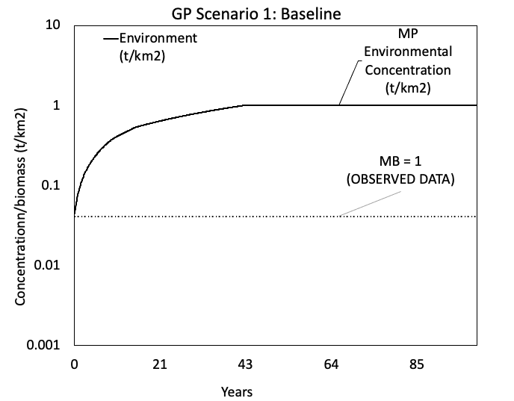 | 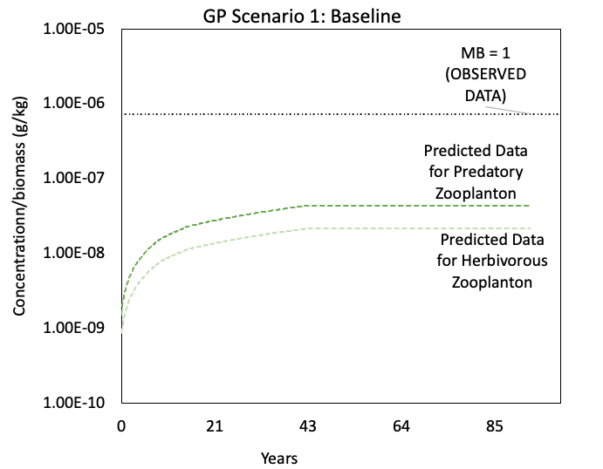
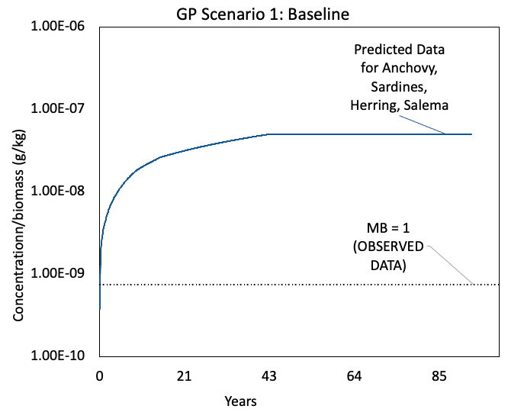 | 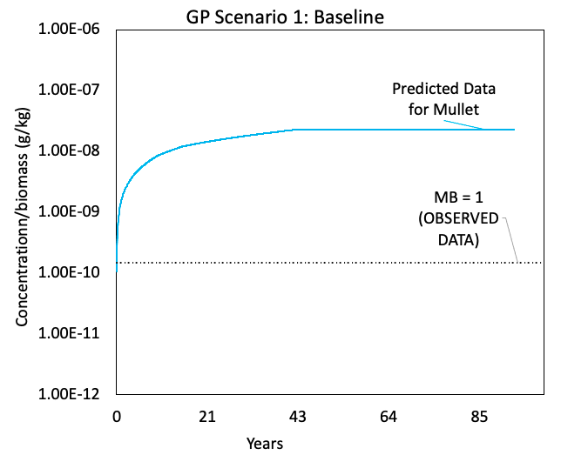

B)

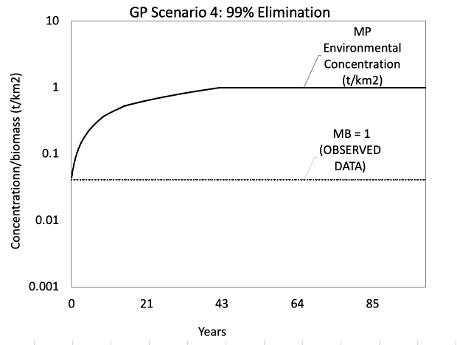 | 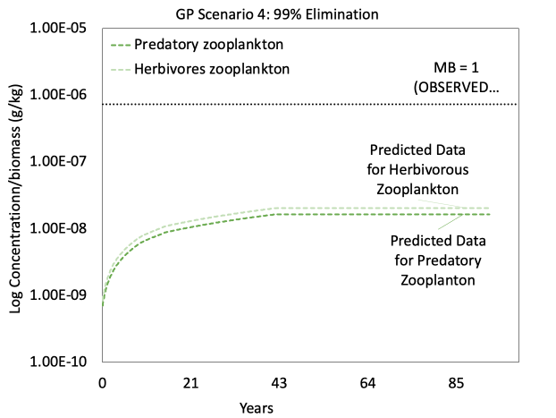
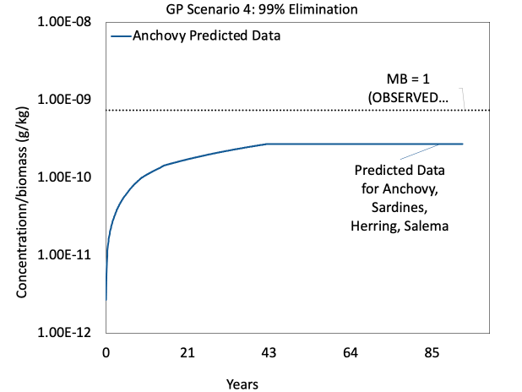 | 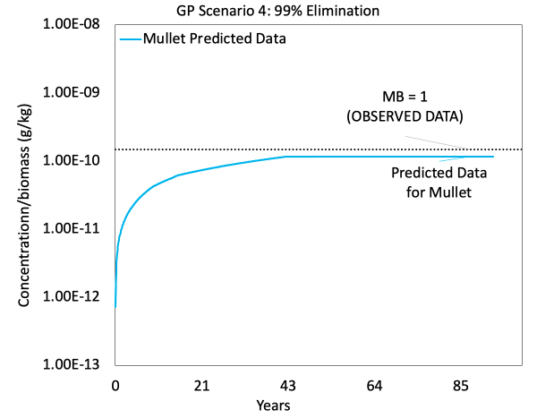

C)

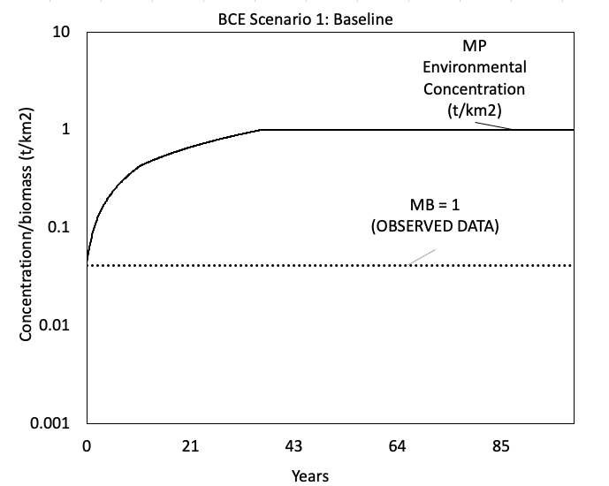 | 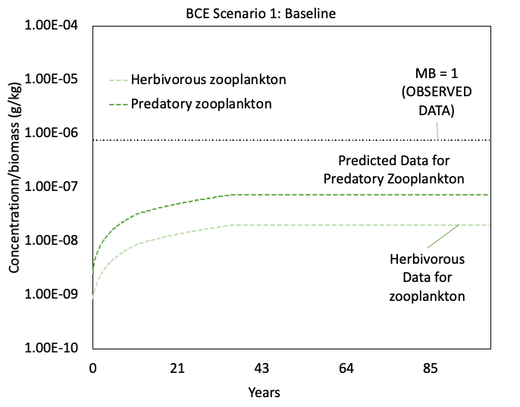
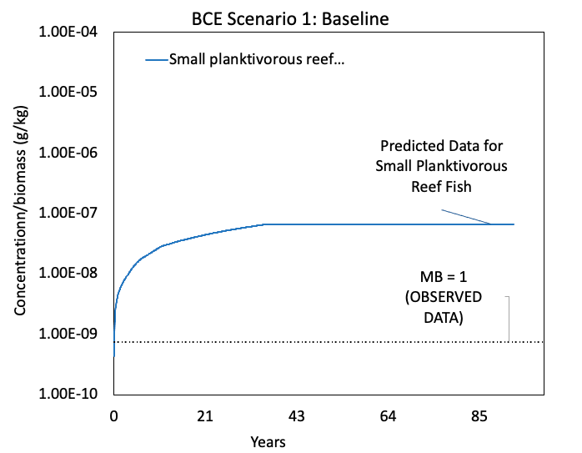 | 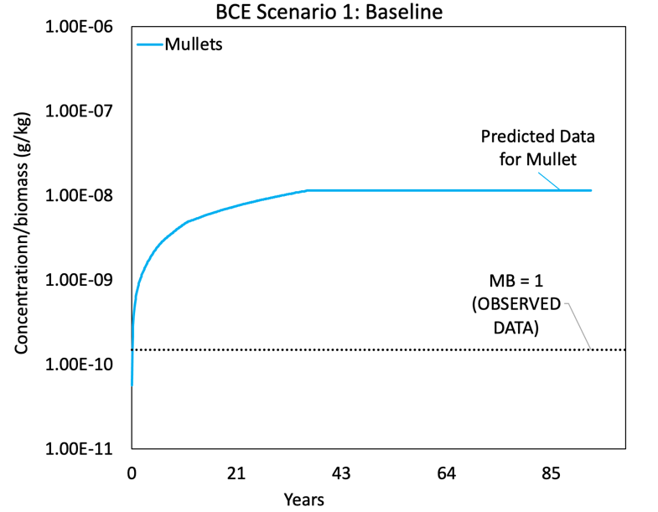

D)

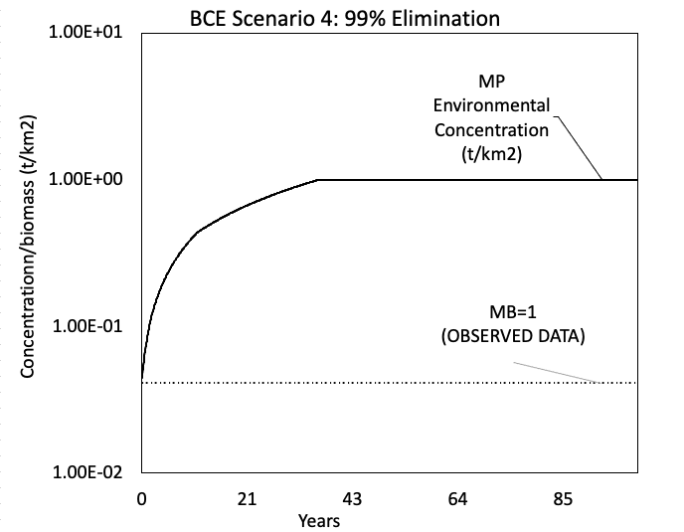 | 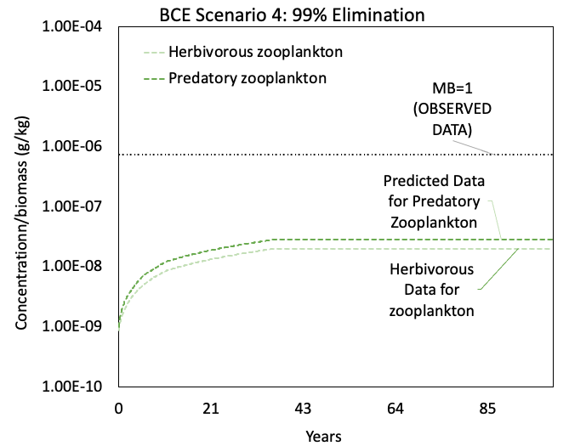
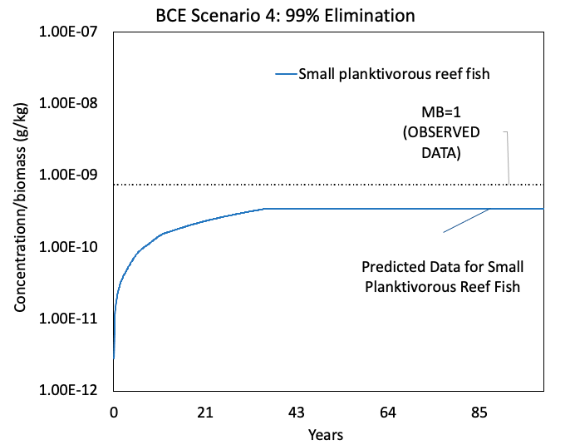 | 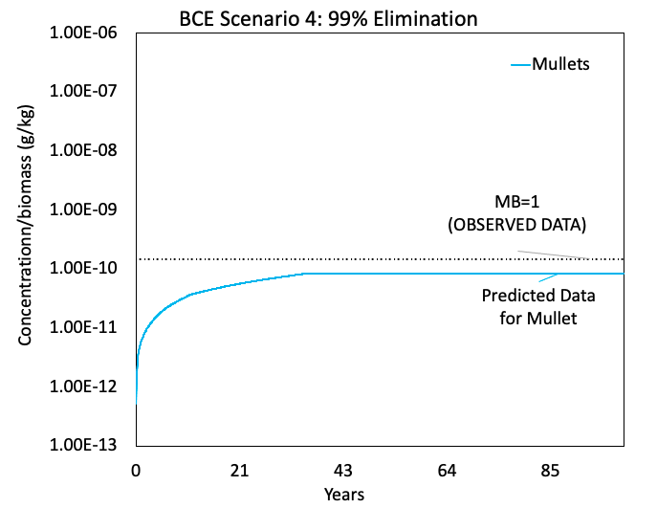

Supplementary Figure S1: Assessment of the model bias using the (A-B) Galápagos penguin (GP) and (C-D) Bolivar Channel Ecosystem (BCE) models run with Ecotracer to project microplastic concentration simulations from year 1 to 100 as predicted microplastic concentrations in the abiotic and biotic compartments. Results are presented by seawater microplastic abundance, microplastic concentrations in zooplankton, microplastic concentrations in anchovies, and microplastic concentrations in mullets. Predicted data is compared to empirically measured data on anthropogenic particle concentrations in Galápagos seawater and ingestion rates for zooplankton, anchovies, and mullets collected in October 2021. Two scenarios are presented for each model: GP model baseline (A), GP 99% elimination rates (B), BCE model baseline (C), BCE 99% elimination rates (D).

References
See references in the main text.

