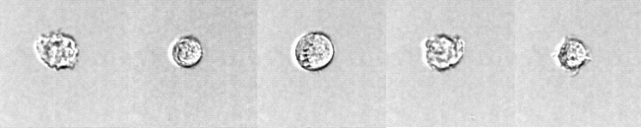

**(E)**

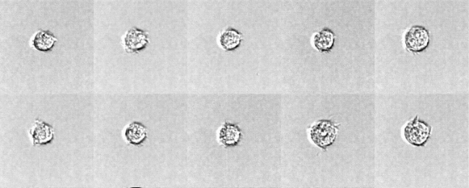

**(D)**

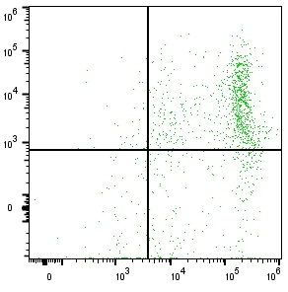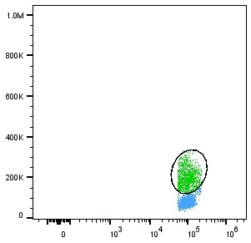

SSC

CD45

CD41

CD33

Mo41+

Mo41-

**(C)**

**(F)**

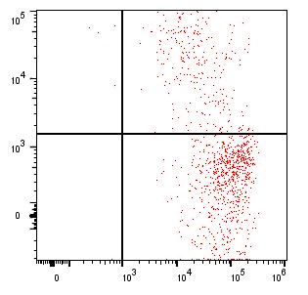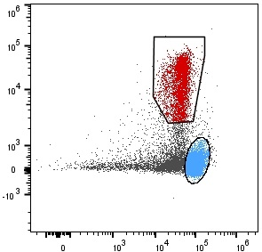

CD34

CD45

CD41

CD33

BL41+

BL41-

**(B)**

**(E)**

FSC

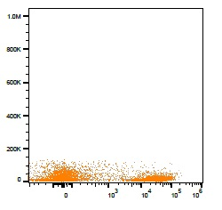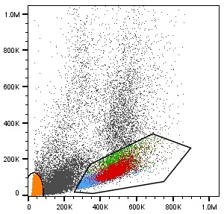

SSC

SSC

CD41

Platelets

**(A)**

**(D)**

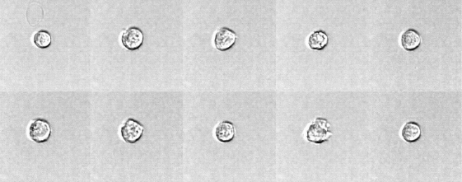

**(C)**

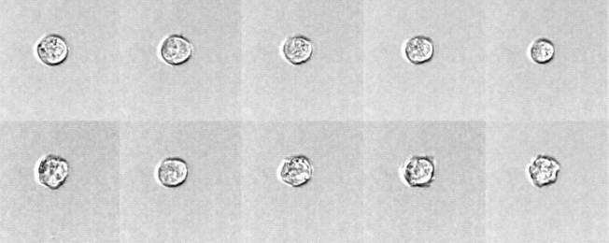

**(B)**

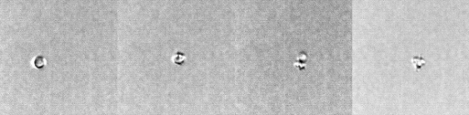

**(A)**

**Supplementary Figure 4B. Case 6**

P1