Supplementary material
Supplementary Table 1
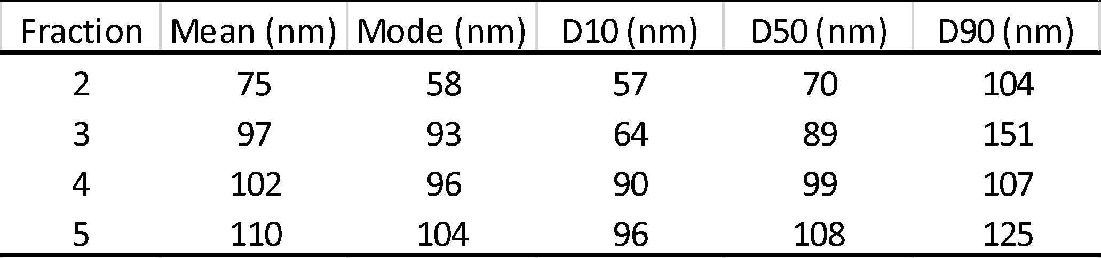
Supplementary Table 1. Size and distribution parameters. Mean size, mode, D10, D50 and D90 parameters from the tRPS analysis for fractions 2, 3, 4 and 5.

