Supplementary material
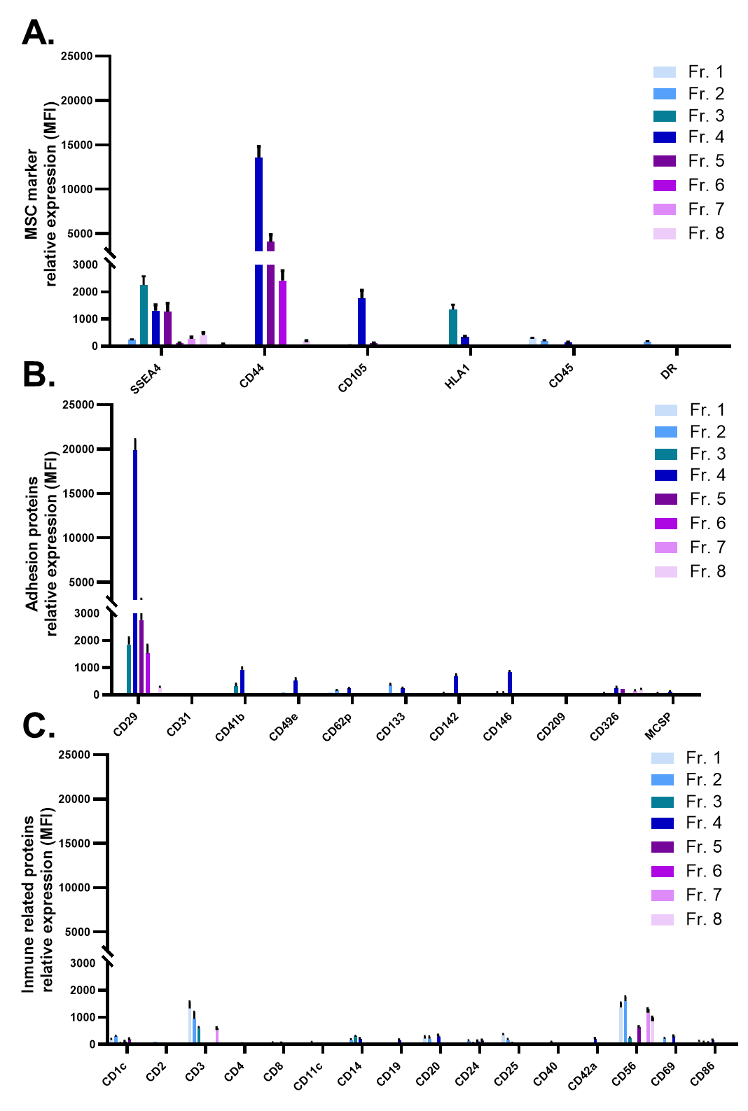
Supplementary Figure 1
Fig S1. sEV surface proteins assessment. The presence of surface proteins was assessed by flow cytometry using the MACSPlex kit. MSC related proteins are depicted in (A), adhesion molecules are shown in (B) and immunological related proteins are shown in (C).

