Supporting Information

Figure S1. Enlarged panels for Figure 1. Enlarged protein sequences alignments of the outer membrane beta-barrel and their QTY variants. The readers can see the five native protein and QTY code variant sequences and understand how the QTY code works.

a) BamA, Uniprot: Q5F5W8, (PDB: 4K3B)

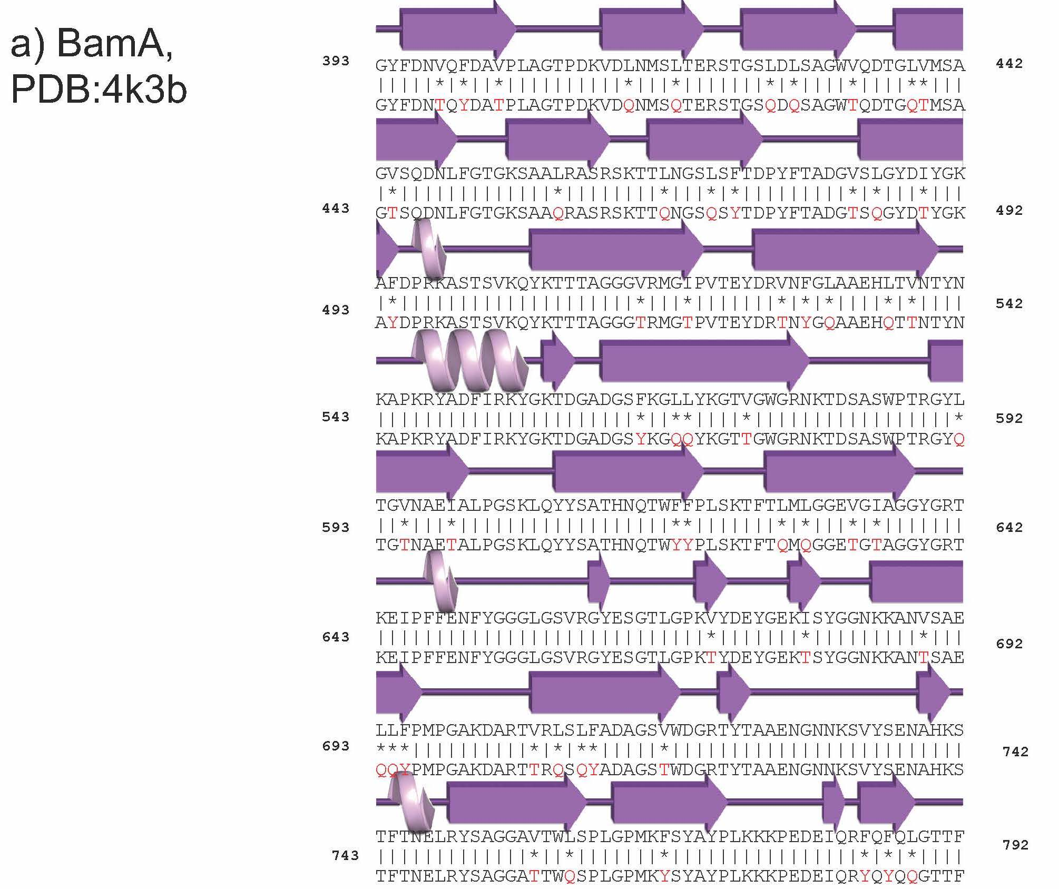
BamA
PDB: 4K3B

b) Omp85, Uniprot: G2QFF9 (PDB: 6WUT)

OMP85
PDB: 6WUT
c) FecA, Uniprot: P13036 (PDB: 1KMO),

FecA
PDB: 1KMO
d) Tsx, Uniprot: P0A927 (PDB: 1TLY)
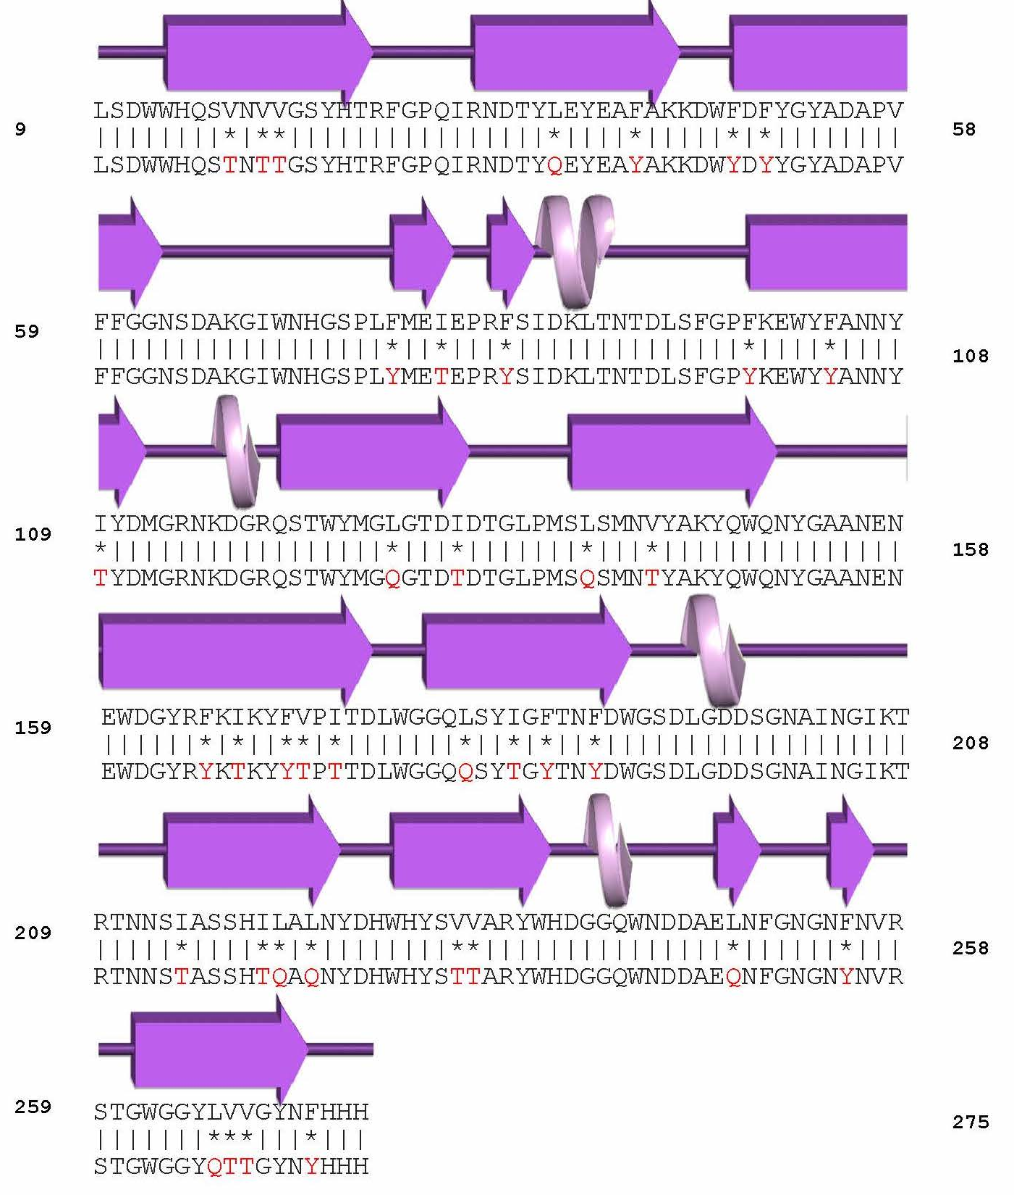
TSX
PDB: 1TLY
e) OmpC, Uniprot: P06996 (PDB: 2J1N)
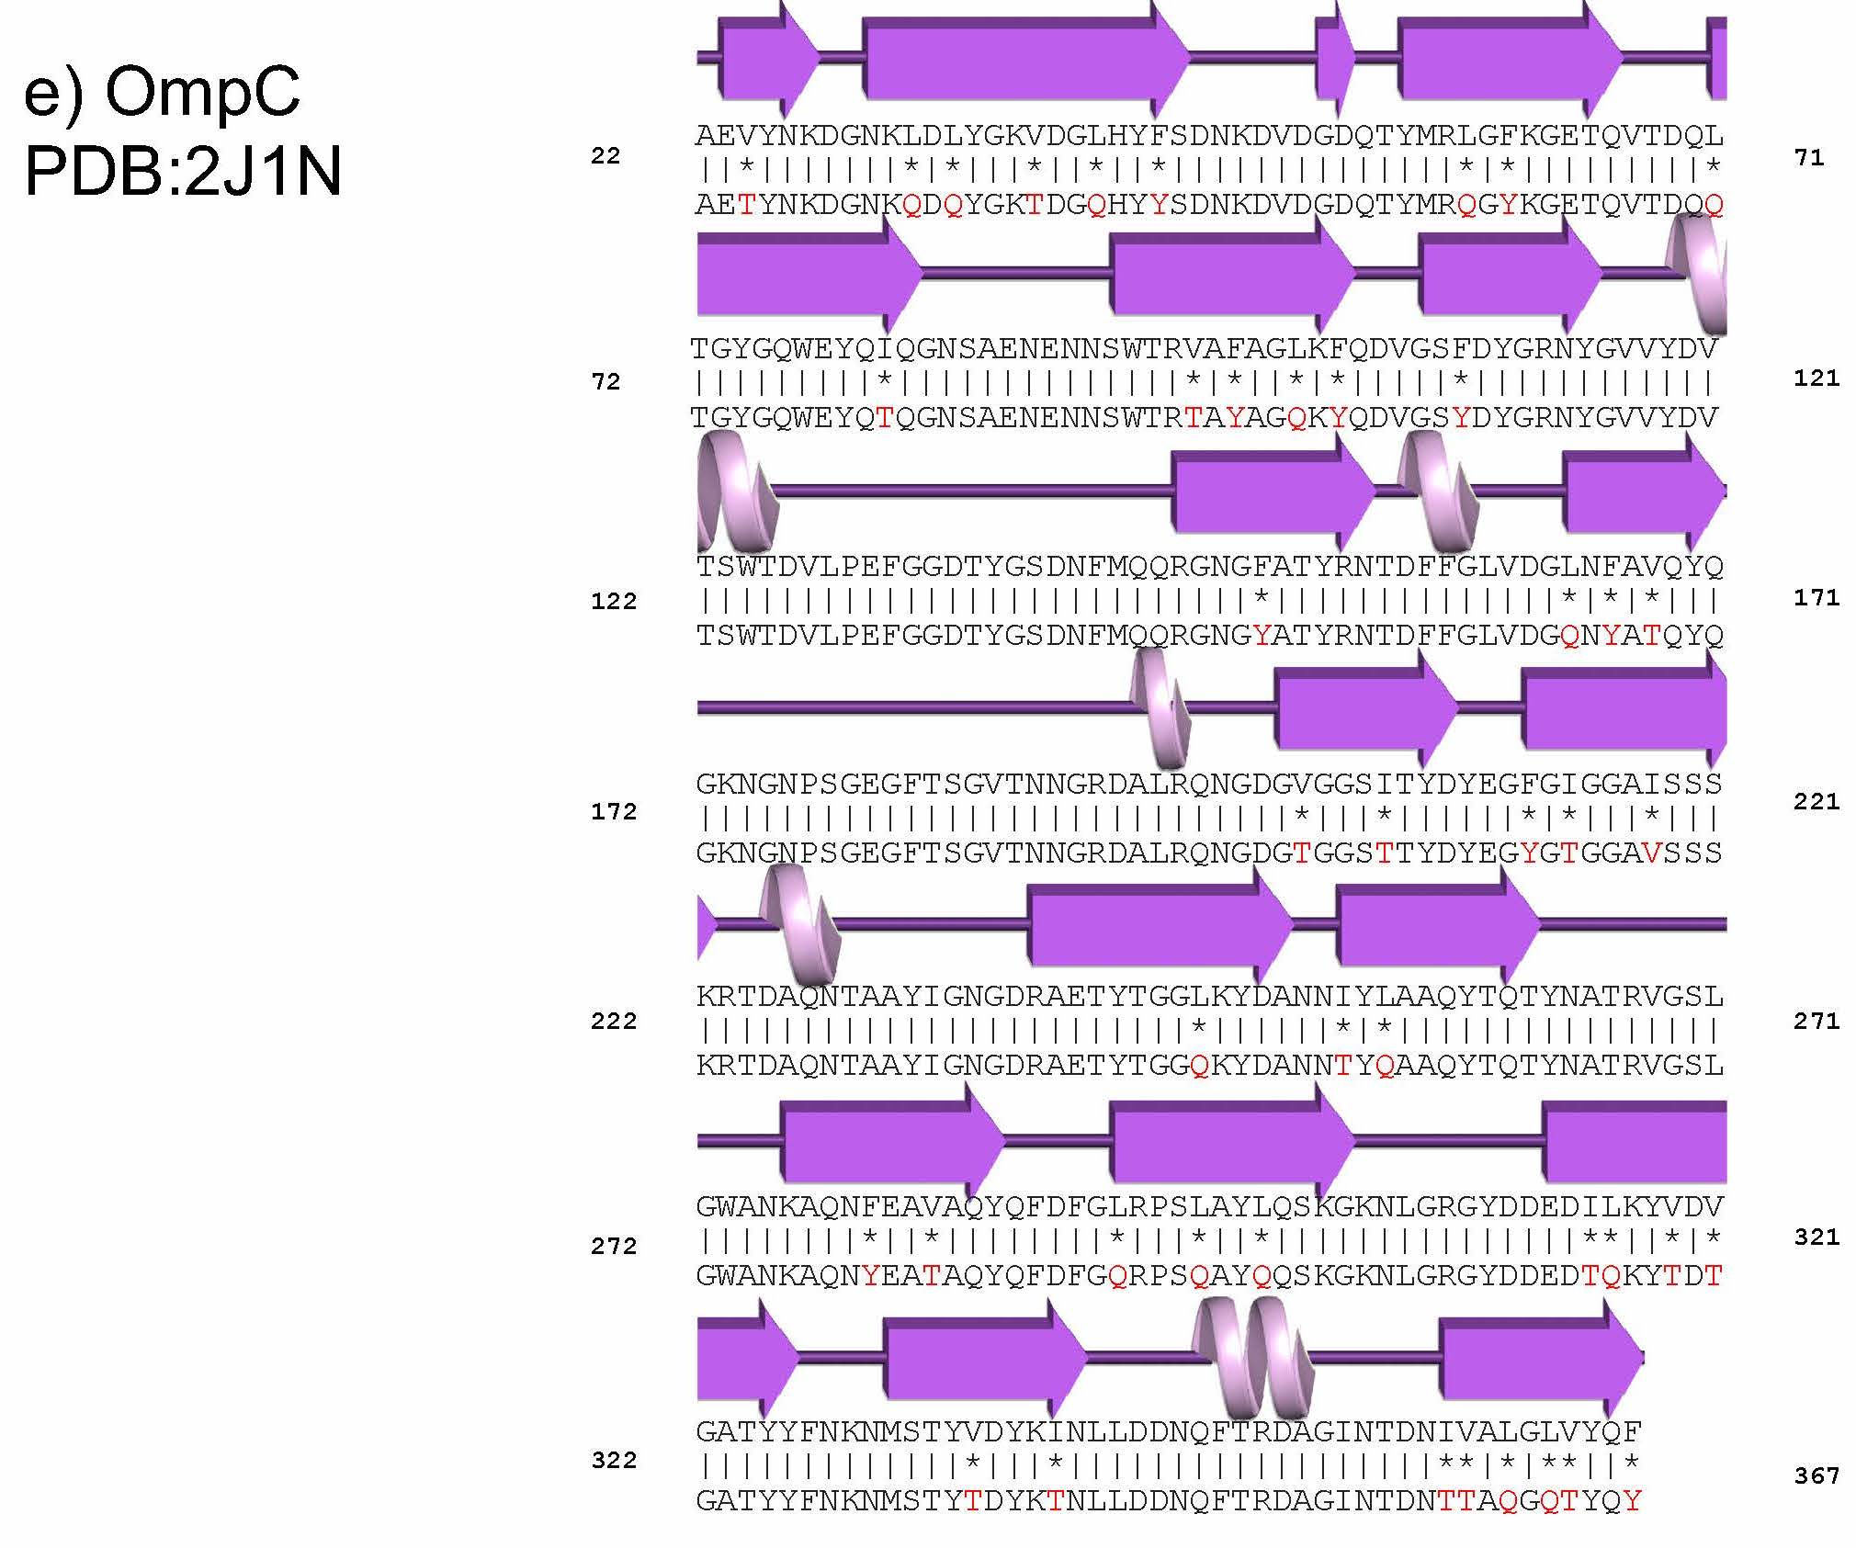

OmpC
PDB: 2J1N
Figure S2. Hydropathy plots of Outer Membrane Beta-Barrel Native vs. QTY Variants to confirm the changes in hydrophobicity. A clear distinction in hydrophobicity becomes evident when comparing hydropathy plots of the native proteins with their corresponding QTY variants of the five OMPs. The x-axis shows the position of amino acid residues in the protein sequence, while the y-axis (score) represents the hydrophobicity or hydrophilicity of those residues. Higher values along the y-axis indicate greater hydrophobicity, while lower values indicate increased hydrophilicity—window size: adjacent amino acid residues used for hydrophobicity calculation in hydropathy plots.

Expasy - ProtScale window size=9

a) BamA (PDB: 4K3B) 395-795 part (400 Amino Acids)

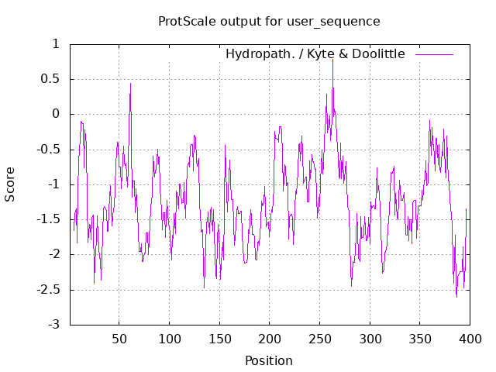
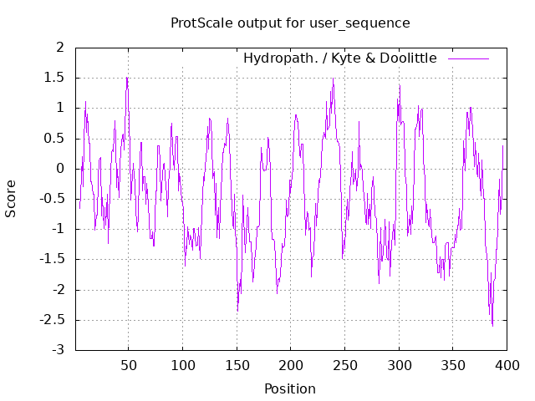
Native QTY

b) Omp85 (PDB: 6WUT) 47 to 512 (466 Amino Acids)

Native QTY

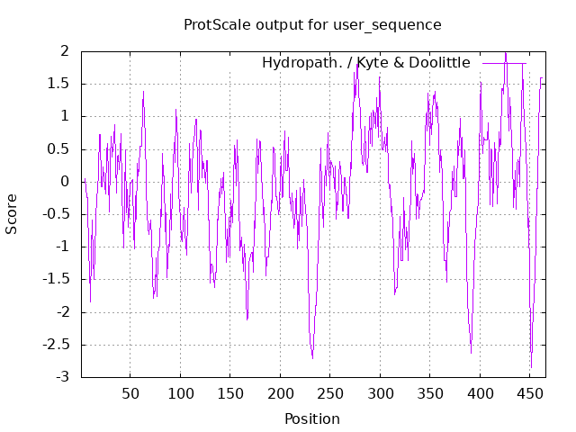
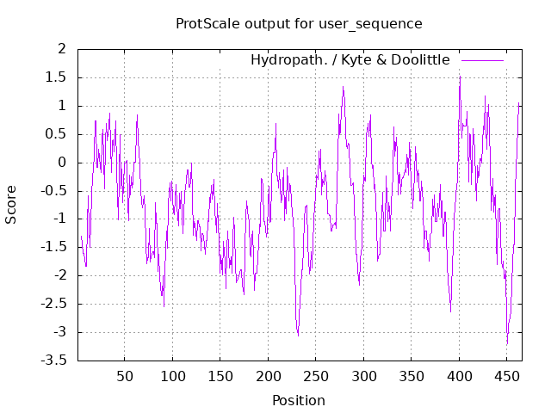
c) FecA (PDB: 1KMO) 81-741 part (661 Amino Acids)

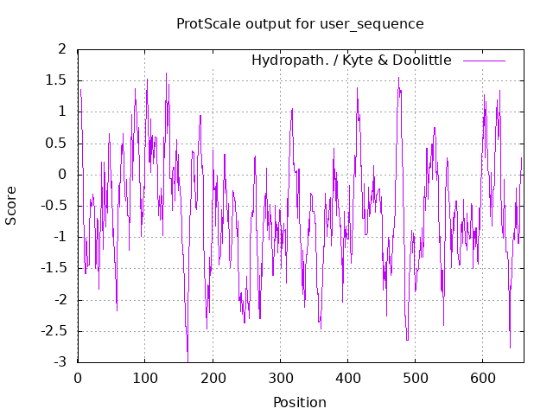
Native QTY
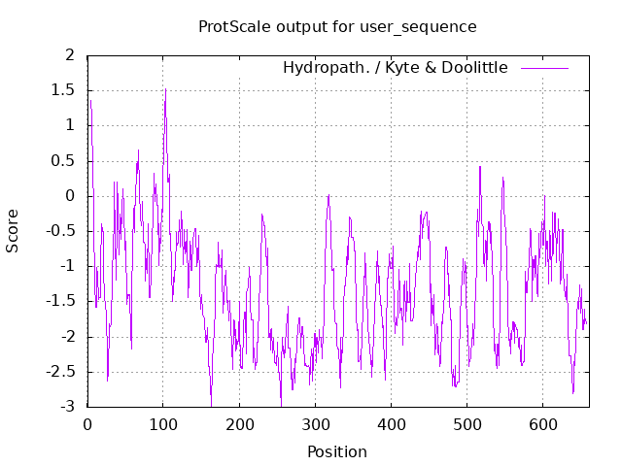

d)TSX (PDB: 1TLY) 9-275aa (267 Amino acids)

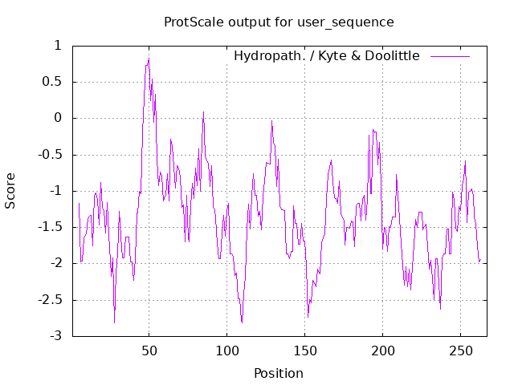
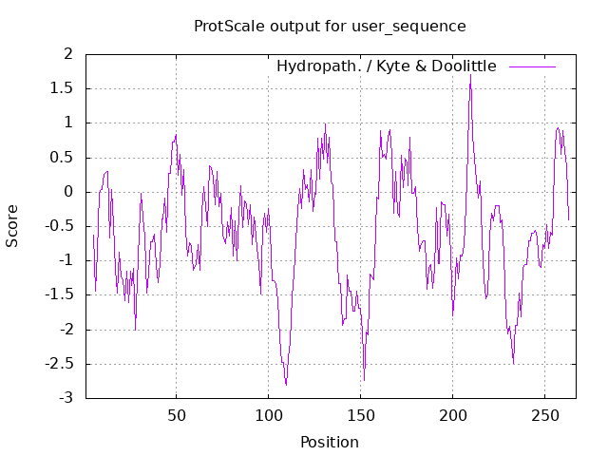
Native QTY

e)OmpC (PDB: 2J1N) 22-367- part (346Amino Acids)

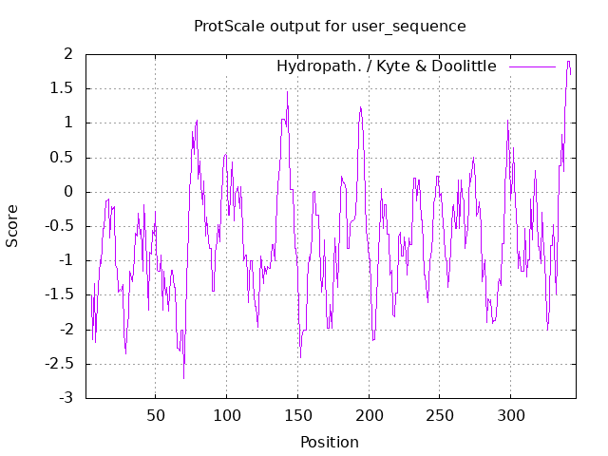
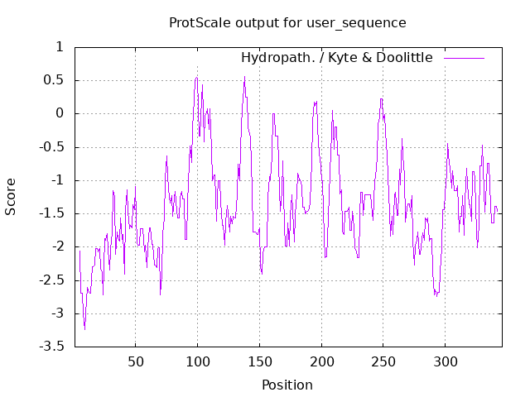
Native QTY

