File S2. Decomposition of temporal series
Figs 1 to 27 show temporal series decomposition of each capital analyzed.
Southeast macro-region
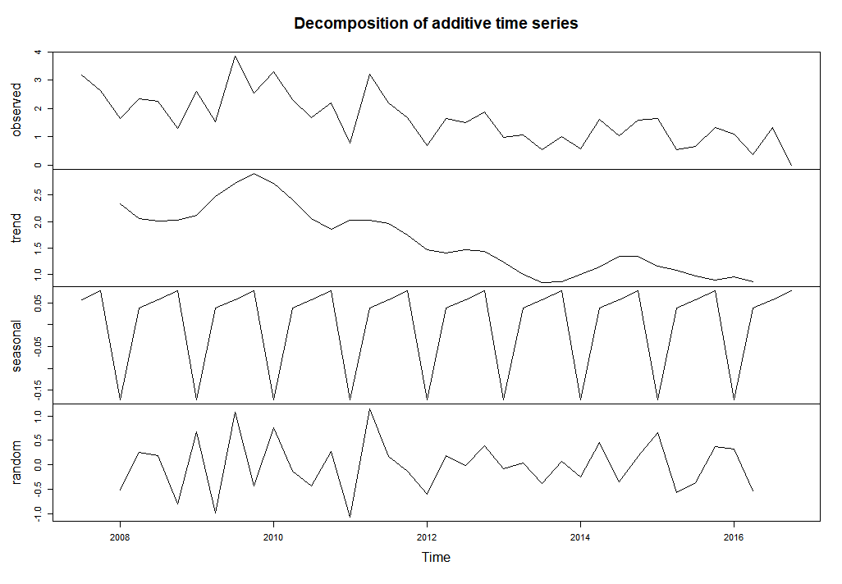
Fig 1. Decomposition of the temporal series in trend, seasonality, and irregularity of the city of Belo Horizonte (state of Minas Gerais).
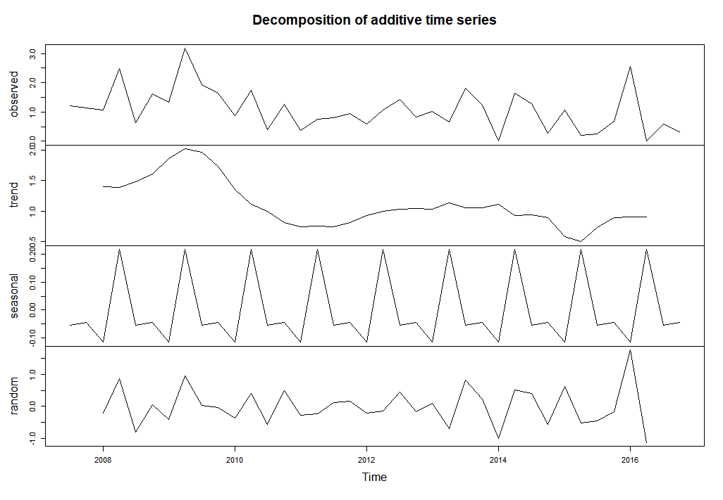
Fig 2. Decomposition of the temporal series in trend, seasonality, and irregularity of the city of Rio de Janeiro (state of Rio de Janeiro)

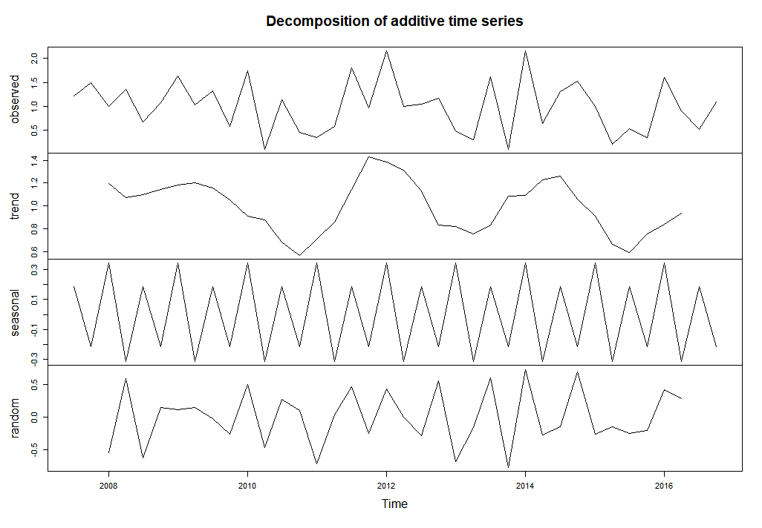
Figura 3. Decomposition of the temporal series in trend, seasonality, and irregularity of the city of São Paulo (state of São Paulo)
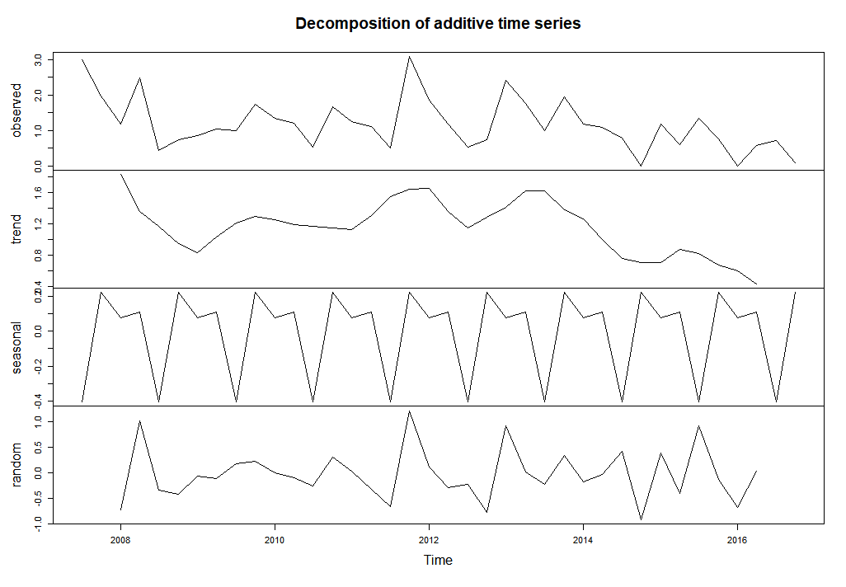
Fig 4. Decomposition of the temporal series in trend, seasonality, and irregularity of the city of Vitória (State of Espírito Santo)

South macro-region
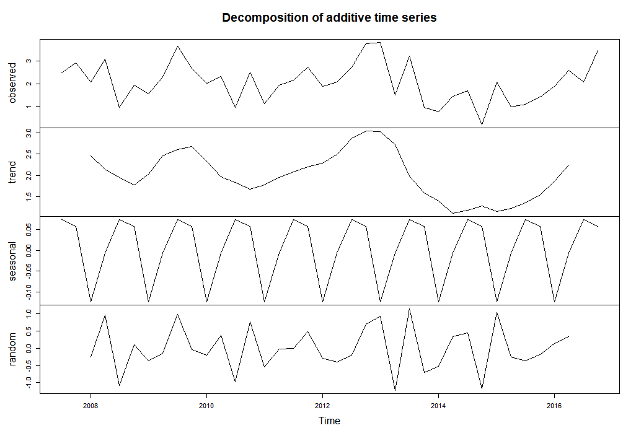
Fig 5. Decomposition of the temporal series in trend, seasonality, and irregularity of the city of Curitiba (State of Paraná)
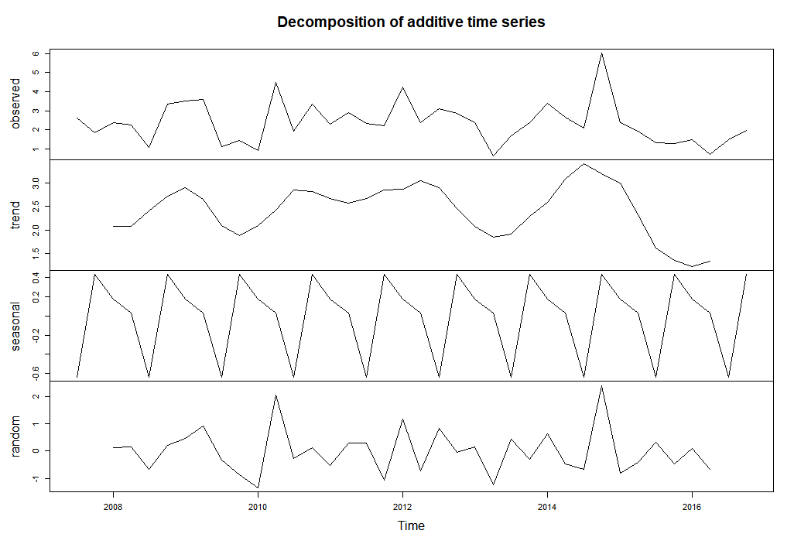
Fig 6. Decomposition of the temporal series in trend, seasonality, and irregularity of the city of Florianópolis (state of Santa Catarina)

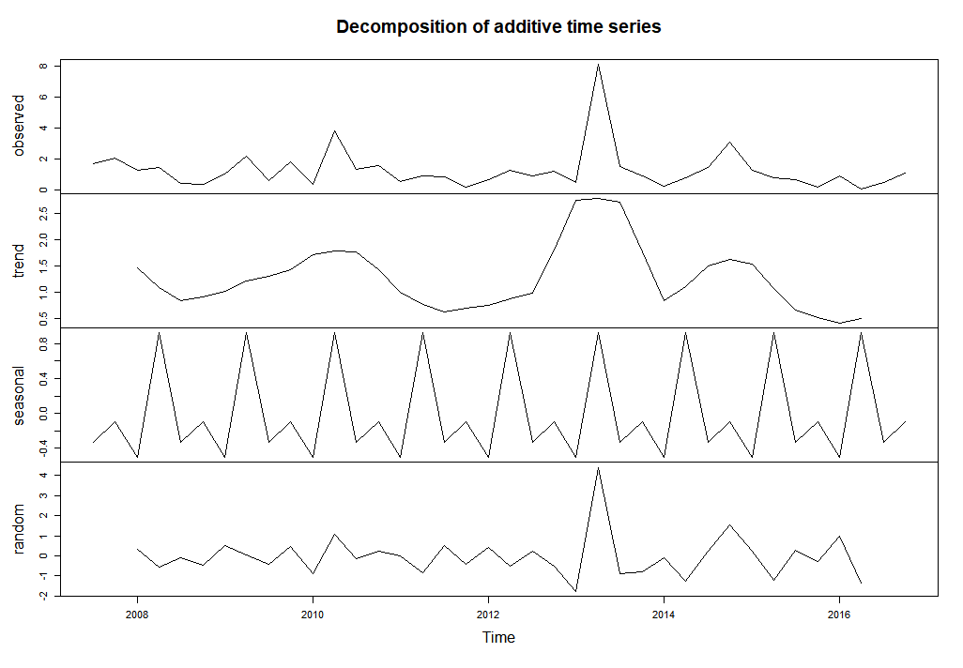
Fig 7 Decomposition of the temporal series in trend, seasonality, and irregularity of the city of Porto Alegre (state of Rio Grande do Sul).

Midwest macro-region
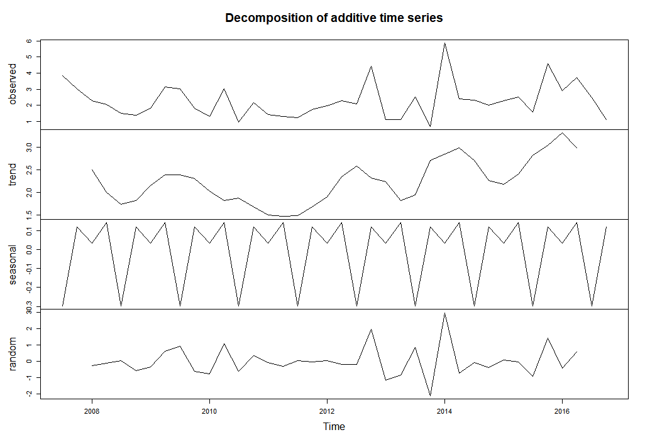
Fig 8. Decomposition of the temporal series in trend, seasonality, and irregularity of the city of Brasília (Distrito Federal).

Fig 9. Decomposition of the temporal series in trend, seasonality, and irregularity of the city of Campo Grande (state of Mato Grosso do Sul)

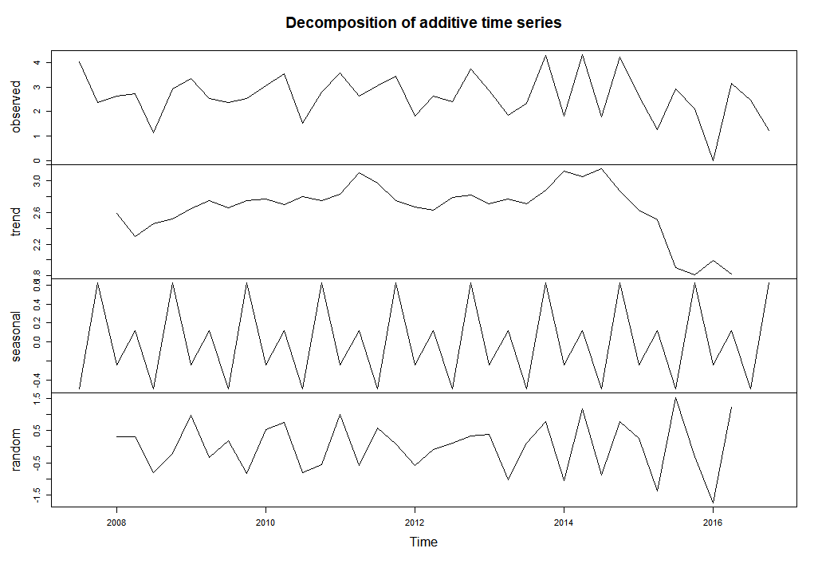
Fig 10. Decomposition of the temporal series in trend, seasonality, and irregularity of the city of Cuiabá (state of Mato Grosso State)

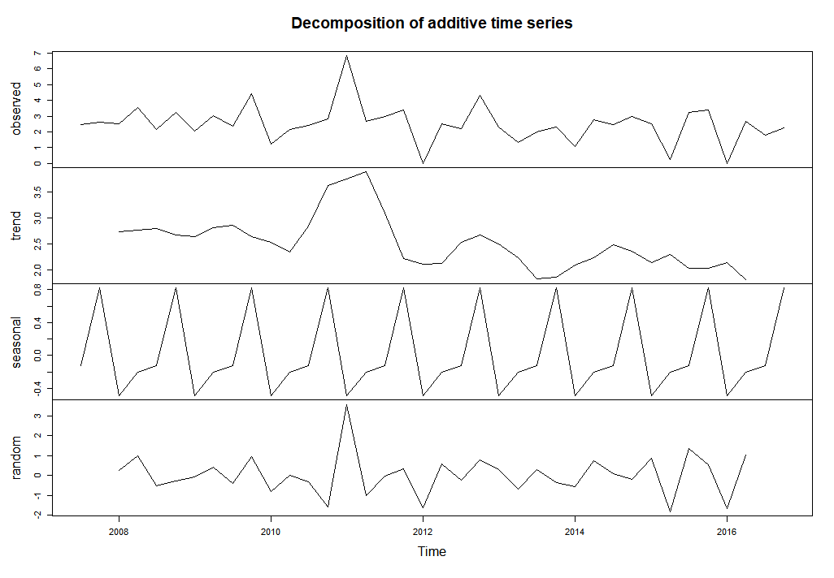
Fig 11. Decomposition of the temporal series in trend, seasonality, and irregularity of the city of Goiânia (state of Goiás).

North macro-region
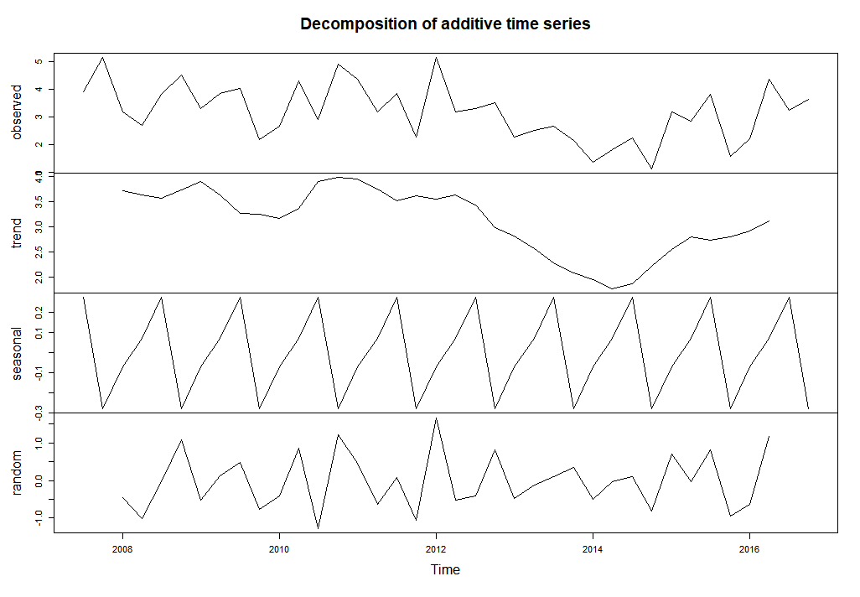
Fig 12. Decomposition of the temporal series in trend, seasonality, and irregularity of the city of Palmas (state of Tocantins)

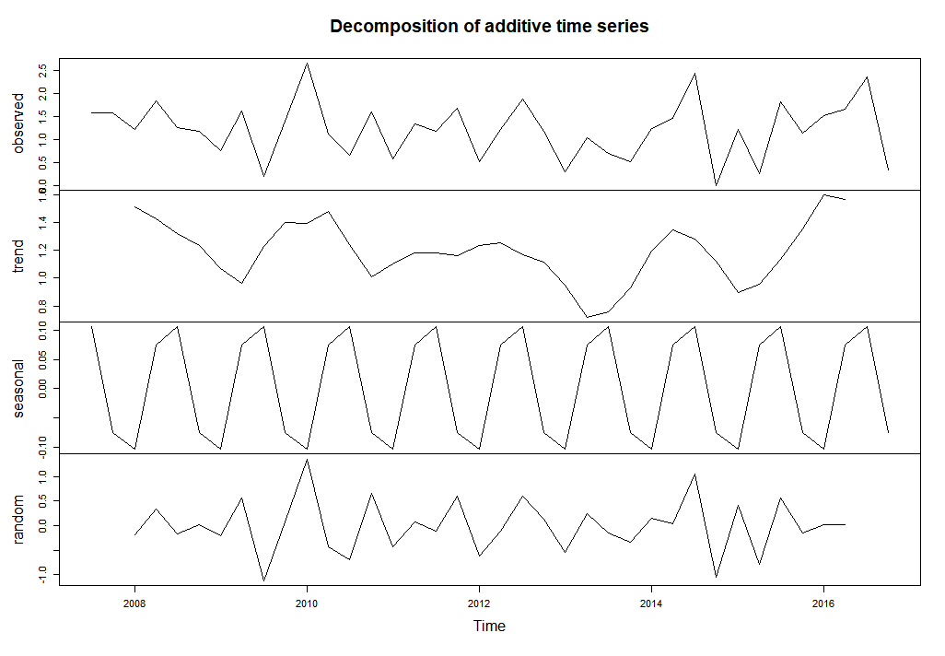
Fig 13. Decomposition of the temporal series in trend, seasonality, and irregularity of the city of Belém (state of Pará)

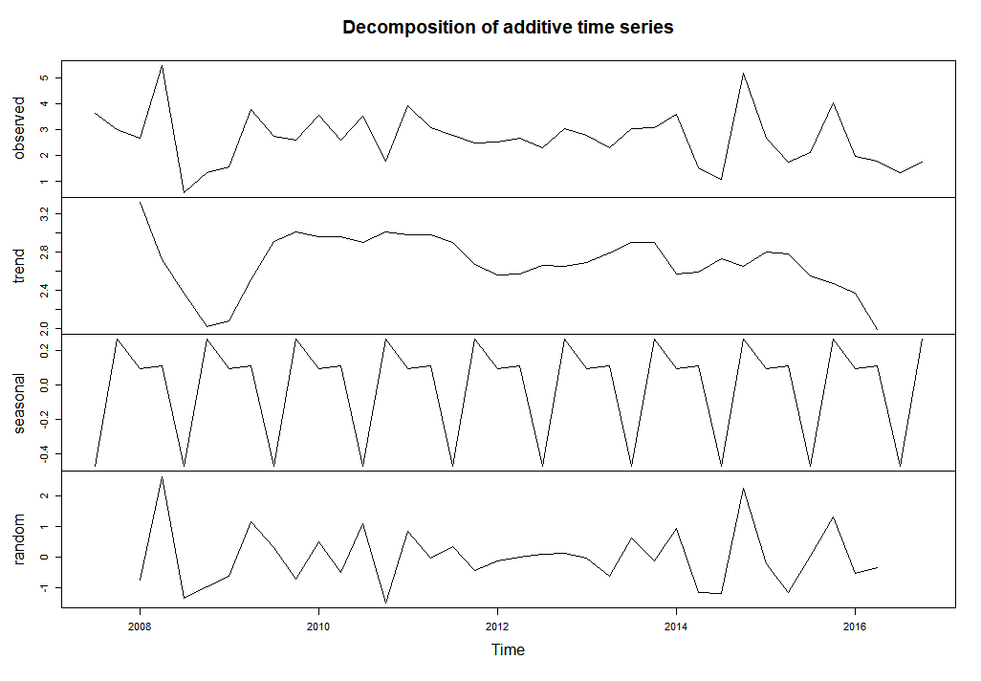
Fig 14. Decomposition of the temporal series in trend, seasonality, and irregularity of the city of Boa Vista (state of Roraima).
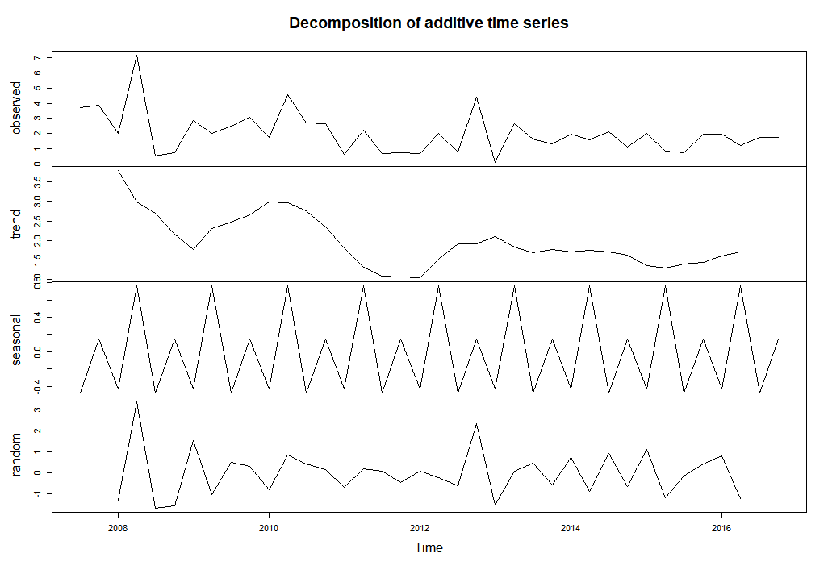
Fig 15. Decomposition of the temporal series in trend, seasonality, and irregularity of the city of Macapá (state of Amapá).
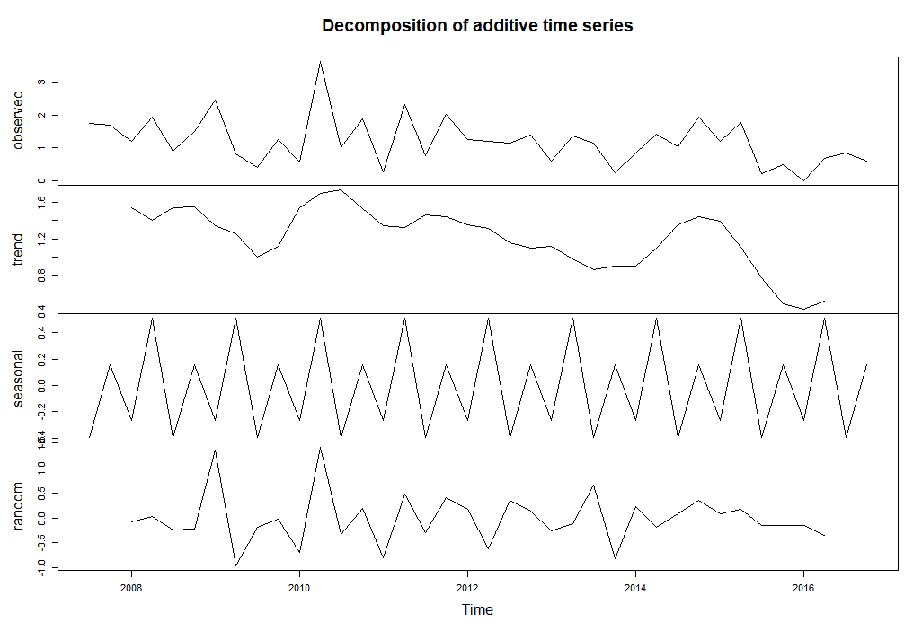
Fig 16. Decomposition of the temporal series in trend, seasonality, and irregularity of the city of Manaus (state of Amazonas)

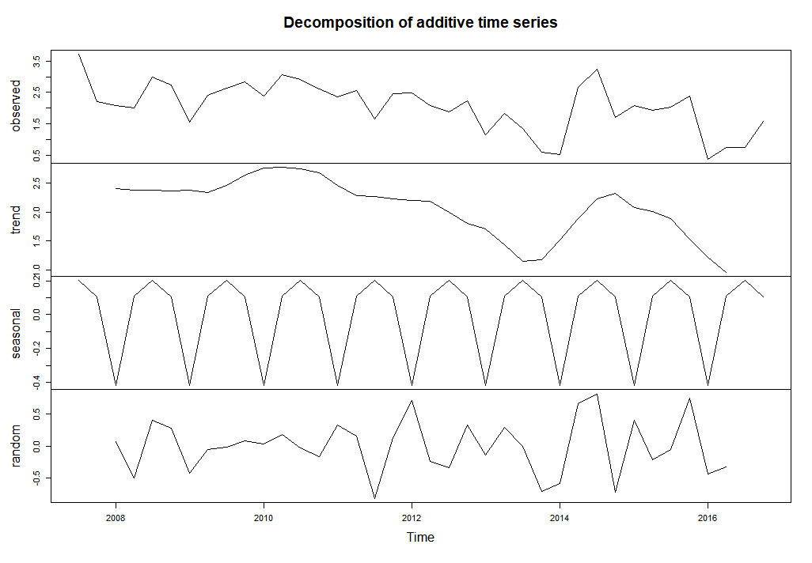
Fig 17. Decomposition of the temporal series in trend, seasonality, and irregularity of the city of Porto Velho (state of Rondônia)

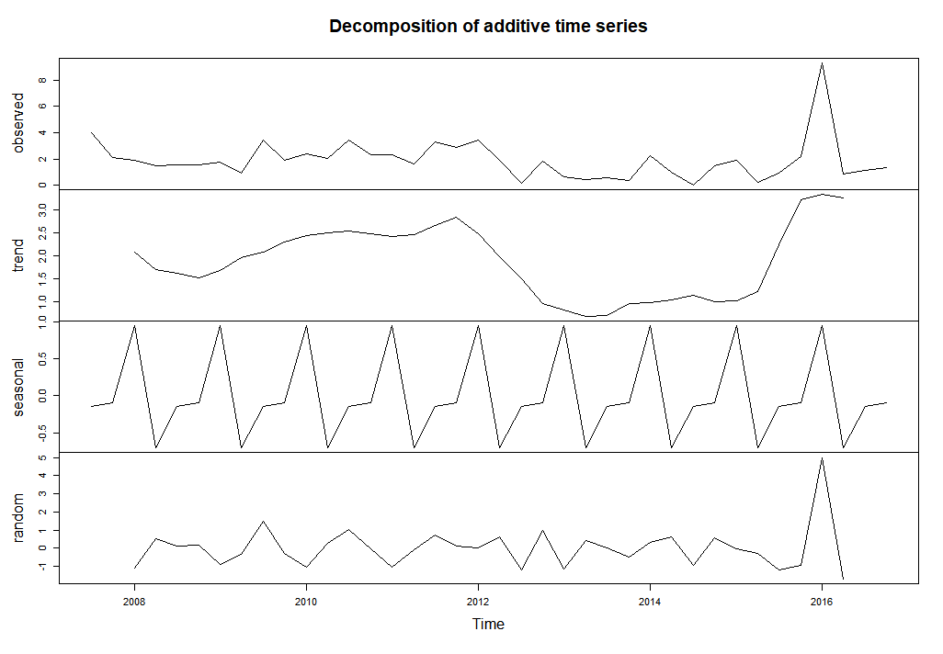
Fig 18. Decomposition of the temporal series in trend, seasonality, and irregularity of the city of Rio Branco (State of Acre).
Northeast macro-region
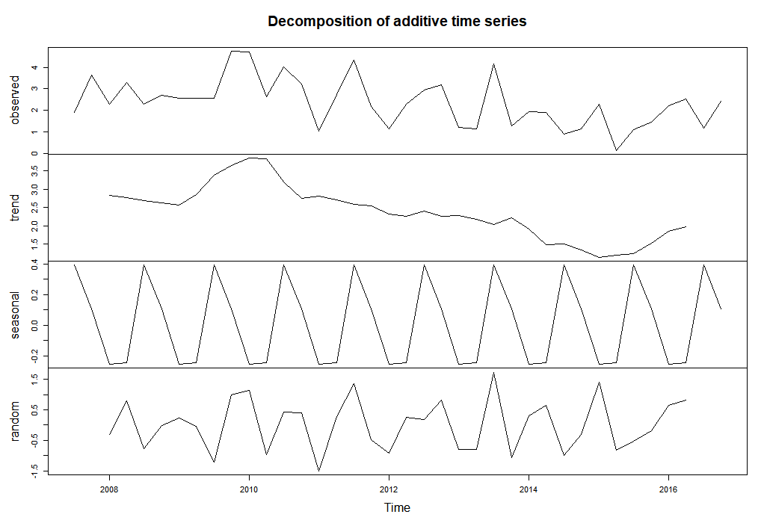
Fig 19. Decomposition of the temporal series in trend, seasonality, and irregularity of the city of Aracaju (state of Sergipe)

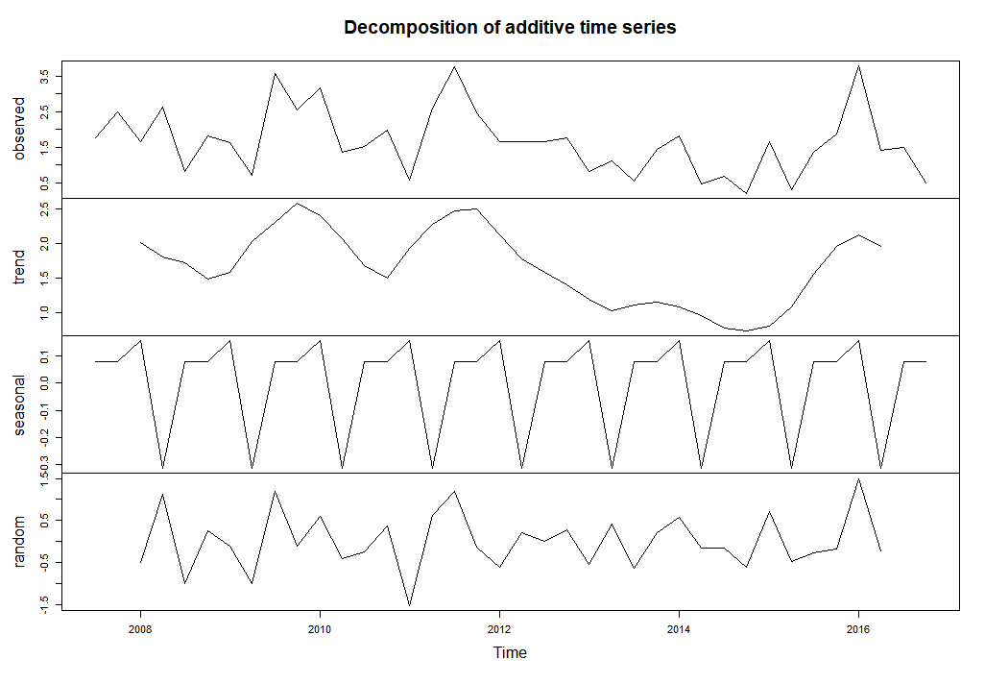
Fig 20. Decomposition of the temporal series in trend, seasonality, and irregularity of the city of Fortaleza (state of Ceará)

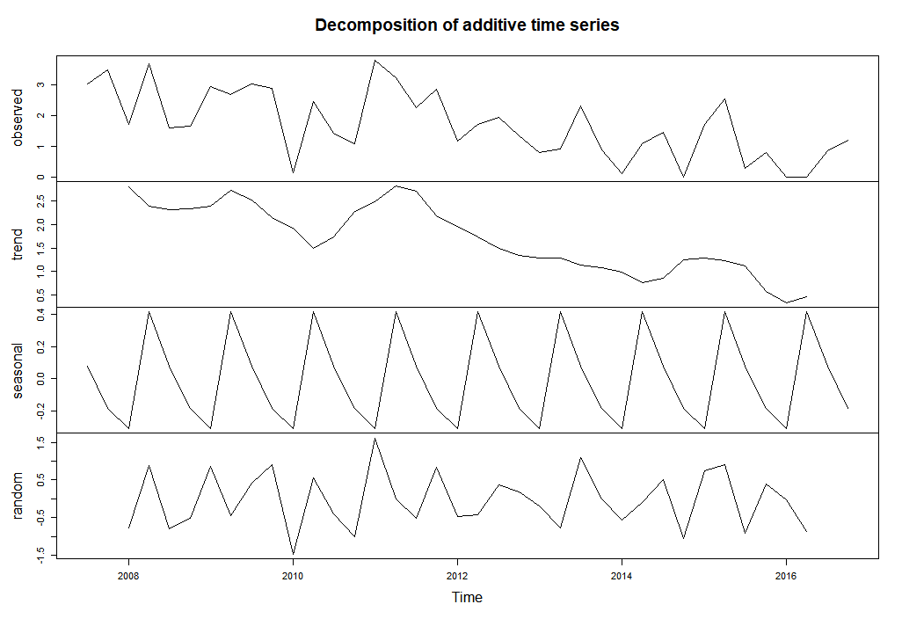
Fig 21. Decomposition of the temporal series in trend, seasonality, and irregularity of the city of João Pessoa (state of Paraíba)
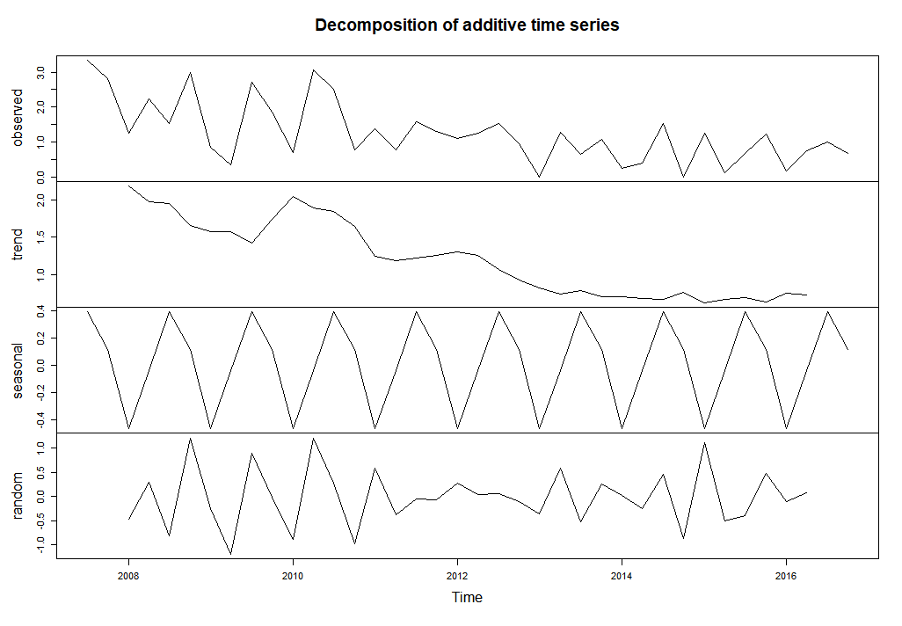
Fig 22. Decomposition of the temporal series in trend, seasonality, and irregularity of the city of Maceió (state of Alagoas)

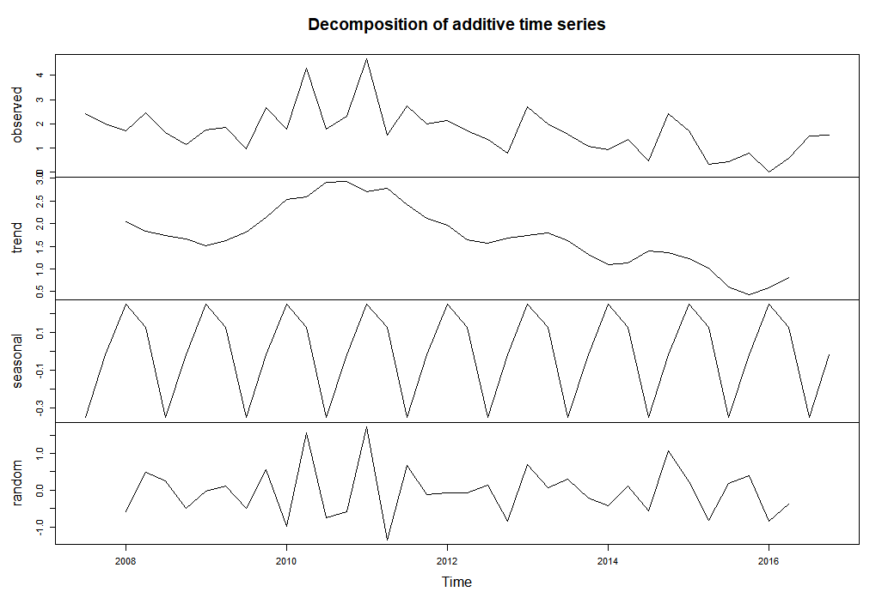
Fig 23. Decomposition of the temporal series in trend, seasonality, and irregularity of the city of Natal (state of Rio Grande do Norte)

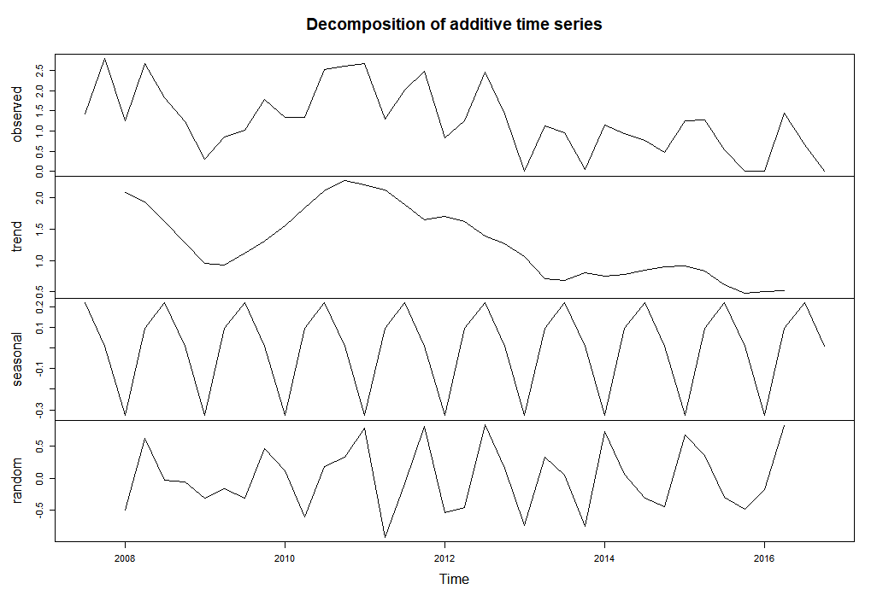
Fig 24. Decomposition of the temporal series in trend, seasonality, and irregularity of the city of Recife (state of Pernambuco)

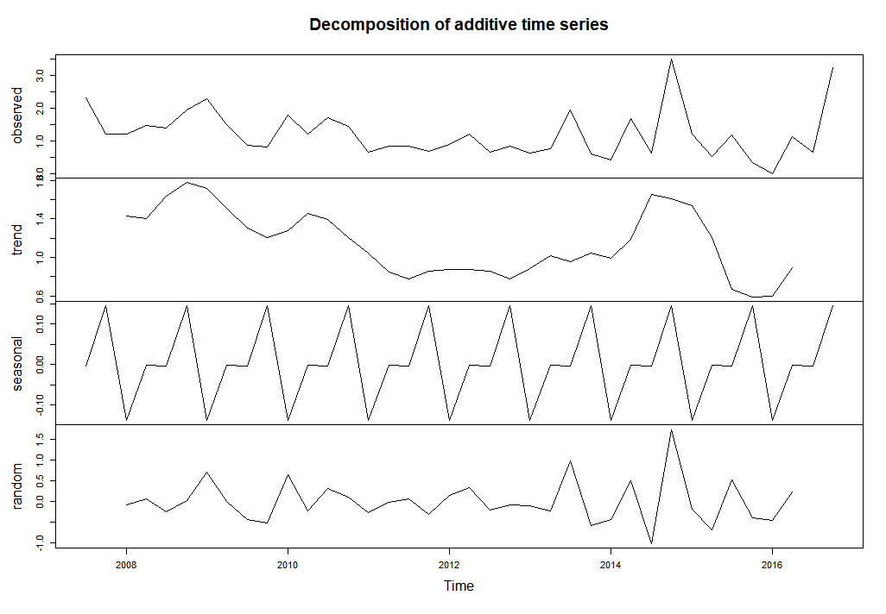
Fig 25 Decomposition of the temporal series in trend, seasonality, and irregularity of the city of Salvador (state of Bahia)

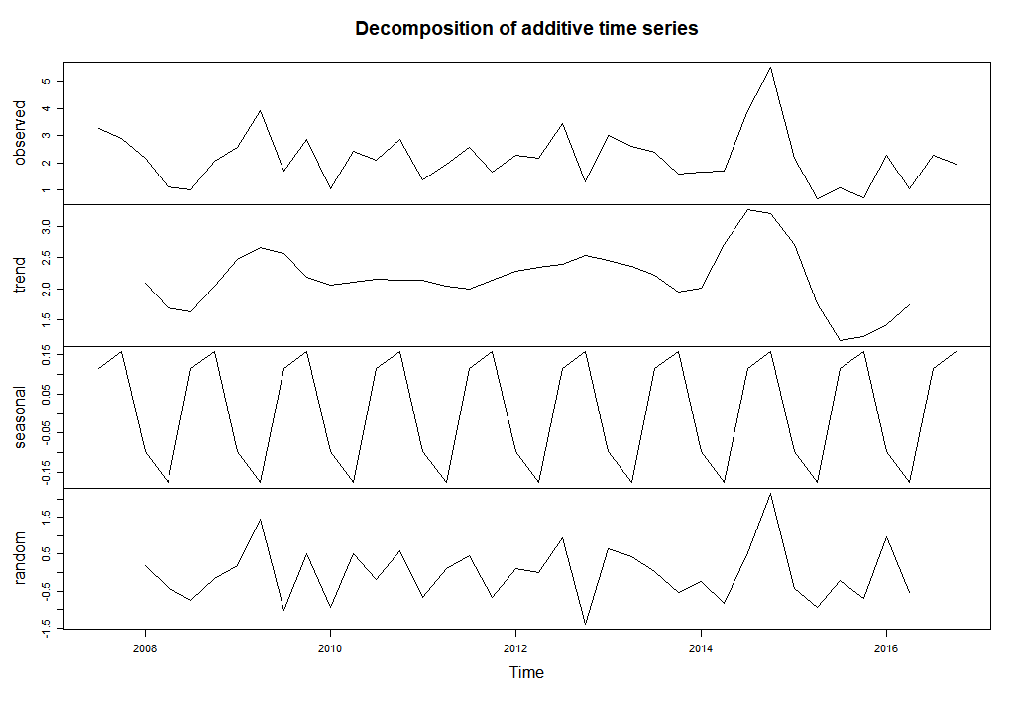
Fig 26. Decomposition of the temporal series in trend, seasonality, and irregularity of the city of São Luís (state of Maranhão)

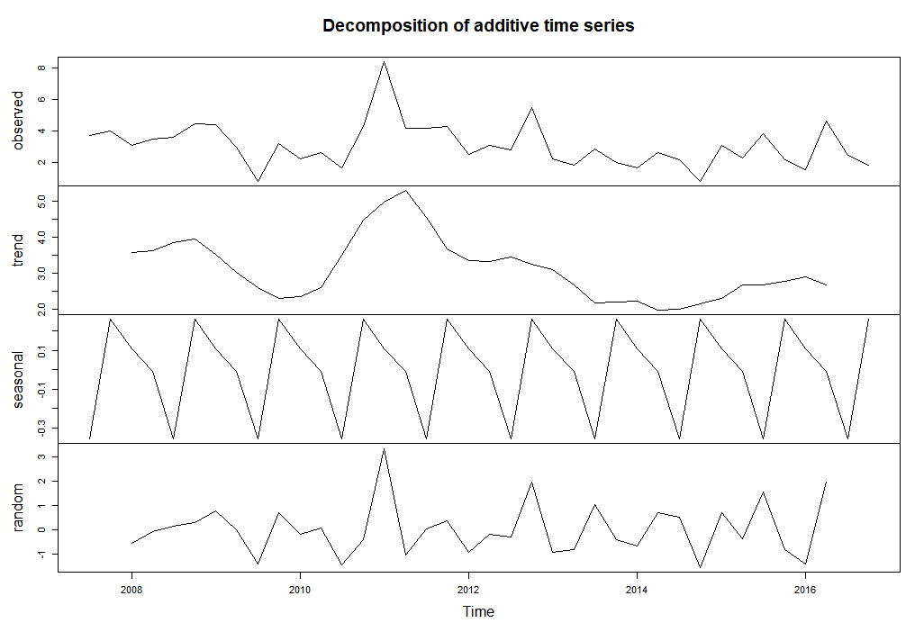
Fig 27. Decomposition of the temporal series in trend, seasonality, and irregularity of the city of Teresina (state of Piauí);

