SUPPLEMENTARY INFORMATION

Contents
Elemental Analysis 3
Taxon Bothriolepis 8
Evolution of number of Bothriolepis species 8
List of Bothriolepis species 8
Bothriolepididae and Bothriolepis (Placodermi, Antiarcha) through the Devonian world 14
Palaeogeographic distribution of Bothriolepididae 14
Emsian 14
Eifelian 15
Givetian 16
Frasnian 17
Famennian 18
Late Famennian 19
Bothriolepididae taxa, strata and localities 20
Data matrix taxa * characters 32
Data matrix 32
List of characters 32
Original complete set 32
Final reduced set 41
Phylogenetic analyses 49
Different outgroups 49
all characters and all taxa (but Dianolepis) 50
all taxa (but Dianolepis) 51
Outgroup = Remigolepis + Grossilepis 52
Outgroup = Grossilepis 53
Outgroup = B. niushoushanensis 54
Outgroup = B. shaokuanensis 55
Outgroup = B. askinae 56
Outgroup = B. askinae (B. virginiensis removed) 58
Outgroup = Remigolepis + Grossilepis + Dianolepis 60
Outgroup = Grossilepis + Dianolepis 62
Outgroup = Dianolepis + Grossilepis 62
Outgroup = Dianolepis 63
Successive weighting of character “shape of preorbital recess” 64
indices 64
Topologies and distribution of states of character #1 65
Robustness of the tree: Bremer decay index 73
3D pdf captions 77
NMING:F35203-UU201ab_HQ 77
NMING:F35229-CH003 77
NMING:F35216-UUSFB001 77
NHM P 59677 (complete, ORG end RELOC files) 77
NHM P 59678 77
NHM P 59679 77
NHM P 59687 77
References 79

Elemental Analysis

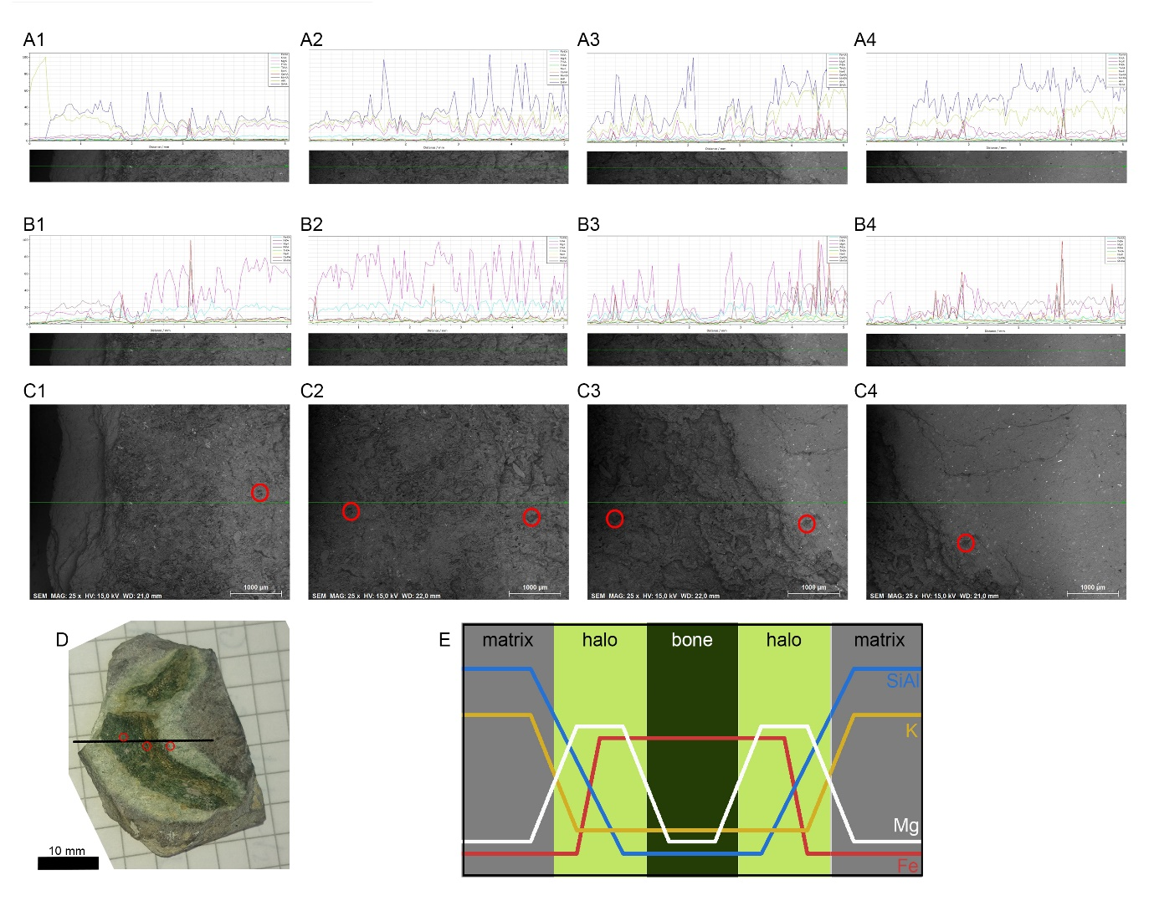
S1 Fig. A. Elemental analysis along transect in C (green line), taking into account Silicon and Aluminium. B. Elemental analysis along transect in C, without taking into account Silicon and Aluminium. C. larger images around transect (green line). D. Specimen NMING:F35231 (Vertebrata indet.) with transect (black line) and markers (red circles). E. Simplification of element distribution along transect and through matrix, halo and bone, for silicon (Si, blue), aluminium (Al, blue), potassium (K, yellow), magnesium (Mg, white), and iron (Fe, red). Below are magnification of values in transect in A1-4 and B1-4.

A1
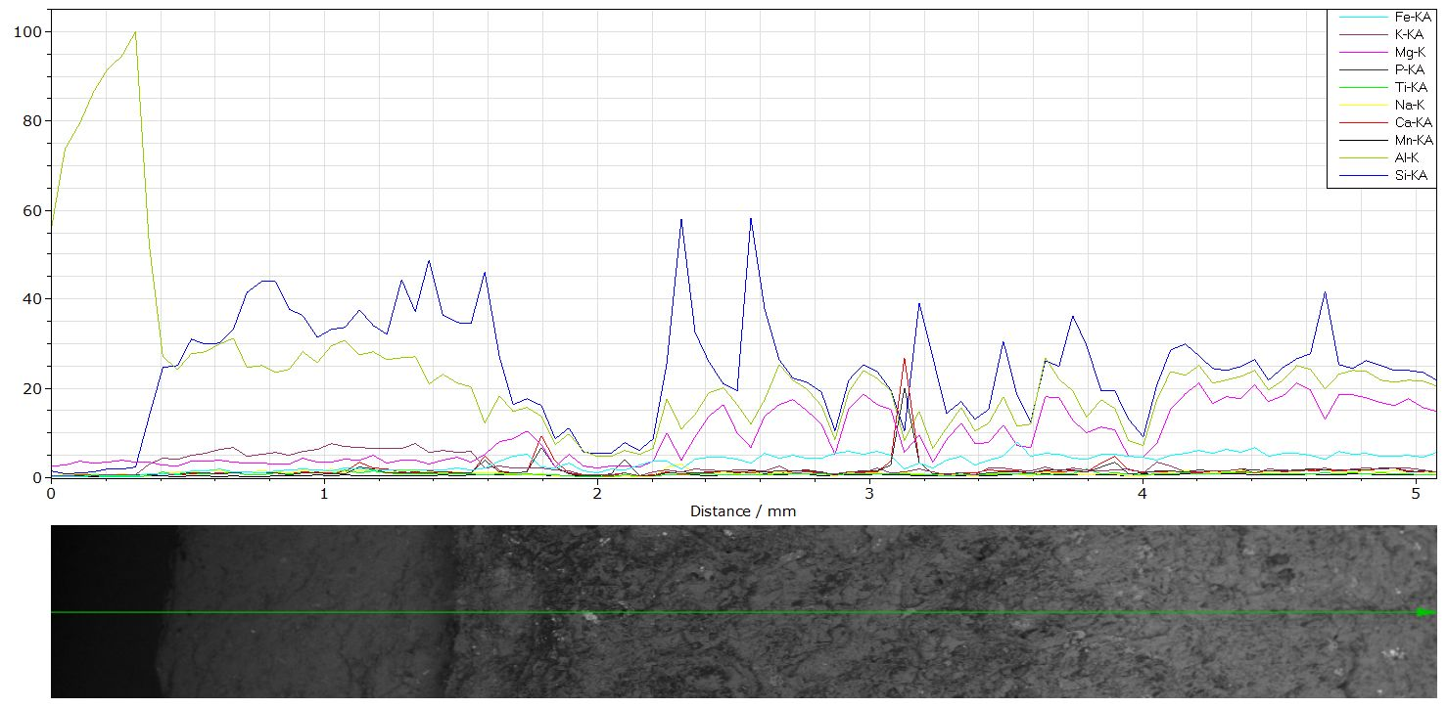

A2
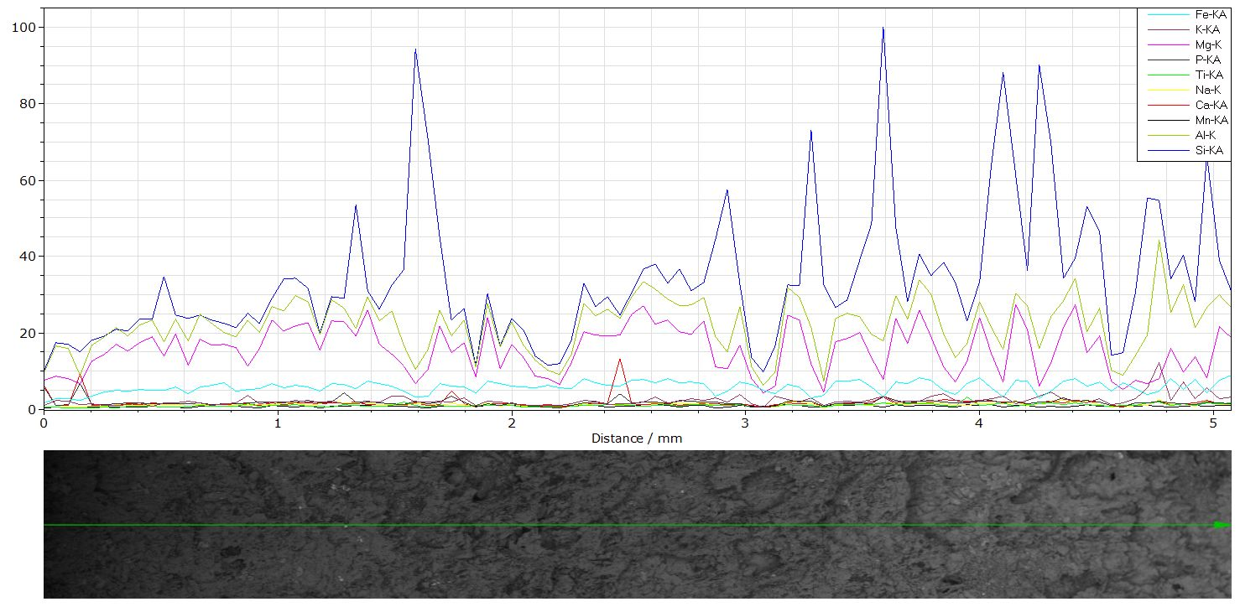

A3
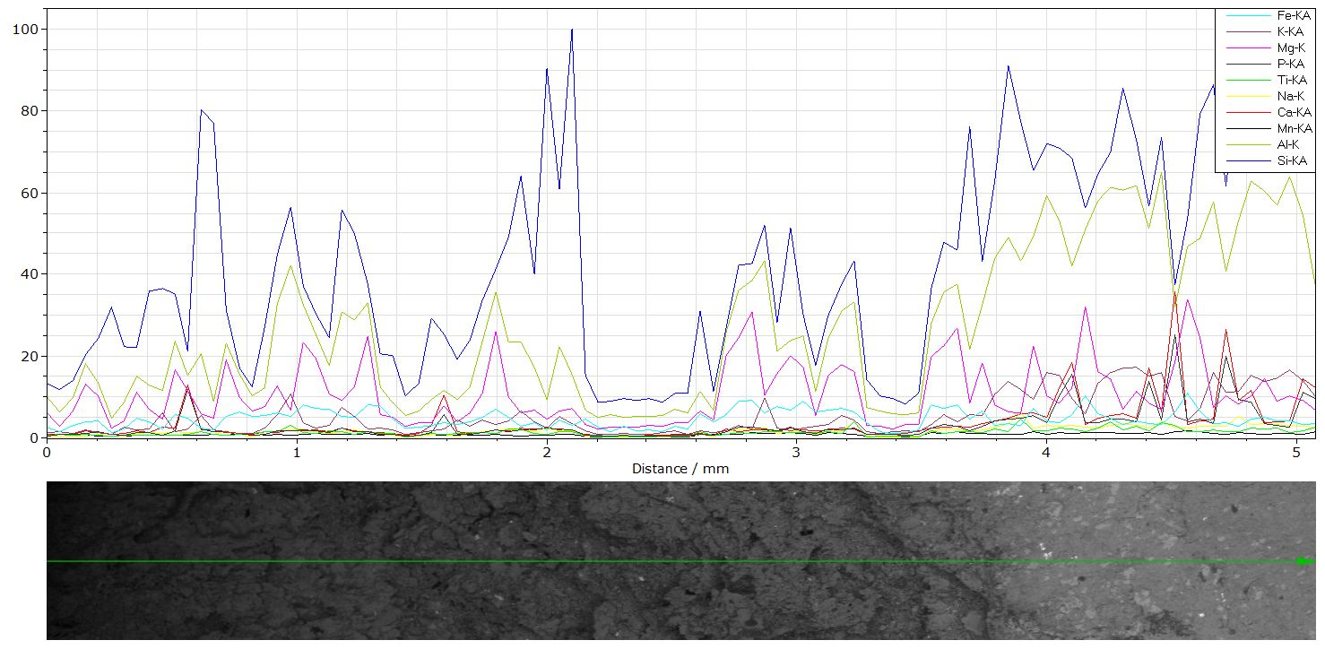

A4
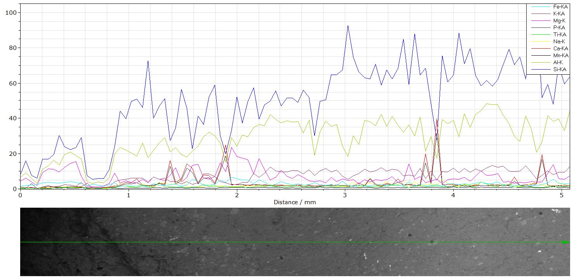

B1
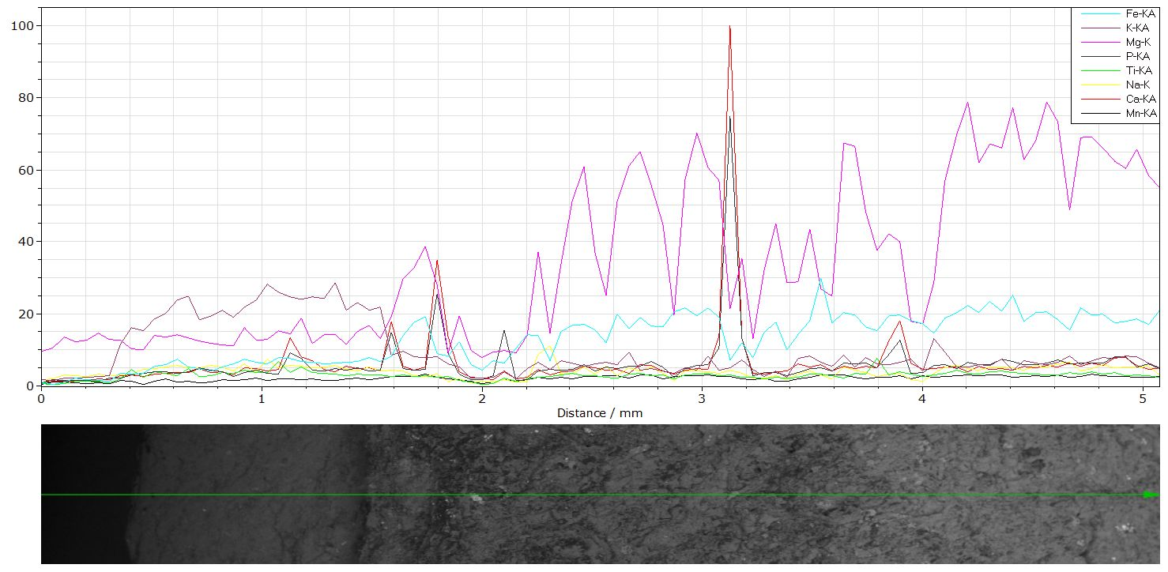

B2
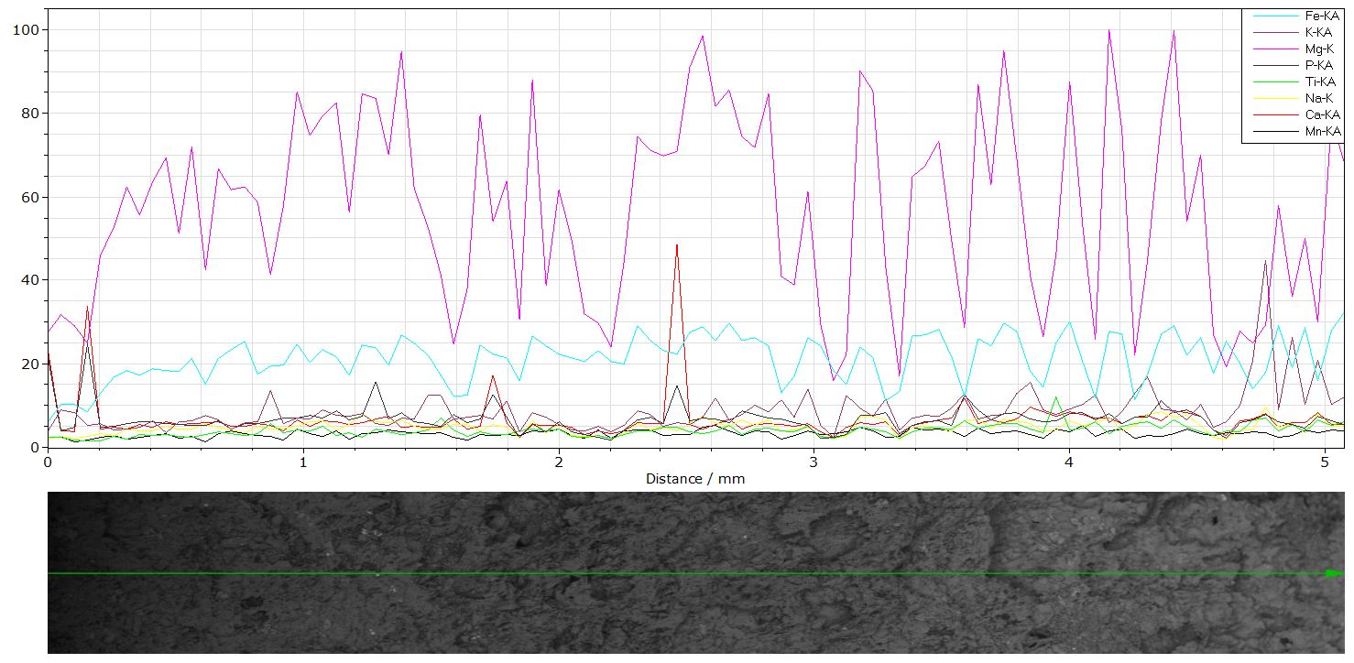

B3
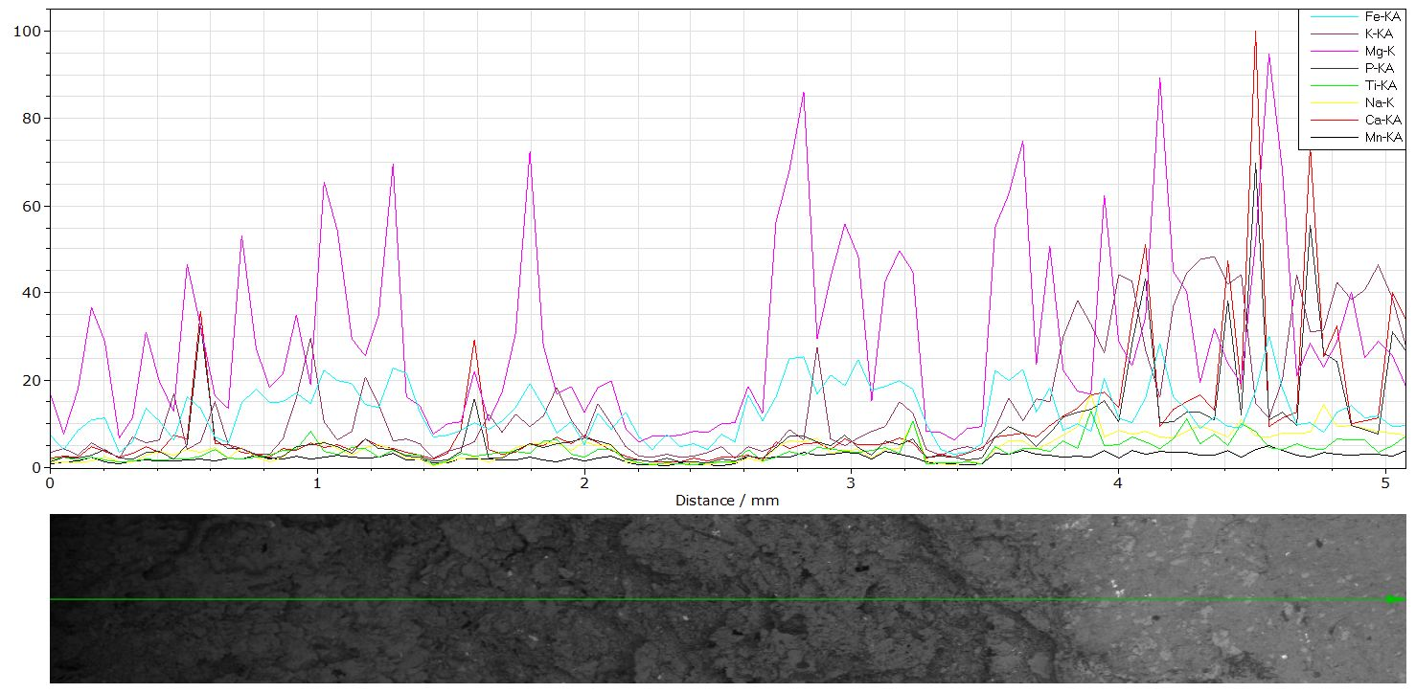

B4
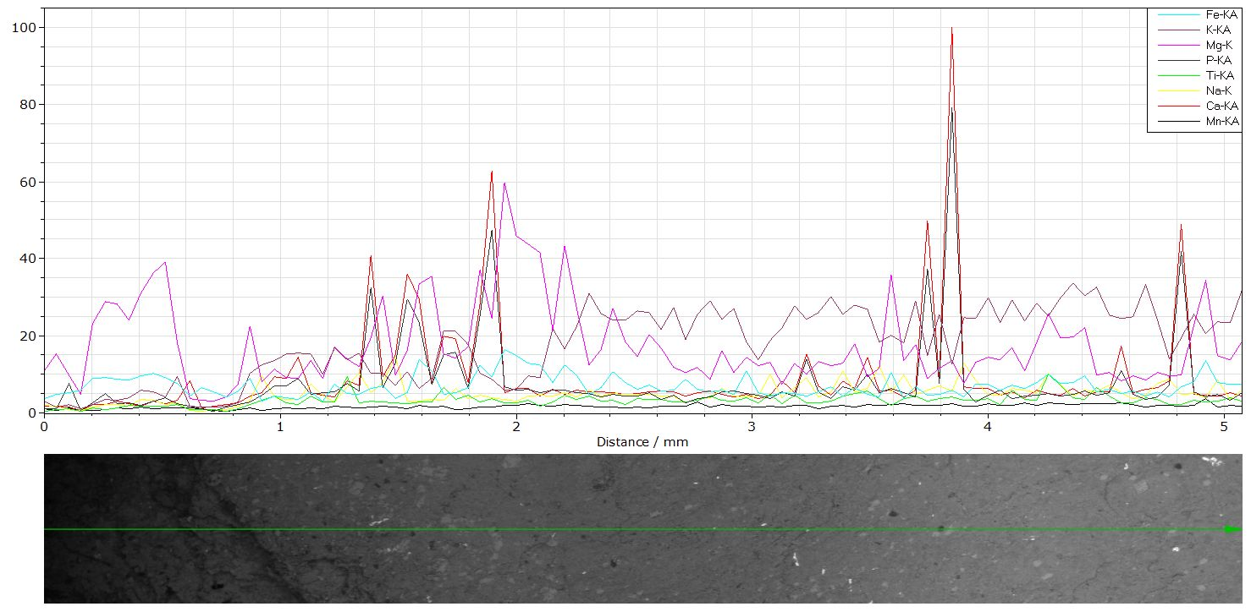

Taxon Bothriolepis

Evolution of number of Bothriolepis species

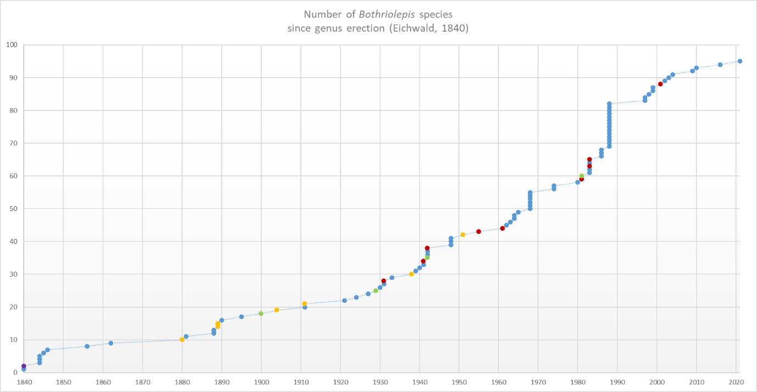
S2 Fig. Number of Bothriolepis species through time (blue, normal; purple, nodem nudum; red, change of genus; orange, synonym of other Bothriolepis species; green, change but back to Bothriolepis or new status within Bothriolepis).

List of Bothriolepis species
Species |  | Taxonomic authority | Reference of taxonomic authority | n | Comments
Bothriolepis ornata |  | Eichwald, 1840 | [1] | 1 | Type-species
Botryolepis prisca Eichwald, 1840 |  | Eichwald, 1840 | [1] | 2 | nomen nudum in Denison, 1978 [2]
Bothriolepis favosa |  | Agassiz, 1844 | [3] | 3
Bothriolepis hydrophila |  | (Agassiz, 1844) | ([3]) | 4
Bothriolepis major |  | (Agassiz, 1844) | ([3]) | 5
Bothriolepis paradoxa |  | (Agassiz, 1845) | ([4]) | 6
Bothriolepis cellulosa |  | (Pander, 1846) in Keyserling, 1846 | ([5]) in [6] | 7 | Pander, 1846 always cited in Keyserling, 1846 Keyserling, 1846
Bothriolepis nitida |  | Leidy, 1856 | [7] | 8
Bothriolepis macrocephala |  | (Egerton, 1862) | ([8]) | 9
Bothriolepis panderi |  | Lahusen, 1880 | [9] | 10 | synonym of B. favosa, in Denison, 1978 [2]
Bothriolepis canadensis |  | (Whiteaves, 1881) | ([10]) | 11
Bothriolepis gigantea |  | Traquair, 1888 | [11] | 12
Bothriolepis obesa |  | Traquair, 1888 | [11] | 13
Bothriolepis minor |  | Newberry, 1889 | [12] | 14 | synonym of B. nitida by Thomson and Thomas, 2001 [13]
Bothriolepis leidyi |  | Newberry, 1889 | [12] | 15 | synonym of B. nitida by Thomson and Thomas, 2001 [13]
Bothriolepis leptocheira |  | Traquair, 1890-92 | [14] | 16
Bothriolepis cristata |  | Traquair, 1895 | [15] | 17
Bothriolepis jeremijevi |  | Rohon, 1900 | [16] | 18 | Reassigned to B. leptocheira jeremijevi by Lukševičs et al., 2017 [17]
Bothriolepis coloradensis |  | Eastman, 1904 | [18] | 19 | synonym of B. nitida by Thomson and Thomas, 2001 [13]
Bothriolepis maeandrina |  | Hoffman, 1911 | [19] | 20
Bothriolepis retinata |  | Hoffman, 1911 | [19] | 21 | synonym of B. cellulosa in Denison, 1978 [2]
Bothriolepis antarctica |  | Woodward, 1921 | [20] | 22
Bothriolepis traquairi |  | Bryant, 1924 | [21] | 23
Bothriolepis traudscholdi |  | Jaekel, 1927 | [22] | 24
Bothriolepis gippslandiensis |  | Hills, 1929 | [23] | 25 | reassigned at some point to Hillsaspis (by Stensiö, 1969 [24]), then reassigned to Bothriolepis (Young and Gorter, 1981 [25])
Bothriolepis groenlandica |  | Heintz, 1930 | Heintz, 1930 | 26
Bothriolepis lohesti |  | Leriche, 1931 | [26] | 27
Bothriolepis ymeri |  | Stensiö, 1931 | [27] | 28 | reassigned to Remigolepis by Denison, 1978 [2]
Bothriolepis maxima |  | Gross, 1933 | [28] | 29
Bothriolepis stensioi |  | Sohn, 1938 | [29] | 30 | synonym of B. canadensis by Robertson, 1938 [30]
Bothriolepis turanica |  | Obruchev, 1939 | [31] | 31
Bothriolepis sinensis |  | Chi, 1940 | [32] | 32
Bothriolepis siberica |  | Obruchev, 1941 | [33] | 33
Bothriolepis tuberculata |  | Gross, 1941 | [34] | 34 | reassigned to Grossilepis by Stensiö, 1948 [35]
Bothriolepis curonica |  | Gross, 1942 | [36] | 35 | reassigned subspecies status by Lukševičs, 2001 [37]
Bothriolepis obrutschewi |  | Gross, 1942 | [36] | 36
Bothriolepis prima |  | Gross, 1942 | [36] | 37
Bothriolepis spinosa |  | Gross, 1942 | [36] | 38 | reassigned to Grossilepis by Stensiö, 1948 [35]
Bothriolepis alvesiensis |  | Stensiö, 1948 | [35] | 39
Bothriolepis jarviki |  | Stensiö, 1948 | [35] | 40
Bothriolepis nielseni |  | Stensiö, 1948 | [35] | 41
Bothriolepis darbiensis |  | Denison, 1951 | [38] | 42 | synonym of B. nitida by Thomson and Thomas, 2001 [13]
Bothriolepis asiatica |  | Obrucheva, 1955 | [39] | 43 | reassigned to Stegolepis tuberculata by Malinovskaya, 1988 [40] (see Denison, 1978 [2])
Bothriolepis extensa |  | Sergienko, 1961 | [41] | 44 | reassigned to Tubalepis by Panteleyev and Moloshnikov, 2003 [42]
Bothriolepis yunnanensis |  | Liu, 1962 | [43] | 45
Bothriolepis shaokuanensis |  | Chang, 1963 | [44] | 47
Bothriolepis kwangtungensis |  | P'an, 1964 | [45] | 48
Bothriolepis lochangensis |  | P'an, 1964 | [45] | 49
Bothriolepis tungseni |  | Chang, 1965 | [46] | 50
Bothriolepis hayi |  | Miles, 1968 | [47] | 51
Bothriolepis hicklingi |  | Miles, 1968 | [47] | 52
Bothriolepis laverocklochensis |  | Miles, 1968 | [47] | 53
Bothriolepis stevensoni |  | Miles, 1968 | [47] | 54
Bothriolepis taylori |  | Miles, 1968 | [47] | 55
Bothriolepis wilsoni |  | Miles, 1968 | [47] | 56
Bothriolepis ciecere |  | Lyarskaya, 1974 in Lyarskaja and Savvaitova, 1974 | Lyarskaya, 1974 in [48] | 57
Bothriolepis pavariensis |  | Lyarskaya, 1974 in Lyarskaja and Savvaitova, 1974 | Lyarskaya, 1974 in [48] | 58
Bothriolepis niushoushanensis |  | Pan et al., 1980 | [49] | 59
Bothriolepis verrucosa |  | Young and Gorter, 1981 | [25] |  | reassigned to genus Monarolepis by Young, 1988 [50]
Bothriolepis virginiensis |  | Weems et al., 1981 | [51] | 60 | synonym of B. nitida by Thomson and Thomas, 2001 [13]; reconsidered valid by Weems, 2004 [52]
Bothriolepis cullodenensis |  | Long, 1983 | [53] | 61
Bothriolepis fergusoni |  | Long, 1983 | [53] | 62
Bothriolepis warreni |  | Long, 1983 | [53] | 63 | reassigned to Briagalepis by Long et al., 1990 [54]
Bothriolepis bindareei |  | Long, 1983 | [53] | 64
Bothriolepis zadonica |  | Obrucheva, 1983 | [55] | 65 | reassigned to Livnolepis by Moloshnikov, 2008 [56]
Bothriolepis evaldi |  | Lyarskaja, 1986 | [57] | 66
Bothriolepis jani |  | Lukševičs, 1986 | [58] | 67
Bothriolepis tatongensis |  | Long and Werdelin, 1986 | [59] | 68
Bothriolepis alexi |  | Young, 1988 | [50] | 69
Bothriolepis askinae |  | Young, 1988 | [50] | 70
Bothriolepis barretti |  | Young, 1988 | [50] | 71
Bothriolepis karawaka |  | Young, 1988 | [50] | 72
Bothriolepis kohni |  | Young, 1988 | [50] | 73
Bothriolepis macphersoni |  | Young, 1988 | [50] | 74
Bothriolepis mawsoni |  | Young, 1988 | [50] | 75
Bothriolepis nikitinae |  | Young, 1988 | [50] | 76
Bothriolepis portalensis |  | Young, 1988 | [50] | 77
Bothriolepis vuwae |  | Young, 1988 | [50] | 78
Bothriolepis amankonyrica |  | Malinovskaya, 1988 | [40] | 79
Bothriolepis babichevi |  | Malinovskaya, 1988 | [40] | 80 | reassigned to Tubalepis by Panteleyev and Moloshnikov, 2003 [42]
Bothriolepis kassini |  | Malinovskaya, 1988 | [40] | 81
Bothriolepis tastenica |  | Malinovskaya, 1988 | [40] | 82
Bothriolepis africana |  | Long et al., 1997 | [60] | 83
Bothriolepis grenfellensis |  | Johanson, 1997 | [61] | 84
Bothriolepis yeungae |  | Johanson, 1998 | [62] | 85
Bothriolepis longi |  | Johanson and Young, 1999 | [63] | 86
Bothriolepis volongensis |  | Lyarskaja & Lukševičs, 1999, in Lukševičs and Sorokin, 1999 | Lyarskaja & Lukševičs, 1999, in [64] | 87 | This species has an authority different from the article in which it is created (i.e. there is no publication Lyarskaja & Lukševičs, 1999 Lyarskaja & Lukševičs, 1999).
Bothriolepis heckeri |  | Lukševičs, 2001 | [37] | 88 | reassigned to Livnolepis by Moloshnikov and Linkevich, 2020[65]
Bothriolepis perija |  | Young and Moody, 2002 | [66] | 89
Bothriolepis sosnensis |  | Moloshnikov, 2003 | [67] | 90
Bothriolepis jazwicensis |  | Szrek, 2004 | [68] | 91
Bothriolepis dorakarasugensis |  | Moloshnikov, 2009 | [69] | 92
Bothriolepis sanzarensis |  | Moloshnikov, 2010b | [70] | 93
Bothriolepis rex |  | Downs et al., 2016 | [71] | 94
Bothriolepis dairbhrensis |  | current article | current article | 96
 | purple: nomen nudum
 | red: genus reassignment
 | orange: synonym of another Bothriolepis species
 | green: new status with Bothriolepis or change of genus then back to Bothriolepis

Table A. List of Bothriolepis species

Bothriolepididae and Bothriolepis (Placodermi, Antiarcha) through the Devonian world

Palaeogeographic distribution of Bothriolepididae
Palaeomaps are taken from [72]. White circles indicate Bothriolepis species; black circles indicate other genera than Bothriolepis within Bothriolepididae. Chinese taxa are indicated with blue discs; Gondwanan taxa with green discs, Kazakh taxa with orange discs, and Euramerican taxa with red discs; for Gondwana and Euramerica, a darker shade indicates a western location in the supercontinent margin (colour consistent with cladograms and phylogenetic trees of the article). References for locations and stratigraphy are given after maps.

Emsian
Emsian
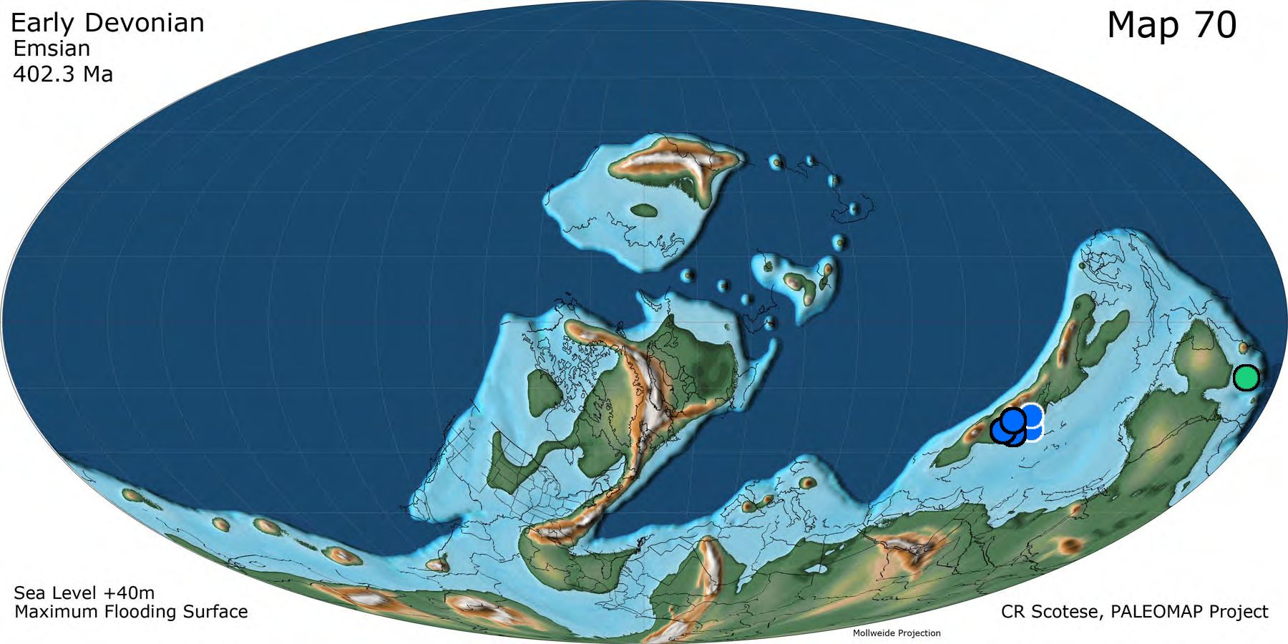
S3 Fig. Distribution of Bothriolepididae during the Emsian (palaeomap reprinted from [72] under a CC BY license, with permission from Christopher Scotese, original copyright 2014).

Eifelian
Eifelian
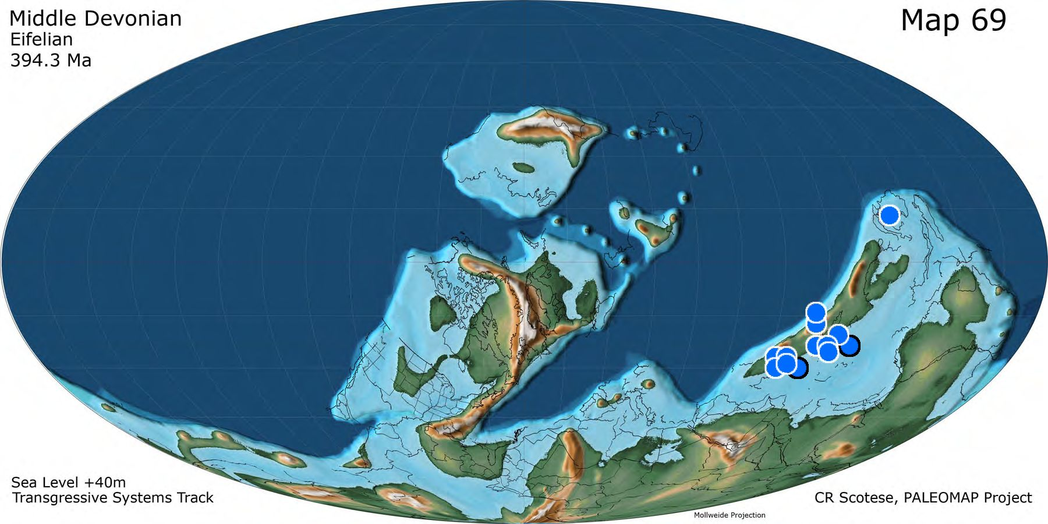
S4 Fig. Distribution of Bothriolepididae during the Eifelian (palaeomap reprinted from [72] under a CC BY license, with permission from Christopher Scotese, original copyright 2014).

Givetian
Givetian
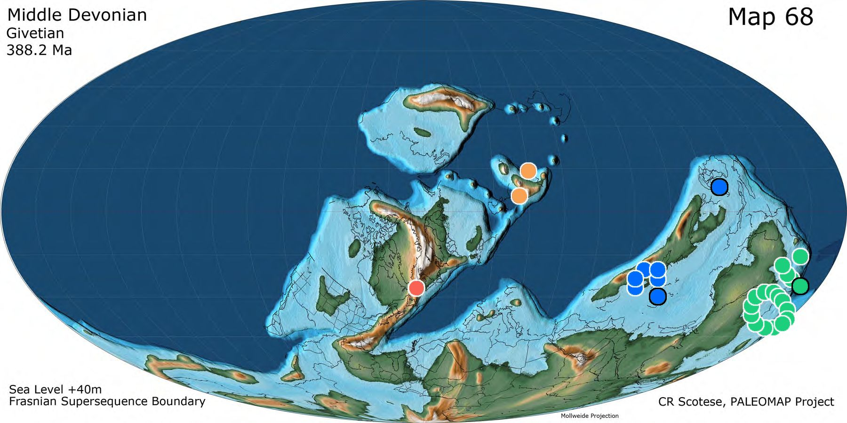
S5 Fig. Distribution of Bothriolepididae during the Givetian (palaeomap reprinted from [72] under a CC BY license, with permission from Christopher Scotese, original copyright 2014).

Frasnian
Frasnian
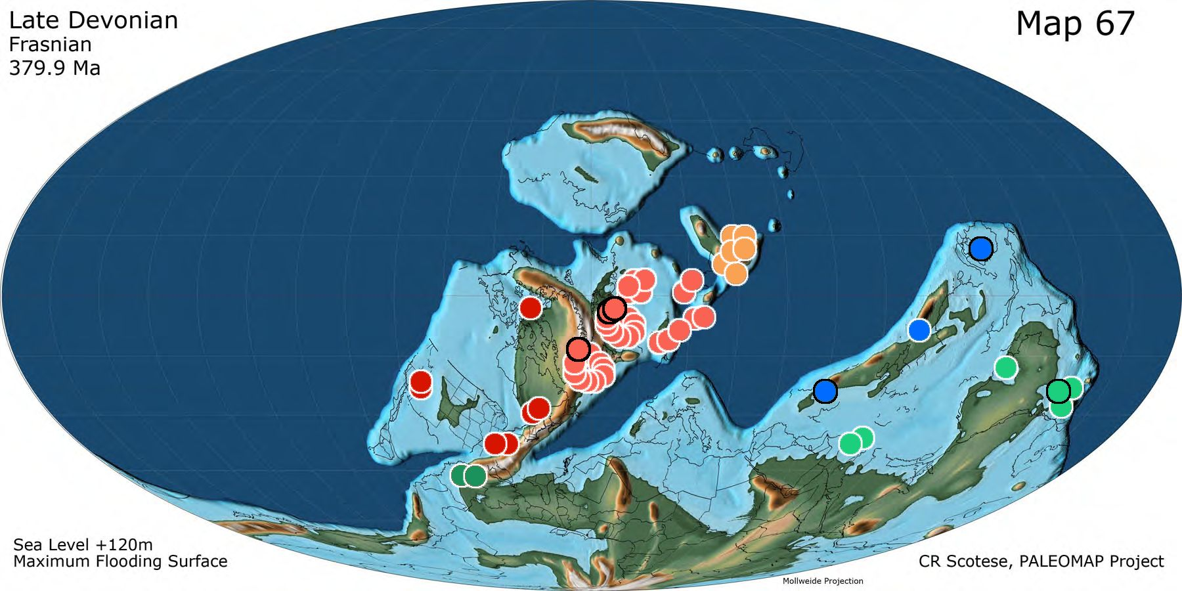
S6 Fig. Distribution of Bothriolepididae during the Frasnian (palaeomap reprinted from [72] under a CC BY license, with permission from Christopher Scotese, original copyright 2014).

Famennian
Famennian
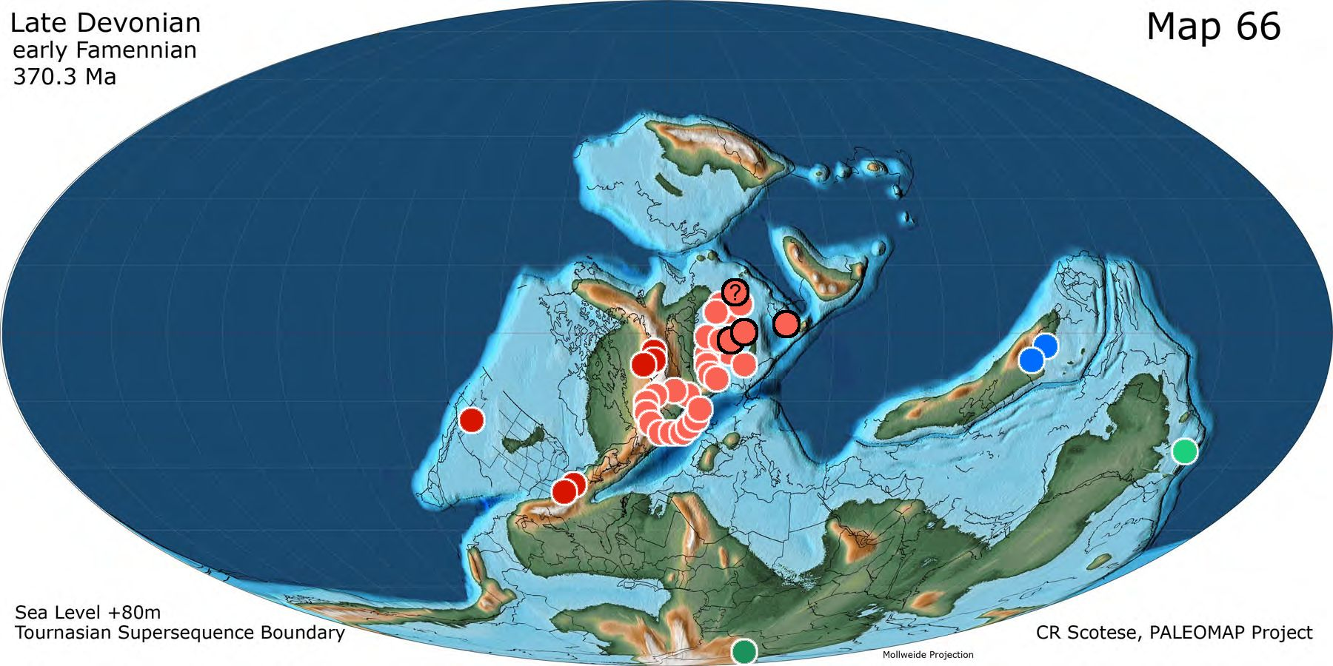
S7 Fig. Distribution of Bothriolepididae during the Famennian (palaeomap reprinted from [72] under a CC BY license, with permission from Christopher Scotese, original copyright 2014).

Late Famennian
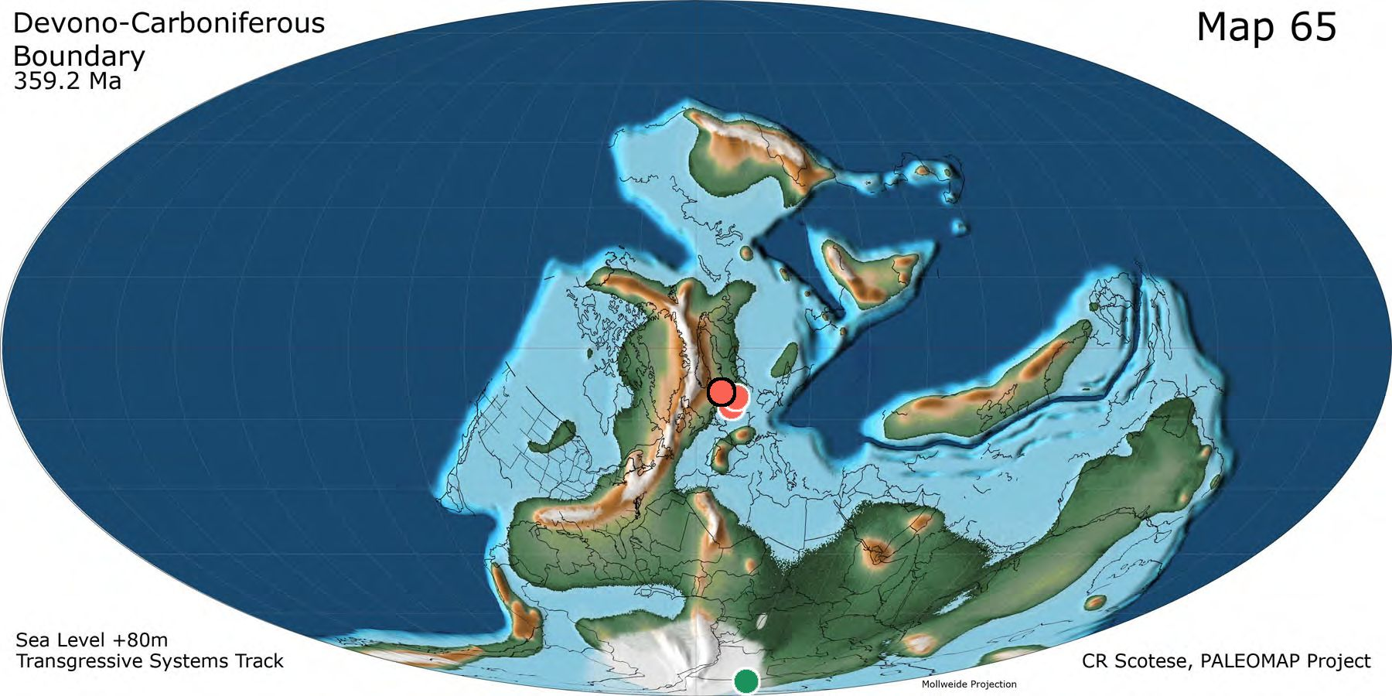
S8 Fig. Distribution of Bothriolepididae during the late Famennian (palaeomap reprinted from [72] under a CC BY license, with permission from Christopher Scotese, original copyright 2014).

Bothriolepididae taxa, strata and localities
Some of the taxa below are considered as junior synonyms of others (see dedicated section in Supplementary Information); they are however mapped when they belong to different localities than their senior, and listed with their old name for convenience. Non-mapped species because same locality as their senior synonym are: B. leidyi, B. retinata, B. stensioi.

Taxon | Geography |  |  | Stratigraphy | Comments
 | Locality | Province / Area | Country
Bothriolepidoidei
Luquanolepis pileos | Luquan | Yunnan | China | Emsian | in [76]
Bothriolepididae
Bothriolepididae | Tarim | Xinjiang | China | Frasnian | in [76]
Bothriolepis
Bothriolepis africana | Witpoort | South Africa | South Africa | Famennian | near Grahamstown, South Africa; in [60]
Bothriolepis alexi | Aztec | Victoria Land | East Antarctica | Givetian | in [77]
Bothriolepis alvesiensis | Rosebrae | Scotland | United Kingdom | Famennian | Early Frasnian in [77] (Upper Devonian, in [2]); corrected from Famennian to Frasnian on 20200605; back to Famennian on 20201102 based on Marshall in [78]
Bothriolepis alvesiensis | Alves and Rosebrae beds | Scotland | United Kingdom | Frasnian | Famennian in Denison, but corrected to Frasnian by [79] (Alves: mid-late Frasnian; Rosebrae: late Famennian) 20201102)
Bothriolepis amankonyrica | Central Kazakhstan | Central Kazakhstan | Kazakhstan | Frasnian | Central Kazakhstan, Olenty River, 60 km north of the village of Molodezhnyi, Amankonyr locality; Upper Devonian, Frasnian, basal Sofa Formation (in Moloshnikov, 2011)
Bothriolepis antarctica | Aztec | Victoria Land | East Antarctica | Middle Devonian | Middle or Upper Devonian, Beacon sandstone, in [2] - changed from Victoria Land into Aztec to fit [77]
Bothriolepis askinae | Aztec | Victoria Land | East Antarctica | Givetian | in [77]
Bothriolepis askinae | Aztec | Victoria Land | East Antarctica | Givetian | in [77]
Bothriolepis babichevi | Trudovoe | Central Kazakhstan | Kazakhstan | Givetian | Central Kazakhstan, north east of the city of Karaganda, right bank of the Shiderty River, village of Trudovoe; Middle Devonian,  Givetian, Konyr Formation, lower subformation. In [80]
Bothriolepis babichevi | Trudovoe | Central Kazakhstan | Kazakhstan | Givetian | Central Kazakhstan, north east of the city of Karaganda, right bank of the Shiderty River, village of Trudovoe; Middle Devonian, Givetian, Konyr Formation, lower subformation (in [81])
Bothriolepis barretti | Aztec | Victoria Land | East Antarctica | Givetian | in [77]
Bothriolepis bindareei | Mount Howitt | Victoria | Australia | Givetian
Bothriolepis canadensis | Miguasha | Québec (QBC) | Canada | Frasnian | Escuminac Fm., in [2]; [77]
Bothriolepis cellulosa | Baltic States | Baltic States | Baltic States | Frasnian | Snetogor stage, Baltic States + NW USSR, in [2]; Earliest Frasnian in [37]
Bothriolepis cellulosa | Timan | Timan | Russia | Frasnian | Timan and Tuva Depression, in [2]; Earliest Frasnian in [37]
Bothriolepis cf. kwangungensis | Lechang | Guangdong | China | Givetian | Dahepo Fm., in [76]
Bothriolepis cf. kwangungensis | Anfu | Jiangxi | China | Givetian | Dahepo Fm., in [76]
Bothriolepis ciecere | Ketleri | Latvia | Latvia | Famennian | in [77]
Bothriolepis ciecere | Pavari | Vidzeme | Latvia | Famennian | Upper Ketleri stage, in [2]; locality name from [82]
Bothriolepis coloradensis | Chaffee | Colorado (CO) | U.S.A. | Famennian | Chaffee Fm., in [2, 38] but noted as Frasnian; relabelled as Famennian following [77]; species is synonym of B. nitida ([13])
Bothriolepis coloradensis | La Plata County | Colorado (CO) | U.S.A. | Frasnian | Elbert Fm., Colorado, in [2, 38]; species is synonym of B. nitida ([13])
Bothriolepis cristata | Dura Den | Scotland | United Kingdom | Famennian | in [2]; in [77]
Bothriolepis cristata | Rosebrae | Scotland | United Kingdom | Famennian | in [2]; in [77]
Bothriolepis cullodenensis | Mount Howitt | Victoria | Australia | Givetian | in [77]
Bothriolepis curonica | Latvia | Latvia | Latvia | Frasnian | [37]
Bothriolepis dairbhrensis | Valentia Island | Kerry | Ireland | Givetian | Current article
Bothriolepis darbiensis | Fort Washakie | Wyoming (WY) | U.S.A. | Frasnian | in Denison, 1951, 1978
Bothriolepis darbiensis | Teton Pass | Wyoming (WY) | U.S.A. | Frasnian | in Denison, 1951, 1978
Bothriolepis dorakarasungensis | Tuva Basin | Tuva Republic | Russia | Frasnian | central Tuva, upper reaches of the Dora-Kara-Sug River; Upper Devonian, Frasnian, Kokhai Formation ([69])
Bothriolepis evaldi | Kalnamuiza | Kandava | Latvia | Frasnian | Middle Frasnian according to [37]
Bothriolepis evaldi | Kaibala | Lielvarde | Latvia | Frasnian | Middle Frasnian according to [37]
Bothriolepis favosa | Baltic States | Baltic States | Baltic States | Frasnian | Snetogor and Shelon-Ilmen stages, Baltic states and western USSR, in [2]
Bothriolepis fergusoni | Mount Howitt | Victoria | Australia | Givetian | in [77]
Bothriolepis gigantea | Alves beds | Scotland | United Kingdom | Frasnian | mid-late Frasnian in [79] (modified from Famennian in [2])
Bothriolepis gippslandiensis | Mount Howitt | Victoria | Australia | Givetian | in [77]
Bothriolepis grenfellensis | Grenfell | New South Wales | Australia | Famennian | in [77]
Bothriolepis groenlandica | Greenland | Greenland | Greenland | Famennian | Phyllolepis series, East Greenland, in [2]; early Famennian in [83]
Bothriolepis hayi | Oxendean beds | Scotland | United Kingdom | Famennian | Upper Devonian, in [2]; not more precise in [84], although lowest member containing B. hicklingi is dated as Famennian (based on Bothriolepis sp. and Holoptychius)
Bothriolepis heckeri | Bilovo | Novgorod Oblast | Russia | Famennian | Bilovo Beds? (corresponding to Akemene beds/Fm., so just below mid-Famennian in [37])
Bothriolepis hicklingi | Redheugh Mudstones | Scotland | United Kingdom | Famennian | Upper Old Red Sandstones in [2]; [84] propose a Famennian Age
Bothriolepis hydrophila | Portishead | England | United Kingdom | Famennian | in [77]
Bothriolepis hydrophila | Dura Den | Scotland | United Kingdom | Famennian | in [77]; Upper Devonian in [2]
Bothriolepis jani | Tervete | Tervete | Latvia | Famennian | in [77]
Bothriolepis jarviki | Greenland | Greenland | Greenland | Famennian | Phyllolepis series, East Greenland, in [2]; end Frasnian - early Famennian in [83]
Bothriolepis jazwicensis | Cheiloceras beds | Holy Cross Mountain | Poland | Famennian | in [77]
Bothriolepis jeremijevi | Timan | Timan | Russia | Upper Devonian | poorly known and undefinable, in [2]; reassigned to B. leptocheira jeremijevi by [17]
Bothriolepis karawaka | Aztec | Victoria Land | East Antarctica | Givetian | in [77]
Bothriolepis kassini | Central Kazakhstan | Central Kazakhstan | Kazakhstan | Frasnian | central Kazakhstan, right bank of the Shiderty River, Krasnyi Pakhar’ locality; Upper Devonian, Frasnian,  Shatskaya Group, basal Sofa Formation. In [85]
Bothriolepis kassini | Trudovoe | Central Kazakhstan | Kazakhstan | Givetian | Komyr Fm. Revised by [85] (after Malinovskaya's works)
Bothriolepis kohni | Aztec | Victoria Land | East Antarctica | Givetian | in [77]
Bothriolepis kwangtungensis | Lechang | Guangdong | China | Givetian | in [2]; [76]
Bothriolepis kwangtungensis | Anfu | Jiangxi | China | Givetian | in [2]; [76]
Bothriolepis laverocklochensis | Rosebrae | Scotland | United Kingdom | Famennian | in [77] (upper Devonian in [2])
Bothriolepis leptocheira | Gauja | Lode | Latvia | Famennian | in [77]; subspecies B. leptocheira curonica according to [37]; age changed from Givetian ([77], who entered it as B. curonica) to Famennian ([37])
Bothriolepis leptocheira | Latvia | Latvia | Latvia | Frasnian | Horizon e, Latvia, in [2] (subspecies B. leptocheira curonica after [37])
Bothriolepis leptocheira | Upper Old Red Sandstones (Scotland) | Scotland | United Kingdom | Upper Devonian | in [2]
Bothriolepis leptocheira curonica | Gauja | Lode | Latvia | Famennian | in [77]; subspecies B. leptocheira curonica according to [37]; age changed from Givetian (Sallan & Coates 2010, who entered it as B. curonica) to Famennian ([37])
Bothriolepis leptocheira curonica | Latvia | Latvia | Latvia | Frasnian | Very dubious stratigraphy, not mentioned by Lukševičs: Horizon e, Latvia, in [2] (subspecies B. leptocheira curonica after [37])
Bothriolepis leptocheira curonica | Upper Old Red Sandstones (Scotland) | Scotland | United Kingdom | Upper Devonian | in [2]
Bothriolepis leptocheira jeremejevi | Timan | Timan | Russia | Famennian | earliest Famennian of Sosnogorsk Fm., South Timan (Komi Republic), new subspecies combination by [17]
Bothriolepis leptocheira ssp. | Severnaya Zemlya | Siberia | Russia | Famennian | in [37], [17]
Bothriolepis lochangensis | Lechang | Guangdong | China | Givetian | in [2]; [76]
Bothriolepis lochangensis | Anfu | Jiangxi | China | Givetian | in [2]; [76]
Bothriolepis lohesti | Chèvremont | Wallonie | Belgium | Famennian | [86]
Bothriolepis lohesti | Evieux | Wallonie | Belgium | Famennian | in [77]; obviously duplicate of several localities in the Evieux Fm
Bothriolepis lohesti | Vaux-sous-Chèvremont | Wallonie | Belgium | Famennian | [86]
Bothriolepis longi | Nettleton's Creek | New South Wales | Australia | Middle - Upper Devonian | Givetian or Frasnian according to [63]; strong affinities with Aztec fauna (Antarctica)
Bothriolepis macphersoni | Aztec | Victoria Land | East Antarctica | Givetian | in [77]
Bothriolepis macrocephala | Upper Old Red Sandstones (England) | England | United Kingdom | Upper Devonian | in [2]
Bothriolepis maeandrina | Timan | Timan | Russia | Upper Devonian | in [2]
Bothriolepis major | Edenkillie beds | Scotland | United Kingdom | Frasnian | in [2]
Bothriolepis markovskii | Serpievka | Ural | Russia | Frasnian | southern Ural Mountains, Chelyabinsk Region, IvanKatavskii District, Sim River Basin, village of Serpievka; Upper Devonian, Upper Frasnian, Askyn Regional Stage, Orlovka Formation (in [80])
Bothriolepis mawsoni | Aztec | Victoria Land | East Antarctica | Givetian | in [77]
Bothriolepis maxima | Baltic States | Baltic States | Baltic States | Frasnian | "Baltic States and northwestren USSR", in [2]; see also [37] for mid-Late Franian age
Bothriolepis minor | Oneonta Formation | New York (NY) | U.S.A. | Upper Devonian | in [2]
Bothriolepis minor | Chemung | Pennsylvania (PA) | U.S.A. | Upper Devonian | in [2]
Bothriolepis minor | Hyner | Pennsylvania (PA) | U.S.A. | Upper Devonian | in [2]; in [77] (Late Famennian)
Bothriolepis nielseni | Aina Dal | Greenland | Greenland | Famennian | East Greenland, Remigolepis series; in [2]
Bothriolepis nikitinae | Central Kazakhstan | Central Kazakhstan | Kazakhstan | Frasnian | Central Kazakhstan, right bank of the Shiderty River, 75 km northeast of the village of Molodezhnyi, Krasnyi Pakhar’ locality; Upper Devonian, Frasnian, basal Sofa Formation ([80]).
Bothriolepis nitida | Blossburg | Pennsylvania (PA) | U.S.A. | Famennian | Catskill Formation, Catskill Group, NY state and Pennsylvania, in [2]; in [13]
Bothriolepis nitida | Hyner | Pennsylvania (PA) | U.S.A. | Famennian | in [77]
Bothriolepis nitida | Leroy | Pennsylvania (PA) | U.S.A. | Famennian | Catskill Formation, Catskill Group, NY state and Pennsylvania, in [2]; in [13]
Bothriolepis niushoushanensis | Zhongning | Ningxia | China | Eifelian | strati in [76]-
Bothriolepis obesa | Jedburgh beds | Scotland | United Kingdom | Upper Devonian | in [2]
Bothriolepis obrutschewi | Baltic States | Baltic States | Baltic States | Frasnian | Podsnetogor (Amata) stage; Baltic States, USSR, in [2]. Considered end-Givetian in [37] (Amata regional stage).
Bothriolepis ornata | Tervete | Tervete | Latvia | Famennian | in [77]
Bothriolepis ornata | Leningrad | Russia | Russia | Famennian | Leningrad Area, Nadbilovo stage, in [2]
Bothriolepis ornata | Timan | Timan | Russia | Famennian | in [2]
Bothriolepis panderi | Wietrznia | Holy Cross Mountain | Poland | Frasnian | in [77]; synonym of B. favosa in [2]
Bothriolepis paradoxa | Scaat Craig | Scotland | United Kingdom | Famennian | Upper Devonian in [2]; Famennian in [77]. Scaat Craig beds corresponds to a Low level of Alves beds ([87])
Bothriolepis paradoxa | Alves beds | Scotland | United Kingdom | Upper Devonian | in [2]
Bothriolepis pavariensis | Latvia | Latvia | Latvia | Famennian | Upper Ketleri stage, Latvia, in [2]
Bothriolepis perija | Cano Colorado | Zulia | Venezuela | Frasnian | early mid Frasnian ([66]:164)
Bothriolepis portalensis | Aztec | Victoria Land | East Antarctica | Givetian | in [77]
Bothriolepis prima | Armenia | Armenia | Armenia | Frasnian | doubtful, in [2]
Bothriolepis prima | Latvia | Latvia | Latvia | Frasnian | Podsnetogor (Amata) beds; in [2]. Considered end-Givetian in [37] (Amata regional stage).
Bothriolepis rex | Ellesmere Island | Nunavut (NUN) | Canada | Frasnian | [71]
Bothriolepis sanzarensis | Samarkand | Samarkand | Uzbekistan | Frasnian | Uzbekistan, vicinity of Samarkand, western marginal area of the Turkestan Mountain Range, Malguzar Mountains, Sanzar River Basin, village of Katta_Kara_Shak_Shak; Upper Devonian, Frasnian, Upper Frasnian Substage (in [80])
Bothriolepis shaokuanensis | Shaoguan | Guangdong | China | Eifelian | in [2]; [76]
Bothriolepis siberica | Oryol | Oryol | Russia | Famennian | in [77]
Bothriolepis siberica | Oryol | Oryol | Russia | Famennian | in [77]
Bothriolepis siberica | Minusinsk Basin | Siberia | Russia | Frasnian | Kokhai formation; in [2]
Bothriolepis siberica | Tuva Basin | Tuva Republic | Russia | Frasnian | Kokhai formation; in [2]
Bothriolepis sinensis | Changsha | Hunan | China | Eifelian | in [76]--Tiaomanjian Fm.
Bothriolepis sinensis | Yiyang | Hunan | China | Eifelian | in [76]--Tiaomanjian Fm.
Bothriolepis sinensis | Kunming | Yunnan | China | Eifelian | Haikou Fm; in [76].
Bothriolepis sosnensis | Livny | Oryol | Russia | Famennian | [67]
Bothriolepis stevensoni | Upper Old Red Sandstones (Scotland) | Scotland | United Kingdom | Upper Devonian | in [2]
Bothriolepis tastenica | Central Kazakhstan | Central Kazakhstan | Kazakhstan | Frasnian | Central Kazakhstan, right bank of the Shiderty River, 65 km east of the village of Molodeznyi, Saumalkol’ locality; Upper Devonian, Frasnian, middle part of the Sofa Formation; in [81]
Bothriolepis tatongensis | Tatong | Victoria | Australia | Frasnian | late Givetian - early Frasnian in [59]
Bothriolepis tatongensis | Tatong | Victoria | Australia | Givetian | late Givetian - early Frasnian in [59]
Bothriolepis taylori | Edenkillie beds | Scotland | United Kingdom | Frasnian | in [2]
Bothriolepis traquairi | Miguasha | Québec (QBC) | Canada | Frasnian | Escuminac Fm., in [2]; [77]
Bothriolepis traudscholdi | Stolbovo | Russia | Russia | Frasnian | in [77]
Bothriolepis tungseni | Qujing | Yunnan | China | Eifelian | in [76]
Bothriolepis tungseni | Wuding | Yunnan | China | Eifelian | in [76]
Bothriolepis tungseni | Haikou | Yunnan | China | Givetian | in [77]
Bothriolepis turanica | ZaktanSai | Tien Shan | Uzbekistan | Frasnian | in [2]; [80]
Bothriolepis virginiensis | Chemung | Pennsylvania (PA) | U.S.A. | Upper Devonian | Upper Devonian in [51]
Bothriolepis volongensis | Timan | Timan | Russia | Frasnian | upper part of Rassokha Fm. (in [64])
Bothriolepis vuwae | Aztec | Victoria Land | East Antarctica | Givetian | in [77]
Bothriolepis wilsoni | Harelaw beds | Scotland | United Kingdom | Upper Devonian | in [2]; Upper part of the Upper Old Red Sandstone Lithofacies in [84])
Bothriolepis yeungae | Canowindra | New South Wales | Australia | Famennian | in [77]
Bothriolepis yunnanensis | Wuding | Yunnan | China | Eifelian | in [2]; [76]
Bothriolepis sp. | Bobai | Guangxi | China | Eifelian | in [76]
Bothriolepis sp. | Qujing | Yunnan | China | Eifelian | in [76]
Bothriolepis sp. | Wuding | Yunnan | China | Eifelian | in [76]
Bothriolepis sp. | Qujing | Yunnan | China | Emsian | in [76]
Bothriolepis sp. | Wuding | Yunnan | China | Emsian | in [76]
Bothriolepis sp. | Evieux | Wallonie | Belgium | Famennian | in [77]; obviously duplicate of several localities in the Evieux Fm. (Modave in [86])
Bothriolepis sp. | Lengshuijiang | Hunan | China | Famennian | in [76]
Bothriolepis sp. | Liuyang | Hunan | China | Famennian | in [76]
Bothriolepis sp. | Andreyevka-2 | Siberia | Russia | Famennian | in [77]
Bothriolepis sp. | Gogo formation | Western Australia | Australia | Frasnian | in [77]
Bothriolepis sp. | Taojiang | Hunan | China | Frasnian | in [76]
Bothriolepis sp. | Floresta | Boyaca | Colombia | Frasnian | in [88]
Bothriolepis sp. | Chahriseh | Isfahan | Iran | Frasnian | in [77]
Bothriolepis sp. | Kerman | Kerman | Iran | Frasnian | in [77]
Bothriolepis sp. | Taishan | Guangdong | China | Givetian | in [76]
Bothriolepis sp. | Rockport | Michigan (MI) | U.S.A. | Givetian | in [77]; reattributed to Protitanichthys rockportensis by [89]
Briagalepis
Briagalepis warreni | Mount Howitt | Victoria | Australia | Middle - Upper Devonian | From the lower site at Freestone Creek, within the sediments of the Wellington Rhyolites, and from the upper conglomerate of the Bindaree -- the Bluff section of the Avon River Gp ([90], p. 100) cropping out along Bindaree Road, near Mt Howitt (in [59]).
Dianolepis
Dianolepis liui | Qujing | Yunnan | China | Eifelian | in [2]; [76]
Dianolepis liui | Wuding | Yunnan | China | Eifelian | in [2]; [76]
Dianolepis liui | Haikou | Yunnan | China | Givetian | in [77]
Grossilepis
Grossilepis brandi | Hazeldean Burn Beds | Scotland | United Kingdom | Frasnian | in [2]
Grossilepis rikiki | Strud | Wallonie | Belgium | Famennian
Grossilepis spinosa | Gauja | Lode | Latvia | Frasnian | Sallan and Coates (77) mentioned a Givetian age, but Lukševičs (37) mentioned a middle Frasnian age (Pamūšis regional stage, favoured here)
Grossilepis tuberculata | Snetnaya Gora Beds | Latvia | Latvia | Frasnian | in [2]
Grossilepis tuberculata | Minusinsk Basin | Siberia | Russia | Upper Devonian | in [2], but doubtful according to him
Houershanoelepis
Houershanolepis changi | Dushan | Guizhou | China | Early Devonian | Mount Houershan in Dushu county; based on a single AMD plate; [91]
Livnolepis
Livnolepis zadonica | Oryol | Oryol | Russia | Famennian | in [77]
Monarolepis
Monarolepis verrucosa | Taemas Wee Jasper | New South Wales | Australia | Emsian | [25, 50]
Rossolepis
Rossolepis brodensis | Oryol | Oryol | Russia | Famennian | in [77]
Vietnamaspis
Vietnamaspis trii | Do Son | North Vietnam | Vietnam | Middle - Upper Devonian | [54]
Wudinolepis
Wudinolepis weni | Wuding | Yunnan | China | Emsian | in [76]
Wufensgshania
Wufengshania magniforaminis | Wuding | Yunnan | China | Emsian | [92]

Table B. List of Bothriolepididae with stratigraphic and geographic indications.

Data matrix taxa * characters

Data matrix
The data matrix with complete and reduced list of characters (see below) and indices (character CI and RI, taxon and character completeness and polymorphism) is given as separate XL file. Mesquite-, TNT-, and PAUP-formatted files corresponding to the different steps and results of the phylogenetic analyses are given as Supplementary Files. All analyses were run on a portable DELL PC running Windows 10 64 bits; Compatibility with reader’s operating system not guaranteed.

List of characters

Original complete set
Although unused, this list is provided as a basis for further studies.

1. shape of preorbital recess ([50]:text-fig. 68, character 27e, i, r)
0: absent
1: simple and rounded (see B. askini in [50])
2: trilobate (clover; see B. barretti in [50])
3: pentagonal (spades; see B. portalensis in [50])
4: trifid (see B. nitida in [50])
5: trapezoidal (see Livnolepis (Bothriolepis) zadonica in [93])

2. anterior extension of postorbital process (new)
0: remains behind orbital fenestra
1: extends beyond orbital fenestra anteriorly

3. skull roof shape (for adults only; new)
0 round
1 quadrangular
2 hexagonal (with pointed anterior tip)
3 heptagonal

4. orbitonasal fenestra shape (new)
0 anterior and posterior edges straight and parallel
1 anteriorly concave and posteriorly convex (inversed bean)
2 anteriorly convex and posteriorly concave (bean)
3 concave anteriorly and posteriorly (peanut shaped)
4 convex anteriorly and posteriorly (rounded)

5. ratio length anterior tip / width between lateral corners (new)
This characters is difficult to assess with animals reconstructed flattened or in 3d (width shorter)
calculation relatively consistent throughout Bothriolepis species: 0,6<L/W<0,9 (new)

6. preorbital region of skull
0:short
1: elongated
Character unifying Grossilepis and Bothriolepis (contra other antiarchs) ([50]:text-fig. 68, character 27l)

7. bone thickness on orbital edges of PrM and La
0: even with rest of the plates
1: thicker at orbital edge ([50]:text-fig. 68, character 27o; [37]:char 8)

8. mesial lamina vs ventral lamina of La and PaN (vs. ioc) (new)
0 same level
1 lag

9. position of lateral corner of skull roof relative to PM-La-PaN point (new)
0 corner anterior
1 same level
2 corner posterior

10. position of posterior edge of orbit (contact PPi-Nu-orb) compared to position of La-PM-PaN plate (new)
0 orbit anterior
1 same level
2 orbit posterior

11. posterolateral indentation on PM and PAN for thoracic armour (new)
0: unmarked, rather flat (see B. askini in [50])
1: well marked (see B. portalensis in [50])

12. Lateral edge of premedian plate (new)
0 straight
1 concave
2 convex

13. Premedian plate posterior (new)
0 flat / straight
1 convex
2 concave

14. Premedian plate ratio anterior edge/mesial constriction width (new)
0 <1
1 =1
2 >1

15. Premedian plate ratio anterior edge/posterior edge (new)
0 <1
1 =1
2 >1

16. Premedian plate ratio mesial constriction width / posterior edge (new)
0 <1
1 =1
2 >1

17. lateral pits (internal side of La)
0: small
1: enlarged ([50]:text-fig. 68, character 27d)

18. separate ventrally facing attachment surface for PreLateral on Lateral plate
0: absent
1: present ([50]:text-fig. 68, character 27m)

19. Orbital margin of postpineal PPi at the level of lateral corners of skull roof (modified from [37]:char 18; was binary character)
0 lateral corner anterior to PPi orbital margin
1 same level
2 lateral corner posterior to PPi orbital margin

20. postpineal plate anterior edge (new)
0 concave
1 flat
2 convex

21. postpineal plate (new)
0 without lateral flanges
1 with anterior flanges

22. Nuchal orbital edge (new)
0 absent
1 present

23. Nuchal plate shape #1 ([50]:text-fig. 68, character 27p, modified and split into 3 characters)
0: wider than long
1: longer than wide
2: as wide as long

24. Nuchal plate shape #2 ([50]:text-fig. 68, character 27p, split into 3 characters)
0: contact edge with La straight
1: contact edge with La convex

25. Nuchal plate shape #3 (modified from [50]:text-fig. 68, character 27p. split into 3 characters; original states reversed)
0 long posterolateral corners
1 short posterolateral corners

26. shape contact Nu/PaN (new)
This character is a possible alternative to [50] (character p in text.-fig. 68) and [37] (character 13)
0 straight
1 Nu convex
2 Nu concave
3 sigmoid

27. Nuchal plate ratio width intermesiolateral edge / width interoposterolateral edge (new)
0 <1
1 =1
2 >1

28. ratio length anterolateral margin (Nu-La) / length posterolateral margin (Nu-PaN) (new)
0 <1
1 =1
2 >1

29. Nuchal plate ratio anterolateral edge/posterolateral edge length (in [63]:char 10); [37]:char 13)
0
1 squarish Nu with convex anterior division of the lateral margin and short posterolateral corners

30. obtected nuchal area present on PaN ([37]:char 6)
0 absent
1 present

31. Shape of postmarginal plate (similar to [37]:char 15)
0 triangular
1 quadrangular
2 pentagonal (extra angle on edge with La)

32. Ratio Length/Width of postmarginal plate (new)
0 <1
1 =1
2 >1

33. SM plate shape ([37]:char 10 pro parte; [50]:text-fig. 68, character 27g)
0: long and shallow
1: short and deep

34. anterior SM plate attachment on Lateral plate as a transverse ridge ([50]:text-fig. 68, character 27j)
0: no
1: yes (in transverse lateral groove)

35. anterior portion of submarginal attachment covers spiracular groove ([63])
0 no
1 yes

36. AMD width: broadest at lateral angles in adults ([50]:text-fig. 68, character 27b); [37]:char 1)
0: no
1: yes

37. lateral angles of AMD appear early in ontogeny ([50]:text-fig. 68, character 27c; also in [37]:char 2)
0: no
1: yes

38. Median Dorsal plates crest ([50]:text-fig. 68, character 27f); [37]:char 17))
0: none
1: minor
2: well marked

39. margin AMD-ADL (new)
0 straight
1 sigmoid / sinuous

40. margin AMD-MxL (new)
0 straight
1 sigmoid / sinuous

41. MxL broadest at its dorsal corners in adults ([50]:text-fig. 68, character 27b)
0: no
1: yes

42. crista transversalis interna anterior transversally oriented on ventral lamina of AVL ([50]:text-fig. 68, character 27n; [37]:char 11)
0: no
1: yes

43. ventrolateral ridge makes a keel ([37]:char 20)
0 no
1 yes

44. axillary foramen shape ([50]:text-fig. 68, character 27k; [37]:character 4)
0: higher than long
1: longer than high
2: as long as high

45. contact Cv1, Cv2, Mm1, Mm2 in pectoral fin ([50]:text-fig. 68, character 27h; [37]:char 3)
0 all contact in one point
1 Mm1+Cv2 separate Cv1 from Mm2
2 Cv1 and Mm2 contact

46. Cd5 on distal segment ([37]:char 14)
0 absent
1 present

47. middle pit-line long ([37]:char 9 pro parte)
0 absent
1 present

48. supra-occipital sensory groove long ([37]:char 9 pro parte)
0 absent
1 present

49. branch of infraorbital sensory line diverging on PrL parallel to the rostral margin of the head-shield (also in [37]:char 12)
0 no
1 yes

50. main lateral line canal/groove reaches the posterior margin of the MxL plate ([37]:char 16)
0 no
1 yes

51. Long branch of the infraorbital sensory groove/canal diverging on PrL (also in [37]:char 19)
0 no
1 yes

52. Junction of rostral ifc in midline on PRM (new)
0 straight
1 light posterior indet
2 very deep posterior indent

53. Semi-circular groove on La (new)
0 reduced
1 developed

54. central sensory groove shape (new)
0 straight
1 curved

55. central sensory groove on Nu (new)
0 only Nu
1 extends on La

56. central sensory groove (new; slightly different from character 42 about extension of csc on Nu only or onto La)
0 directed to semicircular groove
1 directed to La/PaNu/Nu point

57. Pectoral pit-line traced on the Cv1 continuing on the Cv2 ([37]:char 5)
0 absent
1 present

58. dermal ornamentation ([50]:text-fig. 68, character 27a)
0: reticulate in juveniles only
1: reticulate in adults only
2: reticulate in juveniles and adults

59. general size and ornamentation
No state coded: Young says large size, vermiculate ornamentation, small orbital fenestra and elongate nuchal for cluster wilsoni + mawsoni] but no definite information for other taxa ([50]:text-fig. 68, character 27q)

Final reduced set
1. shape of preorbital recess ([50]:text-fig. 68, character 27e, i, r)
0: absent
1: simple and rounded (see B. askini in [50])
2: trilobate (clover; see B. barretti in [50])
3: pentagonal (spades; see B. portalensis in [50])
4: trifid (see B. nitida in [50])
5: trapezoidal (see Livnolepis (Bothriolepis) zadonica in [93])

2. anterior extension of postorbital process (new)
0: remains behind orbital fenestra
1: extends beyond orbital fenestra anteriorly

3. skull roof shape (for adults only; new)
0 round
1 quadrangular
2 hexagonal (with pointed anterior tip)
3 heptagonal

4. orbitonasal fenestra shape (new)
0 anterior and posterior edges straight and parallel
1 anteriorly concave and posteriorly convex (inversed bean)
2 anteriorly convex and posteriorly concave (bean)
3 concave anteriorly and posteriorly (peanut shaped)
4 convex anteriorly and posteriorly (rounded)

5. preorbital region of skull
0:short
1: elongated
Character unifying Grossilepis and Bothriolepis (contra other antiarchs) ([50]:text-fig. 68, character 27l)

6. mesial lamina vs ventral lamina of La and PaN (vs. ioc) (new)
0 same level
1 lag

7. position of lateral corner of skull roof relative to PM-La-PaN point (new)
0 corner anterior
1 same level
2 corner posterior

8. position of posterior edge of orbit (contact PPi-Nu-orb) compared to position of La-PM-PaN plate (new)
0 orbit anterior
1 same level
2 orbit posterior

9. posterolateral indentation on PM and PAN for thoracic armour (new)
0: unmarked, rather flat (see B. askini in [50])
1: well marked (see B. portalensis in [50])

10. Lateral edge of premedian plate (new)
0 straight
1 concave
2 convex

11. Premedian plate posterior (new)
0 flat / straight
1 convex
2 concave

12. Premedian plate ratio anterior edge/mesial constriction width (new)
0 <1
1 =1
2 >1

13. Premedian plate ratio anterior edge/posterior edge (new)
0 <1
1 =1
2 >1

14. Premedian plate ratio mesial constriction width / posterior edge (new)
0 <1
1 =1
2 >1

15. lateral pits (internal side of La)
0: small
1: enlarged ([50]:text-fig. 68, character 27d)

16. Orbital margin of postpineal PPi at the level of lateral corners of skull roof (modified from [37]:char 18; was binary character)
0 lateral corner anterior to PPi orbital margin
1 same level
2 lateral corner posterior to PPi orbital margin

17. postpineal plate anterior edge (new)
0 concave
1 flat
2 convex

18. postpineal plate (new)
0 without lateral flanges
1 with anterior flanges

19. Nuchal orbital edge (new)
0 absent
1 present

20. Nuchal plate shape #1 ([50]:text-fig. 68, character 27p, modified and split into 3 characters)
0: wider than long
1: longer than wide
2: as wide as long

21. Nuchal plate shape #2 ([50]:text-fig. 68, character 27p, split into 3 characters)
0: contact edge with La straight
1: contact edge with La convex

22. shape contact Nu/PaN (new)
This character is a possible alternative to [50] (character p in text.-fig. 68) and [37] (character 13)
0 straight
1 Nu convex
2 Nu concave
3 sigmoid

23. Nuchal plate ratio width intermesiolateral edge / width intero posterolateral edge (new)
0 <1
1 =1
2 >1

24. ratio length anterolateral margin (Nu-La) / length posterolateral margin (Nu-PaN) (new)
0 <1
1 =1
2 >1

25. Nuchal plate ratio anterolateral edge/posterolateral edge length (in [63]:char 10); [37]:char 13)
0
1 squarish Nu with convex anterior division of the lateral margin and short posterolateral corners

26. obtected nuchal area present on PaN ([37]:char 6)
0 absent
1 present

27. Shape of postmarginal plate (similar to [37]:char 15)
0 triangular
1 quadrangular
2 pentagonal (extra angle on edge with La)

28. Ratio Length/Width of postmarginal plate (new)
0 <1
1 =1
2 >1

29. SM plate shape ([37]:char 10 pro parte; [50]:text-fig. 68, character 27g)
0: long and shallow
1: short and deep

30. AMD width: broadest at lateral angles in adults ([50]:text-fig. 68, character 27b); [37]:char 1)
0: no
1: yes

31. lateral angles of AMD appear early in ontogeny ([50]:text-fig. 68, character 27c; also in [37]:char 2)
0: no
1: yes

32. Median Dorsal plates crest ([50]:text-fig. 68, character 27f); [37]:char 17))
0: none
1: minor
2: well marked

33. margin AMD-ADL (new)
0 straight
1 sigmoid / sinuous

34. margin AMD-MxL (new)
0 straight
1 sigmoid / sinuous

35. MxL broadest at its dorsal corners in adults ([50]:text-fig. 68, character 27b)
0: no
1: yes

36. crista transversalis interna anterior transversally oriented on ventral lamina of AVL ([50]:text-fig. 68, character 27n; [37]:char 11)
0: no
1: yes

37. ventrolateral ridge makes a keel ([37]:char 20)
0 no
1 yes

38. axillary foramen shape ([50]:text-fig. 68, character 27k; [37]:character 4)
0: higher than long
1: longer than high
2: as long as high

39. contact Cv1, Cv2, Mm1, Mm2 in pectoral fin ([50]:text-fig. 68, character 27h; [37]:char 3)
0 all contact in one point
1 Mm1+Cv2 separate Cv1 from Mm2
2 Cv1 and Mm2 contact

40. Cd5 on distal segment ([37]:char 14)
0 absent
1 present

41. middle pit-line long ([37]:char 9 pro parte) (
0 absent
1 present

42. supra-occipital sensory groove long ([37]:char 9 pro parte)
0 absent
1 present

43. branch of infraorbital sensory line diverging on PrL parallel to the rostral margin of the head-shield (also in [37]:char 12)
0 no
1 yes

44. main lateral line canal/groove reaches the posterior margin of the MxL plate ([37]:char 16)
0 no
1 yes

45. Long branch of the infraorbital sensory groove/canal diverging on PrL (also in [37]:char 19)
0 no
1 yes

46. Junction of rostral ifc in midline on PRM (new)
0 straight
1 light posterior indet
2 very deep posterior indent

47. Semi-circular groove on La (new)
0 reduced
1 developed

48. central sensory groove shape (new)
0 straight
1 curved

49. central sensory groove on Nu (new)
0 only Nu
1 extends on La

50. central sensory groove (new; slightly different from character 42 about extension of csc on Nu only or onto La)
0 directed to semicircular groove
1 directed to La/PaNu/Nu point

Phylogenetic analyses

Different outgroups
 | complete taxa + char | complete taxa | OG Remigolepis | OG Grossilepis | OG niushoushanensis | OG shaokuanensis | OG askinae | OG askinae (-virginiensis)
total char | 59 | 33 | 50 | 50 | 50 | 50 | 50 | 50
total taxa | 54 | 54 | 47 | 46 | 45 | 45 | 45 | 44
n_{MPT} | 10000 (maxtrees) | 10000 (maxtrees) | 50 | 50 | 50 | 54 | 54 | 96
L_{MPT} | 248 | 76 | 228 | 255 | 217 | 217 | 217 | 210
CI_{MPT} | 0.327 | 0.526 | 0.351 | 0.323 | 0.327 | 0.327 | 0.327 | 0.333
RI_{MPT} | 0.512 | 0.747 | 0.502 | 0.513 | 0.507 | 0.507 | 0.507 | 0.509
L_{50%} | 331 | 125 | 266 | 253 | 247 | 247 | 247 | 251
CI_{50%} | 0.245 | 0.32 | 0.282 | 0.292 | 0.287 | 0.287 | 0.287 | 0.279
RI_{50%} | 0.27 | 0.401 | 0.416 | 0.423 | 0.405 | 0.405 | 0.405 | 0.665

Table C. Phylogenetic indices obtained using various outgroups and data sets. n_{MPT}, number of most parsimonious trees; L_{MPT}, length of each most parsimonious tree; CI_{MPT}, consistency index of each most parsimonious tree ; RI_{MPT}, retention index of each most parsimonious tree ; L_{50%}, length of the majority rule consensus tree ; CI_{50%}, consistency index of the majority rule consensus tree ; RI50%, retention index of the majority rule consensus tree.

all characters and all taxa (but Dianolepis)

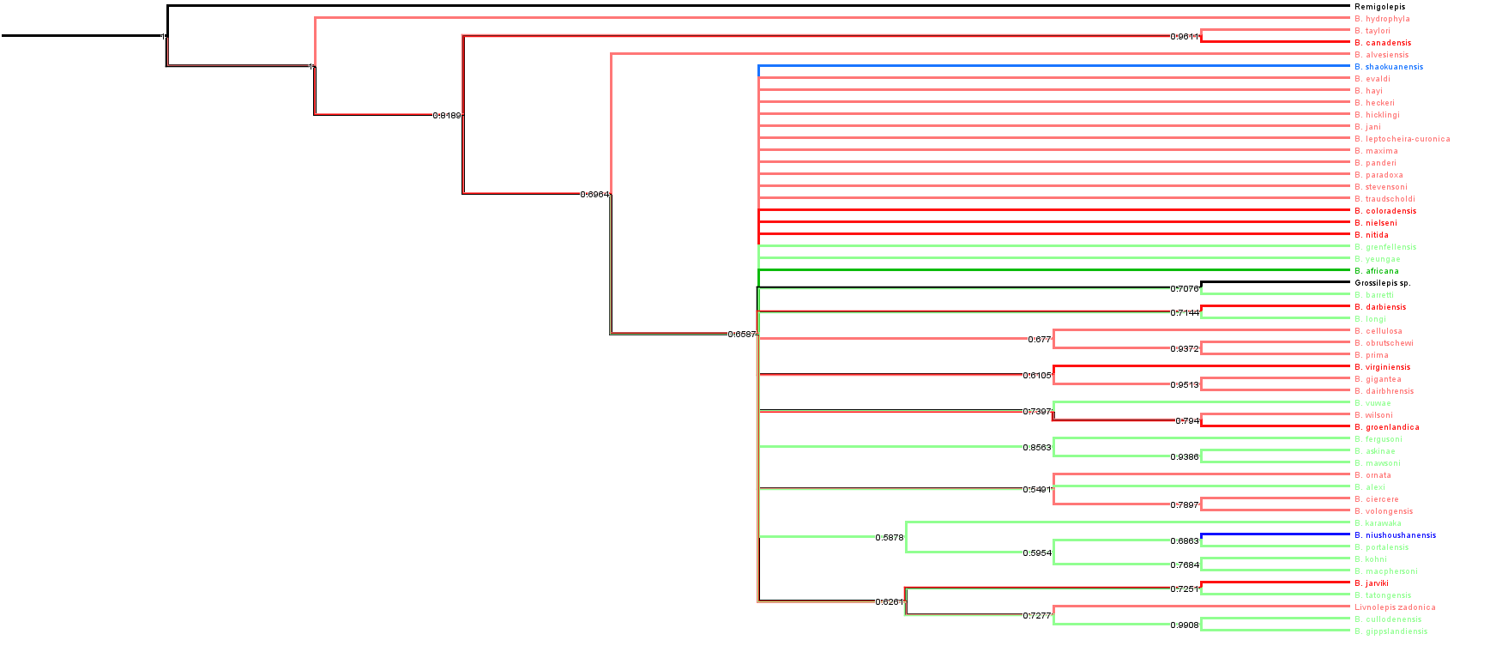
S9 Fig. Majority rule consensus tree of the phylogeny of the genus Bothriolepis using the complete data set (59 characters * 54 taxa). Colours indicate palaeogeographic affinities of taxa (red Laurussia, green Gondwana, blue China; black is outgroup).

all taxa (but Dianolepis)

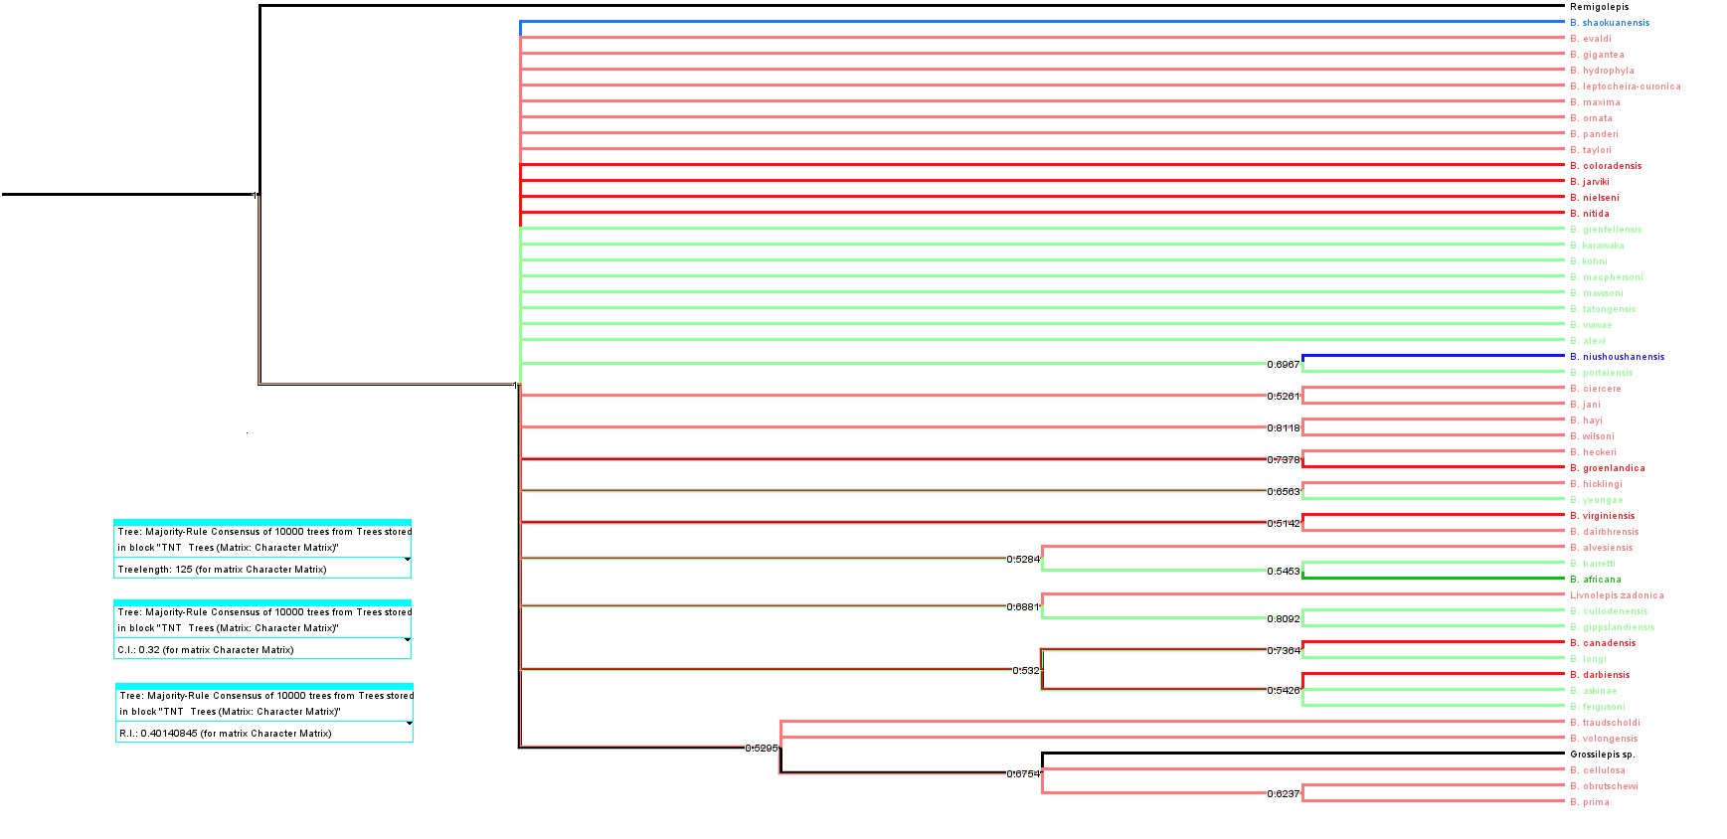
S10 Fig. Majority rule consensus tree of the phylogeny of the genus Bothriolepis using the complete data set (33 characters * 54 taxa). Colours indicate palaeogeographic affinities of taxa (red Laurussia, green Gondwana, blue China; black is outgroup).

n_{MPT} | 10000 (maxtrees)
L_{MPT} | 76
CI_{MPT} | 0,526
RI_{MPT} | 0,747
L_{50%} | 125
CI_{50%} | 0,32
RI_{50%} | 0,401

Outgroup = Remigolepis + Grossilepis
50 characters (bad ones removed) *47 taxa (bad ones removed)
LMPT=228
nMPT=50
CIMPT=0.351
RIMPT=0.502

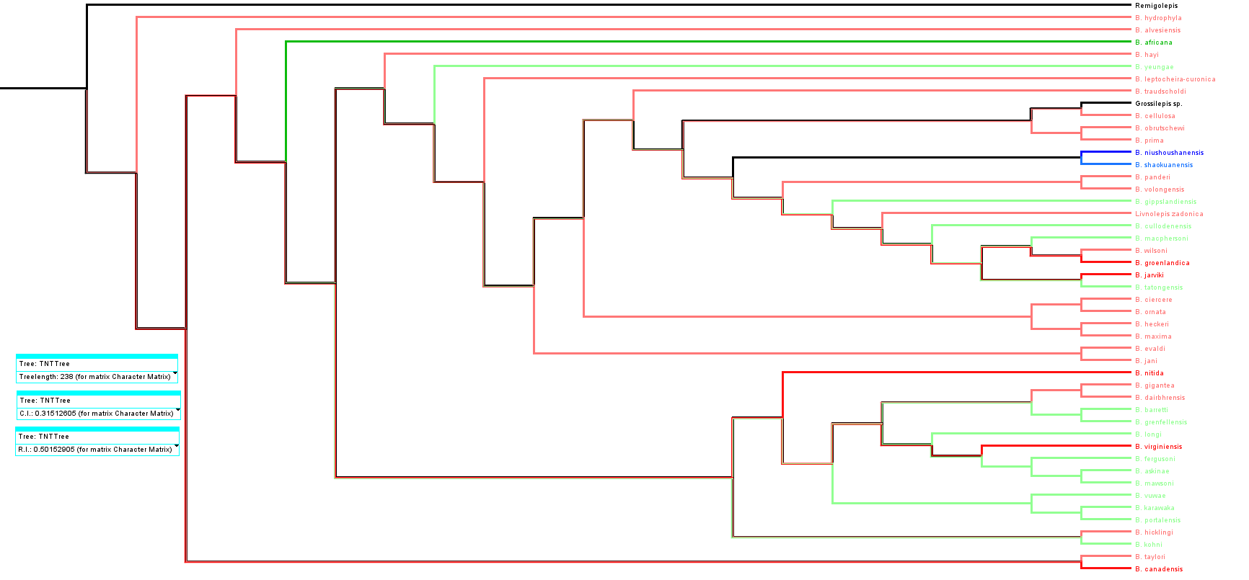
S11 Fig. Tree #1 (out of 50) showing the phylogeny of the genus Bothriolepis using the reduced data set (50 characters * 47 taxa). Colours indicate palaeogeographic affinities of taxa (red Laurussia, green Gondwana, blue China; black is outgroup).

-------------------
50% maj rule:
L50%=266
CI50%=0.282
RI50%=0.416

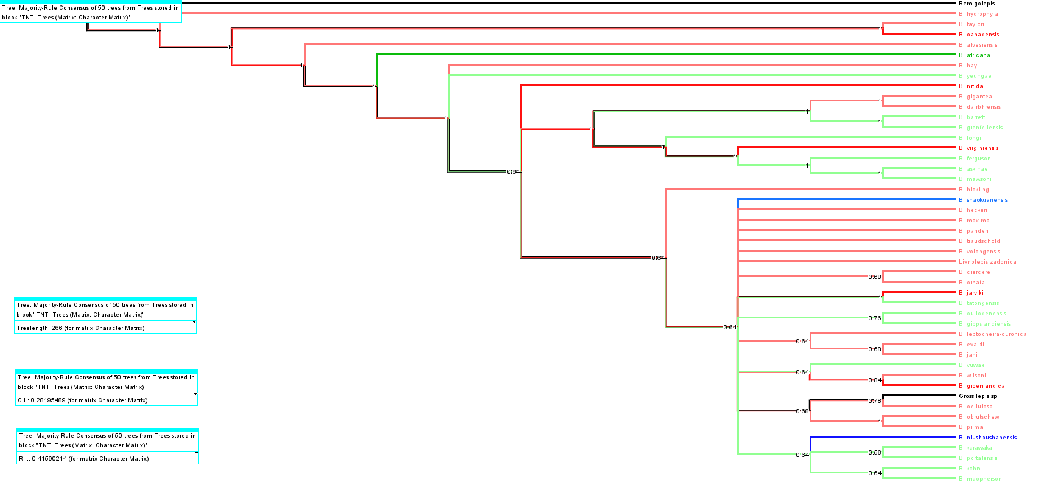
S12 Fig. Majority rule consensus tree of the phylogeny of the genus Bothriolepis using the reduced data set (50 characters * 47 taxa). Colours indicate palaeogeographic affinities of taxa (red Laurussia, green Gondwana, blue China; black is outgroup).

Outgroup = Grossilepis
50 characters (bad ones removed) *46 taxa (bad ones removed)
LMPT=225
nMPT=50
CIMPT=0.323
RIMPT=0.513

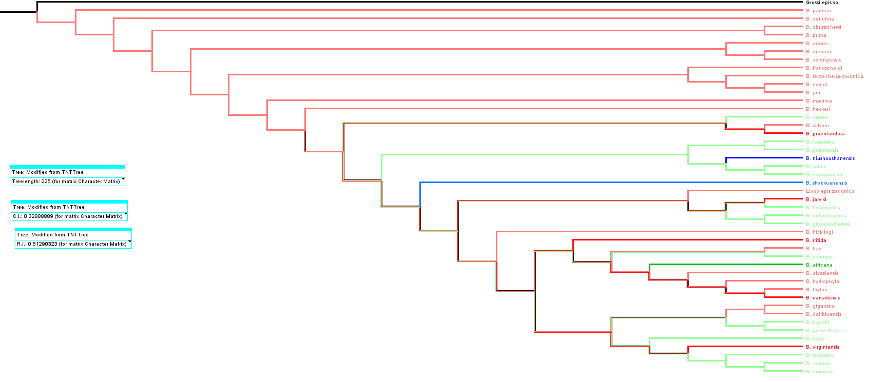
S13 Fig. Tree #1 (out of 50) showing the phylogeny of the genus Bothriolepis using the reduced data set (50 characters * 46 taxa). Colours indicate palaeogeographic affinities of taxa (red Laurussia, green Gondwana, blue China; black is outgroup).

---------------------
50% maj rule:
L50%=253
CI50%=0.292
RI50%=0.423

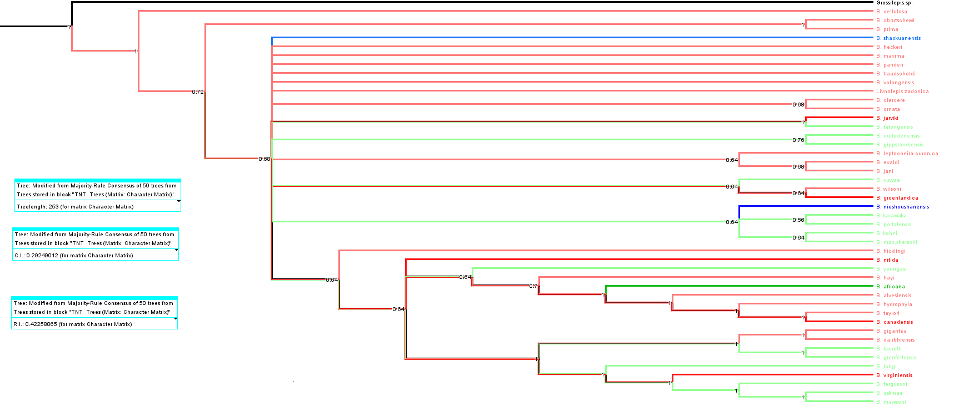
S14 Fig. Majority rule consensus tree of the phylogeny of the genus Bothriolepis using the reduced data set (50 characters * 46 taxa). Colours indicate palaeogeographic affinities of taxa (red Laurussia, green Gondwana, blue China; black is outgroup).

Outgroup = B. niushoushanensis
50 characters (bad ones removed) *45 taxa (bad ones removed)
LMPT=217
nMPT=50
CIMPT=0.327
RIMPT=0.507

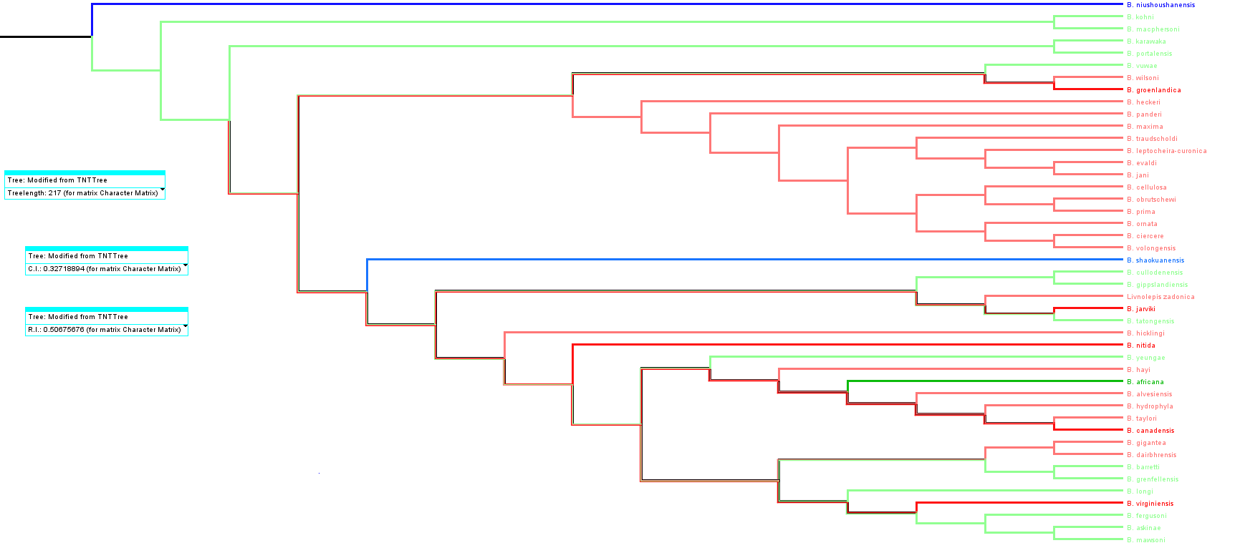
S15 Fig. Tree #1 (out of 50) showing the phylogeny of the genus Bothriolepis using the reduced data set (50 characters * 45 taxa). Colours indicate palaeogeographic affinities of taxa (red Laurussia, green Gondwana, blue China).

---------
50% maj rule:
L50%=247
CI50%=0.287
RI50%=0.405

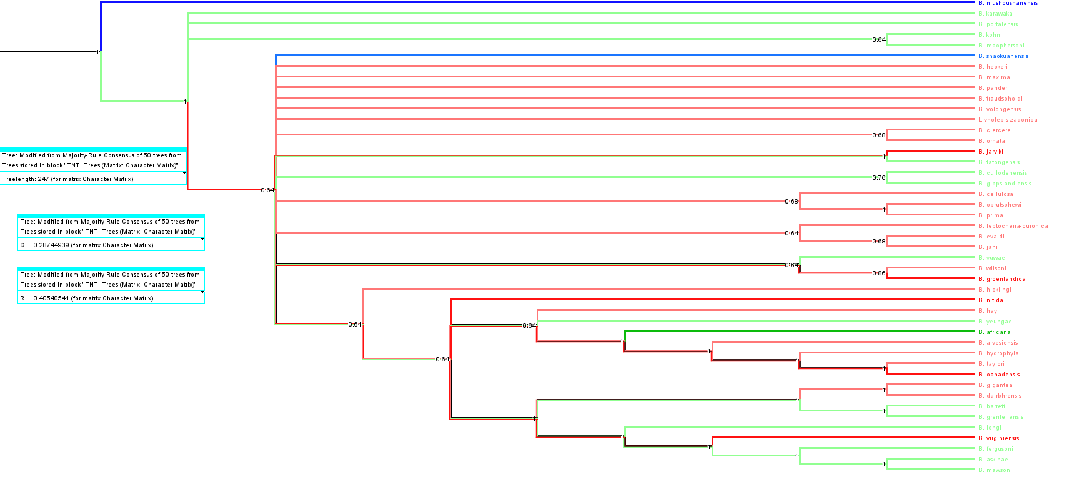
S16 Fig. Majority rule consensus tree of the phylogeny of the genus Bothriolepis using the reduced data set (50 characters * 45 taxa). Colours indicate palaeogeographic affinities of taxa (red Laurussia, green Gondwana, blue China).

Outgroup = B. shaokuanensis
50 characters (bad ones removed) *45 taxa (bad ones removed)
LMPT=217
nMPT=54
CIMPT=0.327
RIMPT=0.507

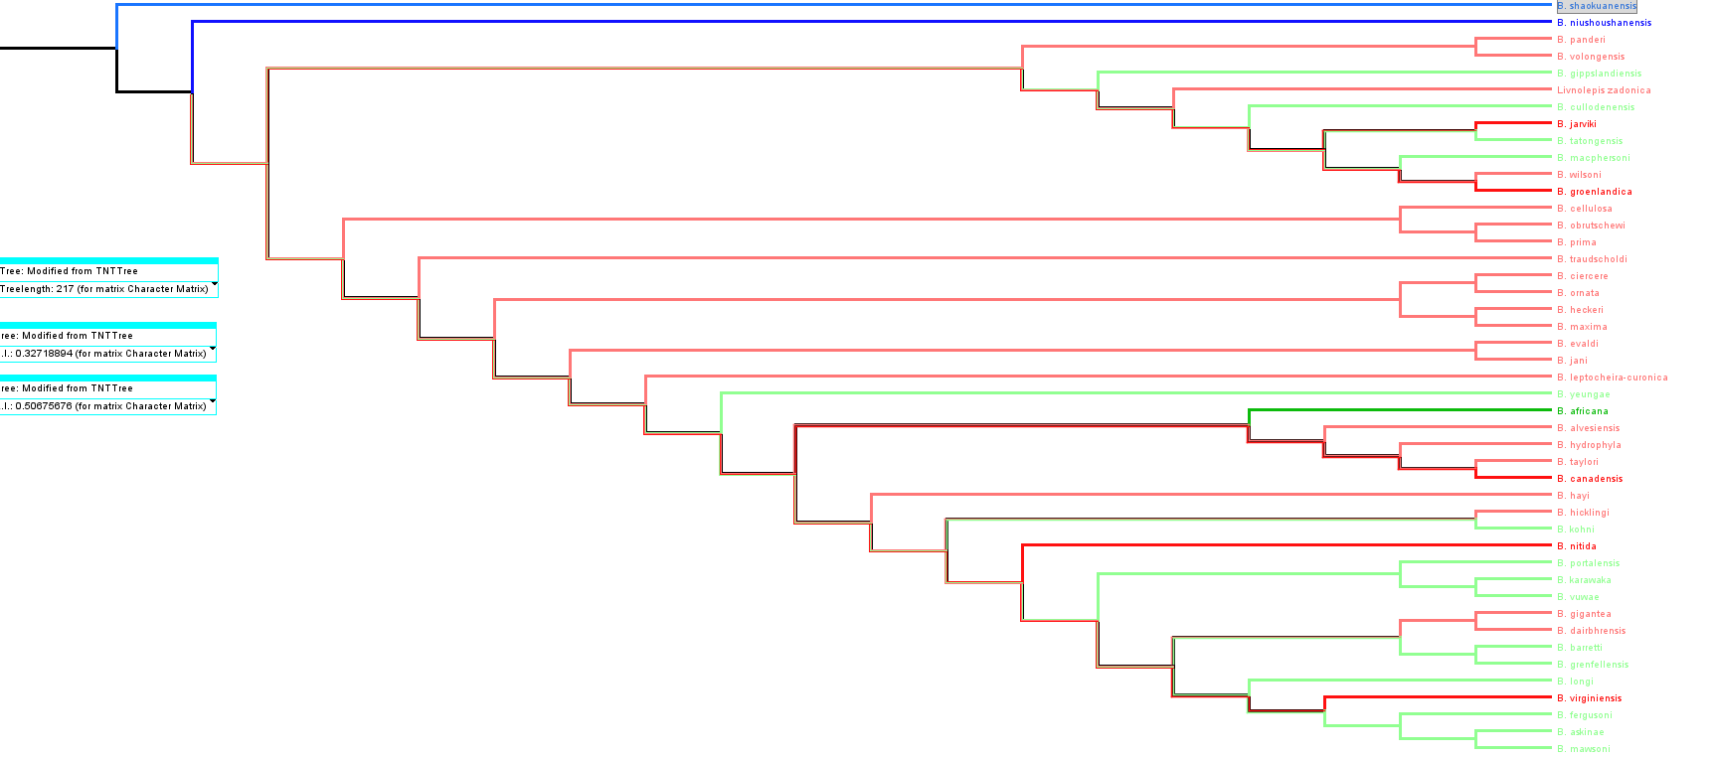
S17 Fig. Tree #1 (out of 50) showing the phylogeny of the genus Bothriolepis using the reduced data set (50 characters * 45 taxa). Colours indicate palaeogeographic affinities of taxa (red Laurussia, green Gondwana, blue China).

----------------
50% maj rule:
L50%=247
CI50%=0.287
RI50%=0.405

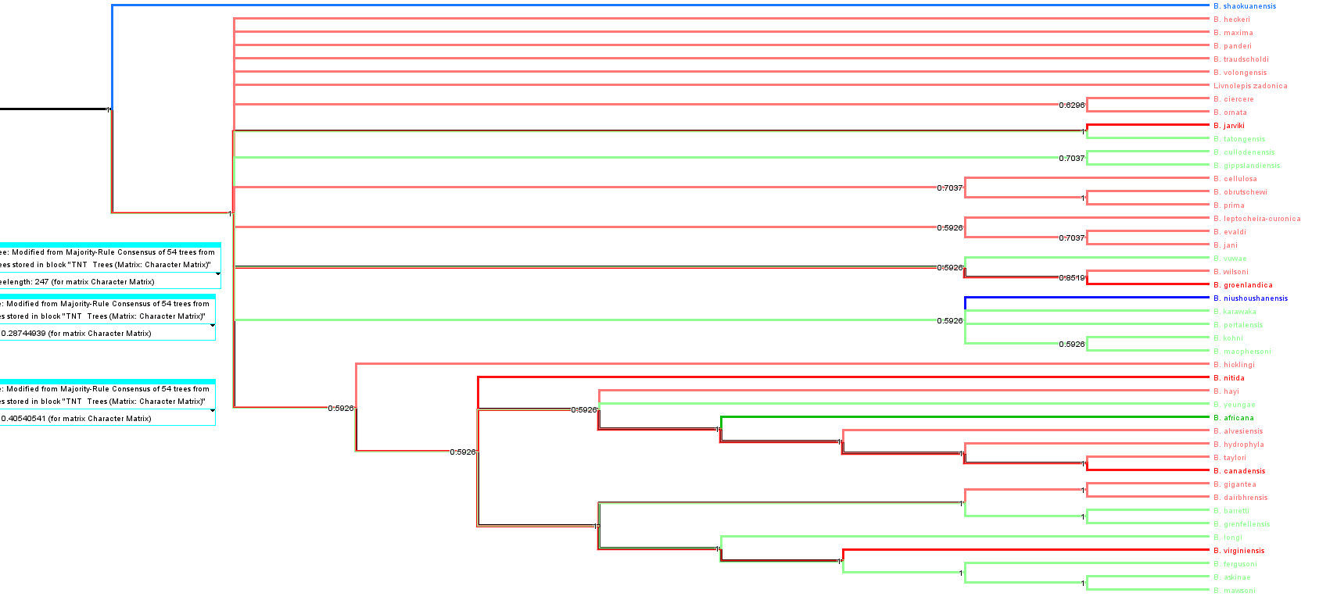
S18 Fig. Majority rule consensus tree of the phylogeny of the genus Bothriolepis using the reduced data set (50 characters * 45 taxa). Colours indicate palaeogeographic affinities of taxa (red Laurussia, green Gondwana, blue China).

Outgroup = B. askinae

50 characters (bad ones removed) *45 taxa (bad ones removed)
LMPT=217
nMPT=54
CIMPT=0.327
RIMPT=0.507

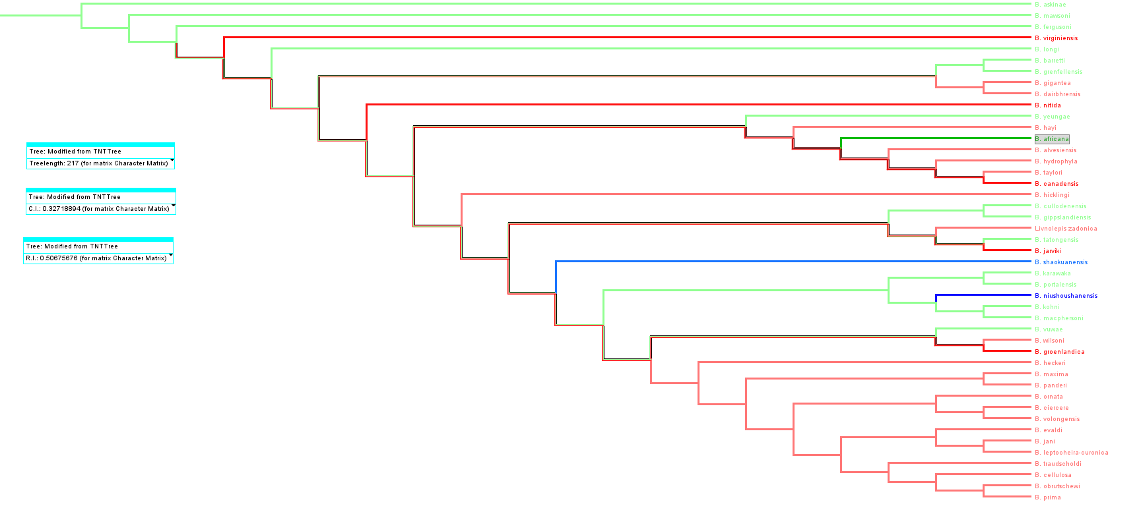
S19 Fig. Tree #1 (out of 50) showing the phylogeny of the genus Bothriolepis using the reduced data set (50 characters * 45 taxa). Colours indicate palaeogeographic affinities of taxa (red Laurussia, green Gondwana, blue China).
-------------------

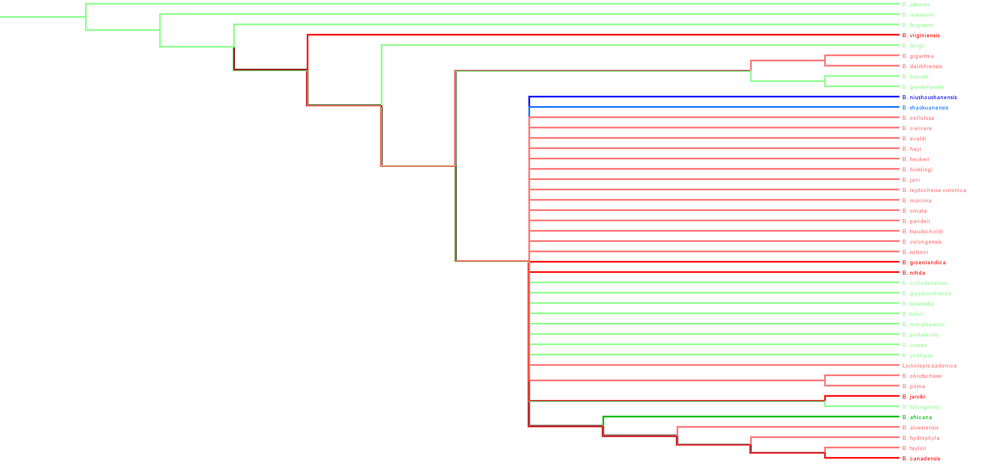
S20 Fig. Strict consensus tree of the phylogeny of the genus Bothriolepis using the reduced data set (50 characters * 45 taxa). Colours indicate palaeogeographic affinities of taxa (red Laurussia, green Gondwana, blue China).
L_{CS} = 308 steps,
CI_{CS} = 0.231,
RI_{CS} = 0.199

----------
50% maj rule:
L50%=247
CI50%=0.287
RI50%=0.405

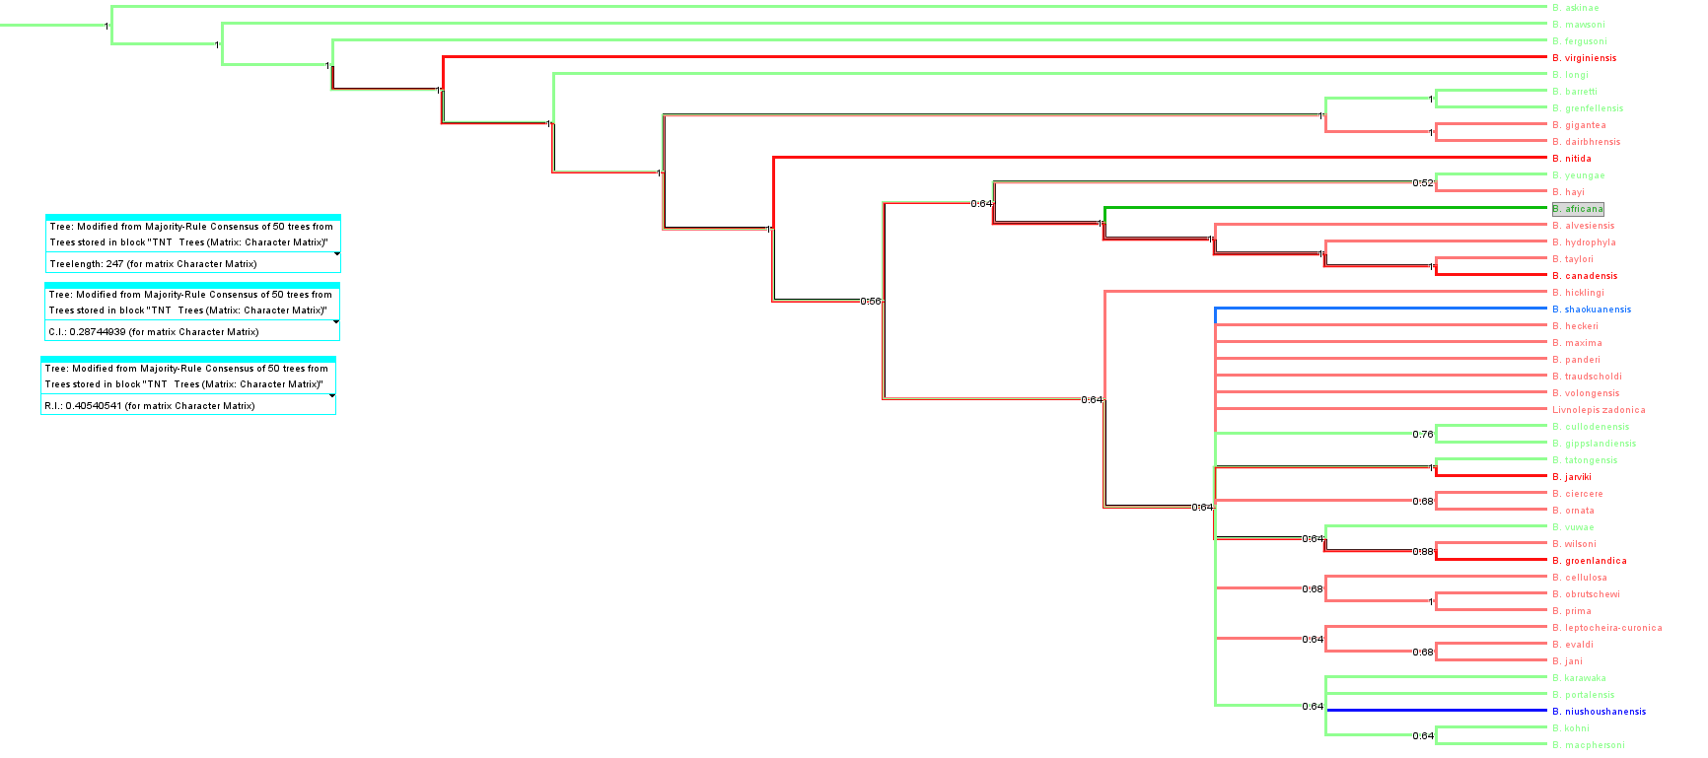
S21 Fig. Majority rule consensus tree of the phylogeny of the genus Bothriolepis using the reduced data set (50 characters * 45 taxa). Colours indicate palaeogeographic affinities of taxa (red Laurussia, green Gondwana, blue China).
------------------

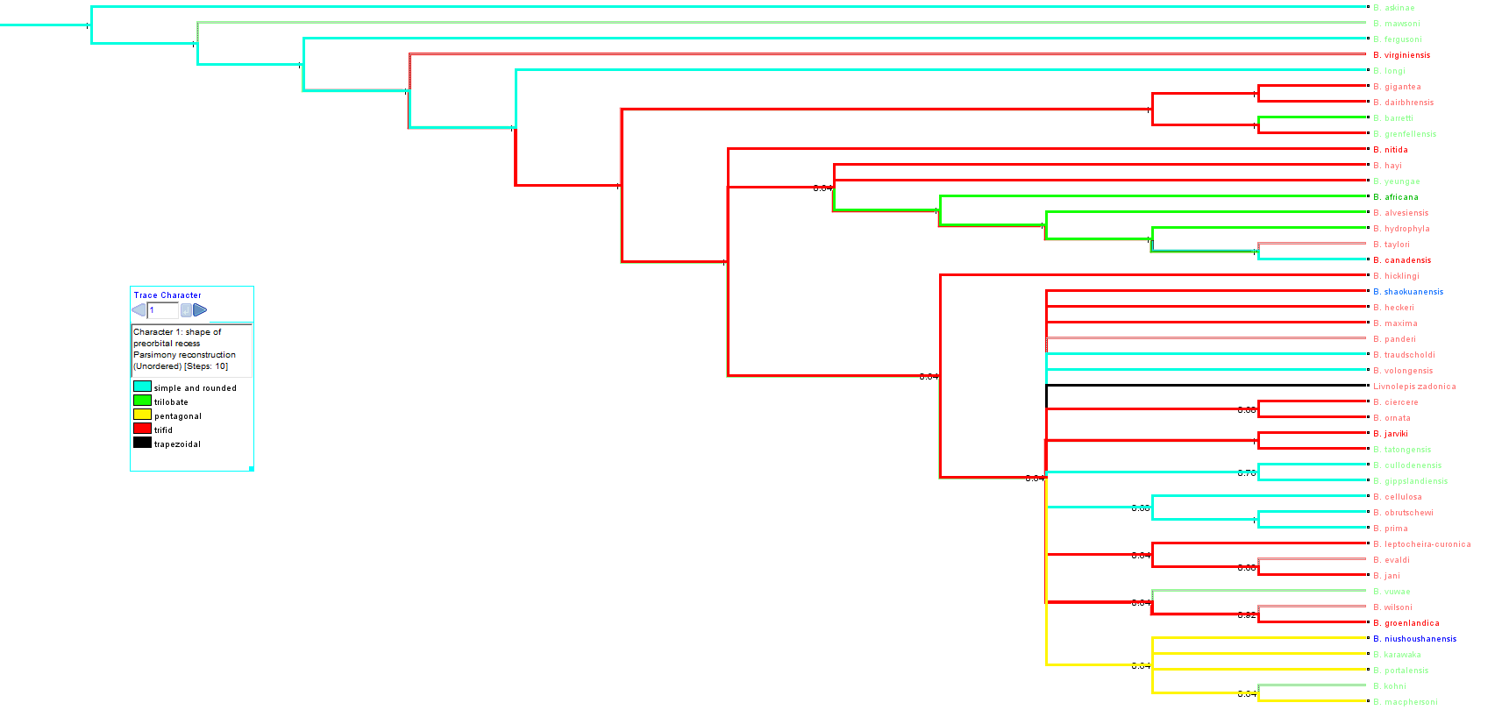
S22 Fig. Majority rule consensus tree of the phylogeny of the genus Bothriolepis using the reduced data set (50 characters * 45 taxa). Colours indicate distribution of preorbital recess shape (character #1; blue simple and rounded, green trilobate, yellow pentagonal, red trifid, black trapezoidal).

Outgroup = B. askinae (B. virginiensis removed)

50 characters (bad ones removed) *44 taxa (bad ones removed)
LMPT=210
nMPT=96
CIMPT=0.333
RIMPT=0.509

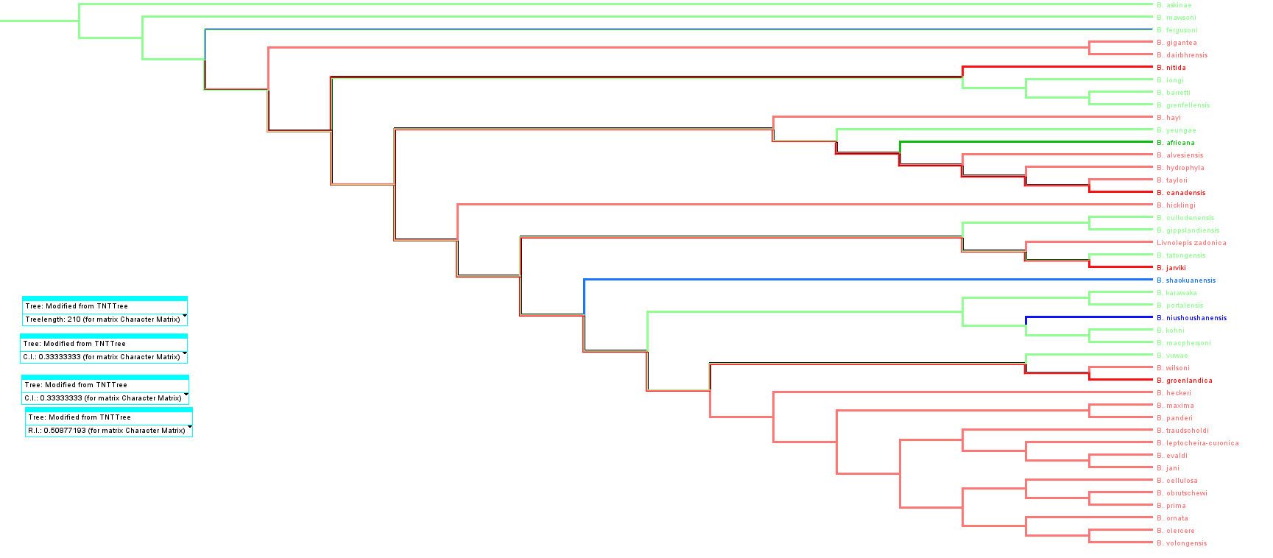
S23 Fig. Tree #1 (out of 50) showing the phylogeny of the genus Bothriolepis using the reduced data set (50 characters * 45 taxa). Colours indicate palaeogeographic affinities of taxa (red Laurussia, green Gondwana, blue China).

S24 Fig. Strict consensus tree of the phylogeny of the genus Bothriolepis using the reduced data set (50 characters * 45 taxa). Colours indicate palaeogeographic affinities of taxa (red Laurussia, green Gondwana, blue China).

L_{CS} = 253 steps,
CI_{CS} = 0.277,
RI_{CS} = 0.358

------------------------
50% maj rule:
L50%=251
CI50%=0.279
RI50%=0.665

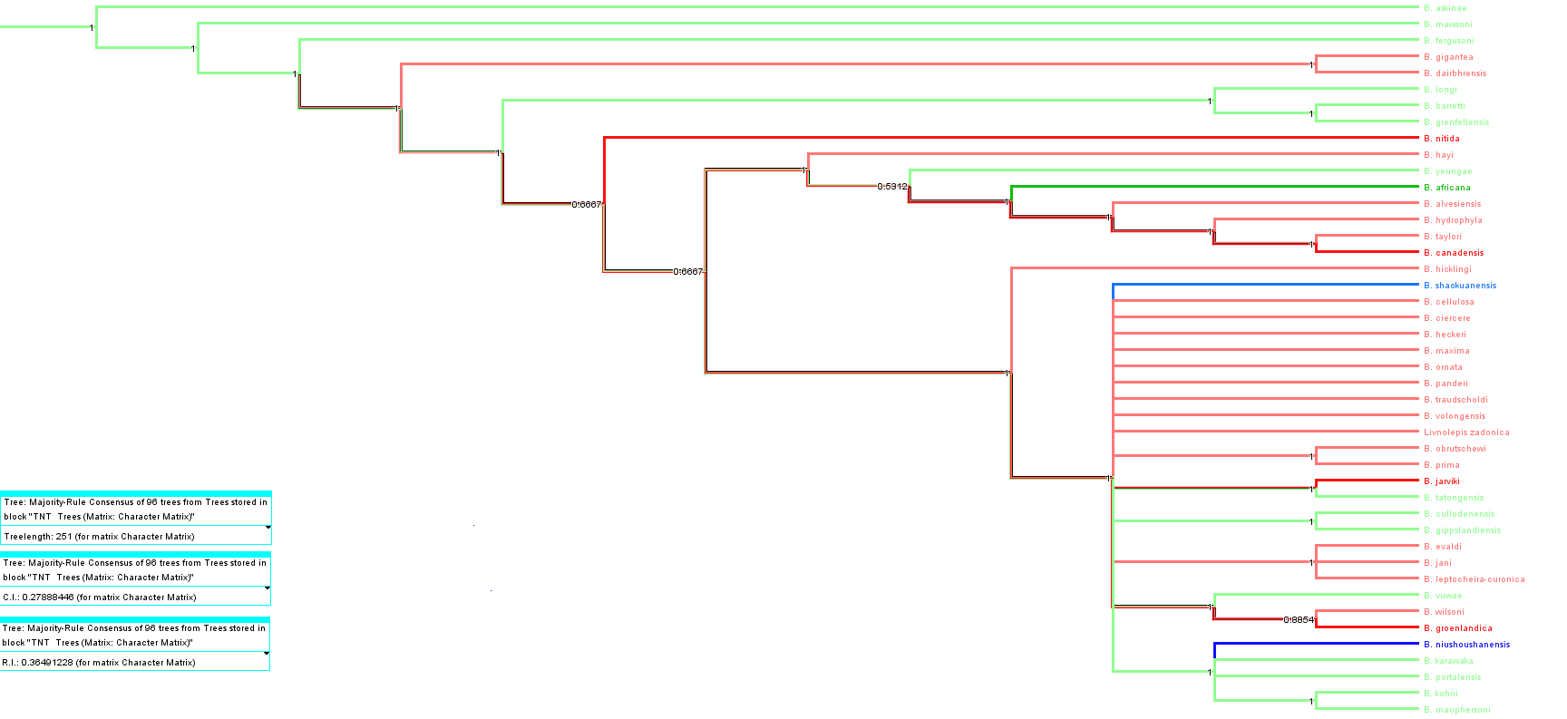
S25 Fig. Majority rule consensus tree of the phylogeny of the genus Bothriolepis using the reduced data set (50 characters * 45 taxa). Colours indicate palaeogeographic affinities of taxa (red Laurussia, green Gondwana, blue China).

------------------------

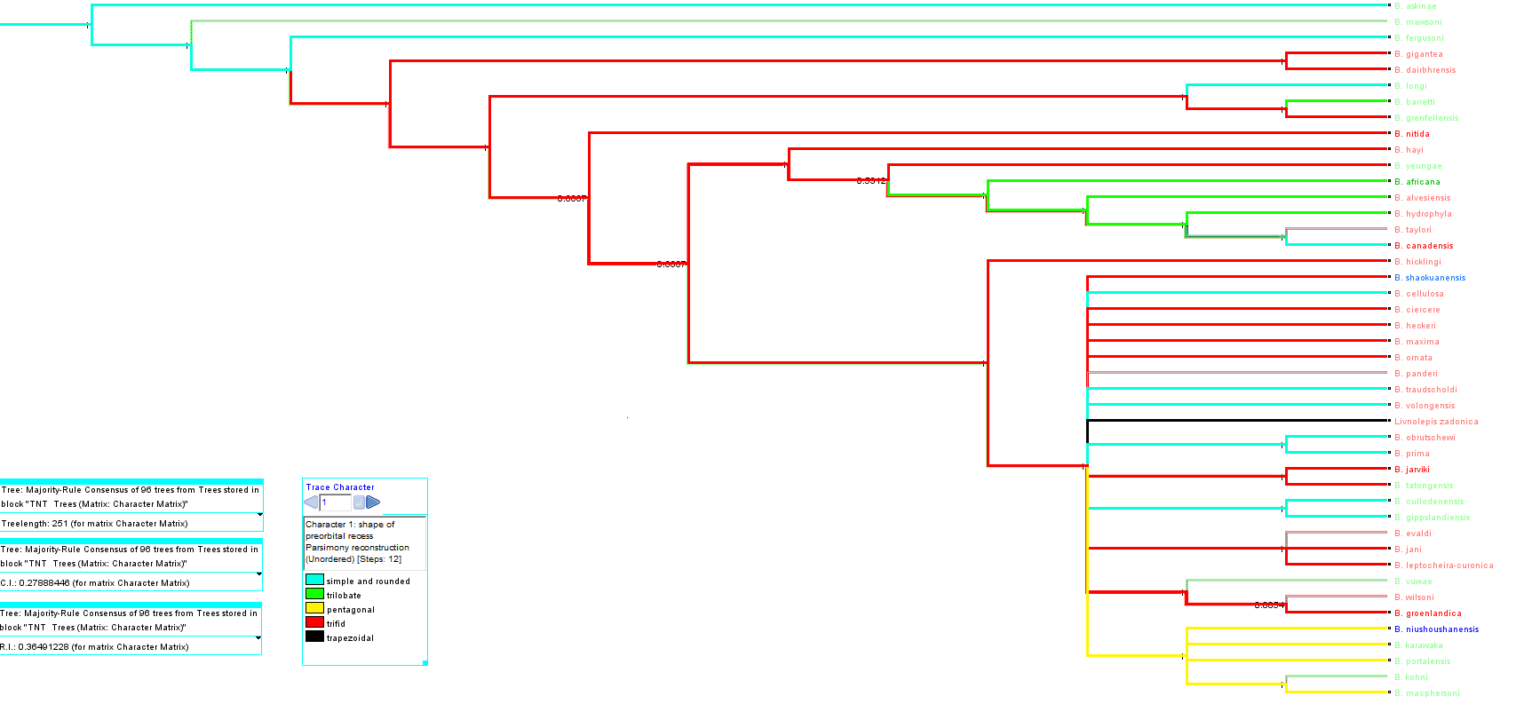
S26 Fig. Majority rule consensus tree of the phylogeny of the genus Bothriolepis using the reduced data set (50 characters * 45 taxa). Colours indicate distribution of preorbital recess shape (character #1; blue simple and rounded, green trilobate, yellow pentagonal, red trifid, black trapezoidal).

Outgroup = Remigolepis + Grossilepis + Dianolepis
Another set of analyses incorporating Dianolepis as outgroup is attempted, as this genus is supposedly close to Bothriolepis but not as close at Grossilepis (see for example [94]). The results of these analyses prove unreliable for several reasons. Firstly, in case of several outgroups, one of them at least is resolved as part of the ingroup; Secondly, most often the most basal taxa are neither Gondwana nor Chinese but Euramerican, contradicting the current fossil record succession. Thirdly, the resulting topologies of the majority rule consensus trees present impressive polytomies basally.

Complete data set (59 characters, 55 taxa)
n=10000; L=258; CI=0.326 ; RI=0.508; L₅₀=280; CI₅₀=0.300; RI₅₀=0.446.
The majority rule consensus tree is poorly resolved and shows a big basal polytomy. Dianolepis is resolved as sister group to Chinese clade, Grossilepis is resolved as sister group to B. panderi; both Grossilepis and Dianolepis are very apical in the tree.

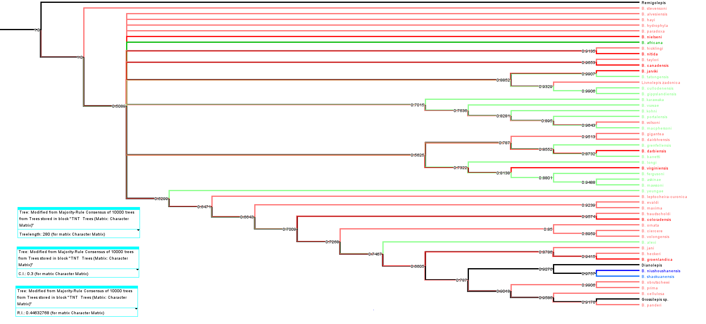
S27 Fig. Majority rule consensus tree of the phylogeny of the genus Bothriolepis, including Remigolepis, Grossilepis and Dianolepis, using the reduced data set (59 characters * 55 taxa). Colours indicate palaeogeographic affinities of taxa (red Laurussia, green Gondwana, blue China; black is outgroup).

Reduced data set (59 characters, 48 taxa)
n=8; L=257; CI=0.327; RI=0.503; L₅₀=258; CI₅₀=0.326; RI₅₀=0.500.
The majority rule consensus tree is well resolved, but the most basal branching taxa are Euramerican species. Dianolepis and Grossilepis are again very apical, but relationships are very different from the previous topology. Dianolepis is sister group with B. groenlandica, Grossilepis is sister group with B. cellulosa.

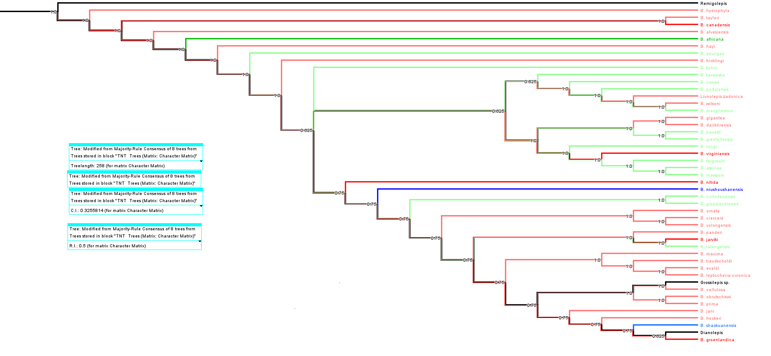
S28. Fig. Majority rule consensus tree of the phylogeny of the genus Bothriolepis, including Remigolepis, Grossilepis and Dianolepis, using the reduced data set (59 characters * 48 taxa). Colours indicate palaeogeographic affinities of taxa (red Laurussia, green Gondwana, blue China; black is outgroup).

Reduced data set (49 characters, 48 taxa)
n=534; L=246; CI=0.313; RI=0.499; L₅₀=300; CI₅₀=0.256; RI₅₀=0.338.
The majority rule consensus tree shows a basal polytomy and a few more apical ones, but the most basal branches are Gondwanan ; Dianolepis is resolved as sister group for B. barretti, and Grossilepis as sister group for B. cellulosa.

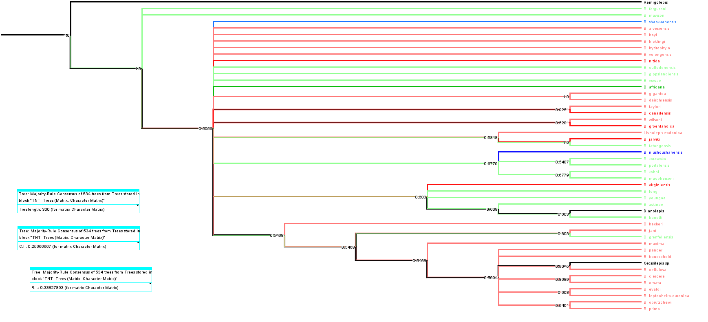
S29 Fig. Majority rule consensus tree of the phylogeny of the genus Bothriolepis, including Remigolepis, Grossilepis and Dianolepis, using the reduced data set (49 characters * 48 taxa). Colours indicate palaeogeographic affinities of taxa (red Laurussia, green Gondwana, blue China; black is outgroup).

Outgroup = Grossilepis + Dianolepis
n=332; L=233; CI=0.330; RI=0.511; L₅₀=286; CI₅₀=0.269; RI₅₀=0.345.
The majority rule consensus tree shows a basal polytomy, and the most basal branch is Euramerican; Dianolepis is unresolved in a basal polytomy; the Chinese species form a clade branching from this polytomy.

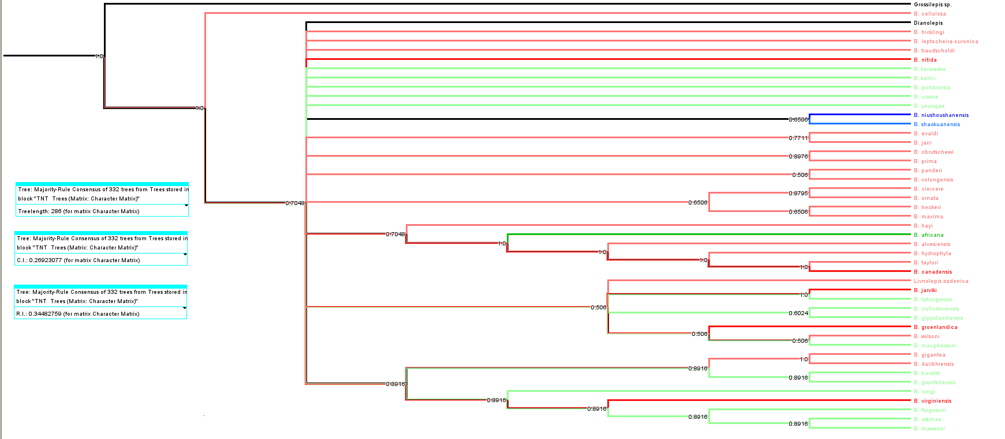
S30 Fig. Majority rule consensus tree of the phylogeny of the genus Bothriolepis, including Grossilepis and Dianolepis, using the reduced data set (49 characters * 47 taxa). Colours indicate palaeogeographic affinities of taxa (red Laurussia, green Gondwana, blue China; black is outgroup).

Outgroup = Dianolepis + Grossilepis
n=262; L=233; CI=0.330; RI=0.511; L₅₀=299; CI₅₀=0.258; RI₅₀=0.304.
The majority rule consensus tree shows a basal polytomy, and no basal branch can be identified; Grossilepis is resolved as sister group for B. cellulosa, and the clade branches from the basal polytomy; the Chinese species are scattered.

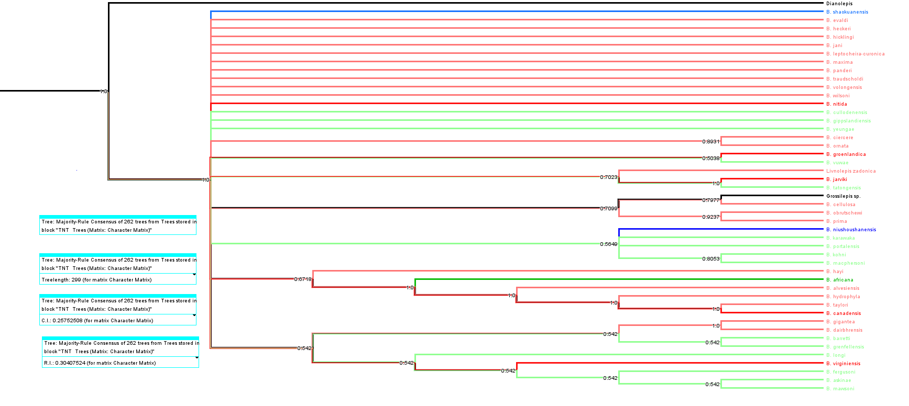
S31 Fig. Majority rule consensus tree of the phylogeny of the genus Bothriolepis, including Grossilepis and Dianolepis, using the reduced data set (49 characters * 47 taxa). Colours indicate palaeogeographic affinities of taxa (red Laurussia, green Gondwana, blue China; black is outgroup).

Outgroup = Dianolepis
n=386; L=226; CI=0.332; RI=0.505; L₅₀=295; CI₅₀=0.254; RI₅₀=0.279.
The majority rule consensus tree shows a basal polytomy, and no basal branch can be identified; Grossilepis is resolved as sister group for B. cellulosa, and the clade branches from the basal polytomy; the Chinese species are resolved as a clade branching from the basal polytomy.

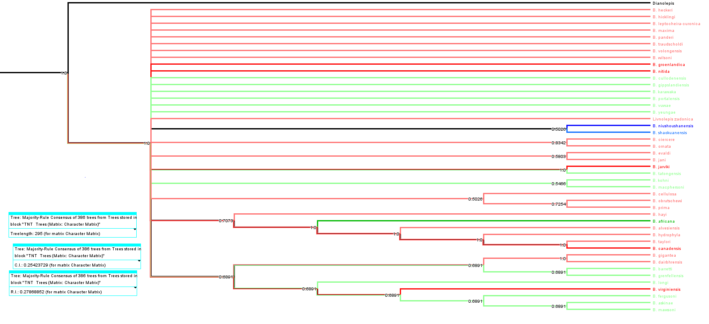 S32 Fig. Majority rule consensus tree of the phylogeny of the genus Bothriolepis, including Dianolepis, using the reduced data set (49 characters * 46 taxa). Colours indicate palaeogeographic affinities of taxa (red Laurussia, green Gondwana, blue China; black is outgroup).

Successive weighting of character “shape of preorbital recess”

indices
weight prh | n | L | CI | RI | CI_{prh} | RI_{prh} | L_{50%} | CI_{50%} | RI_{50%} | CI_{50%prh} | RI_{50%prh}
1 | 96 | 210 | 333 | 509 | 364 | 562,5 | 251 | 279 | 365 | 333 | 500
2 | 268 | 219 | 338 | 518 | 667 | 875 | 247 | 300 | 425 | 400 | 625
3 | 154 | 225 | 470 | 536 | 800 | 935 | 232 | 336 | 514 | 667 | 875
4 | 30 | 230 | 357 | 556 | 800 | 937,5 | 233 | 352 | 547 | 800 | 937,5
5 | 67 | 235 | 366 | 573 | 1000 | 1000 | 249 | 345 | 533 | 800 | 938
6 | 34 | 239 | 377 | 592 | 1000 | 1000 | 243 | 370 | 581 | 1000 | 1000
7 | 34 | 243 | 387 | 609 | 1000 | 1000 | 247 | 381 | 598 | 1000 | 1000
8 | 34 | 247 | 397 | 625 | 1000 | 1000 | 251 | 390 | 615 | 1000 | 1000
Table D: “Evolution” of indices related to the reweight of the character “shape of the preorbital recess” (all CI and RI values are multiplied by 100).

S33 Fig. “Evolution” of indices related to the reweight of the character “shape of the preorbital recess” (all CI and RI values are multiplied by 100). n, number of equiparsimonious trees; L, length of each equiparsimonious tree; CI, consistency index of each equiparsimonious tree; RI, retention index of each equiparsimonious tree; CIprh, consistency index of characters #1 for each equiparsimonious tree; RIprh, retention index of characters #1 for each equiparsimonious tree; L50, length of majority rule consensus tree; CI50, consistency index of majority rule consensus tree; RI50, retention index of majority rule consensus tree; CI50prh, consistency index of characters #1 for majority rule consensus tree; RI50prh, retention index of characters #1 for majority rule consensus tree

Topologies and distribution of states of character #1

w=2
Palaeogeographic aspect

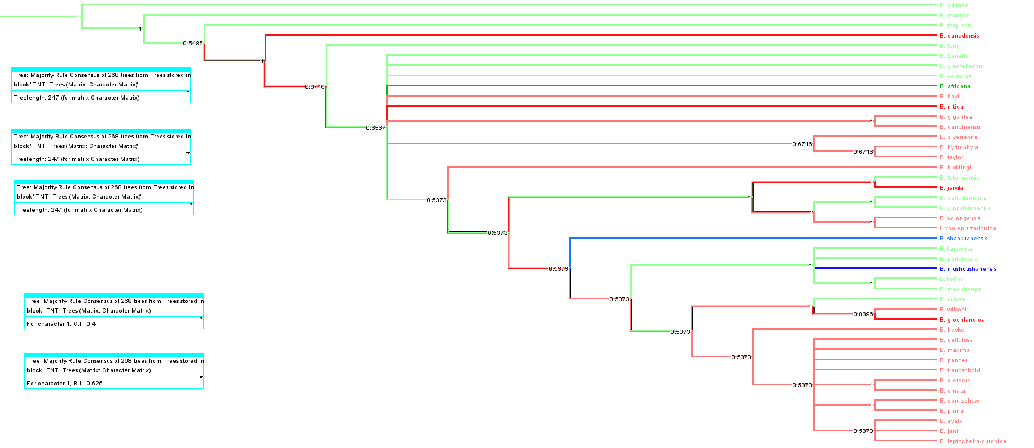
S34 Fig. Majority rule consensus tree of the phylogeny of the genus Bothriolepis using the reduced data set (49 characters * 46 taxa); reweight of character #1 = 2. Colours indicate palaeogeographic affinities of taxa (red Laurussia, green Gondwana, blue China; black is outgroup).
History of character 1

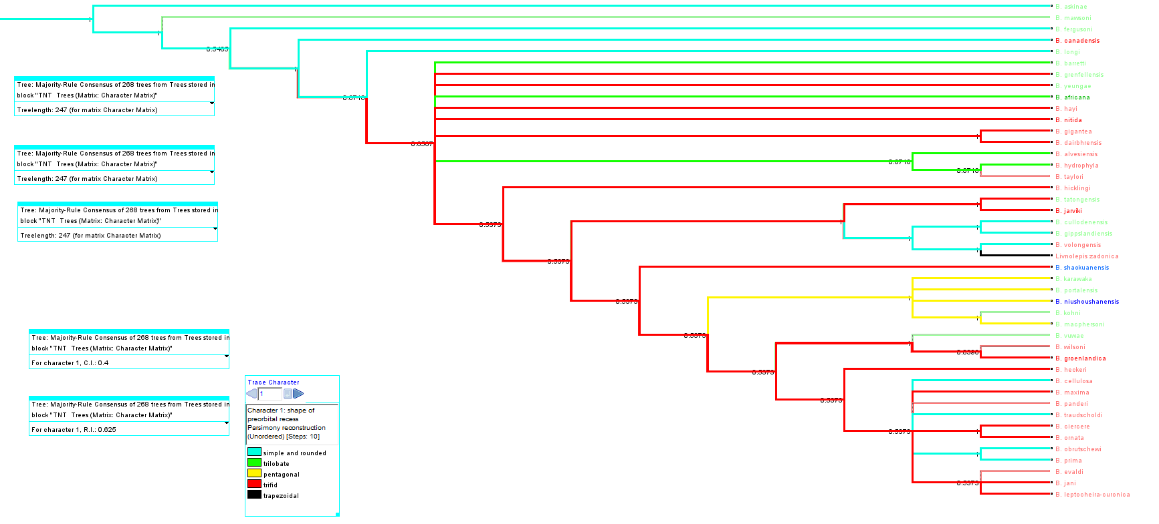
S35 Fig. Majority rule consensus tree of the phylogeny of the genus Bothriolepis using the reduced data set (49 characters * 46 taxa); reweight of character #1 = 2. Colours indicate distribution of preorbital recess shape (character #1; blue simple and rounded, green trilobate, yellow pentagonal, red trifid, black trapezoidal).

W=3
Palaeogeographic aspect
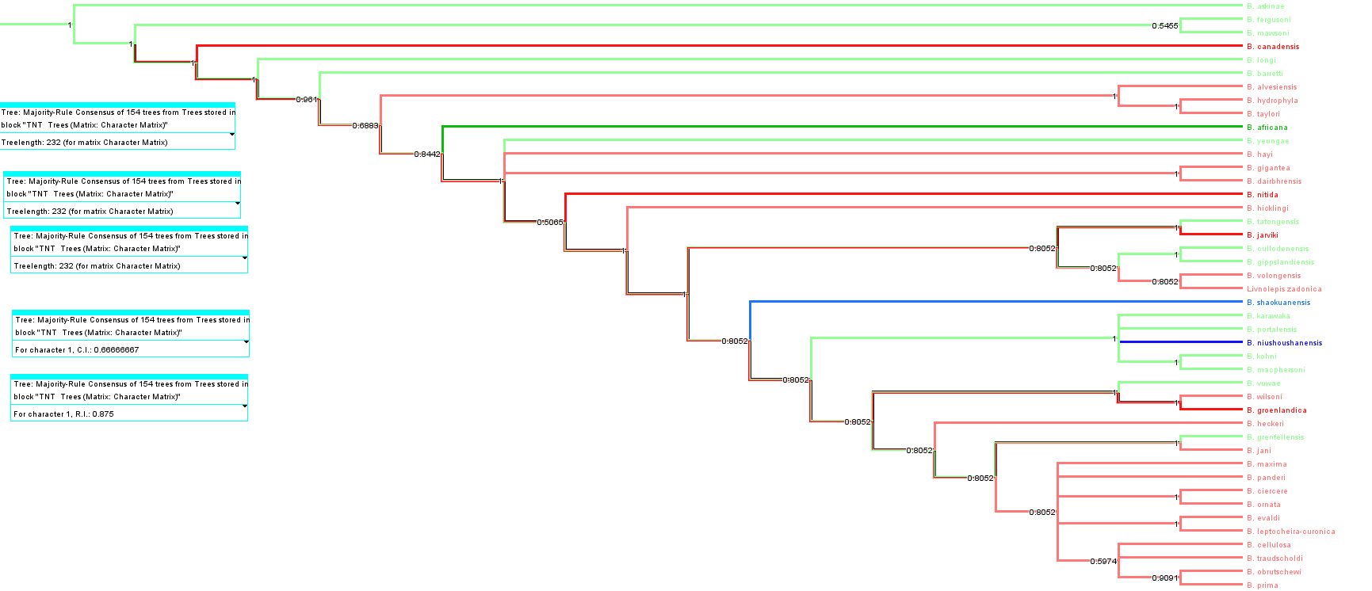
S36 Fig. Majority rule consensus tree of the phylogeny of the genus Bothriolepis using the reduced data set (49 characters * 46 taxa); reweight of character #1 = 3. Colours indicate palaeogeographic affinities of taxa (red Laurussia, green Gondwana, blue China; black is outgroup).

History of character 1

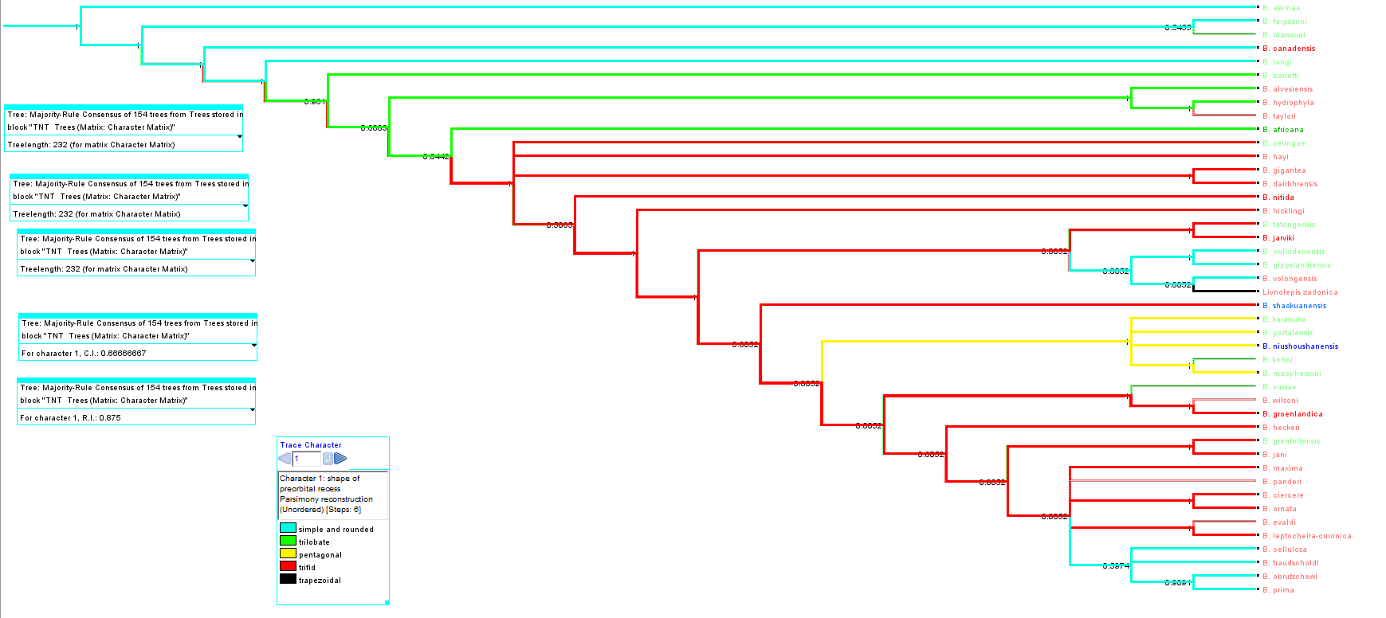
S37 Fig. Majority rule consensus tree of the phylogeny of the genus Bothriolepis using the reduced data set (49 characters * 46 taxa); reweight of character #1 = 3. Colours indicate distribution of preorbital recess shape (character #1; blue simple and rounded, green trilobate, yellow pentagonal, red trifid, black trapezoidal).

W=4
Palaeogeographic aspect
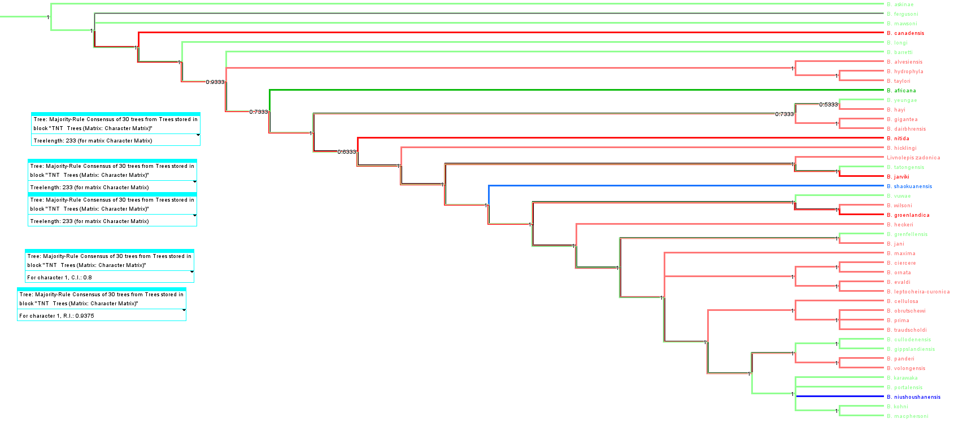
S38 Fig. Majority rule consensus tree of the phylogeny of the genus Bothriolepis using the reduced data set (49 characters * 46 taxa); reweight of character #1 = 4. Colours indicate palaeogeographic affinities of taxa (red Laurussia, green Gondwana, blue China; black is outgroup).

History of character 1
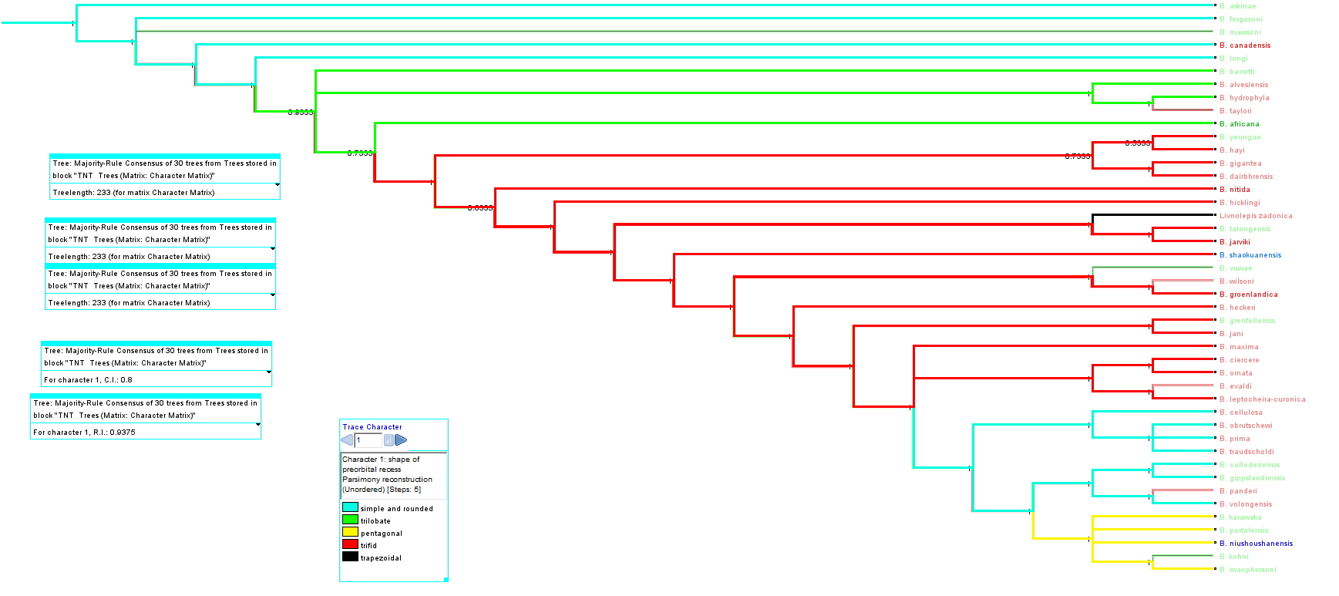
S39. Fig. Majority rule consensus tree of the phylogeny of the genus Bothriolepis using the reduced data set (49 characters * 46 taxa); reweight of character #1 = 4. Colours indicate distribution of preorbital recess shape (character #1; blue simple and rounded, green trilobate, yellow pentagonal, red trifid, black trapezoidal).

W=5
Palaeogeographic aspect
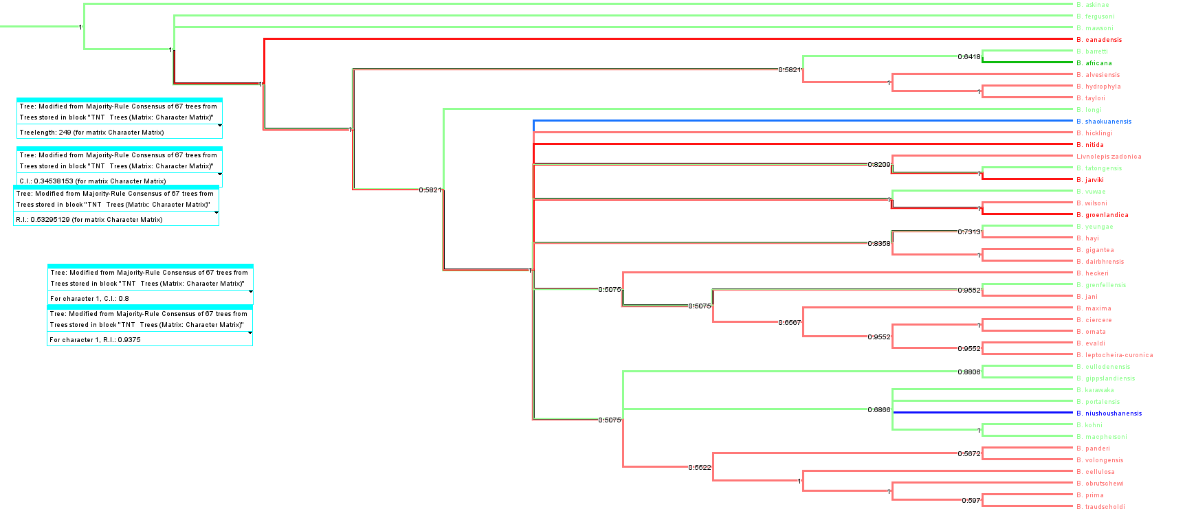
S40 Fig. Majority rule consensus tree of the phylogeny of the genus Bothriolepis using the reduced data set (49 characters * 46 taxa); reweight of character #1 = 5. Colours indicate palaeogeographic affinities of taxa (red Laurussia, green Gondwana, blue China; black is outgroup).

History of character 1
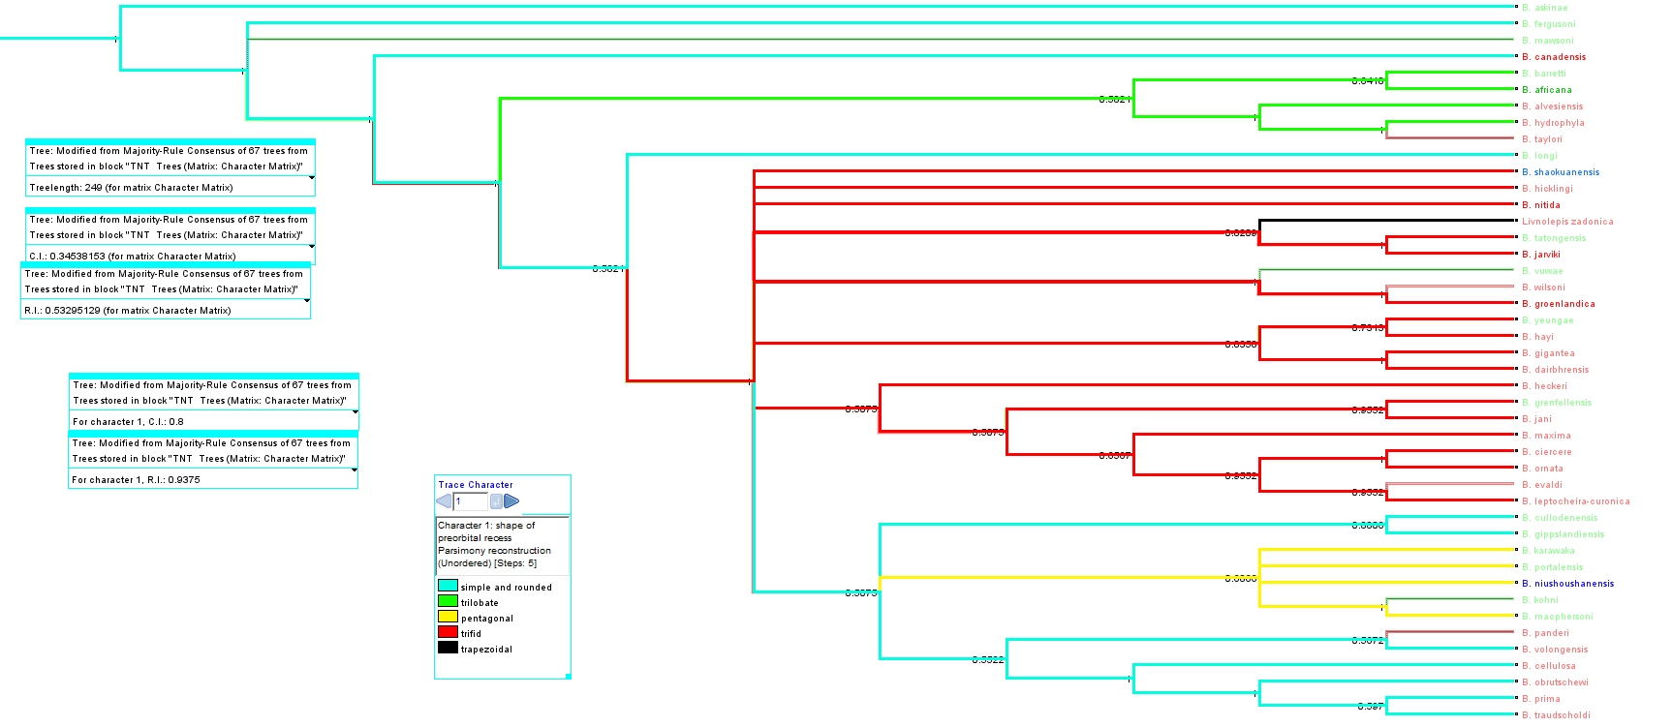
S41 Fig. Majority rule consensus tree of the phylogeny of the genus Bothriolepis using the reduced data set (49 characters * 46 taxa); reweight of character #1 = 5. Colours indicate distribution of preorbital recess shape (character #1; blue simple and rounded, green trilobate, yellow pentagonal, red trifid, black trapezoidal).

W=6
Palaeogeographic aspect
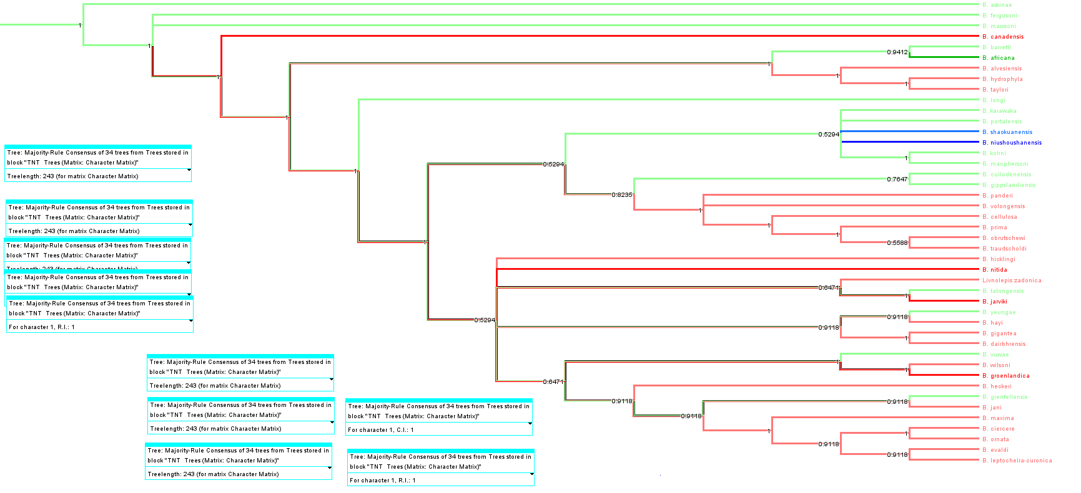
S42 Fig. Majority rule consensus tree of the phylogeny of the genus Bothriolepis using the reduced data set (49 characters * 46 taxa); reweight of character #1 = 6. Colours indicate palaeogeographic affinities of taxa (red Laurussia, green Gondwana, blue China; black is outgroup).

History of character 1
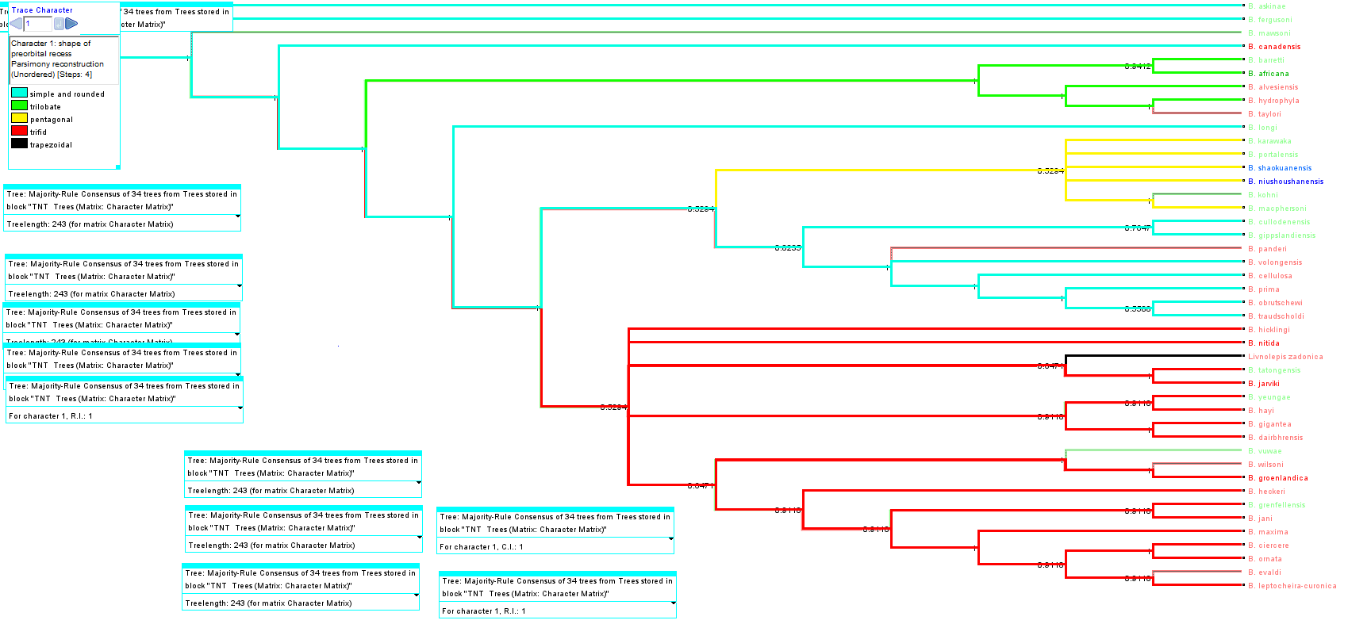
S43 Fig. Majority rule consensus tree of the phylogeny of the genus Bothriolepis using the reduced data set (49 characters * 46 taxa); reweight of character #1 = 6. Colours indicate distribution of preorbital recess shape (character #1; blue simple and rounded, green trilobate, yellow pentagonal, red trifid, black trapezoidal).

W=7
Palaeogeographic aspect
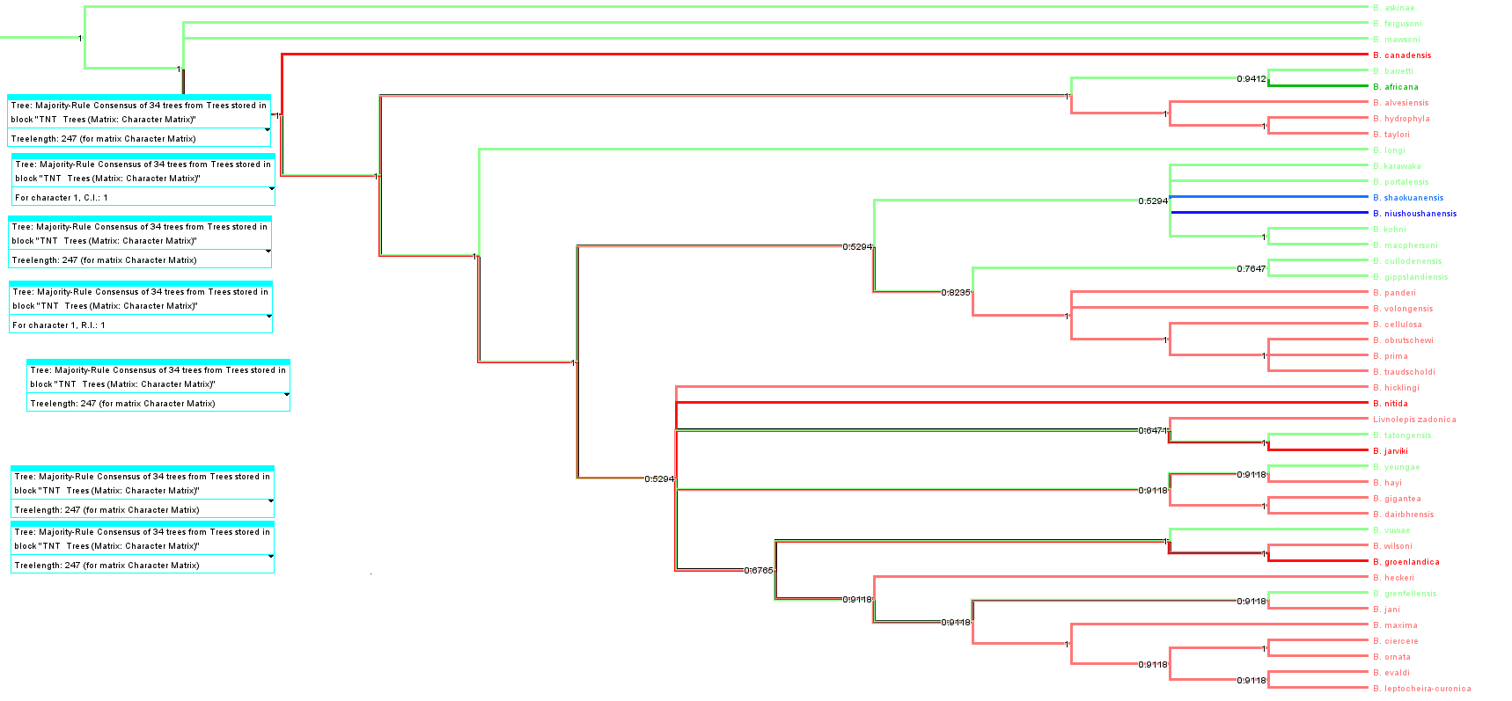
S44 Fig. Majority rule consensus tree of the phylogeny of the genus Bothriolepis using the reduced data set (49 characters * 46 taxa); reweight of character #1 = 7. Colours indicate palaeogeographic affinities of taxa (red Laurussia, green Gondwana, blue China; black is outgroup).

History of character 1
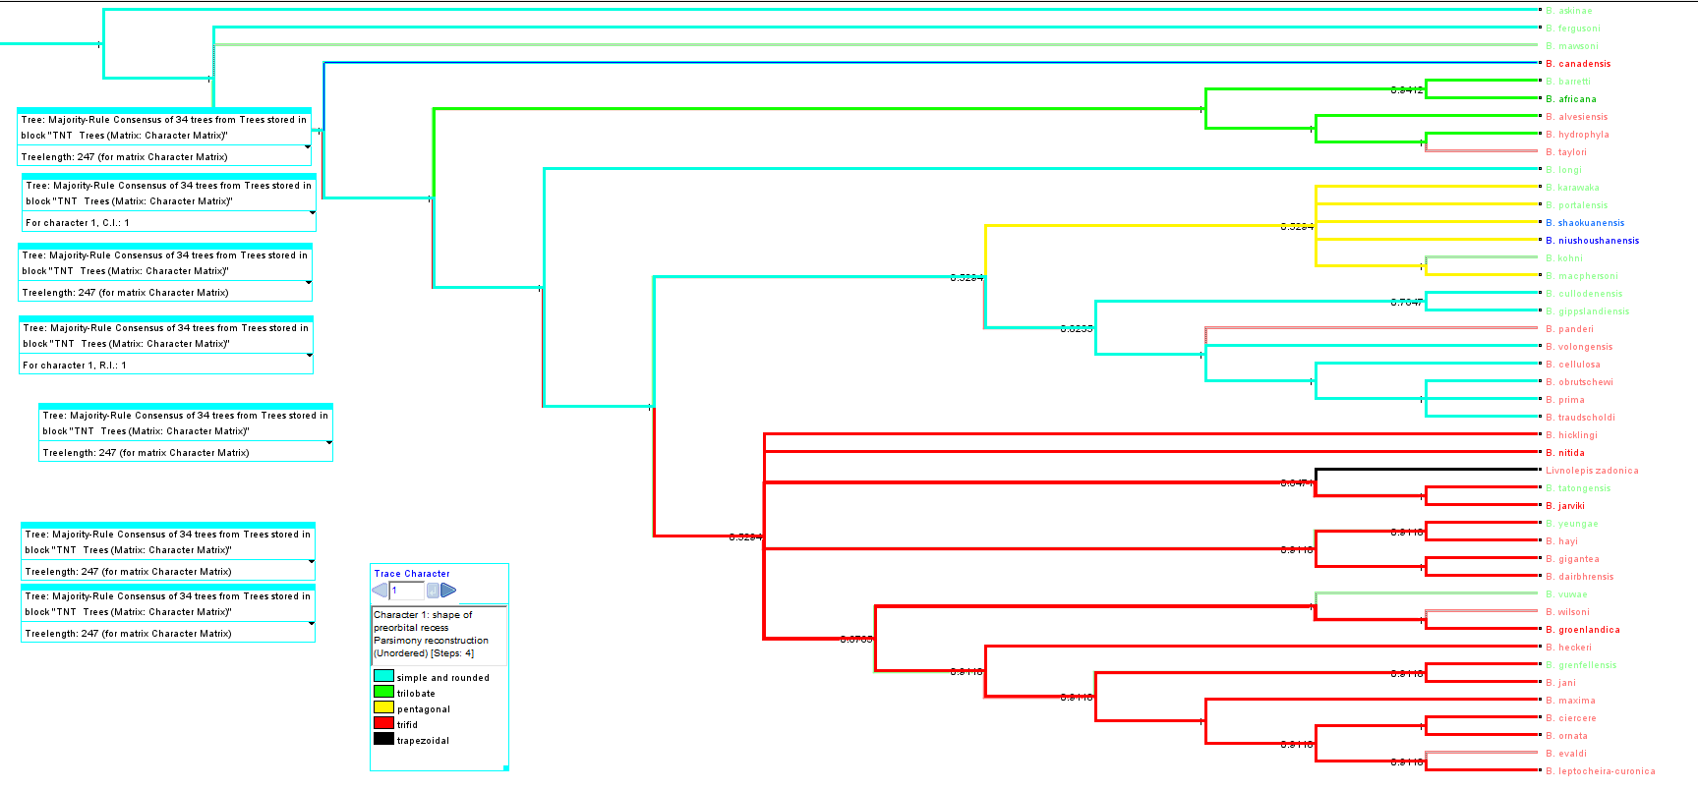
S45 Fig. Majority rule consensus tree of the phylogeny of the genus Bothriolepis using the reduced data set (49 characters * 46 taxa); reweight of character #1 = 7. Colours indicate distribution of preorbital recess shape (character #1; blue simple and rounded, green trilobate, yellow pentagonal, red trifid, black trapezoidal).

W=8
Palaeogeographic aspect
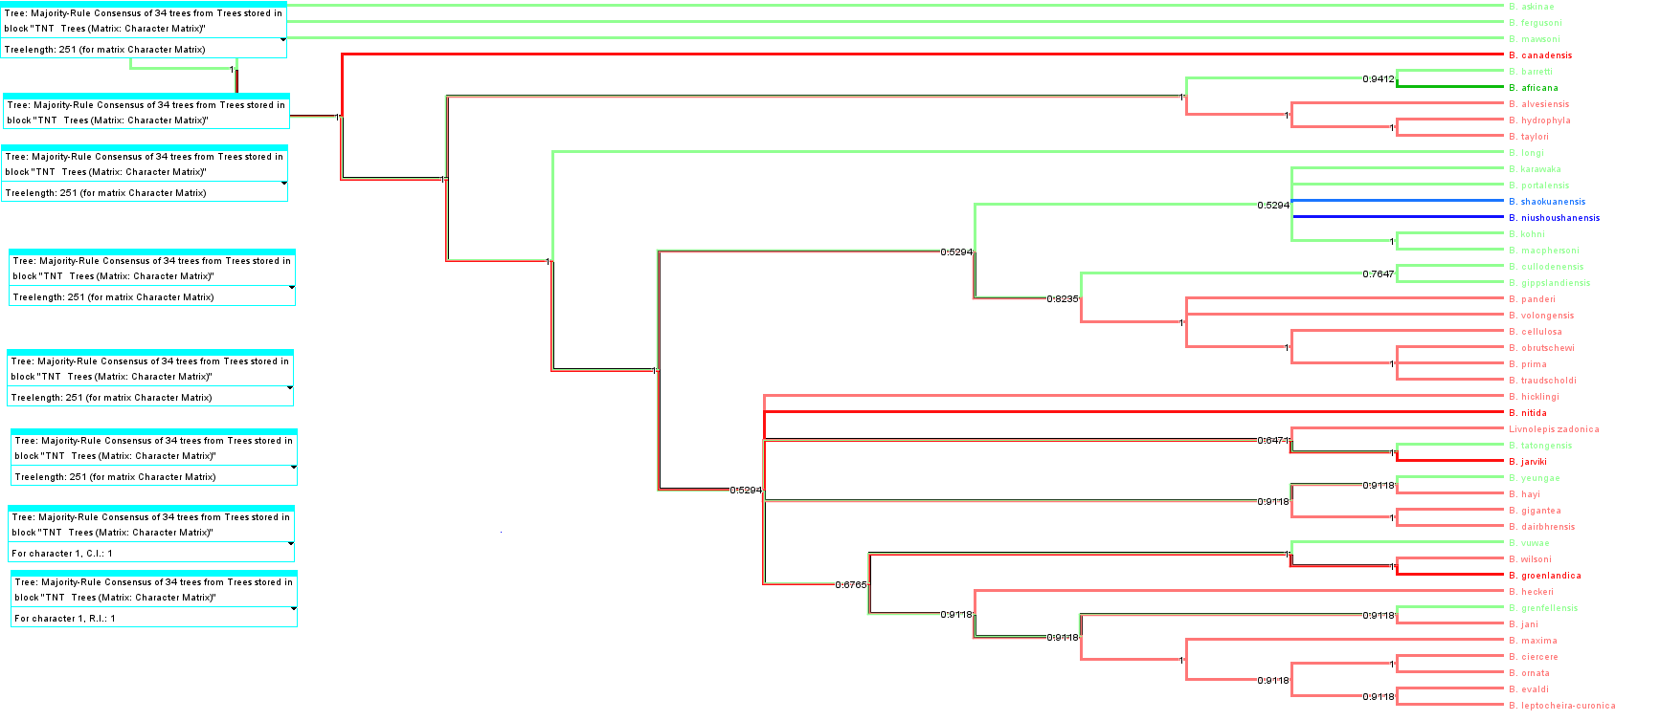
S46 Fig. Majority rule consensus tree of the phylogeny of the genus Bothriolepis using the reduced data set (49 characters * 46 taxa); reweight of character #1 =8. Colours indicate palaeogeographic affinities of taxa (red Laurussia, green Gondwana, blue China; black is outgroup).

History of character 1
–––––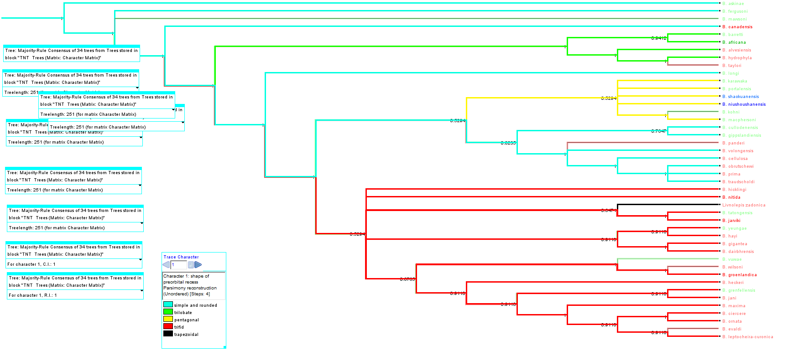
S47 Fig. Majority rule consensus tree of the phylogeny of the genus Bothriolepis using the reduced data set (49 characters * 46 taxa); reweight of character #1 = 8. Colours indicate distribution of preorbital recess shape (character #1; blue simple and rounded, green trilobate, yellow pentagonal, red trifid, black trapezoidal).

Robustness of the tree: Bremer decay index
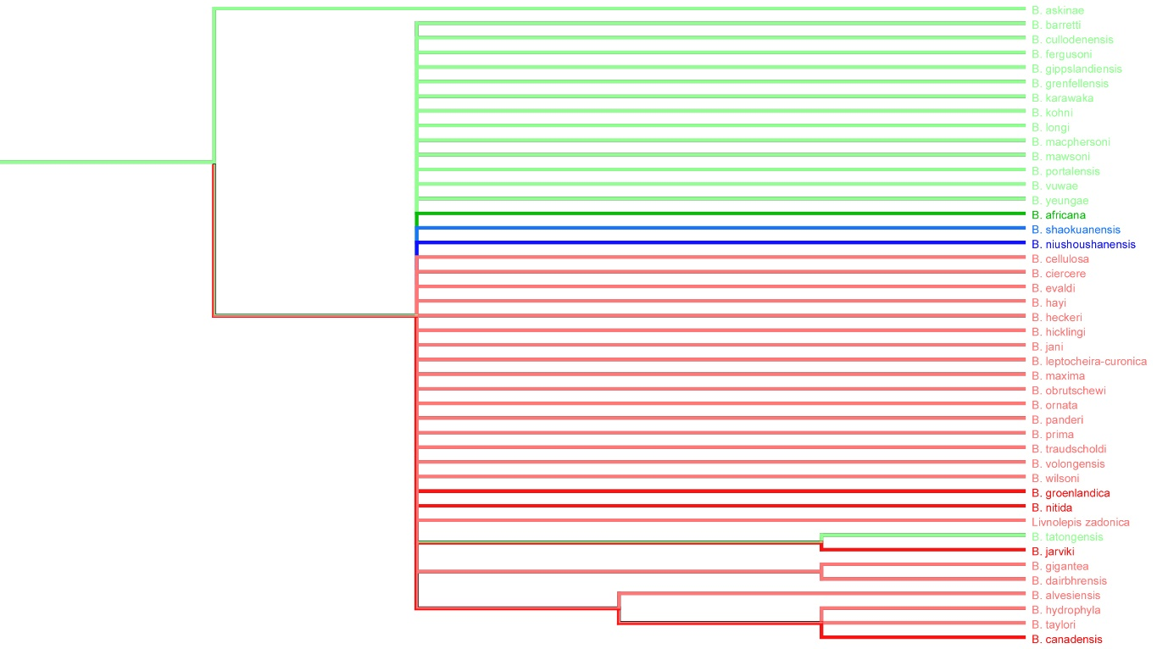
S48 Fig. Strict consensus tree of the phylogeny of the genus Bothriolepis using the reduced data set (49 characters * 46 taxa) with Bremer index BI = 1 (n = 12 629 trees). Colours indicate palaeogeographic affinities of taxa (red Laurussia, green Gondwana, blue China; black is outgroup).

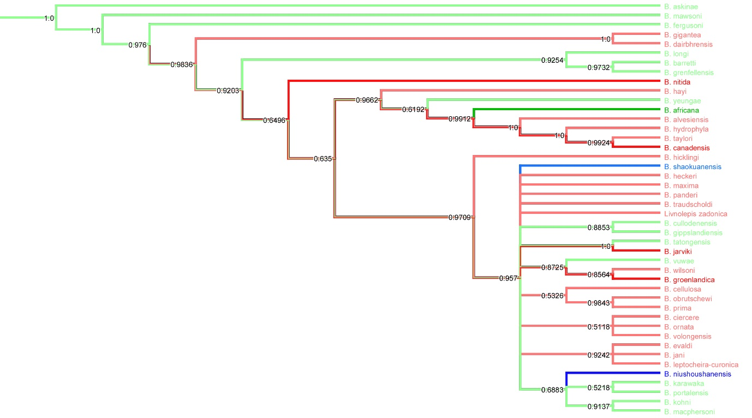
S49 Fig. Majority Rule consensus tree of the phylogeny of the genus Bothriolepis using the reduced data set (49 characters * 46 taxa) with Bremer index BI = 1 (n = 12 629 trees). Values on branches indicate retained frequency. Colours indicate palaeogeographic affinities of taxa (red Laurussia, green Gondwana, blue China; black is outgroup).

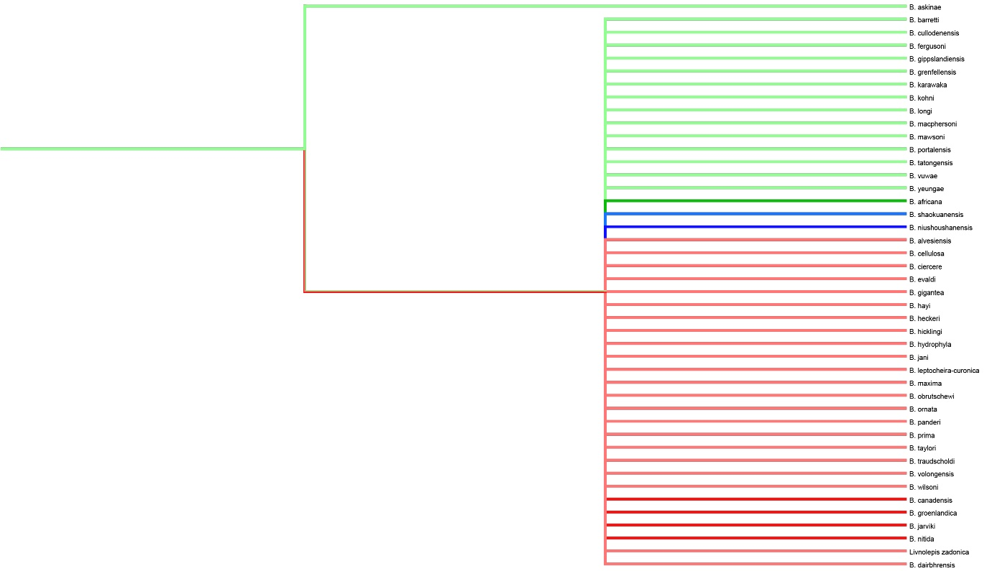
S50 Fig. Strict consensus tree of the phylogeny of the genus Bothriolepis using the reduced data set (49 characters * 46 taxa) with Bremer index BI ≥ 2 (n = 1 000 000 trees). Colours indicate palaeogeographic affinities of taxa (red Laurussia, green Gondwana, blue China; black is outgroup).

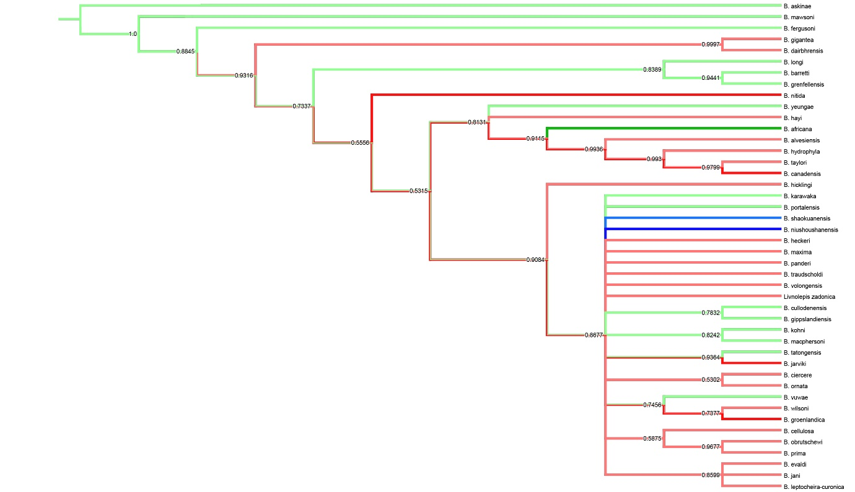
S51 Fig. Majority Rule consensus tree of the phylogeny of the genus Bothriolepis using the reduced data set (49 characters * 46 taxa) with Bremer index BI = 2 (n = 1 000 000 trees). Values on branches indicate retained frequency. Colours indicate palaeogeographic affinities of taxa (red Laurussia, green Gondwana, blue China; black is outgroup).

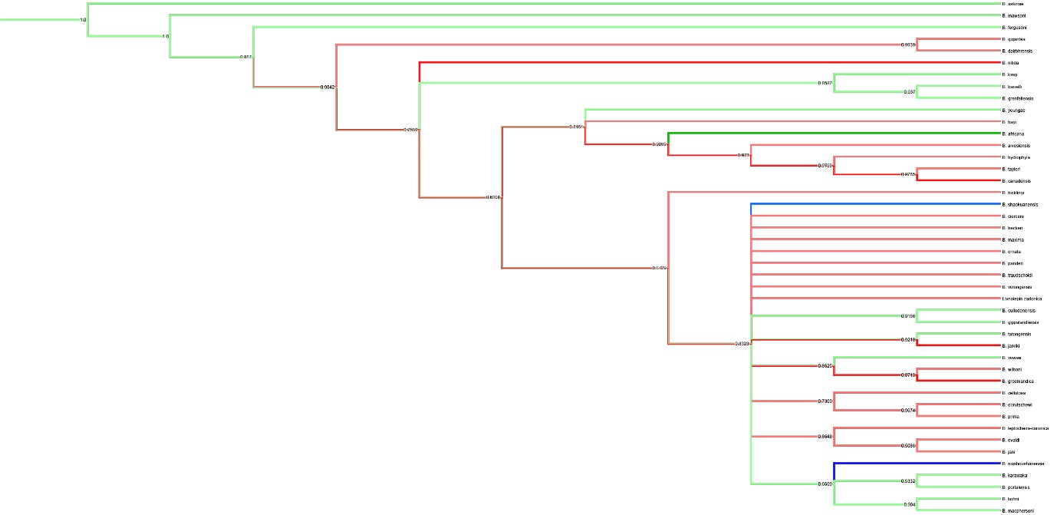
S52 Fig. Majority Rule consensus tree of the phylogeny of the genus Bothriolepis using the reduced data set (49 characters * 46 taxa) with Bremer index BI = 3 (n = 1 000 000 trees). Values on branches indicate retained frequency. Colours indicate palaeogeographic affinities of taxa (red Laurussia, green Gondwana, blue China; black is outgroup).

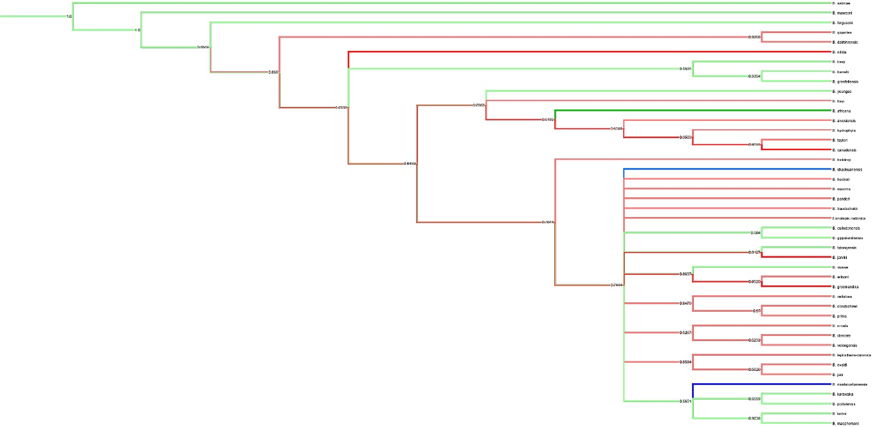
S53 Fig. Majority Rule consensus tree of the phylogeny of the genus Bothriolepis using the reduced data set (49 characters * 46 taxa) with Bremer index BI = 4 (n = 1 000 000 trees). Values on branches indicate retained frequency. Colours indicate palaeogeographic affinities of taxa (red Laurussia, green Gondwana, blue China; black is outgroup).

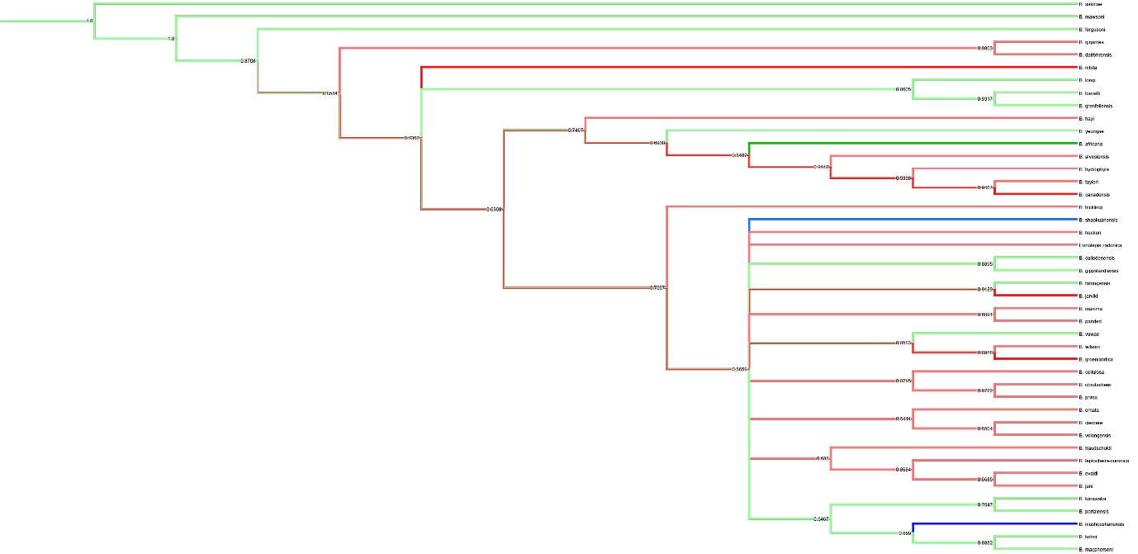S54. Fig. Majority Rule consensus tree of the phylogeny of the genus Bothriolepis using the reduced data set (49 characters * 46 taxa) with Bremer index BI = 5 (n = 1 000 000 trees). Values on branches indicate retained frequency. Colours indicate palaeogeographic affinities of taxa (red Laurussia, green Gondwana, blue China; black is outgroup).

3D pdf captions
In each 3D-pdf, it is possible to change colour of the background, as well as light intensity. Each structure can be rendered opaque, semi-transparent or invisible. Depending on your OS and viewer, you may be prompted to manually authorize opening of the file. Each element can be selected manually either in the tree or in the 3D window for identification.

NMING:F35203-UU201ab_HQ
Bothriolepis dairbhrensis sp. nov. Incomplete lateral plate (better rendering on Drishti) and fragment of indeterminate plate. Segmentation in Mimics, treatment of STLS and 3d PDF exportation in 3-matic. Scale cube edge is 10 mm

NMING:F35229-CH003
Bothriolepis dairbhrensis sp. nov. Assemblage of indeterminate plate and indeterminate scavenging gastropods. Segmentation in Mimics, treatment of STLS and 3d PDF exportation in 3-matic. Scale cube edge is 10 mm.

NMING:F35216-UUSFB001
Bothriolepis dairbhrensis sp. nov. Proximal segment of the pectoral fin, with AVL and articular condyle. [ORG] corresponds to plates in original position; [RELOC] corresponds to plates relocated in life position. Segmentation in Mimics, treatment of STLS and 3d PDF exportation in 3-matic. Scale cube edge is 10 mm.

NHM P 59677 (complete, ORG end RELOC files)
Bothriolepis dairbhrensis sp. nov. Incomplete head (and endocranial processes), ventral body armour and proximal segment of the pectoral fin. [ORG] corresponds to plates in original position; [RELOC] corresponds to plates relocated in life position. Segmentation in Mimics, treatment of STLS and 3d PDF exportation in 3-matic. Scale cube edge is 10 mm.

NHM P 59678
Bothriolepis dairbhrensis sp. nov. Incomplete lateral and indeterminate plates of an adult individual. Scale cube edge is 10 mm.

NHM P 59679
Bothriolepis dairbhrensis sp. nov. Two indeterminate fragments. Scale cube edge is 10 mm.

NHM P 59687
Bothriolepis dairbhrensis sp. nov. Indeterminate fragments and burrows. Scale cube edge is 10 mm.

References
1. Eichwald E. Die Thier- und Pflanzenreste des alten rothen Sandsteins und Bergkalks im Novogrodschen Gouvernement. Bulletin Scientifique publié par l'Académie Impériale des Sciences de Saint-Pétersbourg et rédigé par son Secrétaire perpétuel. 1840;7(6-7):78–91.
2. Denison RH. Placodermi. Schultze H-P, editor. Stuttgart, New York: Gustav Fischer Verlag; 1978. 128 p.
3. Agassiz L. Monographie des poissons fossiles du Vieux Grès Rouge ou système Dévonien (Old Red Sandstone) des Isles britanniques et de Russie: Imprimerie Petitpierre, Neuchâtel et Soleure; 1844. 171 p.
4. Agassiz L. Lettres sur les poissons fossiles du système dévonien de la Russie. In: Murchinson RI, de Verneuil PE, von Keyserling A, editors. The geology of Russia and the Ural Mountains. London and Paris1845. p. 397–418.
5. Pander C, in Keyserling, A.,. Wissenschaftliche Beobachtungen auf einer Reise in das Petschora-Land. Saint-Petersburg1846. 106 p.
6. Keyserling A. Wissenschaftliche Beobachteungen auf eiпer Reise in das Petschora-Land. Saint Petersburg1846.
7. Leidy J. Descriptions of some remains of fishes from the Carboniferous and Devonian formations of the United States. Journal of the Academy of Natural Sciences, Philadelphia 2nd Series. 1856;3(3):156–60.
8. Egerton PdMG. On a new species of Pterichthys (P. macrocephalus, Egerton), from the yellow sandstone of Farlow, Co. Salop. Quaternary Journal of the Geological Society of London. 1862;18:103–8.
9. Lahusen J. Zur Kenntniss der Gattung Bothriolepis Eichw. . Verhandlungen der Russisch-Kaiserlichen Mineralogischen Gesellschaft zu Saint-Petersburg ser 2. 1880;15:125–38.
10. Whiteaves JF. On some remarkable fossil fishes from the Devonian rocks of Scaumenac Bay, in the Province of Quebec. Journal of Natural History Series 5. 1881;8(44):159–62.
11. Traquair RH. Notes on the nomenclature of the fishes of the Old Red Sandstone of Great Britain. Geological Magazine. 1888;5(3):507–17.
12. Newberry JS. The Paleozoic fishes of North America. Washington: Government Print Off; 1889. 340 p.
13. Thomson KS, Thomas B. On the status of species of Bothriolepis (Placodermi, Antiarchi) in North America. Journal of Vertebrate Paleontology. 2001;21(4):679–86.
14. Traquair RH. On the British species of Asterolepidae. Proceedings of the Royal Physical Society of Edinburgh. 1890-92;11:283–6.
15. Traquair RH. The extinct vertebrate animals of the Moray Firth area. In: Harvie-Brown JA, Buckley TE, editors. A vertebrate fauna of the Moray Firth basin. 2. Edinburgh1895. p. 235–85.
16. Rohon JV. Die devonischen Fische von Timan in Russland. Sitzungsberichte der Königlichen Böhmischen Gesellschaft der Wissenschaften, Mathematisch-naturwissenschaftliche Classe, 1899. 1900;8:1–77.
17. Lukševičs E, Beznosov P, Stūris V. A new assessment of the Late Devonian antiarchan fish Bothriolepis leptocheira from South Timan (Russia) and the biotic crisis near the Frasnian–Famennian boundary. Acta Palaeontologica Polonica. 2017;62:97–119. doi: 10.4202/app.00265.2016.
18. Eastman CR. On upper Devonian fish remains from Colorado. American Journal of Science. 1904;4 (18)(106):253–60. doi: 10.2475/ajs.s4-18.106.253.
19. Hoffman G. Über das Ruderorgan der Asterolepiden. Palaeontographica. 1911;57:286–312.
20. Woodward AS. Fish-remains from the Upper Old Red Sandstone of Granite Harbour, Antarctica. British Antarctica ("Terra Nova") expedition, 1910 Natural history report Geology. 1921;1(2):51–62.
21. Bryant WL. A new species of Bothriolepis from the Upper Devonian of Canada. Bulletin of the Buffalo Society of Natural Sciences. 1924;13:54–5.
22. Jaekel O. Der Kopf der Wirbeltiere. Ergebnisse der Anatomie und Entwickelungsgeschichte (III Abteil der Zeitschrift die gesamte Anatomie). 1927;27:815–974.
23. Hills ES. The geology and paleontography of the Cathedral Range and Blue Hills in northwestern Gippsland. Proceedings of the Royal Society of Victoria. 1929;41(N.S.):176–201.
24. Stensiö E. Arthrodires. In: Piveteau J, editor. Traité de Paléontologie. 4. Paris: Masson; 1969. p. 71–693.
25. Young GC, Gorter JD. A new fish fauna of Middle Devonian age from the Taemas/Wee Jasper region of New South Wales. Bureau of Mineral Resources, Geology and Geophysics Bulletin. 1981;209:83–147.
26. Leriche M. Les poissons famenniens de la Belgique - Les faciès du Famennien dans la région gallo-belge - Les relations entre les formations marines et les formations continentales du Dévonien supérieur sur la bordure méridionale du Continent Nord-Atlantique. Mémoire de la Classe des Sciences de l'Académie Royale de Belgique. 1931;4(10):1–72.
27. Stensiö E. Upper Devonian vertebrates from East Greenland. Collected by the Danish Greenland Expeditions in 1929 and 1930. Meddelelser om Grønland. 1931;86(1):1–212.
28. Gross W. Die Fische des baltischen Devons. Palaeontographica Abteilung A. 1933;69:1–74.
29. Sohn IG. Bothriolepis stensiöi, a new Devonian placoderm from Gaspé, Canada. Journal of Paleontology. 1938;12(1):111–3.
30. Robertson GM. Regarding Bothriolepis stensiöi Sohn. Journal of Palaeontology. 1938;12(3):299–300.
31. Obruchev DV. Bothriolepis turanica n. sp. from Western Tian-Shan. Doklady Akademii Nauk, s s. 1939;23:115–6.
32. Chi YS. On the discovery of Bothriolepis in the Devonian of central Hunan. Bulletin of the Geological Society of China. 1940;20(1):57–72. doi: 10.1111/j.1755-6724.1940.mp20001007.x.
33. Obruchev DV. Materials on Devonian Fishes of the USSR. Trudy Paleontologicheskogo Instituta Akademii︠a︡ Nauk SSSR. 1941;8:1–48.
34. Gross W. Die Bothriolepis-Arten der Cellulosa-Mergel Lettlands. Kungliga Svenska Vetenskaps-akademiens Handlingar. 1941;19(5):1–79.
35. Stensiö E. On the Placodermi of the Upper Devonian of East Greenland. II. Antiarchi. Sub-family Bothriolepinae. With an attempt at a revision of the previously described species of the family. Palaeozoologica Groenlandica. 1948;2:5–622.
36. Gross W. Die Fischfaunen des baltischen Devons und ihre biostratigraphische Bedeutung. Korrespondenz-blatt des Naturforscher-Vereins zu Riga. 1942;64:373–436.
37. Lukševičs E. Bothriolepid antiarchs (Vertebrata, Placodermi) from the Devonian of the north-western part of the East European Platform. Geodiversitas. 2001;23(4):489–609.
38. Denison RH. Late Devonian fresh-water fishes from the Western United States. Fieldiana: Geology. 1951;11(5):221–61.
39. Obrucheva OP. Upper Devonian Fishes of Central Kazakhstan. Soviet Geology. 1955;45:84–99.
40. Malinovskaya S. Devonian bothriolepids (Placodermi) from Central Kazakhstan. Byuleten’ Moskovskogo obschestva estestvoispytateley, geologiya. 1988;63(5):56–70.
41. Sergienko AA. A new species, Bothriolepis extensa sp. n., from the Tuba Formation of the Minusinsk Depressions. Tr Sib NauchIssled Inst Geol Geofiz Miner Syr ((Data on Paleontology and Stratigraphy of Western Siberia). 1961;15:139–40.
42. Panteleyev NV, Moloshnikov S. Tubalepis gen. nov. (Placodermi, Antiarchi) from the Upper Devonian of the Minusa Depression. Paleontological Journal. 2003;37:413–6.
43. Liu Y-H. A new species of Bothriolepis from Yunnan. Vertebrata PalAsiatica. 1962;6(1):80–7.
44. Chang K-J. A new species of Bothriolepis from Kwangtung. Vertebrata PalAsiatica. 1963;7(4):342–51.
45. P'an K. Some Devonian and Carboniferous fishes from South China. Acta Palaeontologica Sinica. 1964;12:139–68.
46. Chang K-J. New antiarchs from the Middle Devonian of Yunnan. Vertebrata PalAsiatica. 1965;9(pan1):1–14.
47. Miles RS. The Old Red Sandstone antiarchs of Scotland: Family Bothriolepididae. London: Palaeontographical Society; 1968 1968. 130 p.
48. Lyarskaja L, Savvaitova L. Structure and fossil fish fauna of Ketleri Formation of Latvia. In: Sorokin VS, editor. Rgional’naya geologiya Pribaltitki [= Regional Geology of Baltic]. Riga: Zinātne; 1974. p. 90–106.
49. Pan J, Wang S-T, Liu SY, Gu QC, Hang J. Discovery of Devonian Bothriolepis and Remigolepis in Ningxia. Acta Geologica Sinica. 1980;54:176–85.
50. Young GC. Antiarchs (placoderm fishes) from the Devonian Aztec Siltstone, Southern Victoria Land, Antarctica. Palaeontographica (A). 1988;202:1–125.
51. Weems RE, Beem KA, Miller TA. A new species of Bothriolepis (Placodermi: Bothriolepidae) from the Upper Devonian of Virginia (USA). Proceedings of the Biological Society of Washington. 1981;94(3-4):984–1004.
52. Weems RE. Bothriolepis virginiensis, a valid species of placoderm fish separable from Bothriolepis nitida. Journal of Vertebrate Paleontology. 2004;24(1):245–50.
53. Long JA. New bothriolepid fish from the Late Devonian of Victoria, Australia. Palaeontology. 1983;26(2):295–320.
54. Long JA, Burrett CF, Ngan PK, Janvier P. A new bothriolepid antiarch (Pisces, Placodermi) from the Devonian of Dô Son peninsula, northern Vietnam. Alcheringa: An Australasian Journal of Palaeontology. 1990;14(3):181–94. doi: 10.1080/03115519008619054.
55. Obrucheva HD, editor New bothriolepid species from deposits of the Zadonskian Regional Stage of the Central Devonian Field. Problemy sovremennoj paleoihtiologii (Materialy konferencii,posvâŝennoj D V Obručevu); 1983; Moscow: Nauka.
56. Moloshnikov SV. Devonian antiarchs (Pisces, Antiarchi) from central and southern European Russia. Palaeontological Journal. 2008;42(7):691–773.
57. Lyarskaja L. A new Bothriolepis (Antiarchi) from the Upper Devonian of Baltic states. In: Brangulis A, editor. Biofacii i fauna siluriyskogo i devonskikh basseynov Pribaltiki [=Biofacies and Fauna of Silurian and Devonian Basins of Baltics]. Riga: Zinātne; 1986. p. 123–30.
58. Lukševičs E. A new placoderm fish (Antiarchi) from Tervete Formation of Latvia. In: Brangulis A, editor. Biofacii i fauna siluriyskogo i devonskikh basseynov Pribaltiki [=Biofacies and Fauna of Silurian and Devonian Basins of Baltics]. Riga: Zinātne; 1986. p. 131–7.
59. Long JA, Werdelin L. A new late Devonian bothriolepid (Placodermi, Antiarcha) from Victoria, with descriptions of other species from the state. Alcheringa. 1986;10(4):355–99.
60. Long JA, Anderson ME, Gess R, Hiller N. New placoderm fishes from the Late Devonian of South Africa. Journal of Vertebrate Paleontology. 1997;17(2):253–68.
61. Johanson Z. New antiarchs (Placodermi) from the Hunter Siltstone (Famennian) near Grenfell, NSW. Alcheringa. 1997;21(3):191–217.
62. Johanson Z. The Upper Devonian fish Bothriolepis (Placodermi: Antiarchi) from near Canowindra, New South Wales, Australia. Records of the Australian Museum. 1998;50(3):315–48.
63. Johanson Z, Young GC. New Bothriolepis (Antiarchi: Placodermi) from the Braidwood region, New South Wales, Australia (Frasnian). Records of the Western Australian Museum Supplement. 1999;57:55–75.
64. Lukševičs E, Sorokin VS. A new species of armored fishes of the genus Bothriolepis (Placodermi) from the Upper Devonian of North Timan. Paleontological Journal. 1999;33(4):413–9.
65. Moloshnikov SV, Linkevich VV. Late Devonian bothriolepidids (Placodermi, Antiarchi) of the Tver Oblast. Paleontological Journal. 2020;54(2):157–65. doi: 10.1134/S0031030120020100.
66. Young GC, Moody JM. A Middle-Late Devonian fish fauna from the Sierra de Perijá. Mitteilungen des Museums für Naturkunde Berlin Geowissenschaftliche Reihe. 2002;5:155–206.
67. Moloshnikov SV. A new species of bothriolepidid antiarch (Pisces, Placodermi) from the Zadonskian Regional Stage (Upper Devonian) of the Central Devonian Field. Paleontological Journal (Paleontologicheskii zhurnal). 2003;37:69–72.
68. Szrek P. The first articulated antiarch (Vertebrata, Placodermi) from the Upper Devonian of the Holy Cross Mountains (central Poland). Acta Geologica Polonica. 2004;54(3):401–6.
69. Moloshnikov SV. New data on late Devonian bothriolepidid Placoderms (Pisces, Antiarchi) from Tuva. Paleontological Journal. 2009;43(5):558. doi: 10.1134/S0031030109050128.
70. Moloshnikov SV. A new find of the placoderm genus Bothriolepis Eichwald in the Upper Devonian of Uzbekistan. Paleontological Journal. 2010;44:79–83. doi: 10.1134/S0031030110010107.
71. Downs JP, Daeschler EB, Garcia VE, Shubin NH. A new large-bodied species of Bothriolepis (Antiarchi) from the Upper Devonian of Ellesmere Island, Nunavut, Canada. Journal of Vertebrate Paleontology. 2016;36(6).
72. Scotese C, cartographer Atlas of Devonian Paleogeographic Maps, PALEOMAP Atlas for ArcGIS, volume 4, The Late Paleozoic, Maps 65-72, Mollweide Projection, PALEOMAP Project, Evanston, IL2014.
73. Scotese C. Scotese, C.R., 2014. Atlas of Neogene Paleogeographic Maps (Mollweide Projection), Maps 1-7, Volume 1, The Cenozoic, PALEOMAP Atlas for ArcGIS, PALEOMAP Project, Evanston, IL2014.
74. Scotese C, Wright N. PALEOMAP Paleodigital Elevation Models (PaleoDEMS) for the Phanerozoic PALEOMAP Project, https://www.earthbyte.org/paleodem-resourcescotese-. 2018.
75. Scotese CR. Paleogeographic Atlas, PALEOMAP Progress Report 90-0497. Arlington (Texas): University of Texas Press; 1997. 1–45 p.
76. Zhu M. Catalogue of Devonian vertebrates in China, with notes on bio-events. In: Blieck A, Turner S, editors. Palaeozoic Vertebrate Biochronology and Global Marine/Non-Marine Correlation Final Report of IGCP 328 (1991-1996). 223. Frankfurt: Courier Forschungsinstitut Senckenberg; 2000. p. 373–90.
77. Sallan LC, Coates MI. End-Devonian extinction and a bottleneck in the early evolution of modern jawed vertebrates. Proceedings of the National Academy of Sciences of the United States of America. 2010;107(22):10131–5.
78. Rogers DA. Devonian correlations, environments and tectonics across the Great Glen Fault (Unpublished PhD Thesis): University of Cambridge; 1987.
79. Becker RT, Gradstein FM, Hammer O. The Devonian Period. In: Gradstein FM, Ogg JG, Schmitz M, Ogg G, editors. The Geological Time Scale. Amsterdam: Elsevier; 2012. p. 559–601.
80. Moloshnikov SV. Middle-Late Devonian placoderms (Pisces: Antiarchi) from Central and Northern Asia. Paleontological Journal. 2012;46(10):1097–196.
81. Moloshnikov SV. Bothriolepiform antiarchs (Pisces, Placodermi) from the Devonian of Central Kazakhstan. Paleontological Journal. 2011;45(3):291–304. doi: 10.1134/S0031030111030099.
82. Lukševičs E, Zupiņš I. Sedimentology, fauna, and taphonomy of the Pavari site, Late Devonian of Latvia. Acta Universitatis Latviensis. 2004;(679):99–119.
83. Blom H, Clack JA, Ahlberg PE, Friedman M. Devonian vertebrates from East Greenland: a review of faunal composition and distribution. Geodiversitas. 2007;29(1):119–41.
84. Browne MAE, Smith RA, Aitken AM. Stratigraphical frmework for the Devonian (Old Red Sandstone) rocks of Scotland, south of a line from Fort William to Aberdeen Keyworth, Notthingham: British Geological Survey; 2002. 67 p.
85. Moloshnikov SV. Middle Devonian bothriolepiform antiarchs (Pisces, Placodermi) from central Kazakhstan and their implication for the antiarch system and phylogeny. Paleontological Journal. 2010;44:195–208. doi: 10.1134/S0031030110020127.
86. Olive S. Devonian antiarch placoderms from Belgium revisited. Acta Palaeontologica Polonica. 2015. doi: http://dx.doi.org/10.4202/app.00015.2013.
87. Trewin NH, editor. The Geology of Scotland. 4th edition ed. London: The Geological Society; 2002.
88. Janvier P, Villaroel C. Devonian vertebrates from Colombia. Palaeontology. 2000;43:729–63.
89. Stack J, Sallan L. An examination of the Devonian fishes of Michigan. PeerJ. 2018;6:e5636–e. doi: 10.7717/peerj.5636. PubMed PMID: 30258725.
90. Marsden MA. Upper Devonian Carboniferous. In Geology of Victoria, Douglas, J. G. & Fergusson J. A. eds. Special Publication, Geological Society of Australia. 1976;5:77–124.
91. Lu L-W, Tan K, Wang X. A new Antiarchi (placoderm fishes) from Devonian strata of Dushan, Guizhou Province. Acta Geoscientia Sinica. 2017;38(2):144–8.
92. Pan Z-H, Zhu M, Zhu YA, Jia LT. A new antiarch placoderm from the Emsian (Early Devonian) of Wuding, Yunnan, China. Alcheringa: An Australasian Journal of Palaeontology. 2017;42(1):10–21. doi: 10.1080/03115518.2017.1338357.
93. Moloshnikov SV. Crested antiarch Bothriolepis zadonica H.D. Obrucheva from the Lower Famennian of Centrak European Russia. Acta Geologica Polonica. 2004;49(1):135–46.
94. Wang Y-J, Zhu M. Redescription of Phymolepis cuifengshanensis (Antiarcha: Yunnanolepididae) using high-resolution computed tomography and new insights into anatomical details of the endocranium in antiarchs. PeerJ. 2018;6:e4808. doi: 10.7717/peerj.4808.

