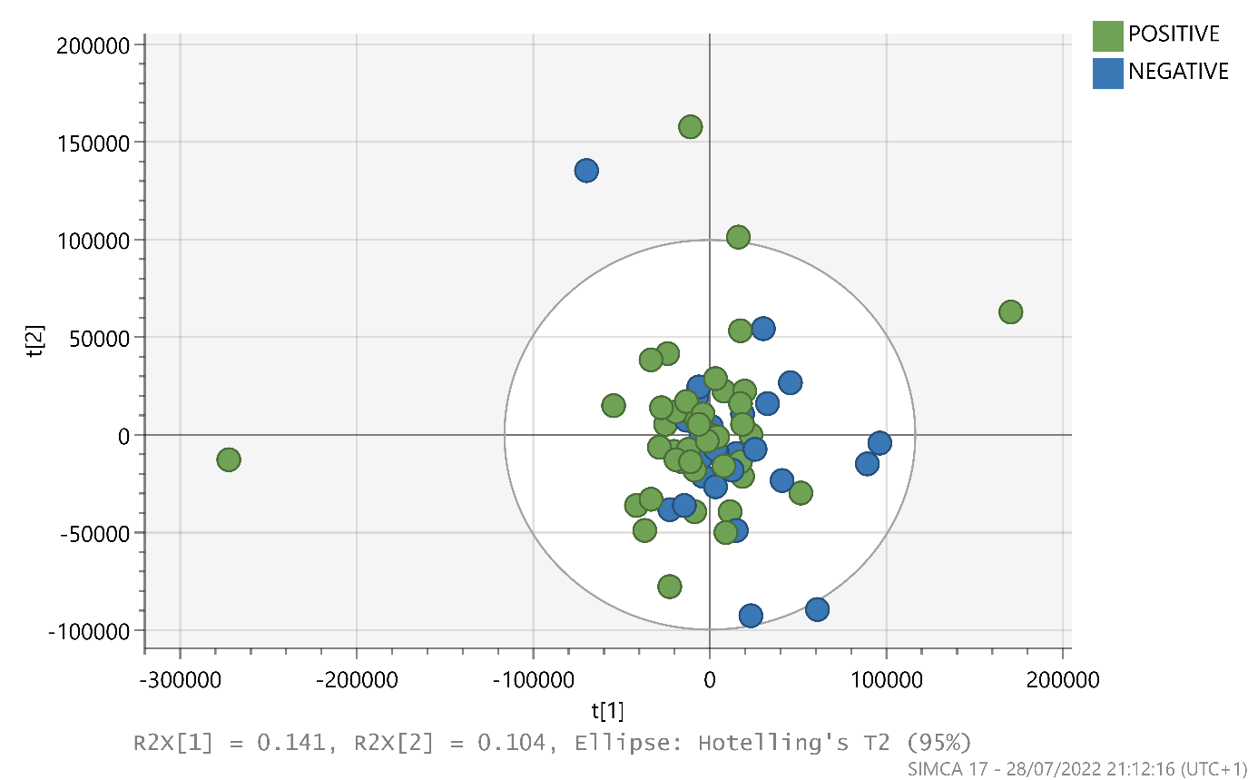
S3 Fig: Principal Component Analysis for 75 participants and 324 features, COVID-19 positive / negative, LC-MS analysis in positive mode.

