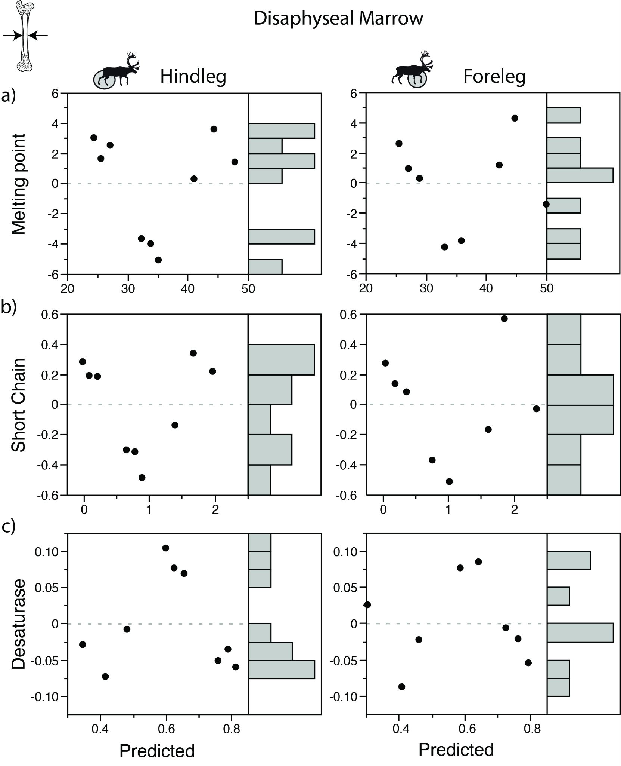

Fig. S2. Plots of residuals for the relationship between fatty acid (FA) parameters and sample distance in the diaphyseal marrow of caribou (linear model): a) weighted melting point (in °C); b) percentage of short chain saturated FA; c) Δ⁹ desaturase index. Melting point and FA values calculated as in Fig. 3. The plots correspond to the mean for the two individuals. Distance data from Fig. S1, melting point and FA data from Table 2.

