Supporting Information 1: Tables and Figures
Demographic Information
Participants reported:

Brexit identity (frequencies reported in main text).
Gender and age (descriptive statistics reported in main text).
Whether English was their first language: 98% said “yes”, “2%” said no.

Table S1. Highest level of education completed.
Education Level | Percentage of sample
No formal qualifications | 0.33%
Secondary education (e.g. GED/GCSE) | 12.69%
High school diploma / A-levels | 12.91%
Technical/community college | 12.47%
Undergraduate degree (BA/BSc/other) | 40.78%
Graduate degree (MA/MSc/MPhil/other) | 18.33%
Doctorate degree (PhD/other) | 2.39%
Don't know / not applicable | 0.11%
Table S2. Previous meditation experience.
Frequency of meditation practice | Percentage of sample
Daily | 2.93%
Four to six times per week | 3.04%
Two to three times per week | 6.62%
Once per week | 5.21%
Two to three times per month | 8.57%
Once per month | 14.75%
Never | 58.89%
Table S3. Equipment used to listen to the audio clip (i.e. the intervention).
Equipment | Percentage of sample
Headphones | 65.40%
Speakers | 33.95%
Other | 0.65%

S1 Fig. Perceived commonality with the political outgroup (presented to Leavers).
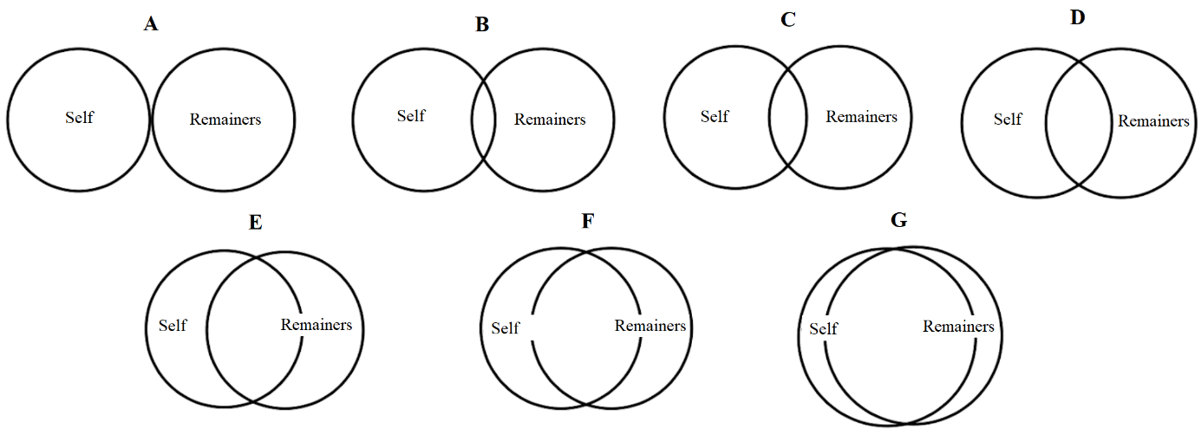

S2 Fig. Perceived commonality with the political outgroup (presented to Remainers).

