S2 Fig. Survival curves limited to 3-years post discharge stratified by year group (solid lines) compared to the matched standard Australian population (dotted lines).
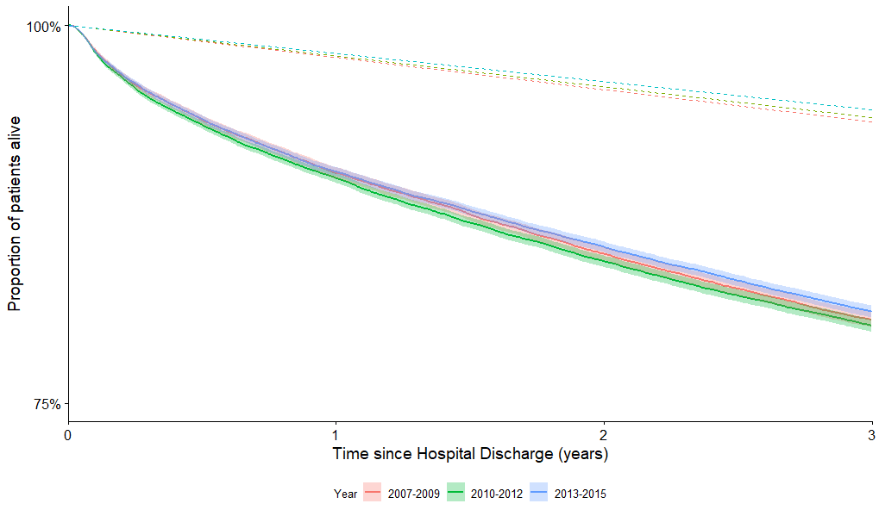
Year period | Study Cohort (95% CI) 3-year survival | Difference from baseline | Matched Cohort 3-year survival | Difference from baseline
2007 – 2009 | 80.5% (80.0% - 81.0%) | Baseline | 97.9% | Baseline
2010 - 2012 | 80.1% (79.7% - 80.5% | -0.4% | 98.0% | +0.1%
2013 - 2015 | 81.0% (80.6% - 81.4%) | +0.5% | 98.1% | +0.2%

Follow-up is only 3-years post hospital discharge to allow comparison between each year period. Three-year period groups were created to facilitate simple comparisons.

