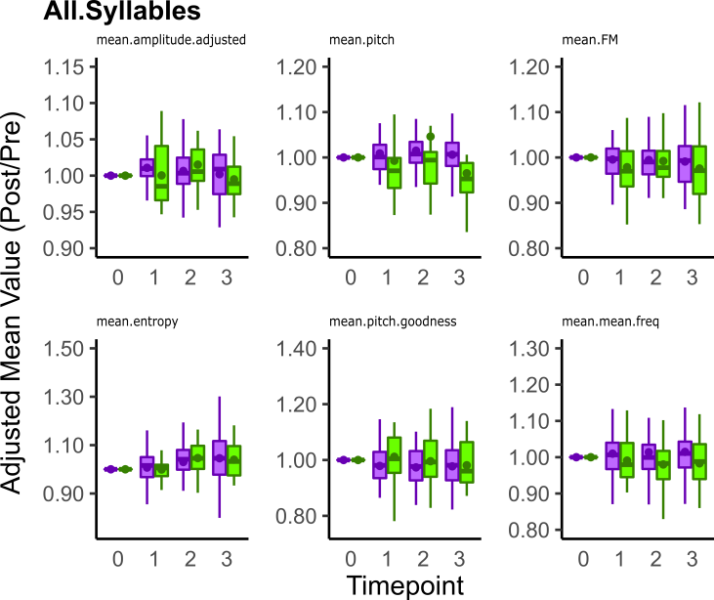
S6. Mean acoustic feature scores for all syllables that are not affected by αsyn overexpression. Remaining acoustic features whose scores are not affected significantly by αsyn overexpression. Reference Fig 7’s legend for explanation of boxplots. Statistical comparisons were made using a Wilcoxon Rank Sum Test.

