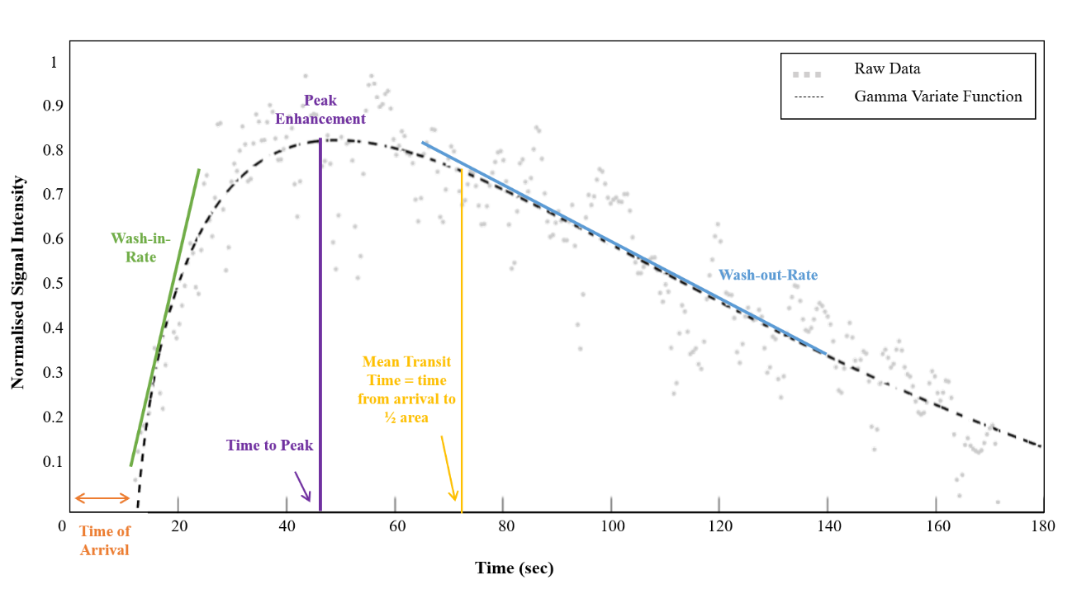
S1 Fig. Example of MB kinetics profile in a tumour obtained by US imaging. The Power Doppler, clutter-filtered images were used to segment the tumour and the global mean time intensity curve (TIC) of the MB enhancement was used to fit a gamma-variate function. This model enables extraction of biologically relevant parameters such as wash-in and wash-out rates, time of arrival, peak enhancement and time to peak, and the mean transit time that corresponds to the time for which the area under the curve is ½ of its total value.

