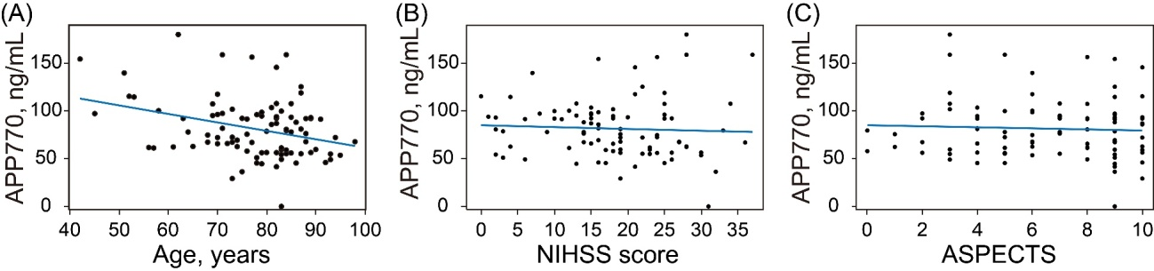
S4 Fig. Association between the level of APP770 and patients characteristics
The levels of APP770 were negatively correlated with age (r = -0.32, P = 0.002). Among patients who achieved successful reperfusion at 24 ± 12 hours after admission, the levels of APP770 were higher in patients with a midline shift ≥ 5 mm than in those without (75 ± 26 vs. 118 ± 41 ng/mL, P = 0.003).

