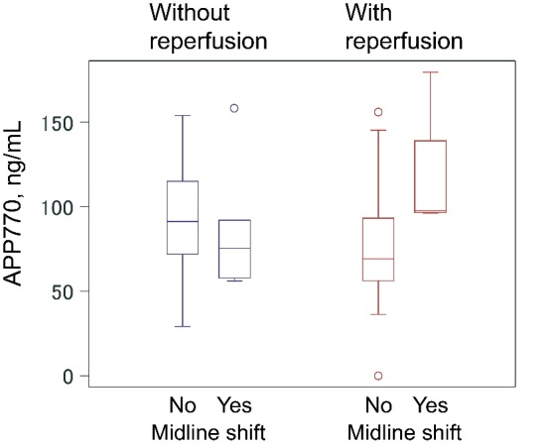
S3 Fig. Association between brain edema and serum APP770 according to the presence or absence of successful reperfusion
Among patients who achieved successful reperfusion, the levels of APP770 were higher in patients with midline shift than in those without (75 ± 26 vs. 118 ± 41 ng/mL, P = 0.003).

