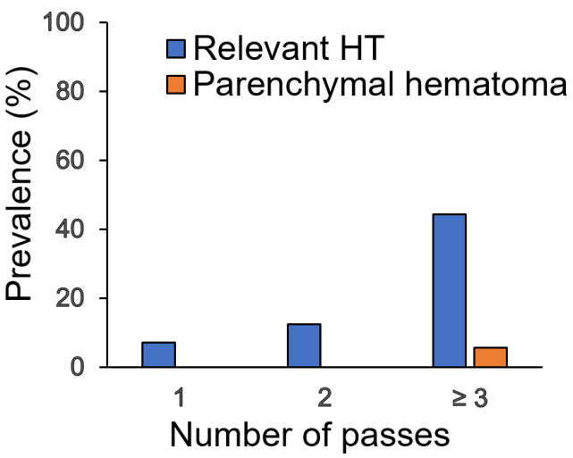
S2 Fig. Association between hemorrhagic transformation and number of device passes
Patients who underwent ≥3 passes had more relevant hemorrhagic transformation than those with <3 passes (44% vs. 8%, P = 0.004).
HT, hemorrhagic transformation.

