S1 File
NMR spectra of compounds 3 and 4

Figure S1: Key HSQC cross peaks observed in the spectrum of compound 3, and their assignment as recorded in CDCl3
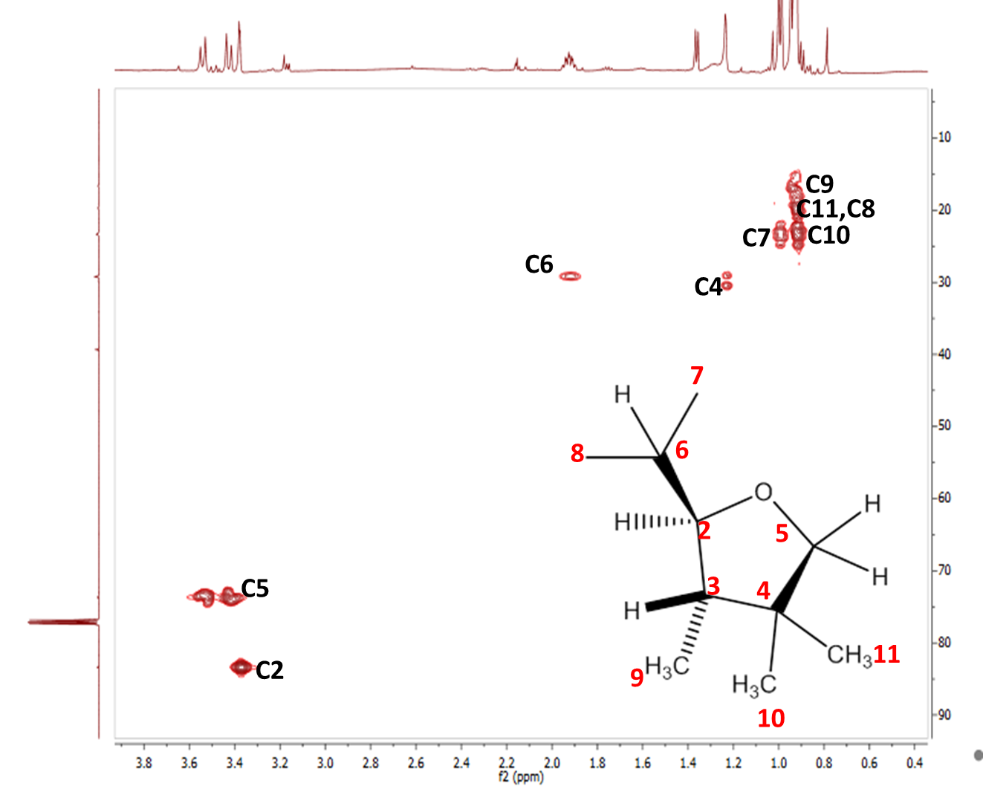

Figure S2: Key cross peaks identified in the HMBC spectrum and key H-C correlations for compound 3 recorded in CDCl3

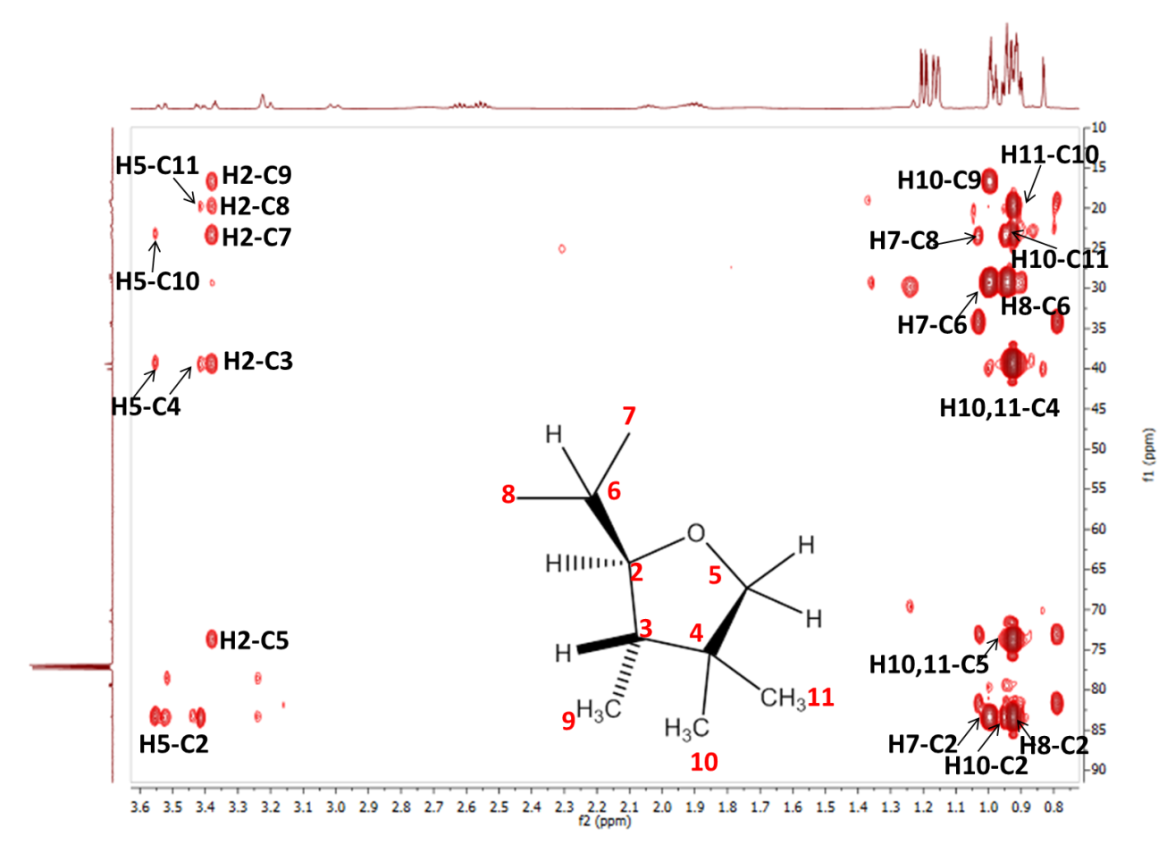
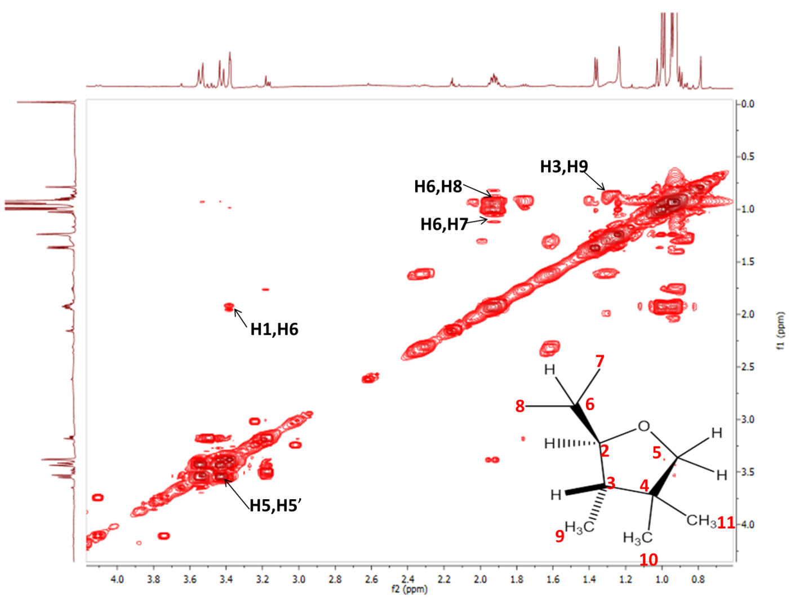
Figure S3: Key H-H correlations in the COSY spectrum of compound 3 recorded in CDCl3

Figure S4: KEY cross peaks in the HSQC spectrum of compound 4 recorded in CDCl3
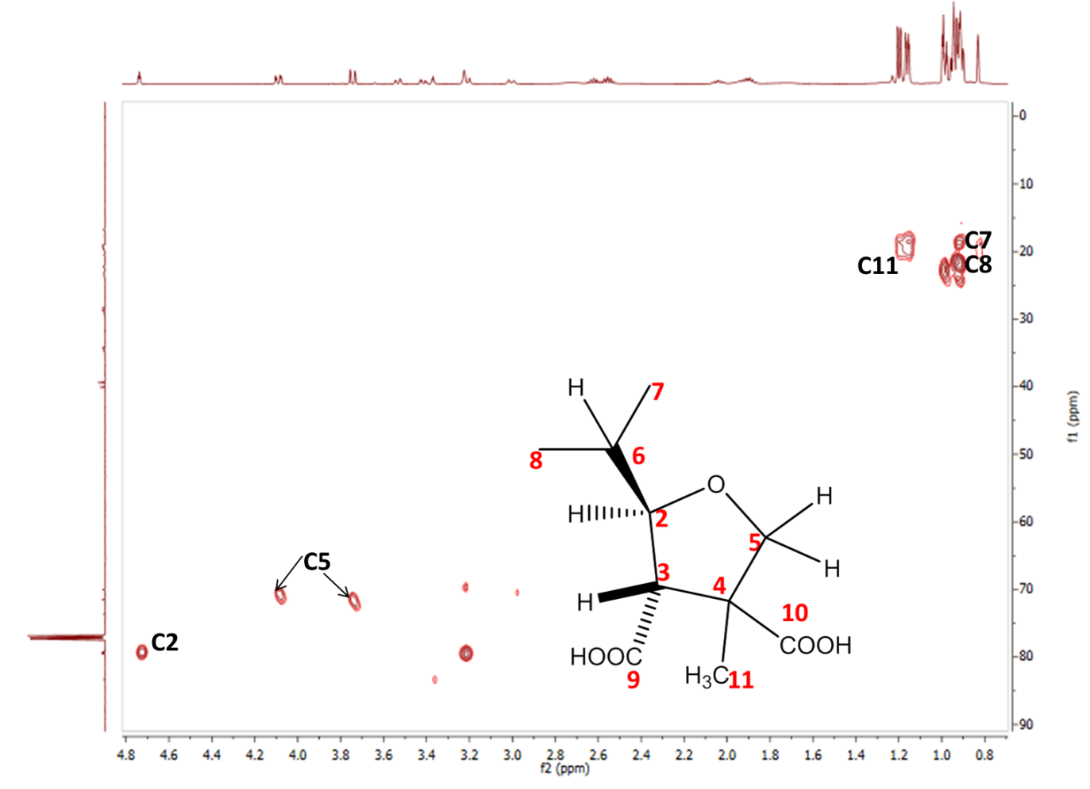
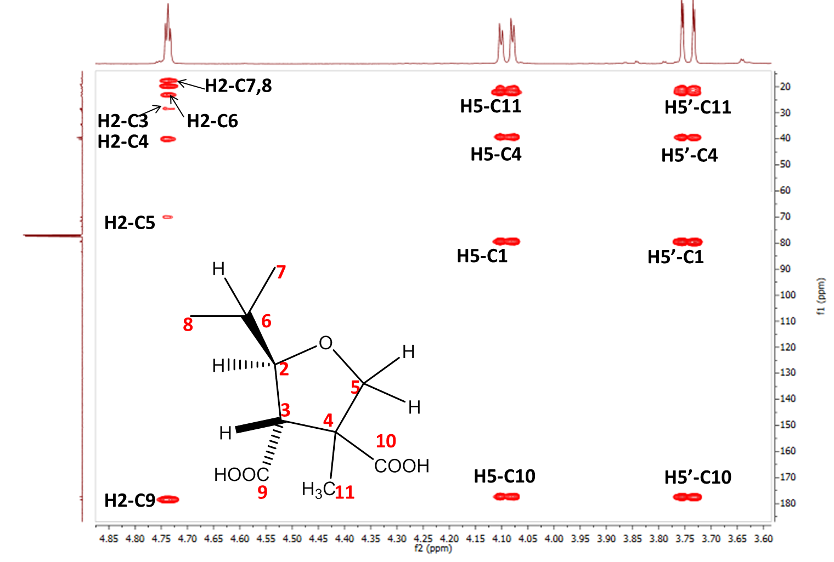
Figure S5: Key cross peaks in the HMBC spectrum of compound 4 recorded in CDCl3

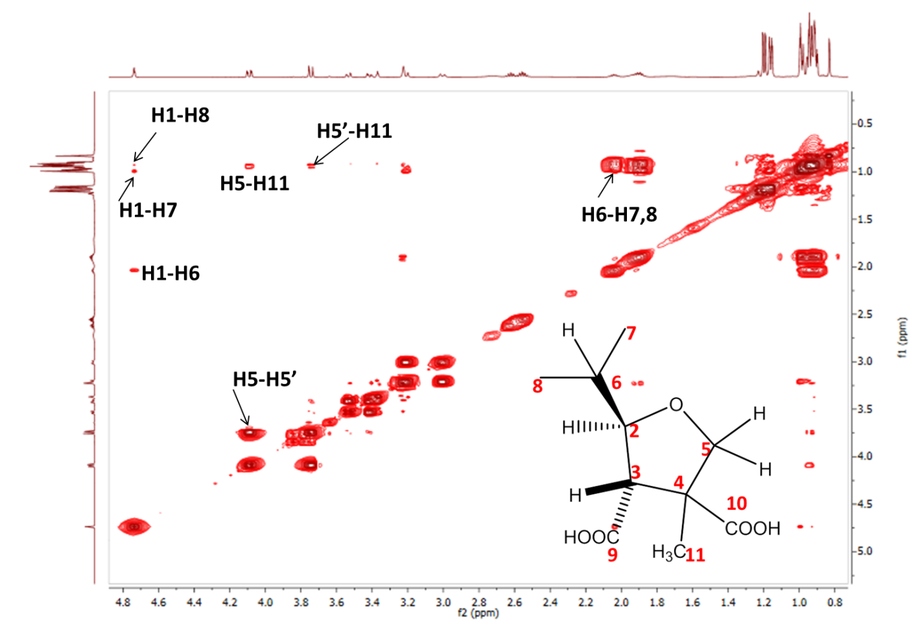
Figure S6: key H-H correlation in the COSY spectrum of compound 4 observed in CDCl3

