Supplementary Material
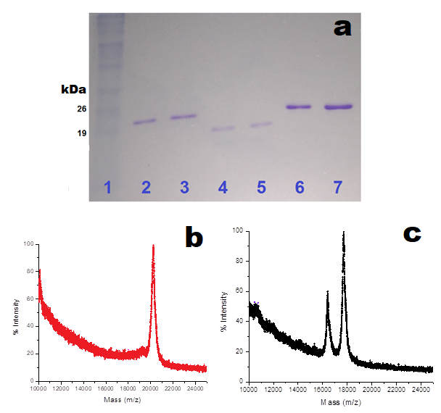
Fig. S1. a) 12% SDS Polyacrylamide gel electrophoresis (SDS-PAGE). Lane 1: Protein Ladder, lanes 2 and 3: BMV CP wild type, lanes 4 and 5 N-terminus cleaved BMV CP and lanes 6 and 7 BMV CP wild type, (the gel was stained with Coomassie Blue). Mass spectrum of b) BMV CP wild type and c) N-terminus cleaved BMV.

