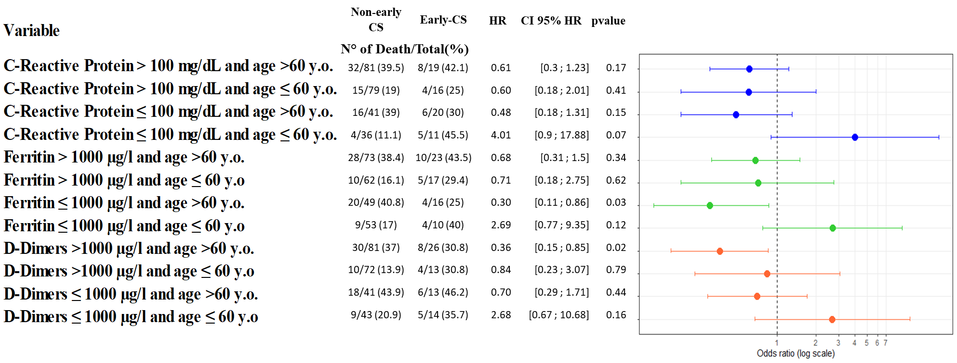
S6 Figure: Subgroup analyses based on C-Reactive protein, Ferritin, and D-Dimer levels and interaction with age.

