Supplementary material to: An evaluation of contralateral hand involvement in the operation of the Delft Self-Grasping Hand, an adjustable passive prosthesis

Self-grasping hand dimensions
All measurements were taken whilst wearing a silicone glove which prevented the thumb from remaining in a fully abducted position (the elasticity of the glove reduced the abduction by 10-15°). Thumb abducted – Hand fully open
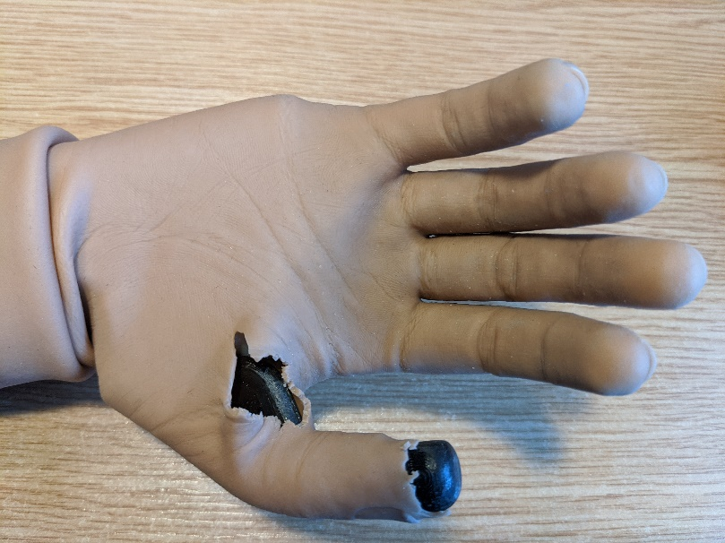
A: Tip of middle finger to base of hand = 14cm
B: Tip of thumb to tip of index finger = 4cm
C: Tip of thumb to tip of little finger = 7cm
D: Base of thumb (excluding web) to base of little finger = 7cm
E: Width of palm = 7cm

A
B
C
D
E
Thumb abducted – Hand fully closed
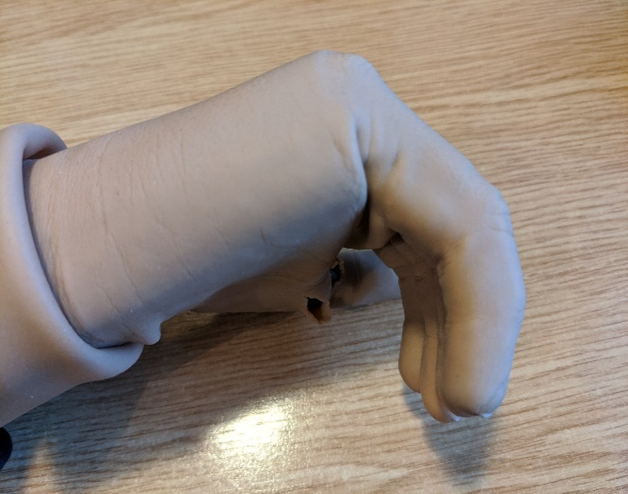
F: Tip of middle finger to top of palm = 5.5cm
G: Tip of middle finger to base of palm = 9cm
F
G
Thumb in opposition – Hand fully open
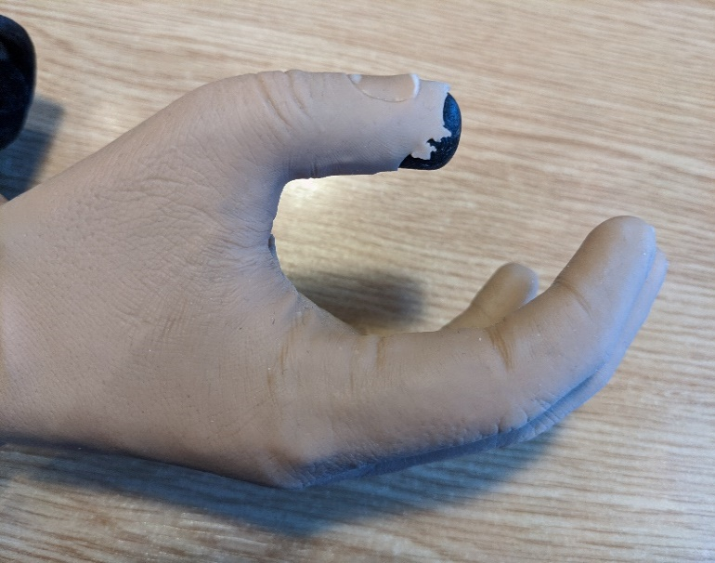
H: Tip of index finger to tip of thumb = 3.5cm
I: Aperture of opening between index finger and thumb = 3.5cm
H
I
Thumb in opposition – Hand partially closed (pinch grip)
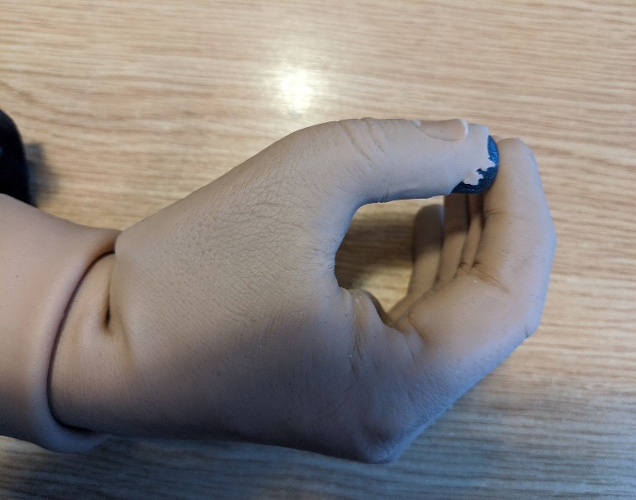
J: Tip of middle finger/thumb to web of glove = 5cm
K: Aperture of opening between index finger and thumb = 3cm
K
J

