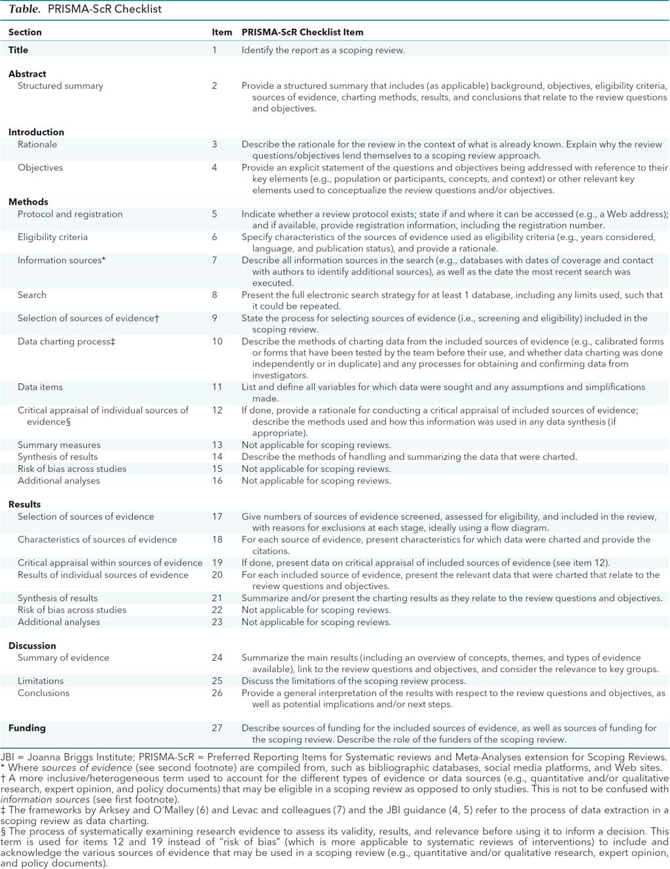
From: Tricco AC, Lillie E, Zarin W, O'Brien KK, Colquhoun H, Levac D, et al. PRISMA Extension for Scoping Reviews (PRISMAScR): Checklist and Explanation. Ann Intern Med. 2018;169:467–473. doi: 10.7326/M18-0850.

