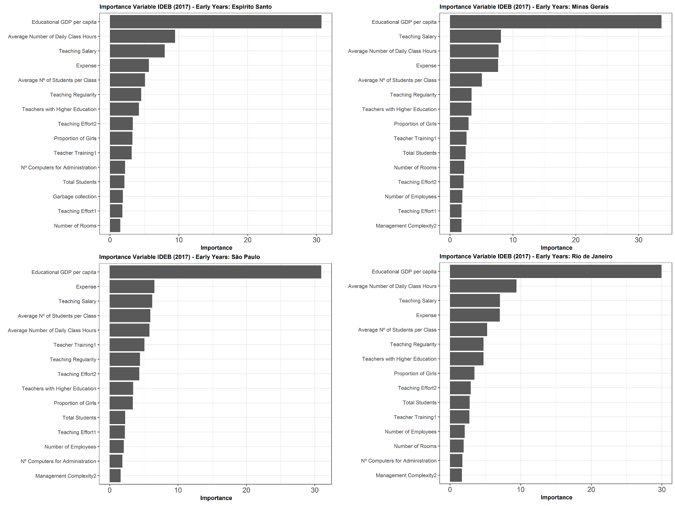
S4 Fig. Importance of variables calculated using the GBM for the Early Years in southeastern states.
IDEB: Basic Education Development Index; GBM: Gradient Boosting Machine; GDP: Gross Domestic Product.

