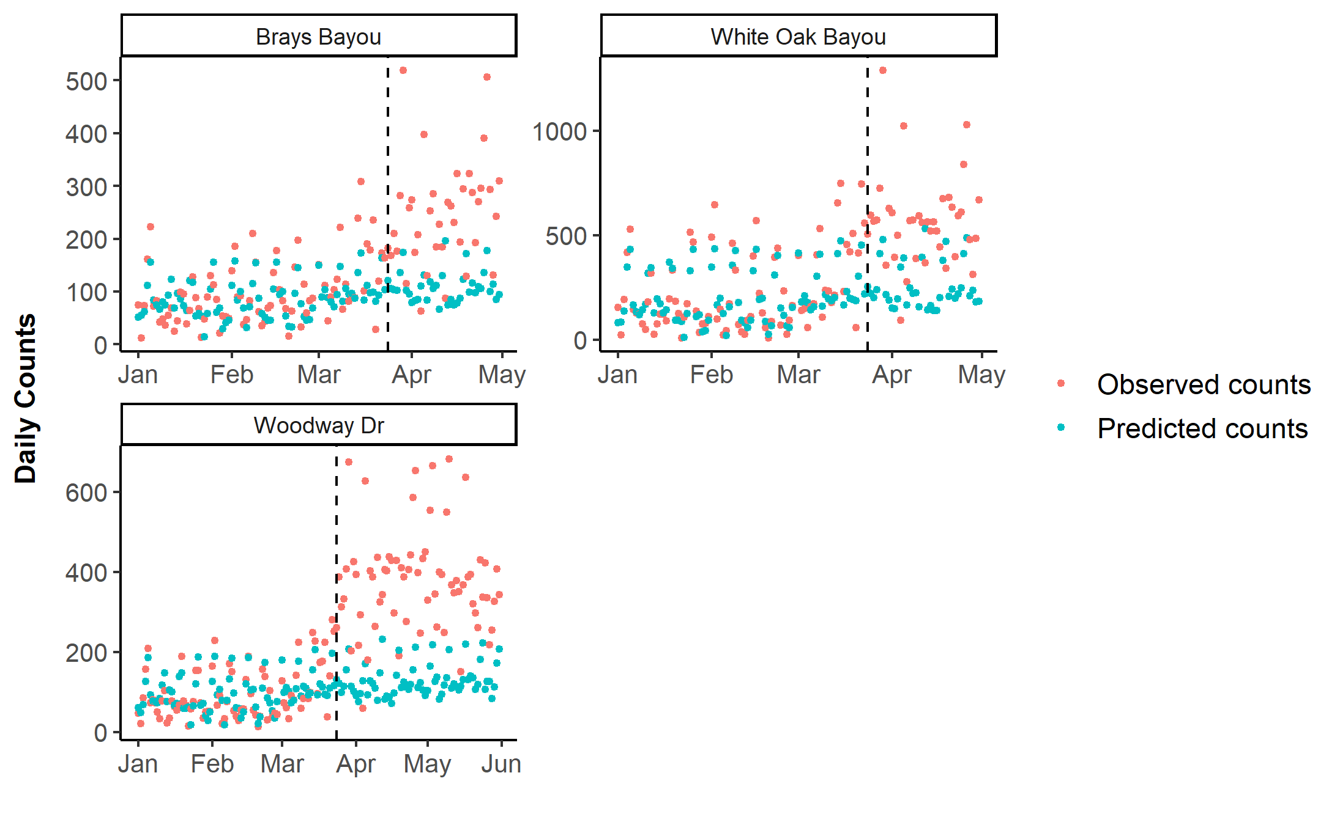
S2 Fig. Daily bicycle counts by counter location in Houston, before and during the Stay Home order. The vertical dashed line corresponds to the Stay Home order on March 24, 2020 in Harris County, Texas.

