S2 Fig: Biomarker concentrations in function of gestational age at blood sampling.
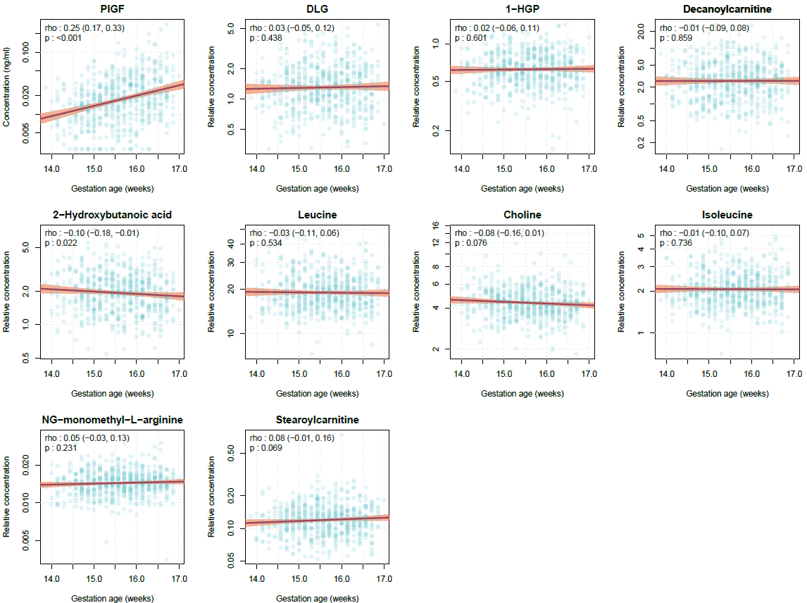

Biomarker levels are log-transformed. Correlation estimated using Pearson's correlation coefficient rho (95% confidence interval) and p-value.

