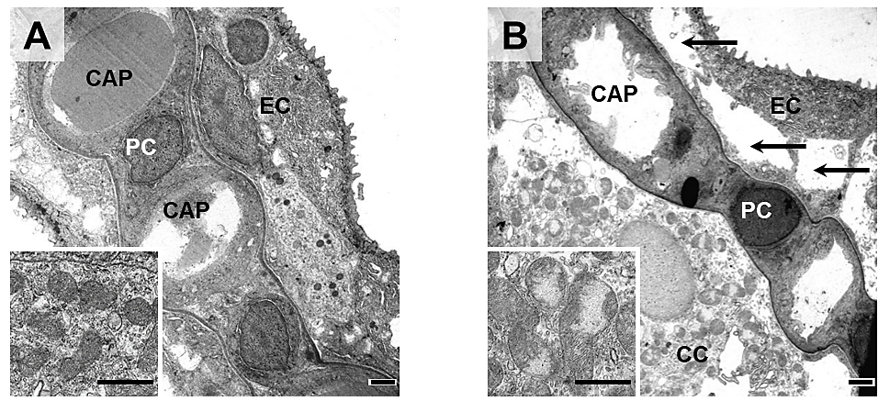

**S4 Fig. Ultrastructural perfusion fixation artifacts in rainbow trout gills.**

Representative transmission electron microscopic images of secondary lamellae of a control fish  
(**A**, non-perfused), and of a gill perfused with ~100 mmHg (**B**). Capillary (CAP), pillar cell (PC), epithelial cell (EC), chloride cell (CC). Note the detachment of the gill epithelium in **B** (arrows). Inset in B shows severely distended and swollen mitochondria of a chloride cell. TEM. Bars = 1 µm.