(a)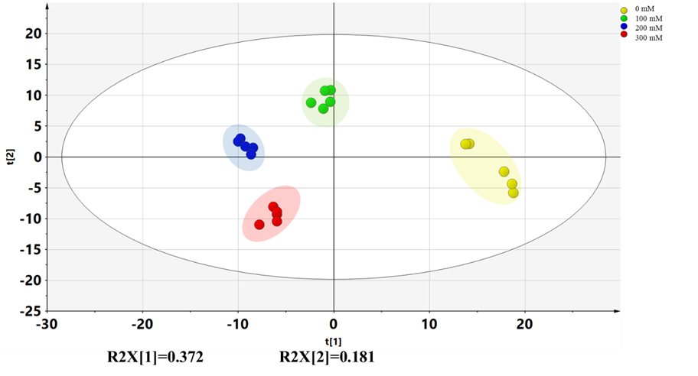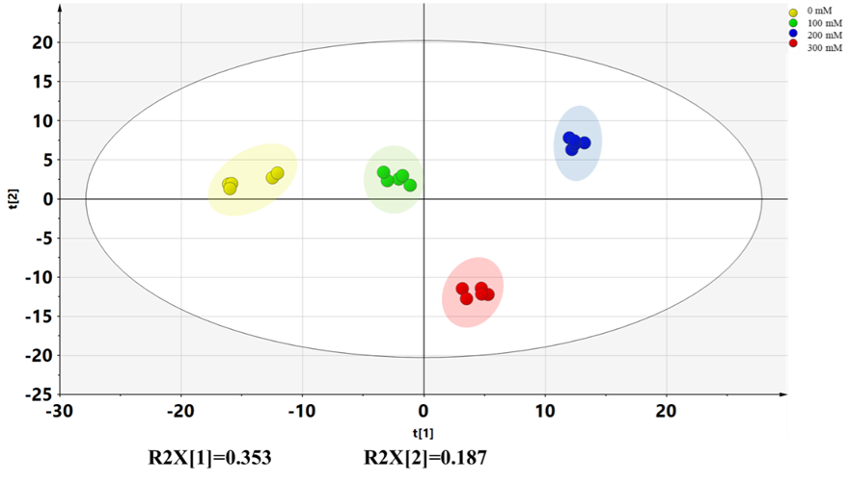(b)
S2 Fig PCA scores plot of LJF induced by different salt stress under positive (a) and negative (b) ion modes, respectively.

