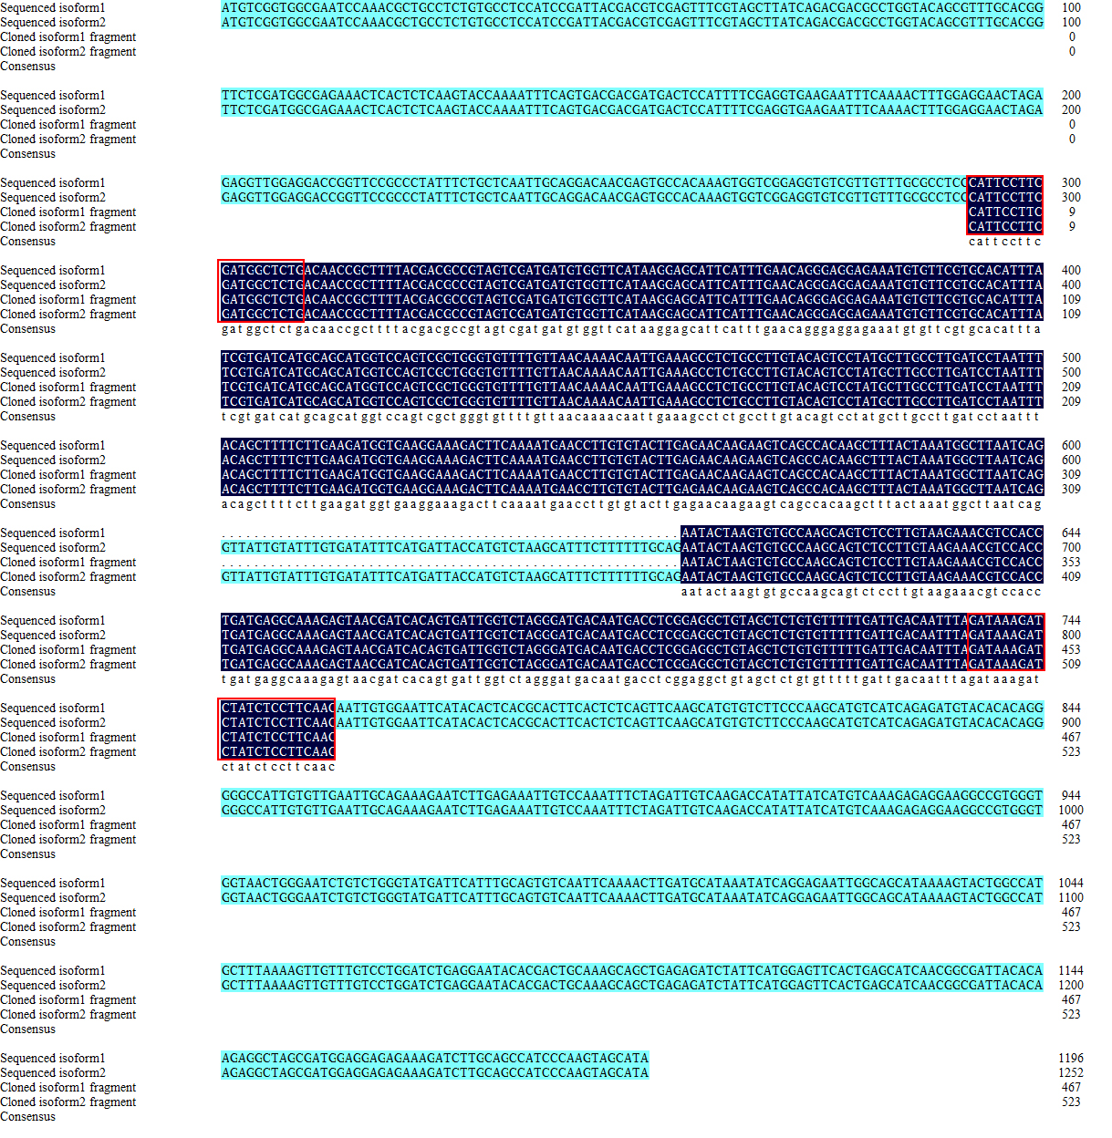
S2 Fig. Transcripts alignment of two Illumina sequencing isoforms and two PCR fragments of the gene 6853.
The bases in frame indicated PCR primer. The isoform1 was normal transcript and isoform2 was included a intron.

