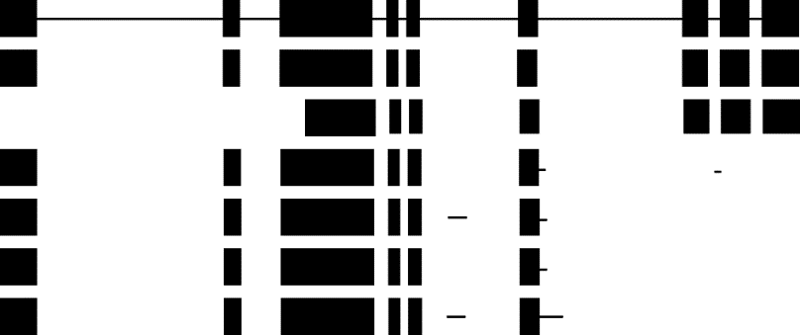
DNA
Isoform-1
Isoform-2
Isoform-3
Isoform-4
Isoform-5
Isoform-6

S1 Fig. Transcripts of the gene Potri.002G124200.v3.0（PABP1）since of AS

