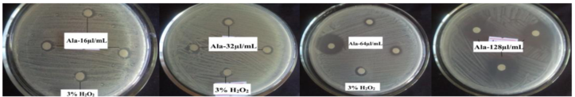
S7_Fig.tif. Inhibition of Lactobacillus by Ala EO (doses: 16μl/mL, 32μl/mL, 64μl/mL, and 128μl/mL respectively)

