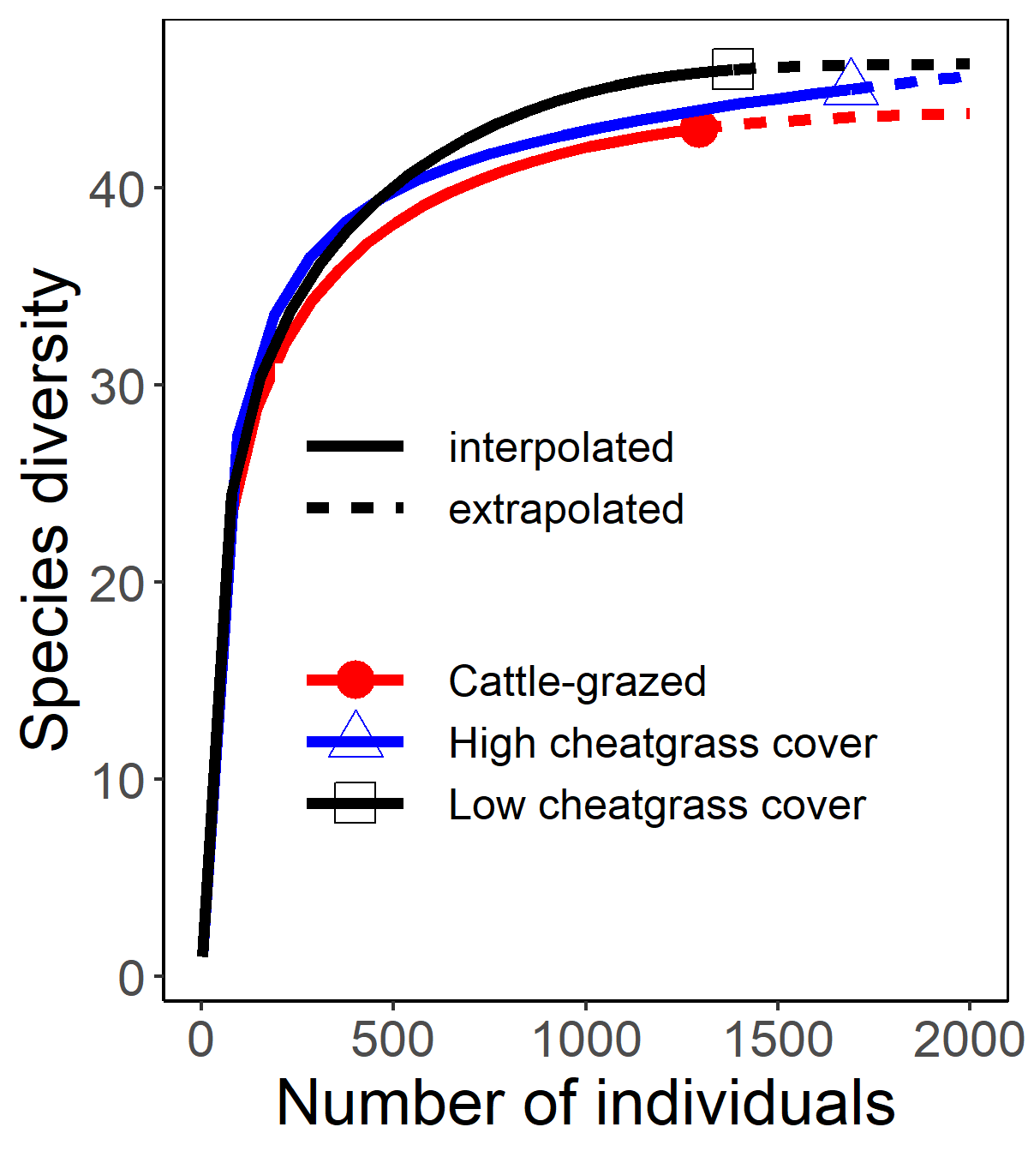
S1 Fig. Species detection curves for wild bees in shortgrass prairie in three habitat types.

