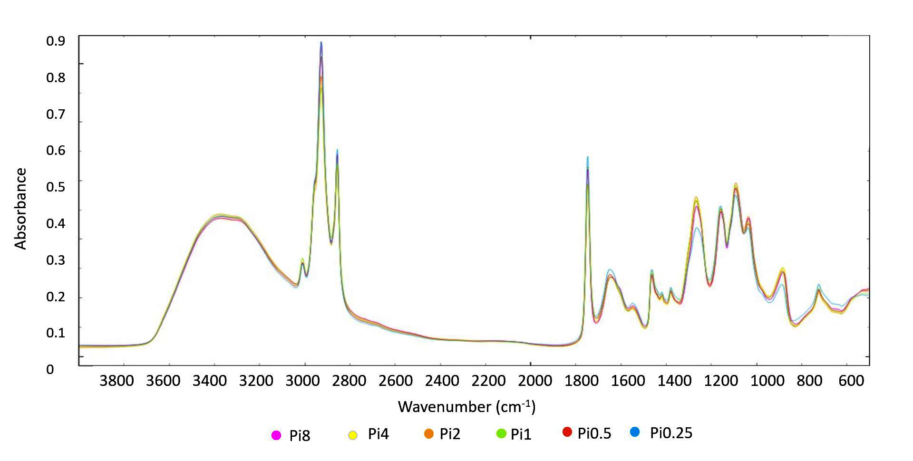

Supplementary Figure 12. FTIR-HTS spectra of Mucor circinelloides (EMSC corrected); yeast extract nitrogen source, different Pi-levels

