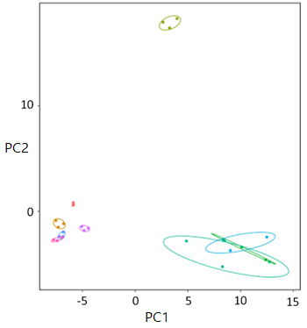

Supplementary figure 2. Root exudate compounds grouped by repetitions of fertilizer level. Treatments within plant developmental stages differ from one another, particularly the vegetative and bolting growth stages. Ellipses circle three repetitions of same fertilizer level. Color code correspond to seedling: 25% (light green), 50% (light blue), 100% (green); vegetative: 25% (purple), 50% (pink), 100% (blue); bolting: 25% (brown), 50% (olive), 100% (orange).

