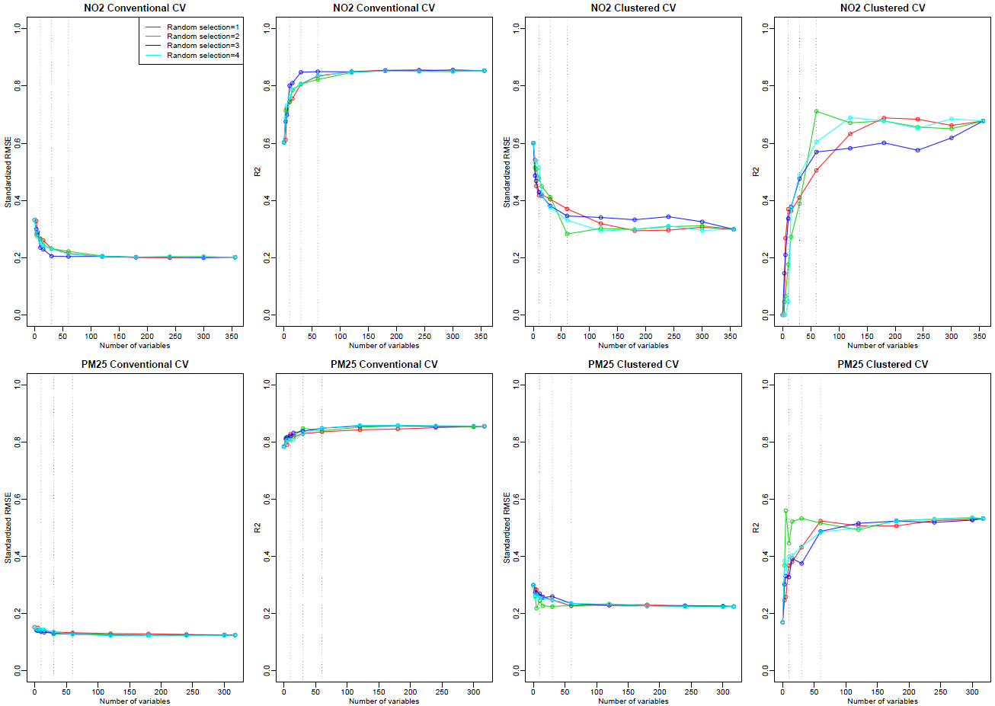
Figure S11. The relationship between the same numbers of randomly selected variables as those in forward selection and cross-validation (CV) statistics from the national Integrated Empirical Geographic (IEG) models of NO₂ and PM_{2.5} in 2000 by conventional and clustered cross-validation. For easy of viewing, vertical lines are shown at x-axis values of 10, 30, and 60

