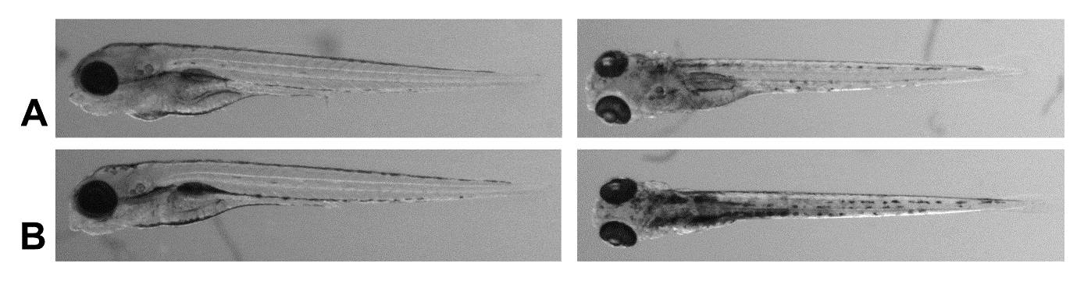
S4 Non-inflated swimbladder wildtype zebrafish morphology A) wildtype zebrafish submerged underwater to prevent swimbladder inflation B) Scn1Lab knockout zebrafish, also without inflated swim-bladder as a comparison.

