Supplementary materials IV: Postoperative evaluation of acetabular fractures
A postoperative evaluation of the acetabular fracture was performed for all patients, in order to determine the percentage of the reduction after surgery. A case example is shown below (Figure
A1).

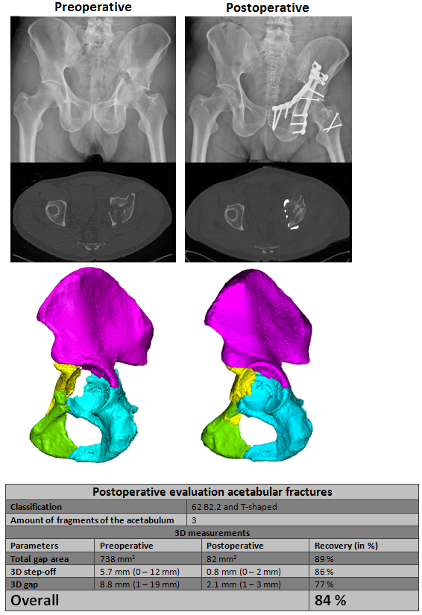
Figure A1: An example of the postoperative evaluation of an acetabular fracture. Left: The preoperative situation and right: The postoperative situation, with the plain radiographs (top), an axial CT slice at the dome (middle) and the pre- and postoperative 3D models (bottom).

