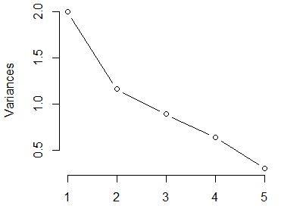
S4 Figure Screeplot of children PCA.

