RNA-Seq analysis of Bread Wheat Root Transcriptome in Response to Salt Stress
Functional and Integrative Genomics
N. Amirbakhtiar¹, A. Ismaili¹*, M.R. Ghaffari², F. Nazarian Firouzabadi¹, Z.S. Shobbar²*
1- Department of Agronomy and Plant Breeding, Faculty of Agriculture, Lorestan University, PO Box 465, Khorramabad, Iran.
2- Department of Systems Biology, Agricultural Biotechnology Research Institute of Iran (ABRII), Agricultural Research, Education and Extension Organization (AREEO), PO Box 31535-1897, Karaj, Iran
* Co-corresponding authors:
Zahra-Sadat Shobbar: Email: shobbar@abrii.ac.ir; Phone: +98-2632703536. Ahmad Ismaili: Email: ismaili.a@lu.ac.ir; Phone: +98-66-33400012.

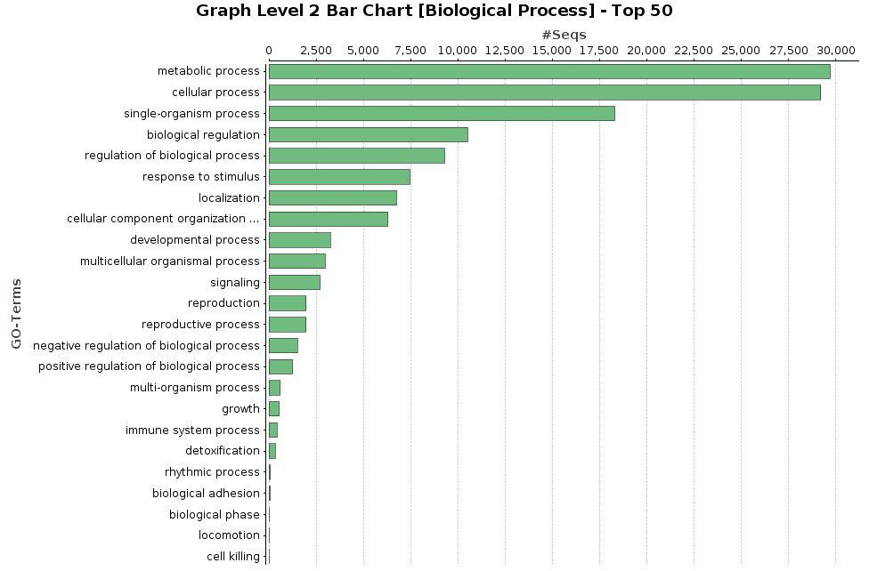
S3 Fig. GOSlim terms(in biological process category) assigned to the transcripts produced through IR AS event.

