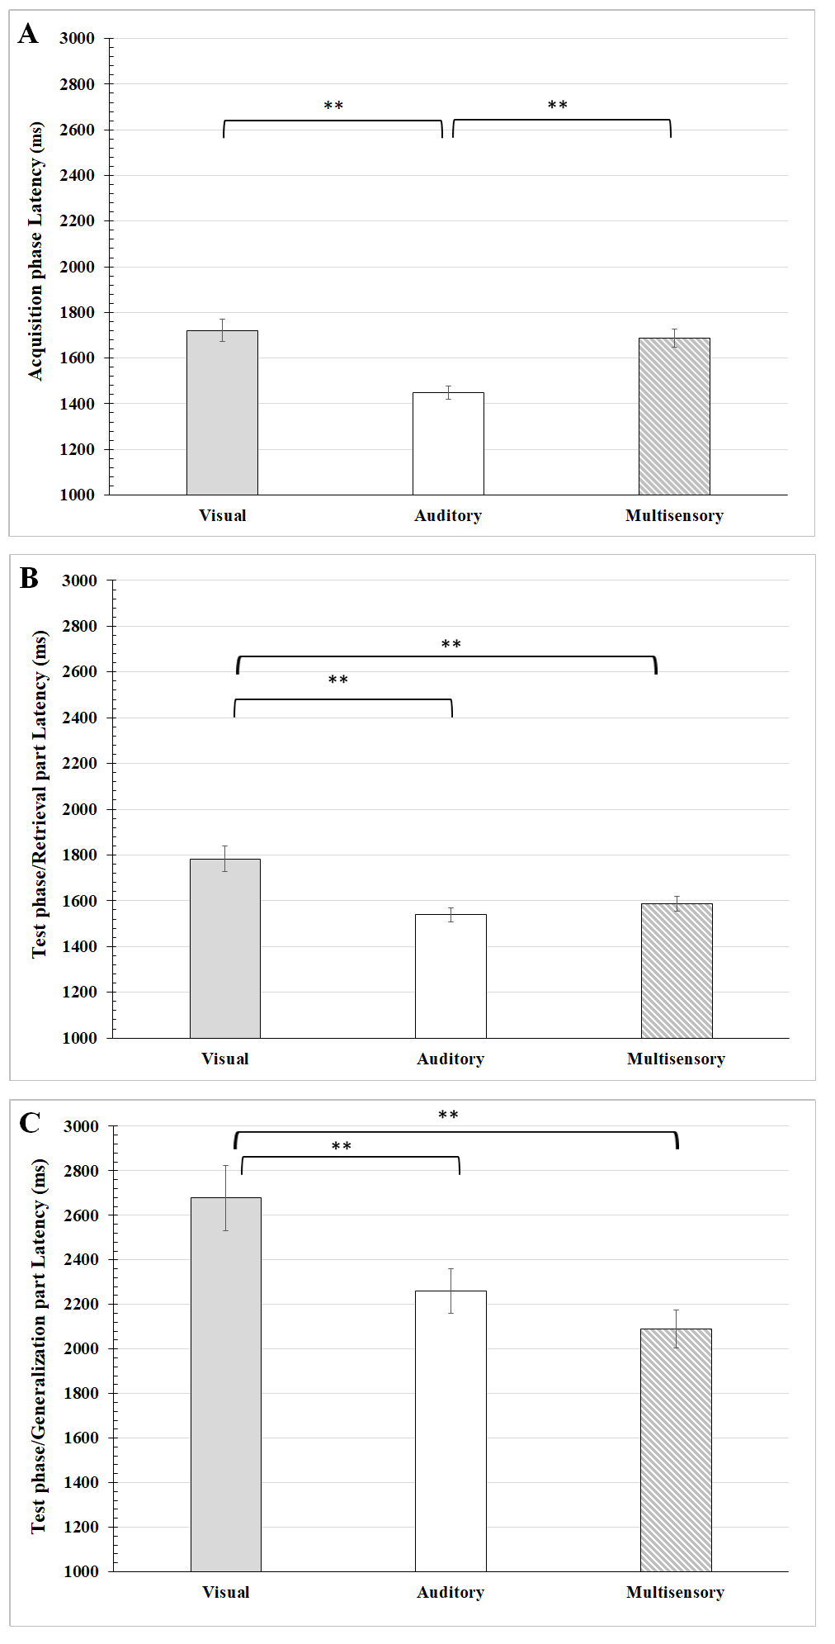

Response latencies in the sensory guided equivalence learning paradigms. (A) shows the response latencies in the acquisition phase of the paradigm, while (B) and (C) denote the response latencies in the retrieval and the generalization parts of the test phase, respectively. The ordinates show the latencies in millisecond (ms). Other conventions are the same as in Suppl. 1.

