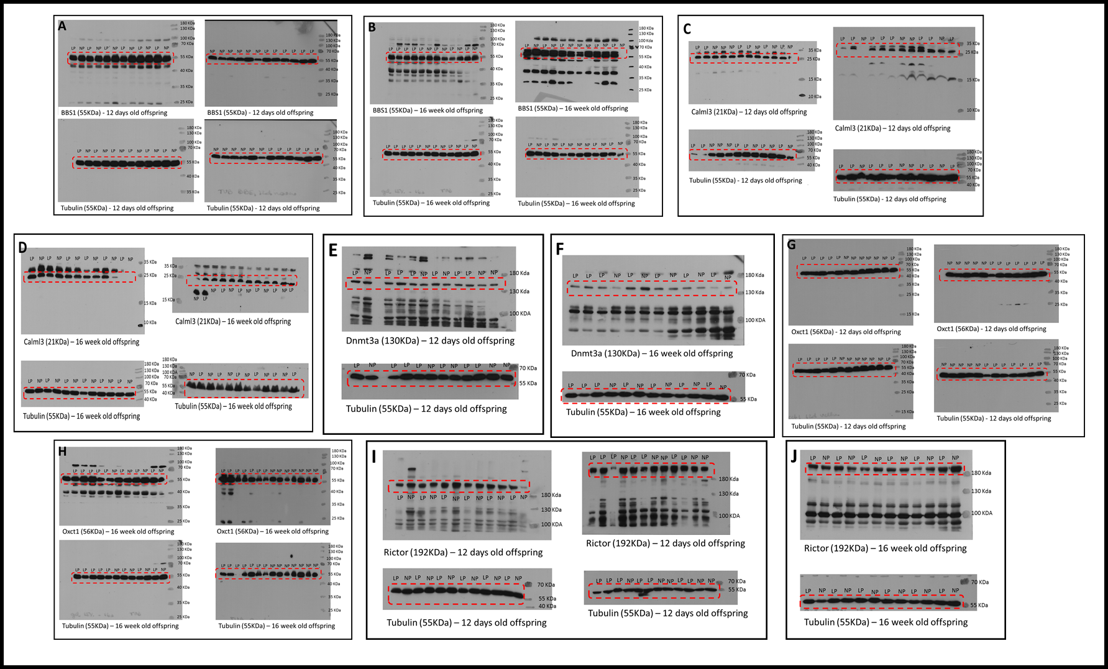
S2 Fig. Western blot gels.
(A) BBS1 blots of 12 days old offspring; (B) BBS1 blots of 16 weeks old offspring; (C) Calml3 blots of 12 days old offspring; (D) Calml3 blots of 16 weeks old offspring; (E) Dnmt3a blots of 12 days old offspring; (F) Dnmt3a blots of 16 weeks old offspring; (G) Oxct1 blots of 12 days old offspring; (H) Oxct1 blots of 16 weeks old offspring; (I) Rictor blots of 12 days old offspring; (J) Rictor blots of 16 weeks old offspring.

