S2 Fig. Hierarchical clustering of the QCs using batch normalization (A) or merged normalization (B).

A)
QCs
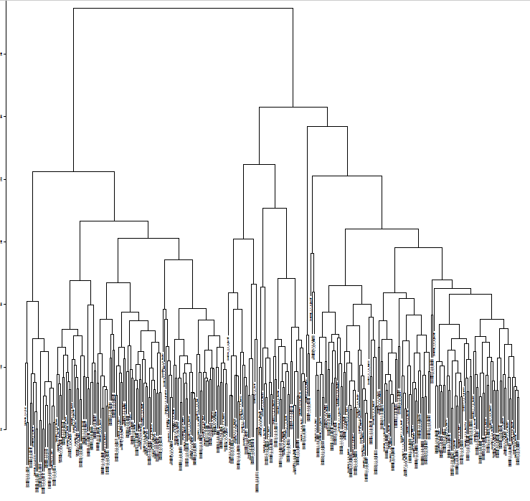

B)
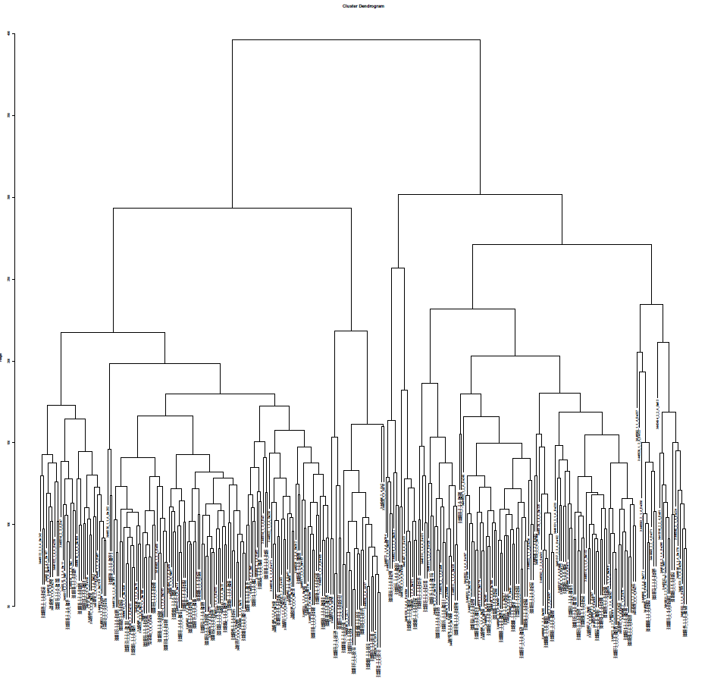

QCs

