S1 Fig. The trend of decrease in droplet size when increase in concentration of surfactant and glycerol was also found when homogenization pressure was at 500 and 700.
(A)

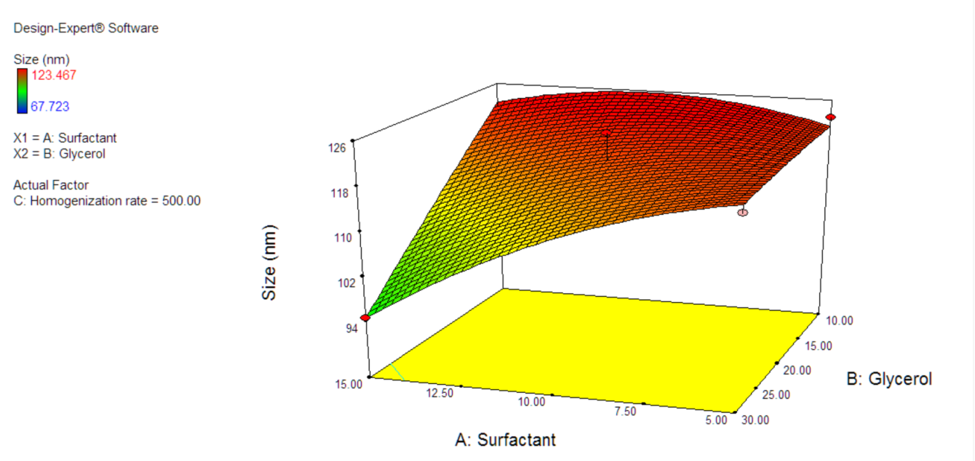.
(B)
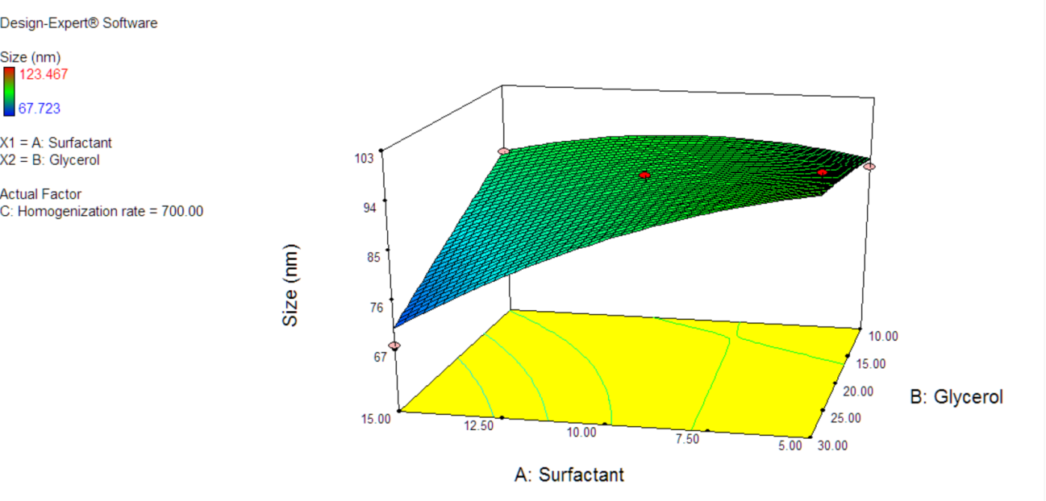

Response surface plot showing the effect of 10 wt% of surfactant concentration, 20 wt% of glycerol concentration and (A) 500 bar homogenization pressure and (B) 700 bar homogenization pressure

