S1 Fig. Q-Q plots. Quantile–quantile plots a, b and c demonstrate the relationship between observed (y-axis) and expected (x-axis) test statistics.

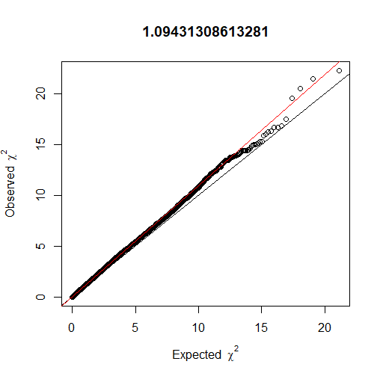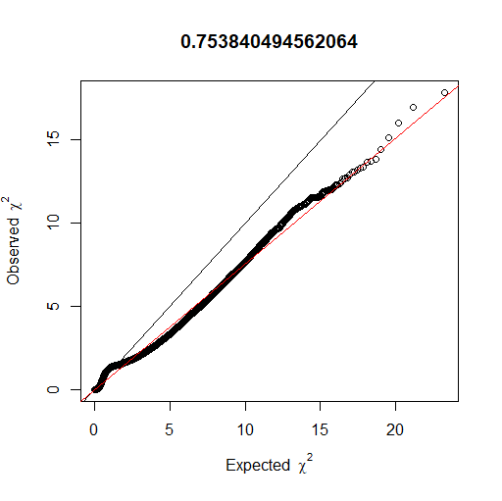
A. Basic association B. Logistic association.
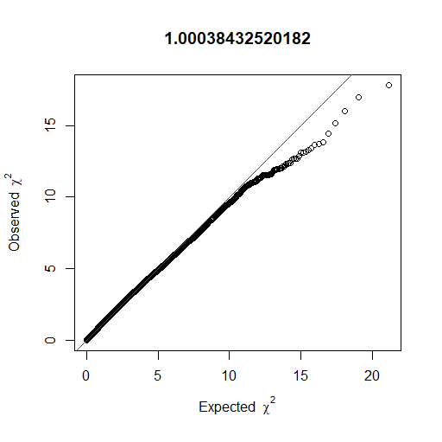
C.Logistic with covariates.

