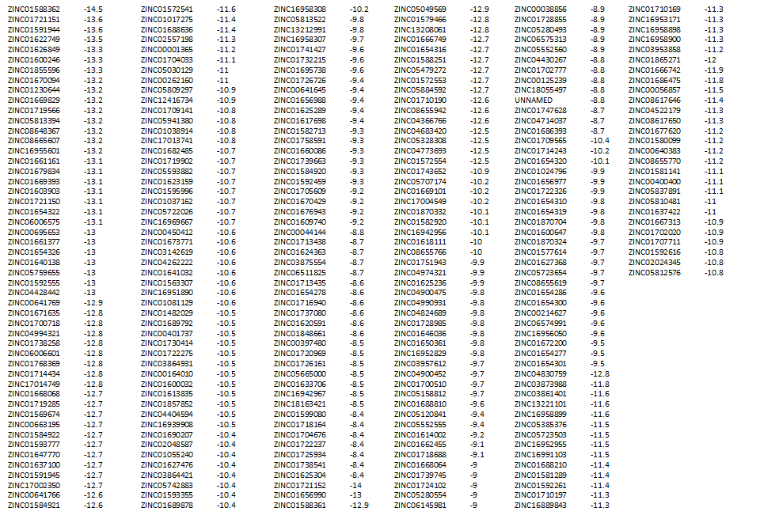
S1 Table. TM domain compounds with highest binding affinities.

