The ARRIVE Guidelines Checklist
Animal Research: Reporting In Vivo Experiments
Carol Kilkenny¹, William J Browne², Innes C Cuthill³, Michael Emerson⁴ and Douglas G Altman⁵
¹The National Centre for the Replacement, Refinement and Reduction of Animals in Research, London, UK, ²School of Veterinary Science, University of Bristol, Bristol, UK, ³School of Biological Sciences, University of Bristol, Bristol, UK, ⁴National Heart and Lung Institute, Imperial College London, UK, ⁵Centre for Statistics in Medicine, University of Oxford, Oxford, UK.

 |  | ITEM | RECOMMENDATION | Section/  Paragraph
 |  |  |  | Title
 |  |  |  | Abstract
 | INTRODUCTION
 | 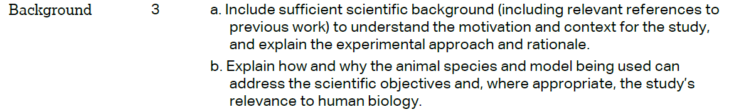 |  |  | Page 4 Line 2 - Page 5 Line 18  Page 5 Line 18 - Page 6 Line 2
 |  |  |  | Page 5 Line 8-16
 | METHODS
 |  |  |  | Page 8 Line 9-17
 | 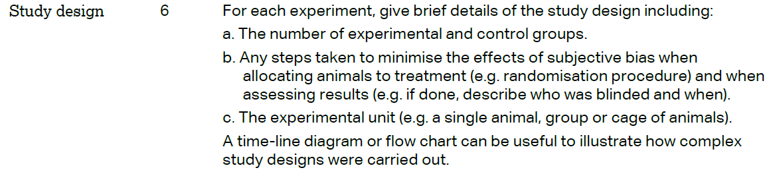 |  |  | a. Page 8 Line 17 - Page 9 Line 8  b. Page 8 Line 18  c. a single animal
 | 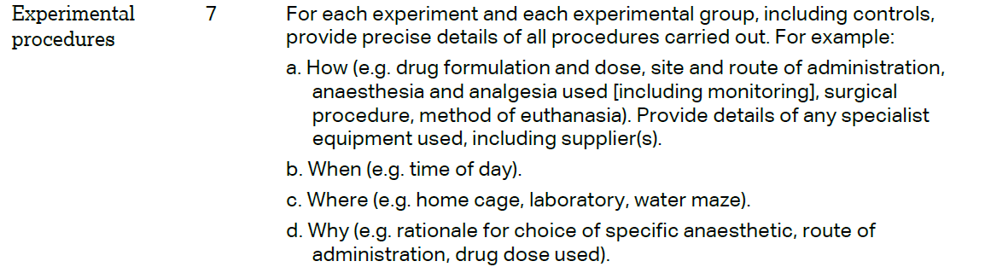 |  |  | Page 8 Line 18 - Page 9 Line 18
 | 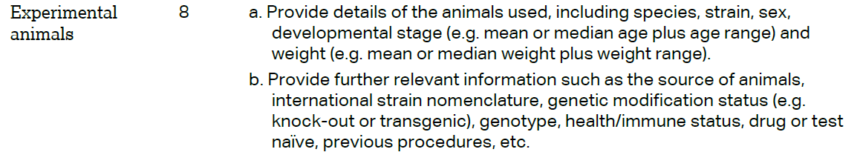 |  |  | Page 9 Line 2 - 3
The ARRIVE guidelines. Originally published in PLoS Biology, June 2010¹
 | 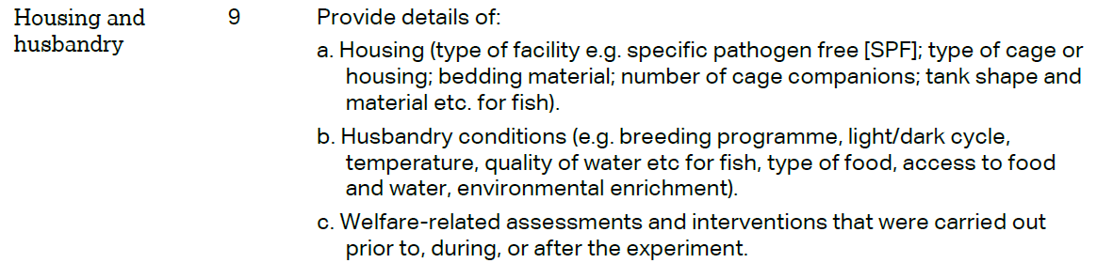 | a. Page 8 Line 13-16  b. Page 8 Line 13-15  c. Not relevant
 | 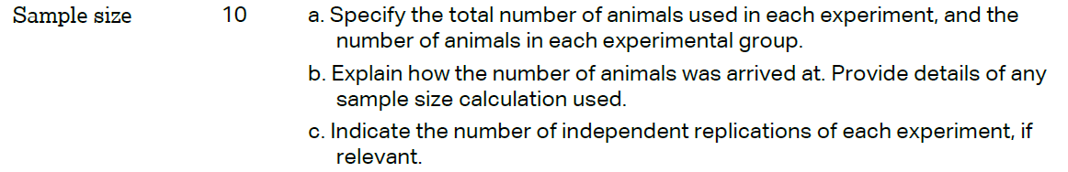 | a. Tables 1-4  b. Page 9 Line 8-10  c. Not relevant
 | 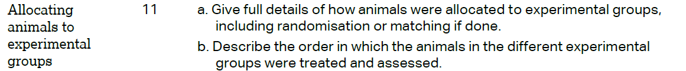 | a. Page 8 Line 18  b. Not relevant
 |  | Page 9 Line 13-14
 | 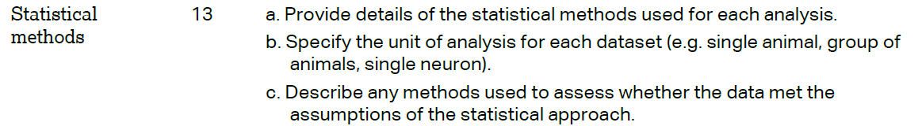 | a. Not relevant  b. Not relevant  c. Not relevant
 | RESULTS
 |  | Page 9 Line 3
a. Tables 1-4
b. Not relevant
 |  | Tables 1-4
 |  | Not relevant
 | DISCUSSION
 | 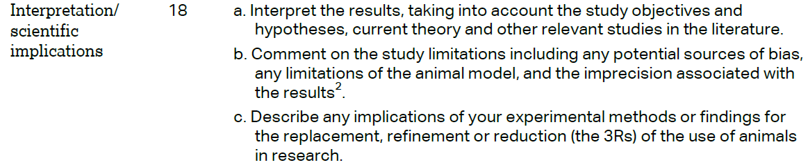 | Page 16 Line 6 - Page 19 Line 15  b. Not relevant  c. Not relevant
 |  | Page 17 Line 3 - 6
 |  | Not relevant
