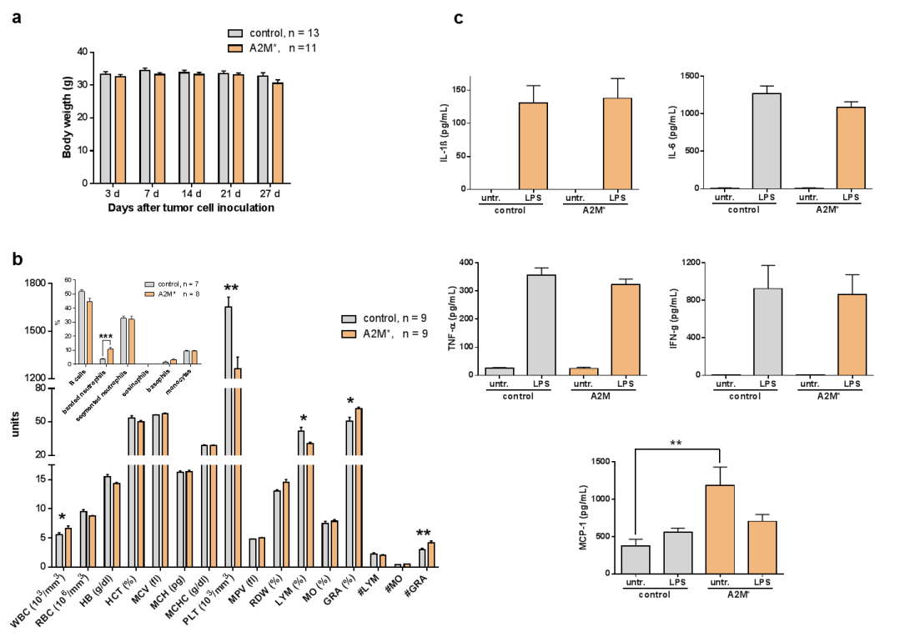
S2 Fig. Analysis of blood cells in tumour-bearing mice before and after treatment with A2M
(a) Coarse of body weight of tumour-bearing A549 mice treated with A2M* (n = 10) compared to control (n = 9). (b) EDTA blood was withdrawn from A549 tumour bearing mice and analysed in a ScilVet apparatus (ScilVet Animal Care Company, Viernheim, Germany). Blood cells were counted at day 7 after tumour induction (control) and day 31 after A2M* treatment. WBC – white blood cells, RBC – red blood cells, HGB - Hemoglobin, HCT – Hematocrit value, MCV – mean corpuscular volume, MCH – mean corpuscular hematocrit, PLT - platelets, MPV – mean platelet volume, RDW – red cell distribution width, LYM – Lymphocytes, MO - Monocytes, GRA - Granulocytes, (n = 9), (* P < 0.05, **P < 0.01, ***P < 0.001). (c), Effect of A2M* on mouse spleen cells. Spleen cells from A549 tumour-bearing mice treated with A2M* were isolated, stimulated with 10 nM lipopolysaccharide (LPS) or PBS (control) and cytokines were measured by cytokine bead arrays (CBA). (n = 10) (**P < 0.01). Error bars represent mean ± s.d.

