The ARRIVE Guidelines Checklist
Animal Research: Reporting In Vivo Experiments
Carol Kilkenny¹, William J Browne², Innes C Cuthill³, Michael Emerson⁴ and Douglas G Altman⁵
¹The National Centre for the Replacement, Refinement and Reduction of Animals in Research, London, UK, ²School of Veterinary Science, University of Bristol, Bristol, UK, ³School of Biological Sciences, University of Bristol, Bristol, UK, ⁴National Heart and Lung Institute, Imperial College London, UK, ⁵Centre for Statistics in Medicine, University of Oxford, Oxford, UK.

 |  | ITEM | RECOMMENDATION | Section/  Paragraph
 |  |  |  | Title, Paragraph 1
 |  |  |  | Abstract, paragraph 1 to paragraph 4
 | INTRODUCTION
 | 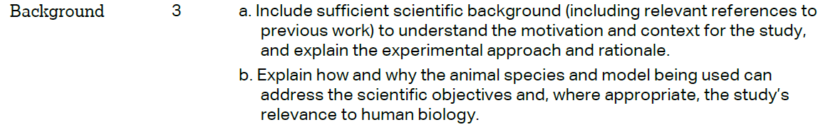 |  |  | Introduction, paragraph 1 to paragraph 3
 |  |  |  | Introduction, paragraph 4
 | METHODS
 |  |  |  | Material and Methods, paragraph 7
 | 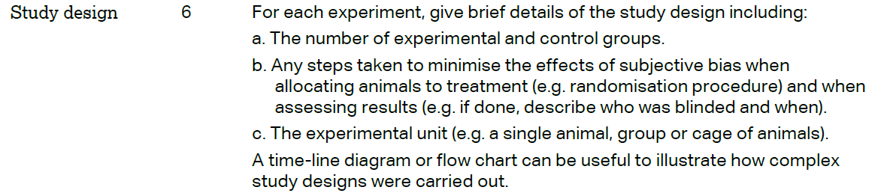 |  |  | Material and Methods, paragraph 7 to  paragraph 9
 | 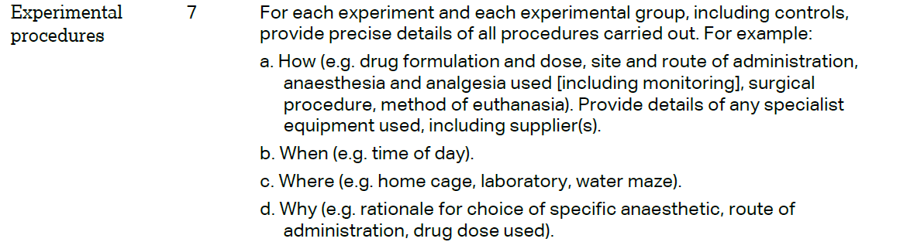 |  |  | Material and Methods, paragraph 7 to  paragraph 9
 | 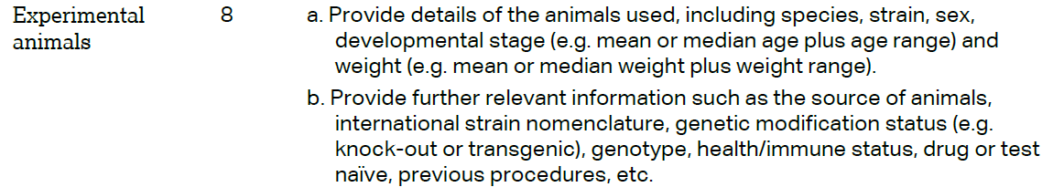 |  |  | Material and Methods, paragraph 7 to  paragraph 9
The ARRIVE guidelines. Originally published in PLoS Biology, June 2010¹
 | 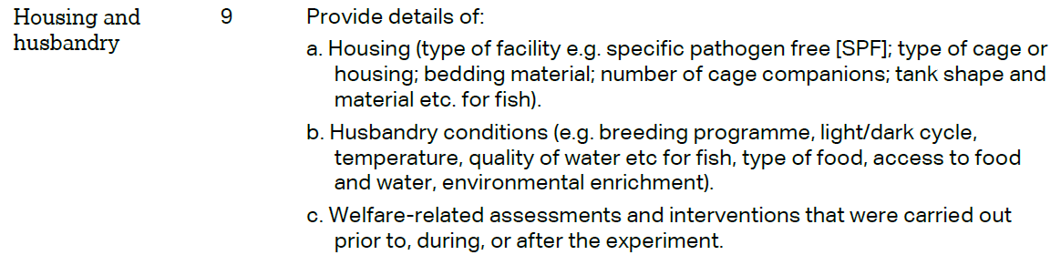 | Material and Methods, paragraph 7
 | 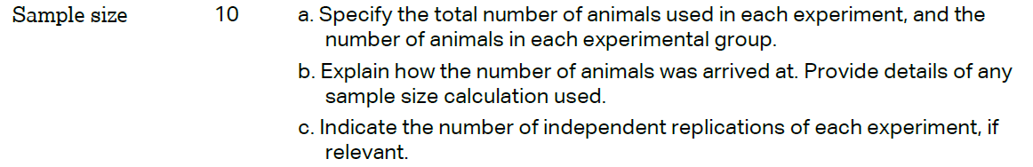 | Material and Methods, paragraph 8
 | 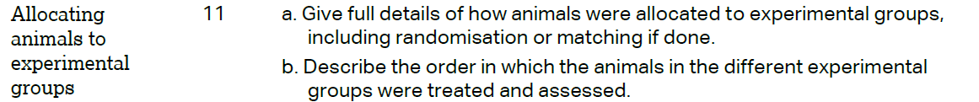 | Material and Methods, paragraph 8 to  paragraph 9
Material and Methods, paragraph 9 to
paragraph 11
 | 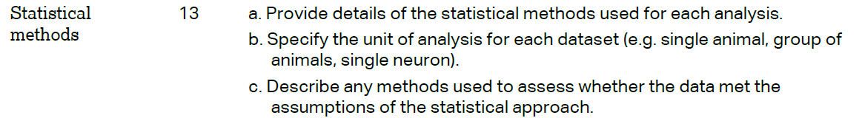 | Material and Methods, paragraph 12
 | RESULTS
 |  | Results, paragraph 4
 |  | Results, paragraph 4
 |  | Results, paragraph 4
 |  | Results, paragraph 4
 | DISCUSSION
 | 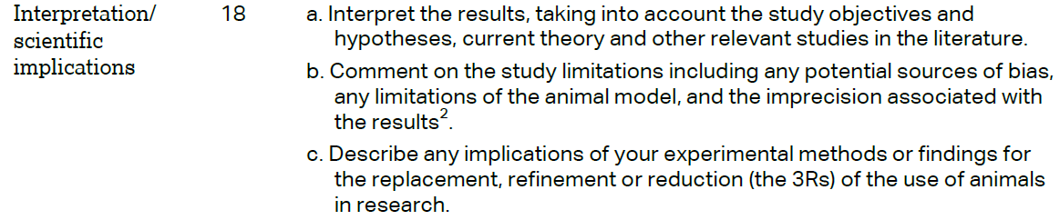 | Discussion, paragraph 1 to paragraph 4
 |  | Discussion,paragraph 4
 |  | Author Contributions, paragraph 1
