The ARRIVE Guidelines Checklist
Animal Research: Reporting In Vivo Experiments
Carol Kilkenny¹, William J Browne², Innes C Cuthill³, Michael Emerson⁴ and Douglas G Altman⁵
¹The National Centre for the Replacement, Refinement and Reduction of Animals in Research, London, UK, ²School of Veterinary Science, University of Bristol, Bristol, UK, ³School of Biological Sciences, University of Bristol, Bristol, UK, ⁴National Heart and Lung Institute, Imperial College London, UK, ⁵Centre for Statistics in Medicine, University of Oxford, Oxford, UK.

 |  | ITEM | RECOMMENDATION | Section/  Paragraph
 |  |  |  | Page 1: Title
 |  |  |  | Page 2: Abstract
 | INTRODUCTION
 | 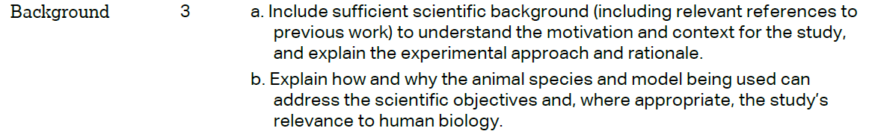 |  |  | Introduction: §1-2
 |  |  |  | Introduction: §3
 | METHODS
 |  |  |  | M&M/Animals/§3
 | 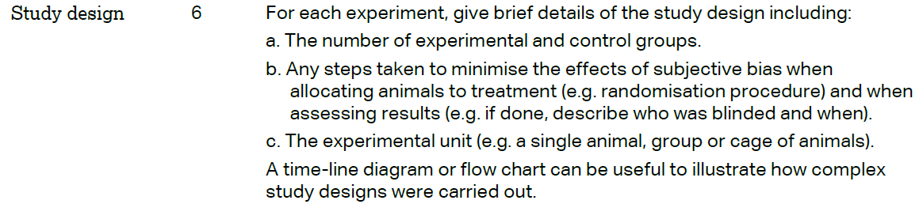
 | 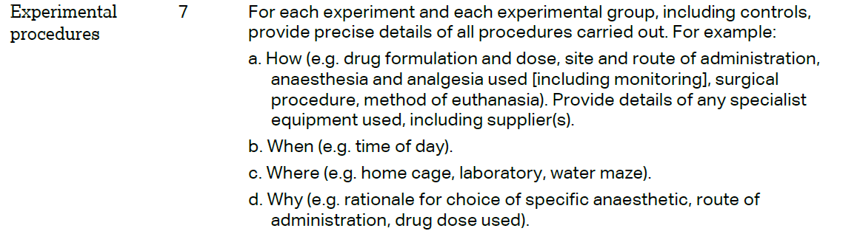 |  |  | M&M/MRI; Vascular corrosion casting
 | 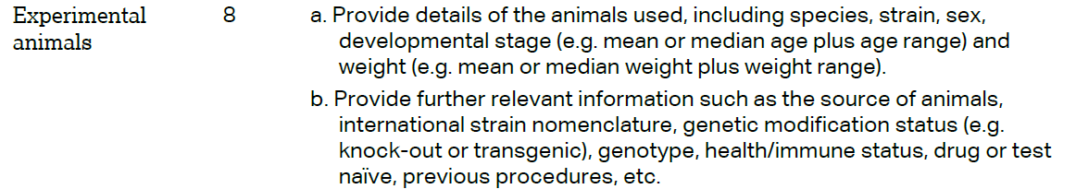 |  |  | M&M/Animals/§1-2
The ARRIVE guidelines. Originally published in PLoS Biology, June 2010¹
 | 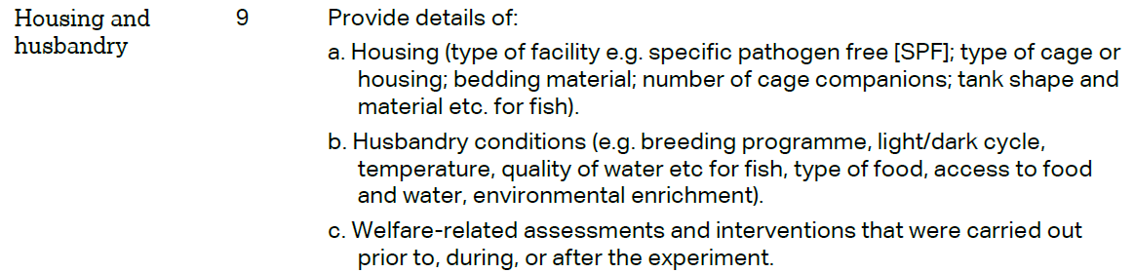 | M&M/Animals/§3
 | 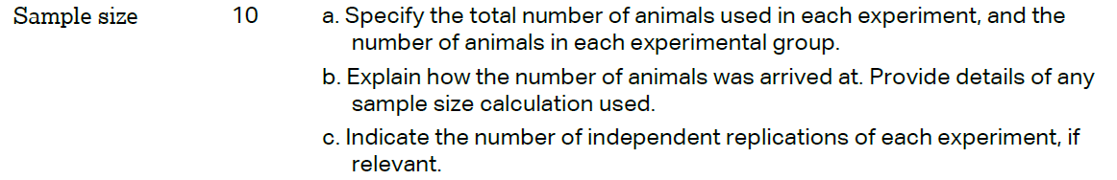 | Results/ Fig 4; Table 1; Fig 6 and Fig 7
 | 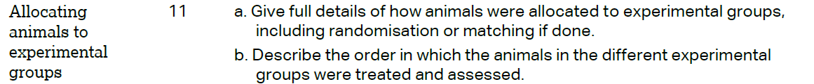
 | 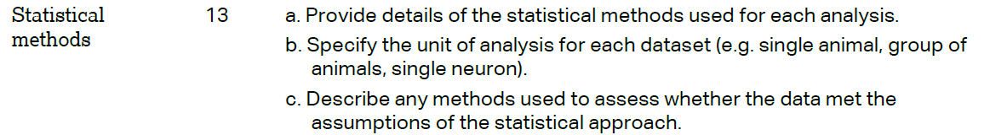 | M&M/Statistics
 | RESULTS
 |  | Results/Fig 4
 |  | Results/ Fig 4; Table 1; Fig 6 and Fig 7
 |  | Results/ Fig 4; Fig 6 and Fig 7
 |  | Results/ Fig 4; Fig 6 and Fig 7
 | DISCUSSION
 | 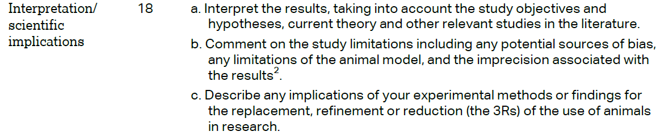 | Discussion/§1-6
