The ARRIVE Guidelines Checklist
Animal Research: Reporting In Vivo Experiments
Carol Kilkenny¹, William J Browne², Innes C Cuthill³, Michael Emerson⁴ and Douglas G Altman⁵
¹The National Centre for the Replacement, Refinement and Reduction of Animals in Research, London, UK, ²School of Veterinary Science, University of Bristol, Bristol, UK, ³School of Biological Sciences, University of Bristol, Bristol, UK, ⁴National Heart and Lung Institute, Imperial College London, UK, ⁵Centre for Statistics in Medicine, University of Oxford, Oxford, UK.

 |  | ITEM | RECOMMENDATION | Section/  Paragraph
 |  |  |  | Title page
 |  |  |  | Abstract/ paragraph 1
 | INTRODUCTION
 | 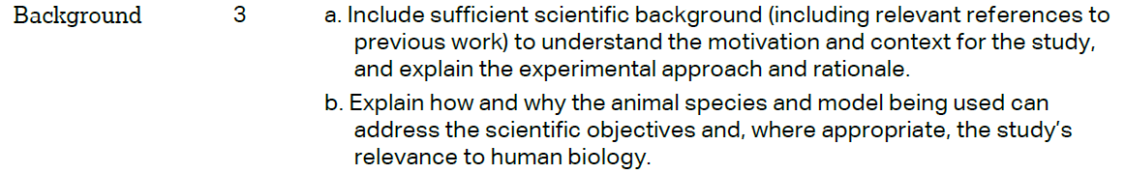 |  |  | Introduction/ paragraph 2-4
 |  |  |  | paragraph 5
 | METHODS
Materials and Method/
paragraph 6
 | 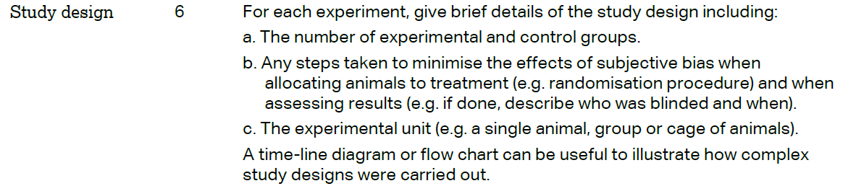 |  |  | Materials and Method/  paragraph 7
 | 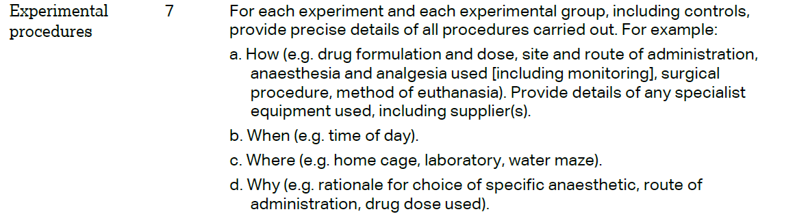 |  |  | Materials and Method/  paragraph 7
 | 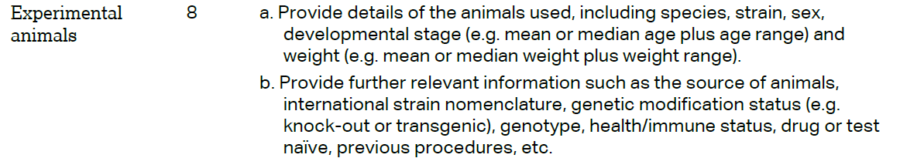 |  |  | Materials and Method/  paragraph 7
The ARRIVE guidelines. Originally published in PLoS Biology, June 2010¹
 | 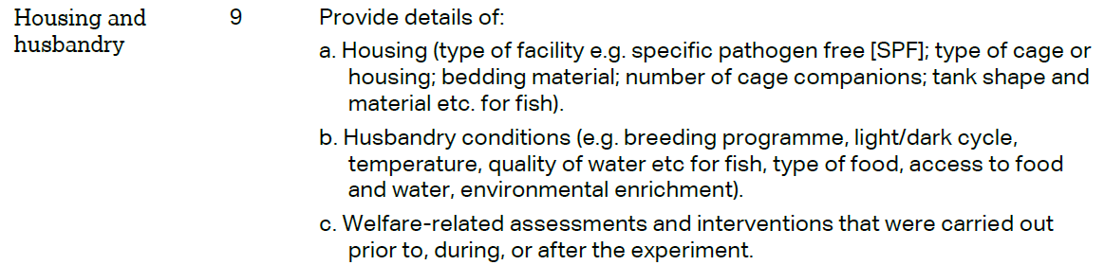 | Materials and Method/  paragraph 6
 | 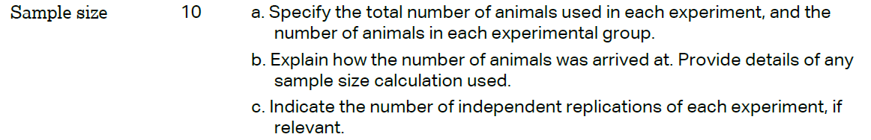 | Materials and Method/  paragraph 7
 | 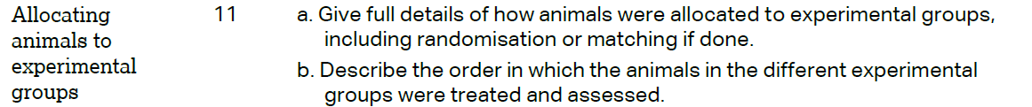 | Materials and Method/  paragraph 7
Materials and Method/
paragraph 8-16
 | 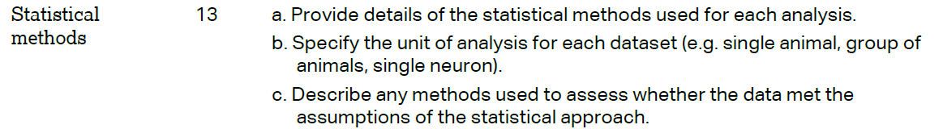 | Materials and Method/  paragraph 17
 | RESULTS
 |  | Results and discussion/
 |  | Materials and Method/ paragraph 7
Results and discussion/
paragraph 18-25
 |  | Materials and Methods paragraph 7
 | DISCUSSION
 | 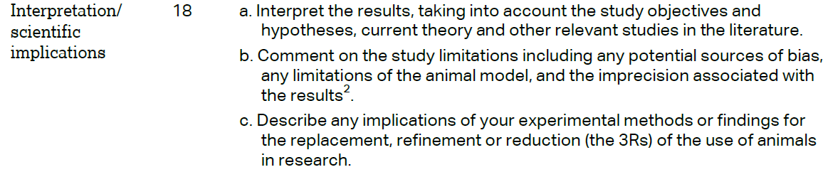 | Results and discussion/  paragraph 26-29
Conclusion/
Paragraph 30
Funding Statement/
Paragraph 32
