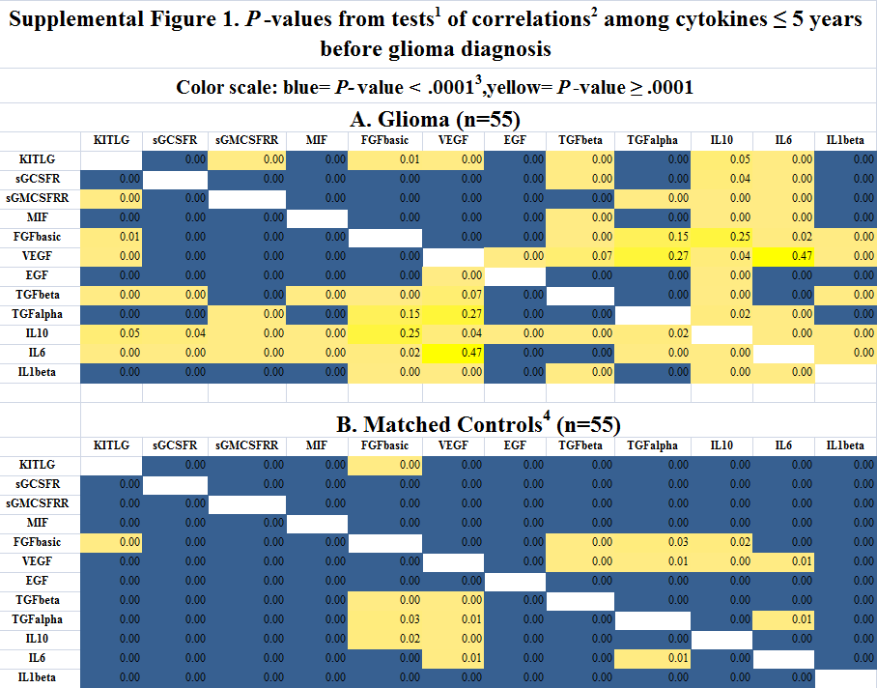
- T-tests of equality of each correlation coefficient to zero
- Pearson correlation coefficients
- Although only two decimal places are shown color formatting program takes four into account
- Controls matched on age and date of blood draw and gender.
- For abbreviations see Fig. 2

